**NGAGE HANDBOOK**

Table of contents

**FRONT-END** 3

1. Login 3

2. Upload your CV 3

3. Job list 5

3.1. Apply to a job 6

3.2. Job advert sharing 7

4. Login for candidate 8

4.1. Personal area and job ads 8

4.2. Job Agent (OPTIONAL MODULE*) 9

4.3. Documents 10

4.4. Video resume (OPTIONAL MODULE*) 10

4.5. Job test 12

4.6. Image upload 12

4.7. Account management 13

5. Mobile version 14

6. Login for contact person 14

6.1. Candidate’s summary 15

6.2. Multimailing 16

6.3. Candidates suggestion (OPTIONAL MODULE*) 18

6.4. Job orders (OPTIONAL MODULE*) 19

6.5. Account management 19

LOGIN FOR EMPLOYER 20

1. Account management 20

1.1. Personal 20

1.2. Users 21

1.3. Candidates 24

1.4. Companies 26

1.5. Management setup 26

1.6. File storage (OPTIONAL MODULE*) 27

1.7. Job ads logo (OPTIONAL MODULE*) 27

2. MODULE “AGENDA” 29

3. MODULE “CANDIDATES” 31

3.1. Dashboard 31

3.2. Post a job 33

3.3. My ads 35

3.4. Recruitment step 38

3.5. Interview step 48

3.6. Selection step 53

3.7. Candidates (Database searches) 64

3.8. Shared with me 66

3.9. Exports 67

3.10. Candidate’s profile 67

3.11. More tools 82

4. MODULE “CLIENTS” 83

4.1. Dashboard 83

4.2. Company 86

4.3. Opportunities 110

4.4. Alerts 113

4.5. Job Radar 113

4.6. Mailing List 116

4.7. Exports 124

5. MODULE “REPORTING” 125

5.1. Selection, Companies and Conversion 125

5.2. Selection > Check competitor-candidates 145

5.3. Data-log 146

5.4. Exports 149

# **FRONT-END**

The software front-end is made up of 3 pages: the login page, the job list page and the application form. Once linked to the company website, these sections are accessible to all users.

## Login

The login page is a page from which users can log into the system. This page can be accessed by all the system users (candidates, employers or contact people).

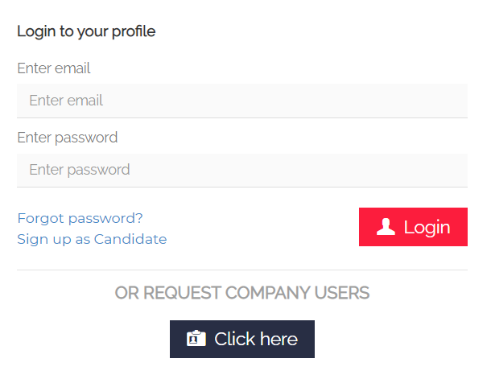

If you have forgotten your password, you can easily click on "Forgot password?" and you will be redirected to the password recovery page. By clicking on "Recover", you will receive an automated e-mail to set a new password. If the e-mail entered has not been registered in the database yet, you will see the following message: 

**N.B.:** It is necessary to access the "recover password" function from the link in the last email received.

## Upload your CV

Here you can access the candidate's application form. Compulsory fields are marked with the symbol * (if you don’t fill in these fields, the application cannot be completed).

The email address is the unique identifier that allows recognizing each candidate profile. If an email address has already been registered into the database, an error message is reported.

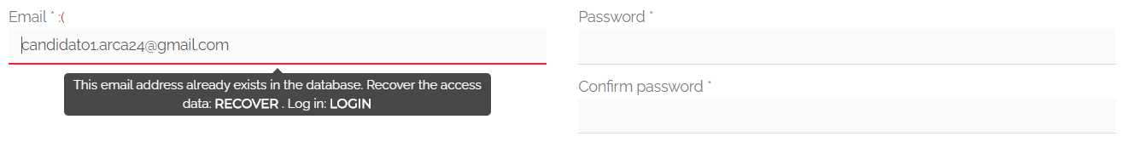

**Upload CV:**Into the section “Personal details”, you have to upload your CV.

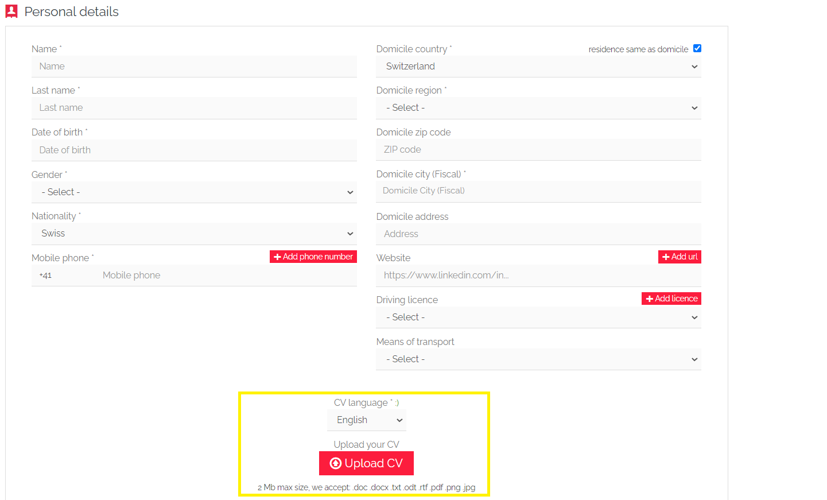

It is necessary to choose the language in which your CV was written (English, German, French, Italian, Portuguese, Spanish and Polish, if provided). The semantic reading will be carried out according to the language used in the CV. The language of all automated emails sent by the system depends on that of the CV. In the event that your software version is monolingual, all emails and SMS will be sent in the installation language, regardless of the language of the CV.

For what concerns the file upload, the system informs you that:

* only the following formats are accepted: .doc .docx .txt .odt .rtf .pdf .png .jpg
* the maximum size accepted is 2MB.

**Privacy**: The standard flags in this section are as follows:

1. “I accept Privacy, Terms & Conditions” -> this is compulsory to proceed with the application

2. “I consent to receive electronic communications” -> this flag creates a filter into candidates’ searches, helpful for activities related to multimailing

3. “Send me e-mails about new job offers aligned with my profile” -> this flag is included only in the systems with the mod “**Job Agent**” activated; it allows to automatically activate job alerts according to the candidate’s professional profile.

Once you have filled in the application form and you have clicked on the button “Save”, you will be shown a second page where you can:

* Upload a new certificate (OPTIONAL MODULE*);
* Add experience. This section allows the candidate to add professional experiences, especially those not mentioned in the CV;
* See and improve the CV extraction as well as the professional tags identified by the semantic engine. The candidate can change the text extracted from the CV and adjust the related professional tags.

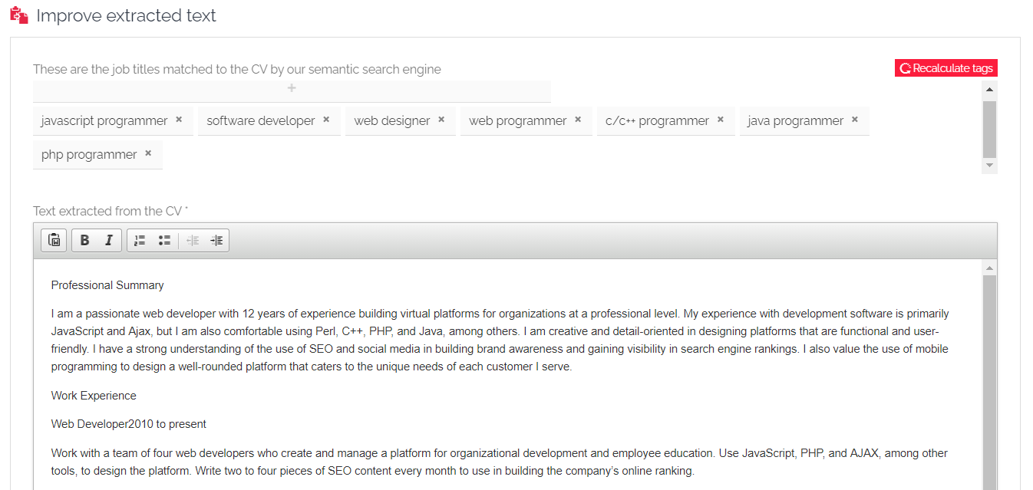

If there are any problems with the CV extraction, the following message will be displayed:

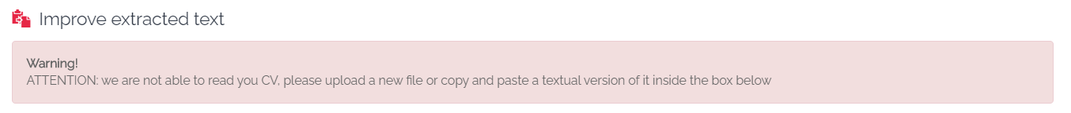

## Job list

The job list includes the full list of online ads.

Each job ad string shows workplace, sector and role, as well as a preview of the ad description (along with the last modification date).

Thanks to the widget on the right, you can use the filters to find job ads aligned with your search. Next to some filters, the link "List all" lists all the current sectors, roles and regions in reference to the active job offers.

Once the filters have been set, click on “**Start the search**” to start selecting the jobs to be displayed:

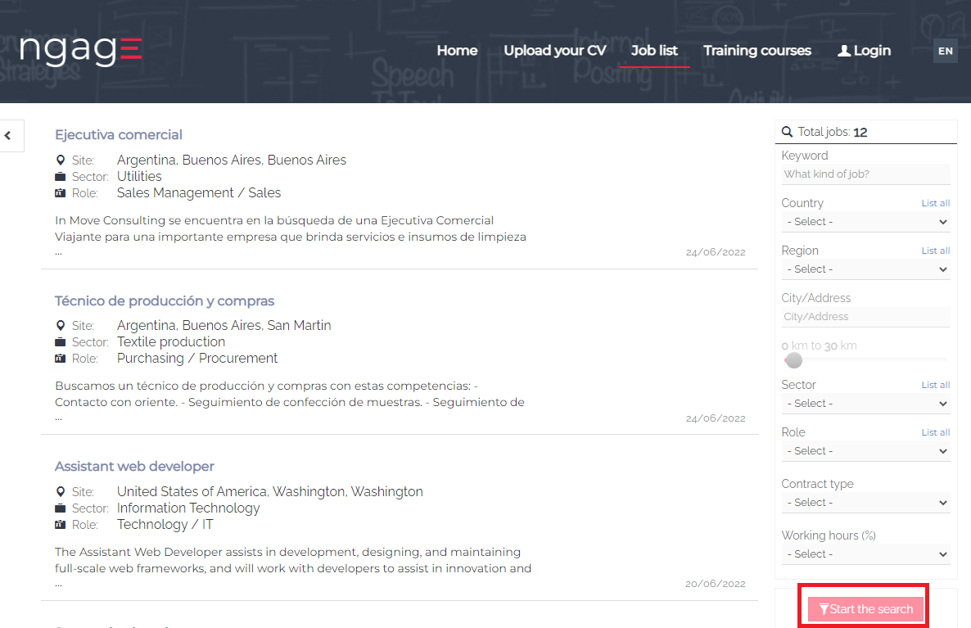

If you click on the individual job, you can see the detail, i.e., all the fields filled in by the recruiter within the job creation form.

### Apply to a job

By clicking on “Apply”, candidates can submit their application for the selected vacancy.

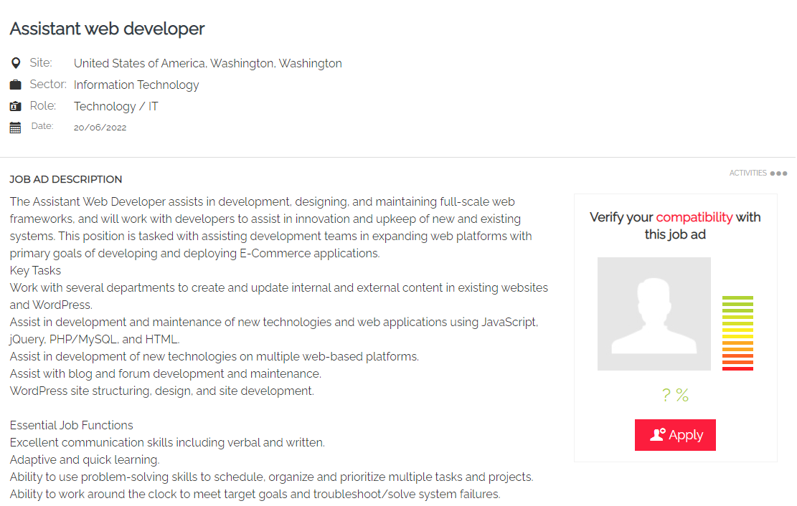

A pop up will be displayed. You can choose between different options:

* “Sign up”. The candidate has not registered yet. He/she will be redirected to the page “Upload your CV” and then directly to his/her personal area -> Tab “My ads” (where he/she will be displayed the online job ad for which he/she has applied);
* “Login”. The candidate is already registered. He/she will only need to add his/her credentials. By clicking on “Login”, the application is automatically submitted;
* “Login with Google”. The candidate has previously logged into his/her account with Google and applies directly to the job with the linked profile.

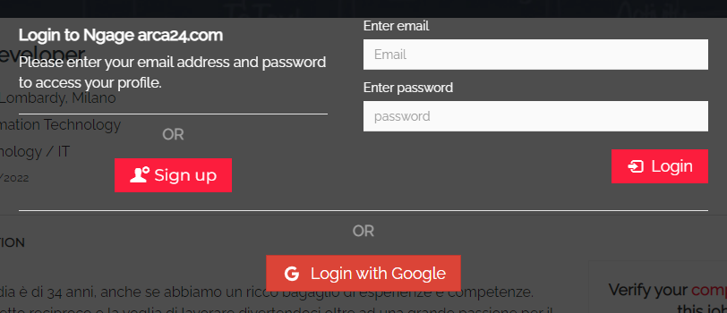

On the right, similar job ads are reported:

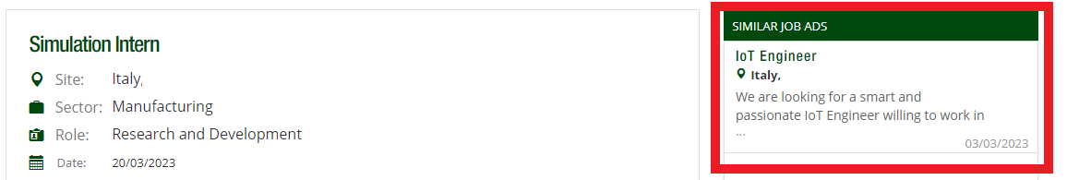

### Job advert sharing

Job adverts can be shared on Facebook, Xing, Twitter and LinkedIn, as shown below:

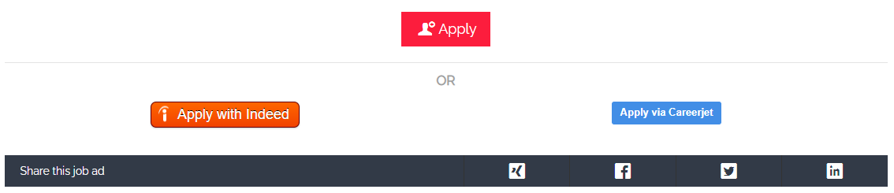

By clicking on “Activities”, it is possible to:

* **If logged in as a candidate**, save a job ad (which will be displayed in the personal area in the tab "My ads");
* Share the job ad via email through the option “Tell a friend”;
* Print the job ad, by clicking on “Print”.

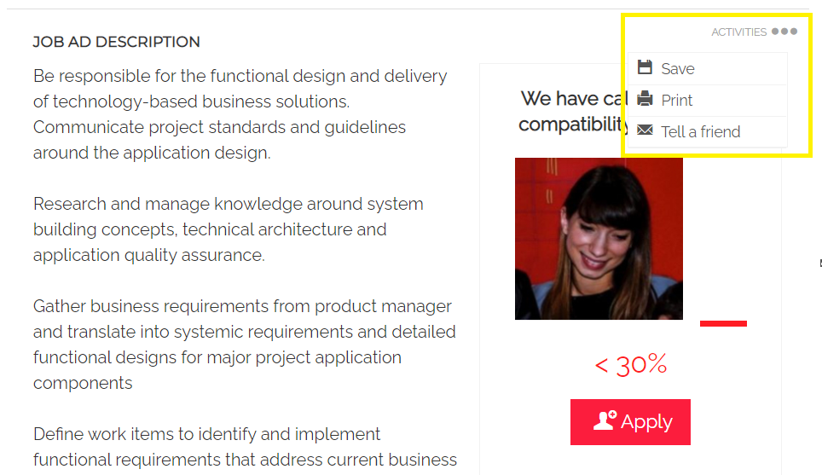

## Login for candidate

The candidate's personal area, which will be accessed via the login page, is divided into several tabs, depending on the functionalities activated.

### Personal area and job ads

The candidate's dashboard consists of a notifications box, in which the candidate can view and access all the requests sent to him/her from employers, and a message box, where he/she will see a welcome message.

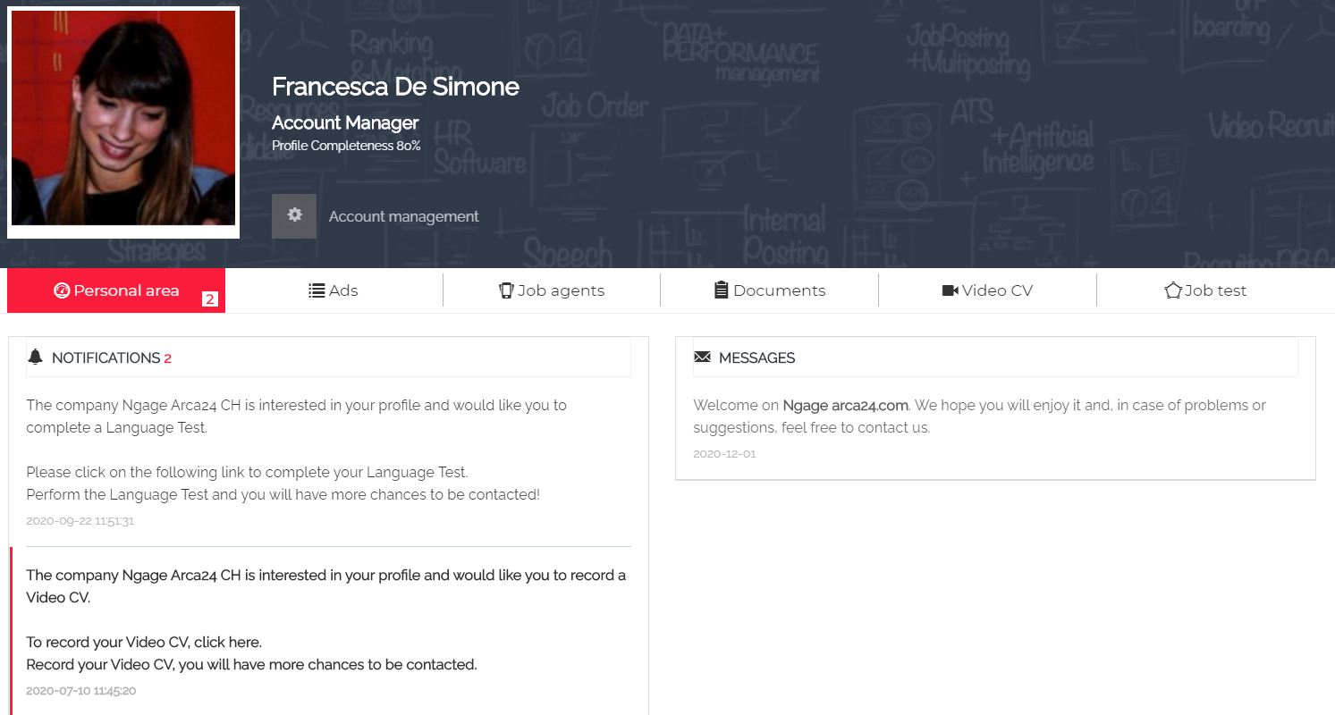

In the tab “My Ads”, two labels differentiate ads to which the candidate has applied ("Applied", green icon) from ads that have only been saved ("Saved", blue icon):

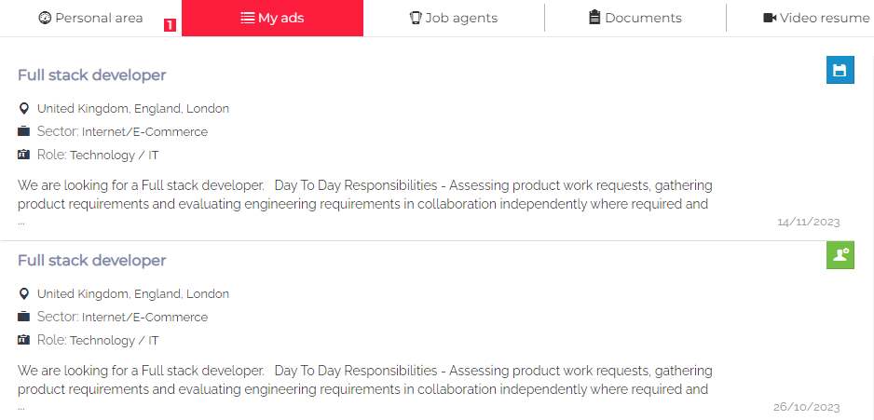

A candidate can delete a submitted application any time: he/she just needs to open the job ad (either from the tab “My ads” or the job list) and to click on “Cancel application”.

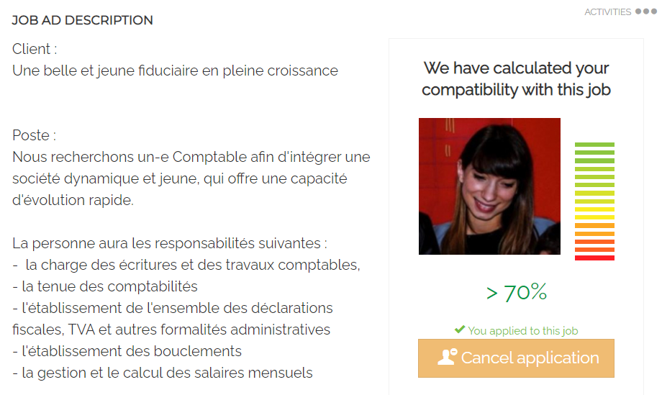

### Job Agent (OPTIONAL MODULE*)

“Job Agent” is a functionality that allows the candidate to set automatic alerts linked to open job vacancies matching his/her profile or other searches. The candidate will receive a weekly email with links to the new job vacancies based on the job agents activated.

A job agent is automatically created upon registration based on the candidate’s professional profile:

• The keyword set for the first alert corresponds to the "main profession" entered by the candidate in the application form (when modifying the main profession in the form, the job agent will be modified as well).

• This job agent can be activated/deactivated but cannot be deleted.

By clicking on "Create a new job agent", it is possible to add new alerts. New job agents can be activated, deactivated, modified and deleted at any time.

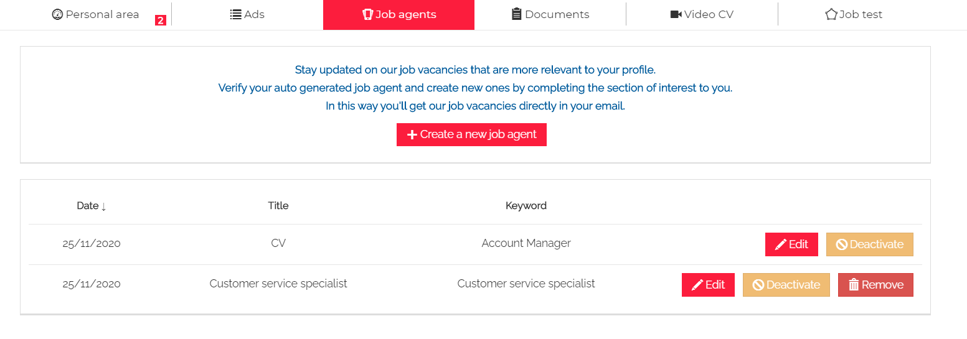

### *Documents*

The candidate can upload files, which can be seen and downloaded by employers from the candidate’s profile. The allowed formats are: pdf, doc, docx, txt, odt, rtf, jpg, jpeg, png, xls, xlsx, csv, ppt, pages, pps, pptx. The maximum size is 2Mb.

If the candidate or employer wants to upload a new document, he/she just needs to click on “Documents” first and then on “Upload documents”.

For each document uploaded, it is possible to:

* Rename the file and add comments (which can be seen by the employer);
* Save changes by clicking on “Update”;
* Download or delete the file by clicking on “Download” or “Delete”;
* Filter the file by:
  + Tag (the dropdown can be freely set by the admin of the system and can be added to a file only by employers – not by candidates themselves)
  + Start/end date, which refer to the period within which the file was uploaded.

To apply the selected filters, you must click on the funnel button 

### Video resume (OPTIONAL MODULE*)

If the mod “Video” is included in your contract and you have enough credits, candidates can record a video resume by clicking on "Record". They can do that in complete autonomy or upon employer’s request.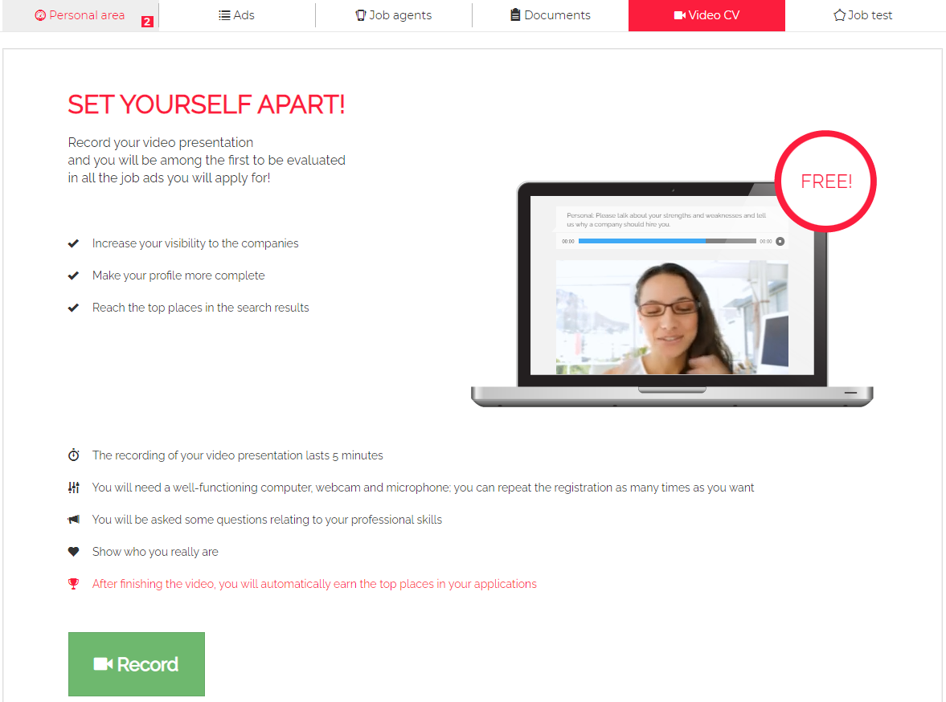

Before recording, an instruction page is displayed to allow the candidate to test both audio and video on his/her computer.

After clicking on "Record your video resume", the candidate must turn on the access permission for both the microphone and the webcam.

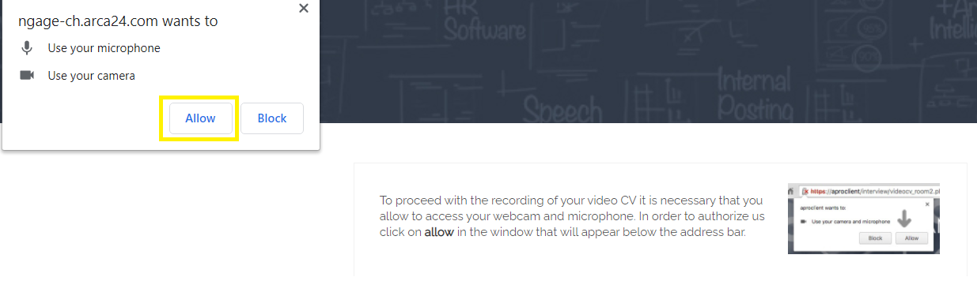The candidate will then see the questions and the time available to answer on his/her device screen. If the candidate answers a question in less time, he/she can click on the button “Stop” to move on to the next question. At the end of the last question, the candidate receives a confirmation that his/her CV video has been completed.

By clicking on "Profile page", the candidate is redirected to the tab “Video resume”, where the following message is shown: “Average processing time: 1 hour”.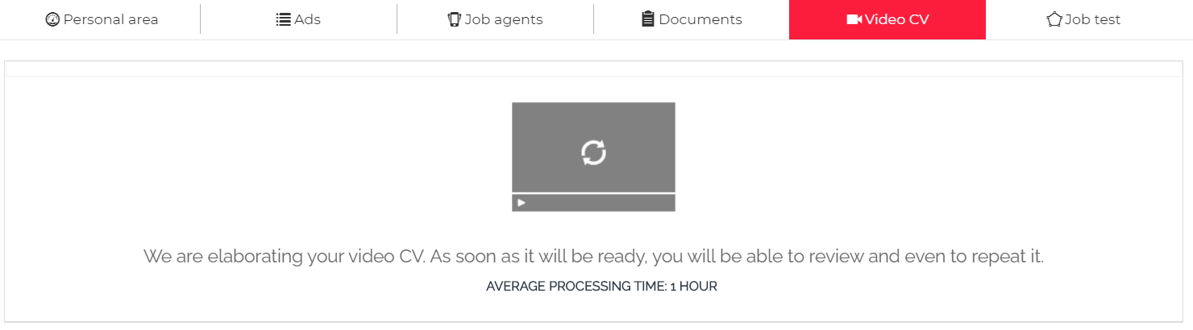

Once the video has been processed, the candidate can decide to record a new video. By clicking on "Record a new video resume", the previous video is automatically deleted and a new one can be recorded.

### Job test

The candidate can take a “Job Test”, i.e., a soft skills test, in complete autonomy or upon employer’s request in his/her personal area, by clicking on “Start your Job Test” in the job test tab. At the end of the test, the result is displayed into the tab. The candidate can see the description of each assessed soft skill by clicking on the red button "Psychological styles".

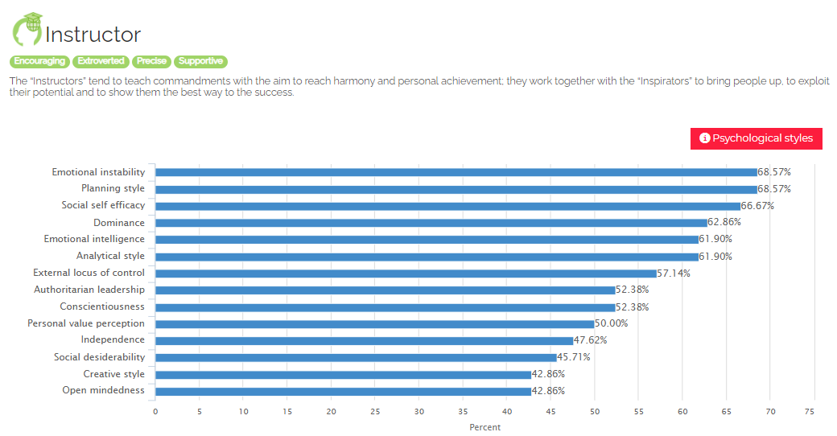

Three months after the test, the button "Repeat the Job Test” will be displayed so that the candidate can repeat the test.

### Image upload

Candidates can manage their profile image by hovering the cursor over the image frame and clicking on "Edit". They can upload an image, cut/resize and rotate it. After every modification, they have to click on “Save”.

### Account management

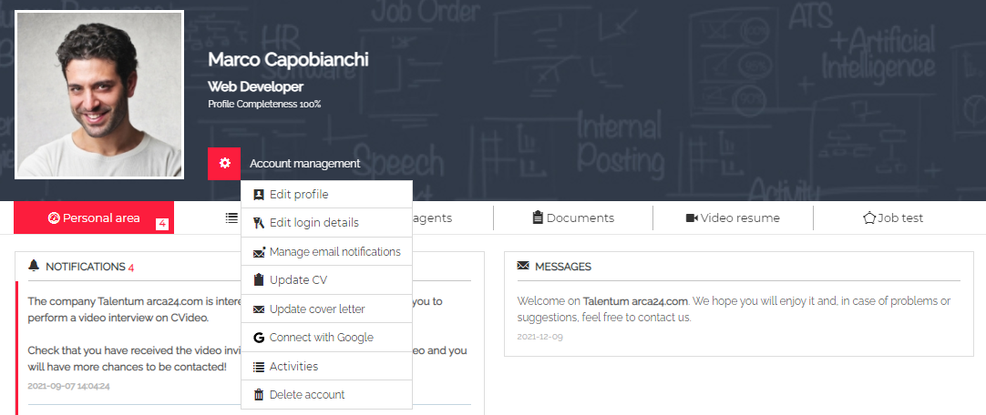

**Edit profile:** it allows to modify the details entered in the application form. (If the profile is less than 75% complete, an email is sent periodically asking the candidate to complete the profile data).

**Edit login details:**it allows to modify the email address and/or password.

**Manage email notifications:**the standard flags to manage email notifications are listed here below.

* “About the status of my CV” allows the candidate to choose whether to receive a few automatic emails by the system or not (thumbs down, move to steps 2 or 3, login invitation email after a few months since the last login, profile completion request to candidates whose profile completeness is less than 75%, periodic email reminders for pending requests).
* “Send me e-mails about new job offers that are suitable to my profile” allows the candidate to receive job agent emails or not.
* “I consent to receive electronic communications” relates to the filter "Subscribed to the newsletter" which recruiters can use to search the database.

**Update CV:** it is possible to edit the CV (language, download/upload files), add or delete working experiences and working on the result of the automatic CV extraction carried out by the system, by adding or deleting the extracted professional tags.

If a new CV is uploaded, a candidate can recalculate the tags by clicking on "Recalculate tags".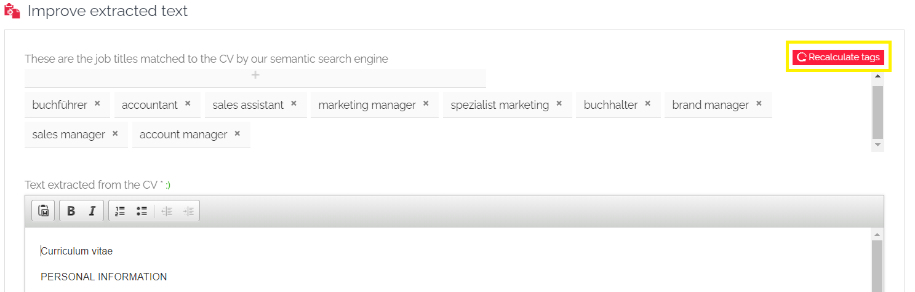

**Update cover letter:**it is possible to add a cover letter through a dedicated textbox. The cover letter will be shown to the recruiter into the candidate’s profile > Profile > CV.

**Connect with Google:**by entering their login details for Google, candidates can easily log in with these credentials by clicking on the Google button on the login page.

**Activities:**activity logs carried out by/on the candidate are listed in this section. The candidate can also download a XML file containing his/her data, in compliance with the right of data portability.

**Delete account:**tab for the candidate to completely delete his/her profile.

## Mobile version

The candidate's front-end and personal area are mobile friendly.

Compared to the desktop version, in the mobile version you can also share the job ad on WhatsApp and Telegram.

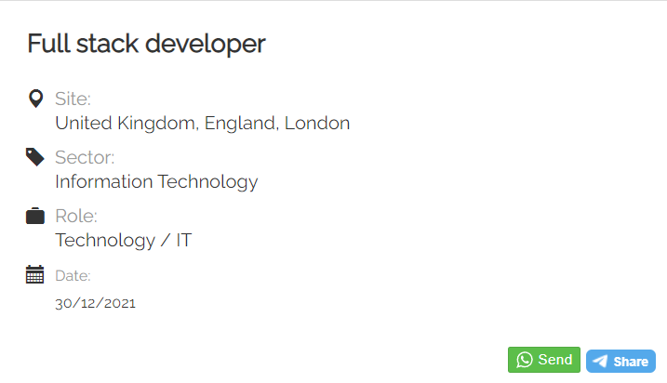

If the candidate applies from a mobile device, he/she will see a pop-up window allowing him/her to enter an email address to receive an email with the link to the job ad, so that he/she can send the application later.

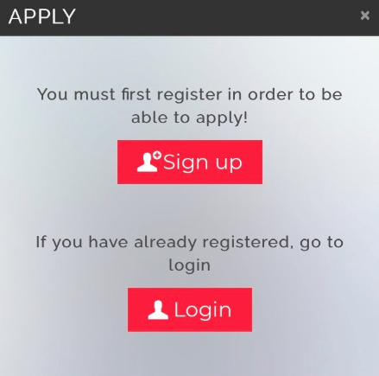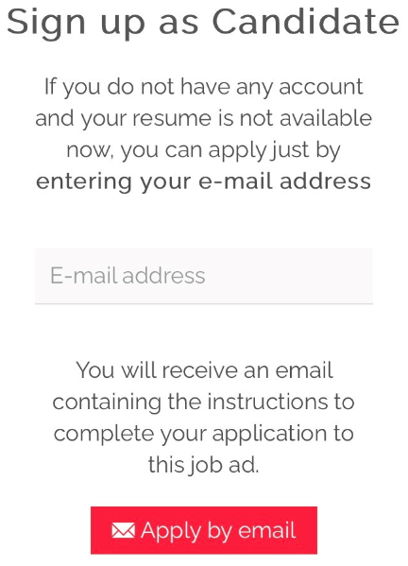

## Login for contact person

If a contact person receives access from an employer (see contact person’s profile), he/she can log into his/her private area. Within this section, the contact person can view “candidate’s summaries”, profiles and candidates proposed via multimailing, documents, contracts and opportunities.

The contact person can view, filter and upload documents:

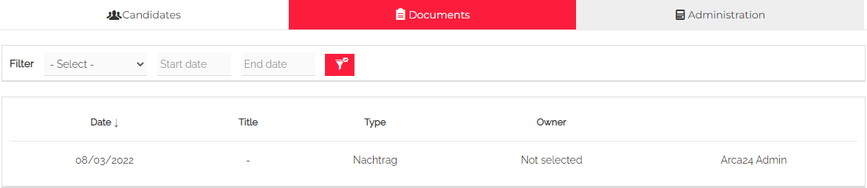

In the case your software is linked to an administrative management system or you manage the administrative part directly in Ngage, it is possible for the contact person to view the contracts linked to him/her by sorting them according to his/her needs (OPTIONAL MODULE*):

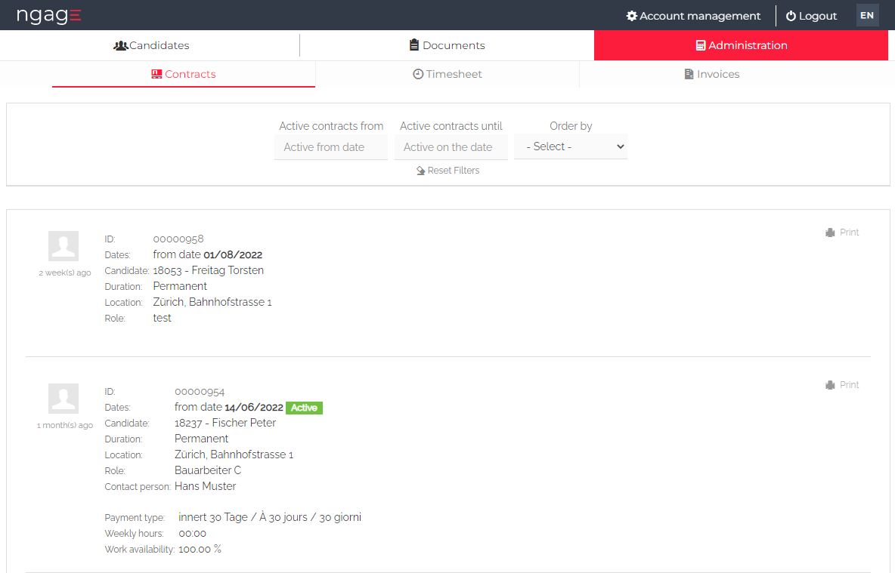

### Candidate’s summary

It is possible to open up each candidate’s summary received and refine the search with the filters by keyword and date range at the top of the section.

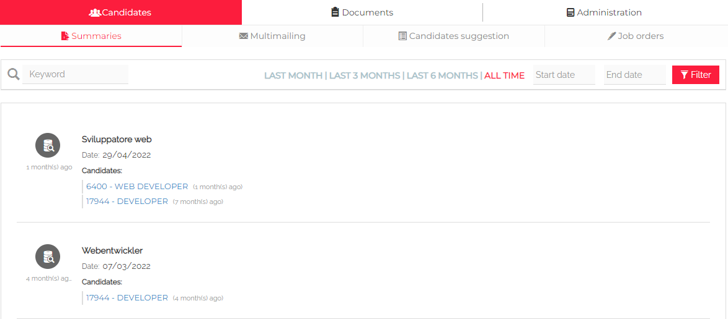

By clicking on each candidate’s profile, the contact person can see the details of the candidate’s summary created, add some feedback and/or print the summary.

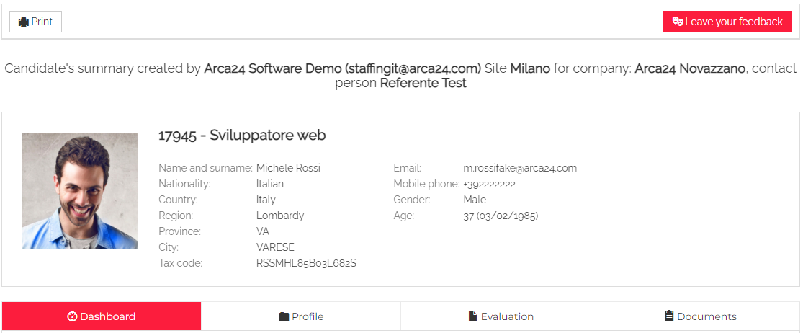

The button "Leave your feedback about this candidate" opens a free text pop-up to the contact person, whose content is notified to the employer who sent the candidate’s summary, recorded in the notifications in the candidate's dashboard and marked in the activities in the candidate’s profile.

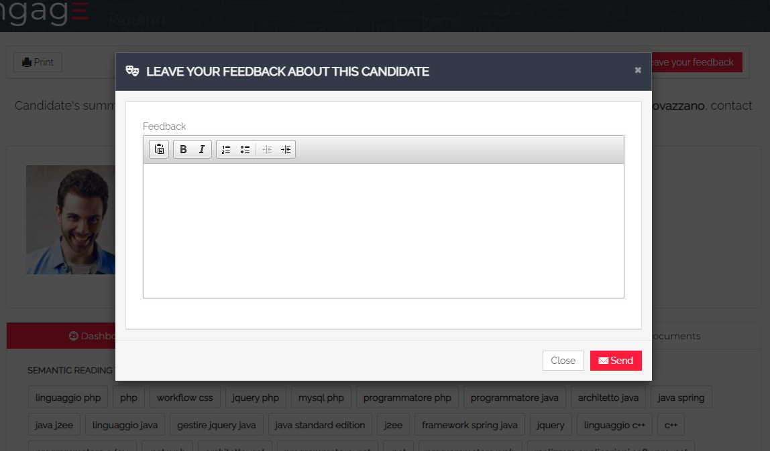

### Multimailing

Contact people can see candidates’ profiles shared through mailing lists.

By clicking on the appropriate icon, they can deactivate the receipt of these profiles and mailing list communications.

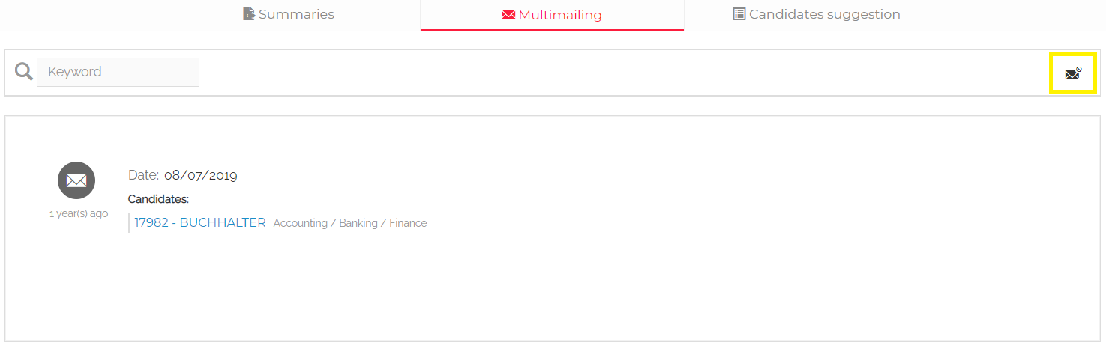

By clicking on each candidate’s profile, they can see some details of his/her profile, the “Evaluation for multimailing” inserted by the employer as well as to leave some feedback.

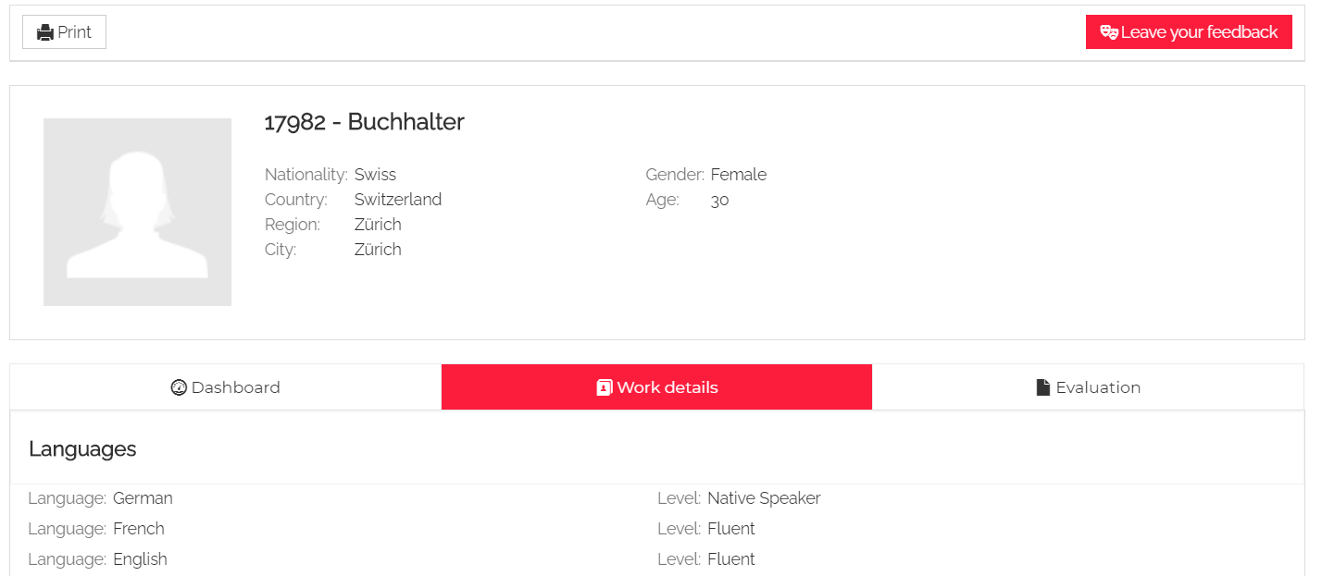

Both in the case of a candidate’s summary and of that of candidates’ profiles shared via multimailing, the button "Leave your feedback about this candidate" opens a free text pop-up to the contact person, whose content is notified to the employer who sent that summary/profile, recorded in the notifications in the candidate's dashboard and marked in the activities in the candidate’s profile.

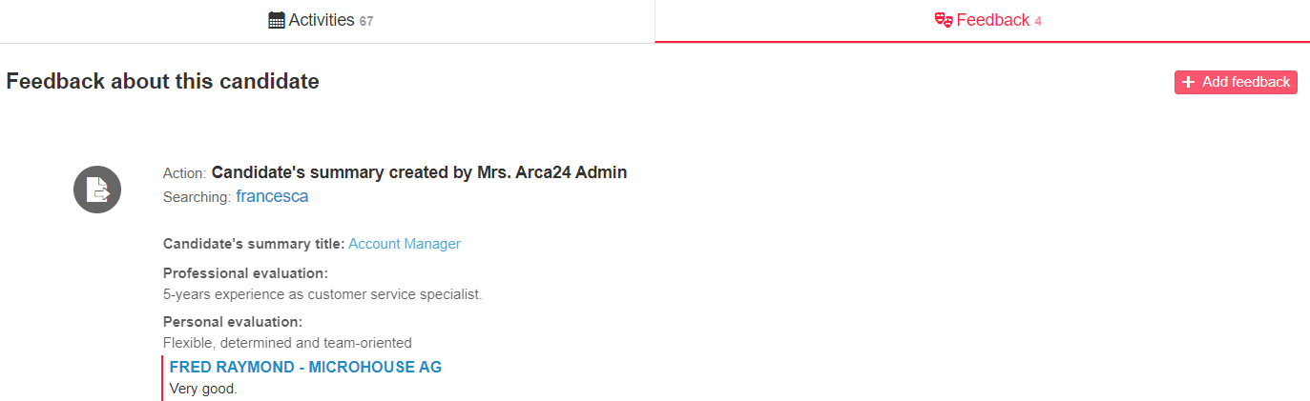

### Candidates suggestion (OPTIONAL MODULE*)

The contact person can see the searches made by employers for him/her into the candidates’ database. For the setting up of “candidates suggestions” see the contact person’s tab in “MODULE CLIENTS”.

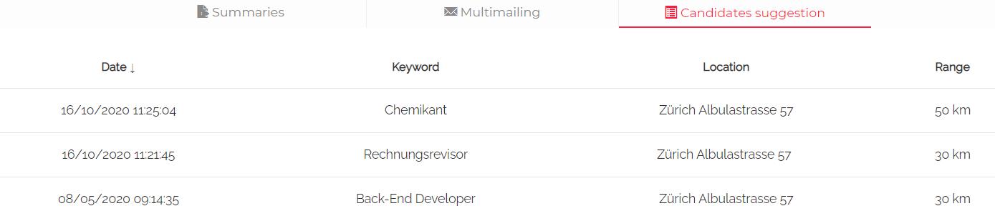

By opening a search, the list of profiles sent is displayed:

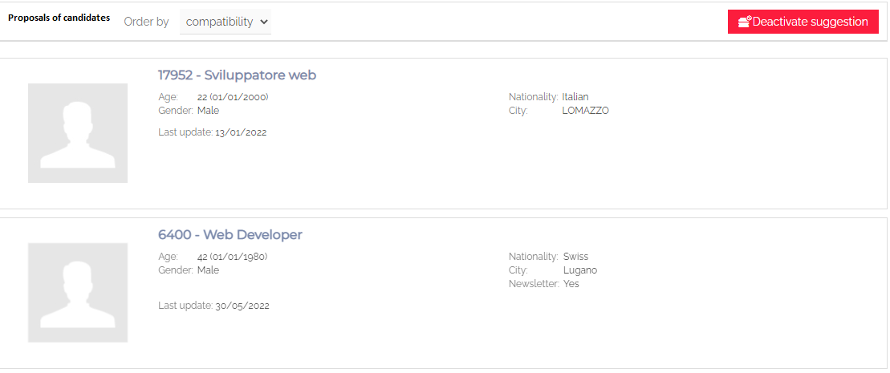

By clicking on each profile, the contact person will just see the candidate’s work, language and instruction details, the professional tags and the candidate’s dashboard.

By clicking on "Ask for more information" within the candidate's profile, he/she can ask questions, which will be sent to the user who created the proposal and displayed as feedback within the candidate's profile. 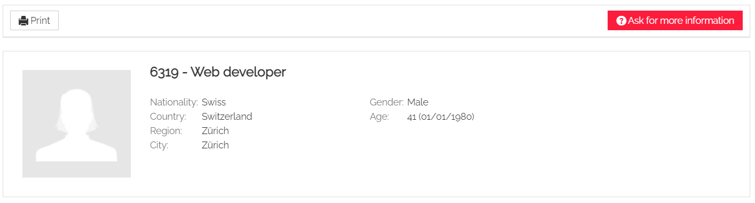

### Job orders (OPTIONAL MODULE*)

In the contact person's area, it is possible to make visible the opportunities linked to him/her, which he/she can view via the filters at the top of the page: keyword, date range, type and status.

The person only has a view of those opportunities but cannot work on them; the module just allows him/her to stay up to date on the progress of his/her orders.

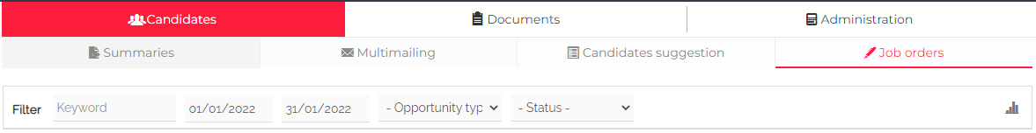

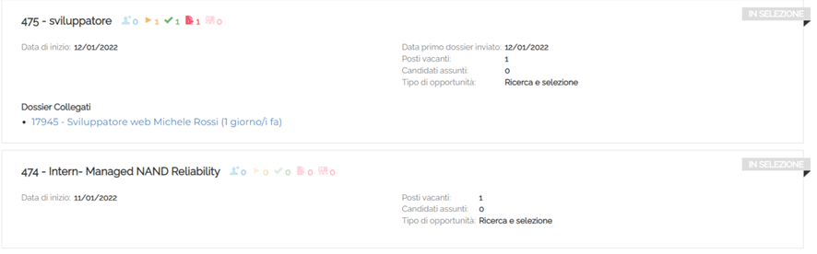

### Account management

The contact person can independently manage his/her account by modifying the login details, switching to another company area (in case the same contact person email address is connected to several company profiles) and, if the function is active, accessing the file storage.

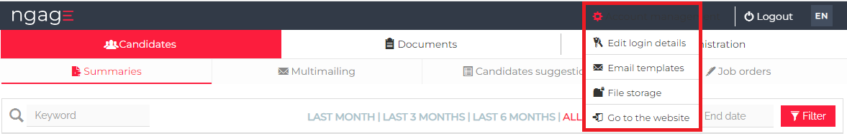

# LOGIN FOR EMPLOYER

**N.B.:** When using the software, we recommend not working on several browser tabs at the same time to ensure that all activities are tracked correctly.

## Account management

In this section, you can access your account configuration as employer and other settings. Some functions are only visible when using the admin account or are subject to the activation of specific permissions. 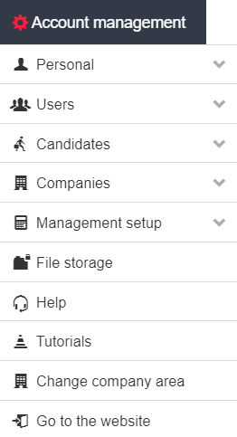

### Personal

You can manage and update your profile (overall information and login credentials).

In the section "Edit profile", you can manage your data; "Name in Emails" and "Signature in Emails" allow you to add the name and signature that will be displayed to recipients.

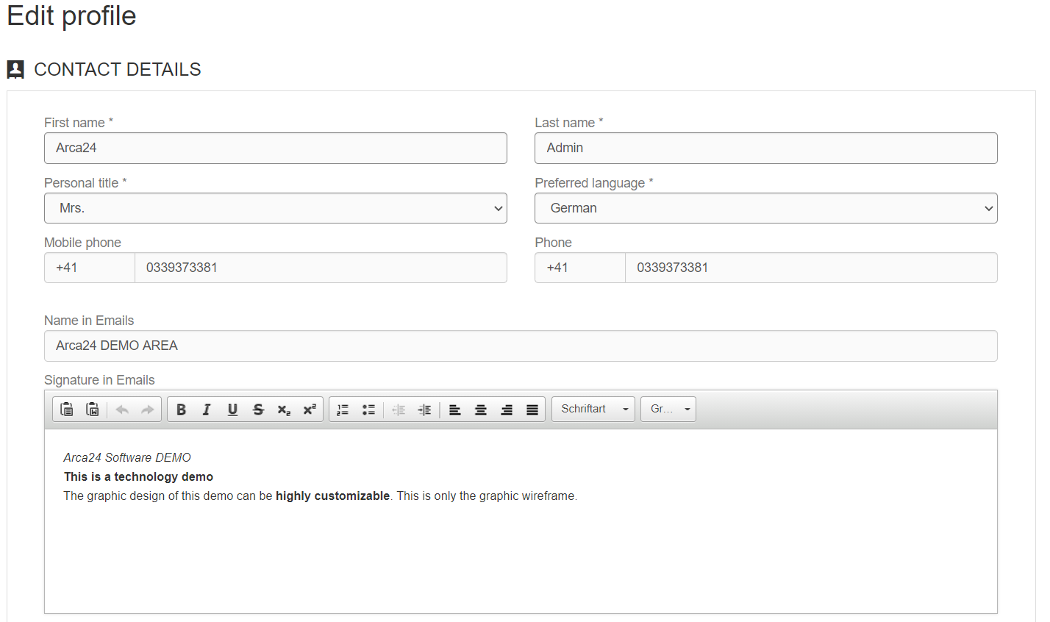

### Users

**N.B.:** This section can only be viewed and managed by the admin.

#### **1.2.1.  User management**

In this section it is possible to add and set a new company user. Always pay attention to permissions, site/user groups and credit distribution. 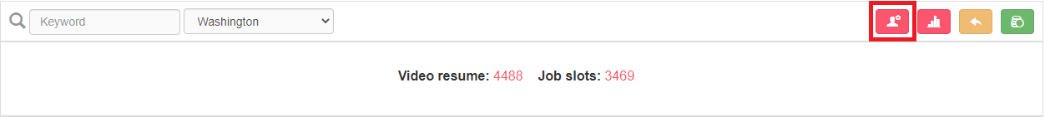

For each user, there are several options available (*Operations)* at the right of their string.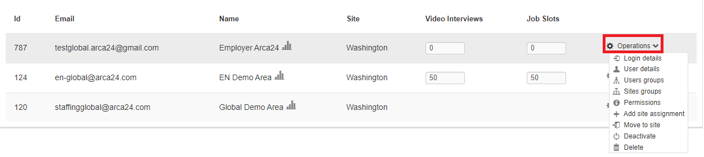

**Login details:**it allows to change the login details (e-mail and password).

**User details:**it allows to view/edit data such as name, surname, preferred language, signature in emails and site.

**User groups:**it allows to set the visibility between users (i.e., whether a user can see and manage job ads, searches, agenda and statistics of colleagues). 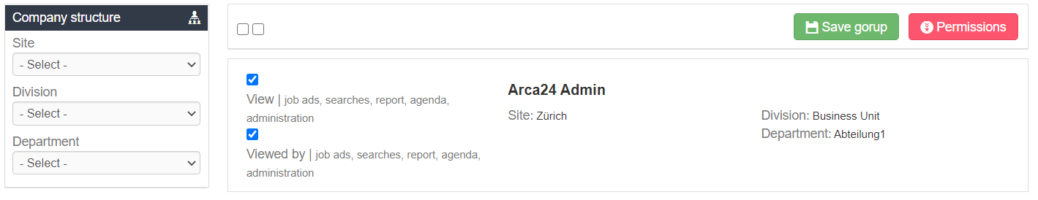

**Sites groups:**it allows to define whether the user can see and manage job ads, searches, agenda and statistics related to other company sites. (Sites groups preset the visibility on users, which can then be modified to detail the visibility on individual users).

**Permissions:**it allows to determine which functions the user can access or not.

**Add site management:**it allows to assign a user to other company sites (while also **keeping** the previously sites set).

**Move to site:**if a user is moved to another site using the function "Move to site", the permissions are maintained and the site hierarchy is adjusted to the new one (e.g., a user moved from the London site to the Dublin site will automatically have the sites hierarchy set to “Dublin”).

**Deactivate or delete?**

By deactivating a profile, with the aim to reactivate the account at a later date, the employer will not be able to access the system with his/her own credentials. Data remain a property of the deactivated user.

Deletion is an irreversible operation. When an employer is deleted, the admin must necessarily assign the data to another employer, selecting the site and the colleague to whom assign the data (activities, job ads, updates, etc.). The ‘Delete’ function affects the Employer/Site binomial; if the same profile is active on more than one location, access will be inhibited only for the location deleted, while on the others the employer will continue to have access.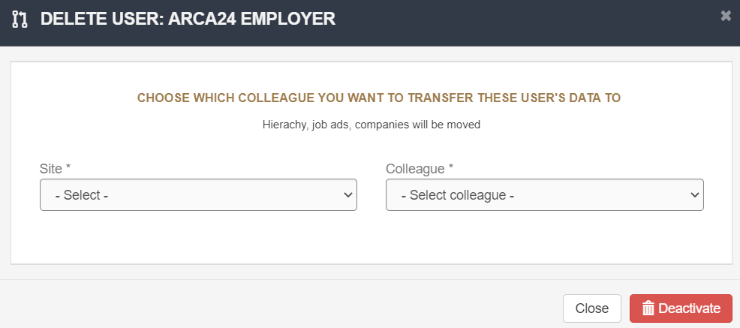

#### 

**User statistics**

For each user, it is possible to view statistics about the use of the ATS:

Total ads: number of ads assigned to the user.

Online ads: number of online ads that have the user colleague assigned and percentage on total ads.

Searches: number of free searches carried out in the database.

Searches saved: number of saved searches and percentage on the total number of searches performed.

Last login.

Viewed candidates: number of candidate profiles opened (the same profile is counted only once, regardless of the number of times it has been opened).

Step 2: number of candidates present in step 2 in the ads assigned to the user.

Step 3: number of candidates present in step 3 in the ads assigned to the user.

#### **1.2.2. Credit management**

For each user, it is possible to distribute video credits, job slots for job advert posting and SMS credits. Video credits can be used for both video resumes and video interviews. To save changes to credit distribution, you need to click on the green button.

Credits not yet allocated will be visible at the top of the page and are linked to the admin user.

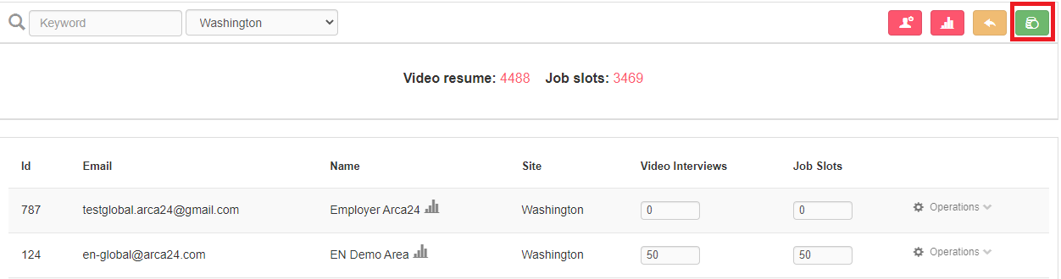

**N.B:** The information about video software compatibility is available at the following links: <https://caniuse.com/?search=mediarecorder> <https://caniuse.com/stream>

**Differences between Video resume and Video interview**: the video resume is a video presentation that the candidate can record independently or upon request from an employer. It consists of four questions which are already set, but editable by the admin user in Account management > Candidates > Video resume questions.

Video interviews are linked to a specific selection process; they are set by the employer in the "Interview" step. Employers can create the questions directly during the selection process or select a preset template from a drop-down field (See “Video interviews templates” in the section “Candidates").

**Video credits**

**Video resume**: credits are deducted from the total amount of credits shown at the top of the page (whether the candidate makes the video in autonomy from his/her personal area or upon request from an employer). If the candidate decides to repeat the video CV, only one credit is deducted. Therefore, we strongly suggest **NOT** to distribute all the credits, but always to leave some to the admin for video resumes. An employer with **at least one credit** can view the icon "Request video resume" in the candidates' profiles and can therefore send a request to candidates.

**Video interview:** credits are deducted from those distributed to the employer. Therefore, if you assign 10 video credits to an employer, these can be used to request 10 video interviews. Video interview requests from the admin are deducted from the total amount of available credits.

If video credits are not distributed, they remain allocated to the **admin** and can therefore be used for spontaneous video resumes by candidates and/or for admin’s requests, both for sending video resumes and video interviews.

**Deduction of credits for VIDEO INTERVIEWS:** one credit is deducted for each candidate, whether the profile has already been moved to the interview step before or after the opening of the interview session.

If a video interview session is **reopened**:

* All candidates who have not taken the test (even if moved to the selection step) will be able to take the video.
* New candidates moved to the interview step will receive an invitation email.

In both cases, one credit will be deducted for each candidate.

**Refund of credits for VIDEO INTERVIEWS:**

* If some candidates have not taken the test **at the close of a session** (whether automatic or manual), the corresponding credits are refunded. The refund is made **immediately** when the session is closed.
* If the candidate **refuses** to take the test by clicking on "Refuse" on the test access page, the corresponding credit is **immediately** returned to the employer.

#### **1.2.3. Permissions management**

In this section, the admin can manage the permissions of all users, by using the filters on the left to display only certain users according to assignment. For each user, the admin selects the functions he/she can use by using the flags. It is not possible to set permissions for the admin account: all permissions will always be active for the admin account.

#### **1.2.4. External portal management**

#### In this section it is possible to enter specific details, which are necessary for the connection between the application and the accounts used to access fee-charging external portals.

#### **1.2.5. Sites, divisions and departments management**

**Sites**: it allows you to add company sites and their details, such as name, country, region, city and address. Site configuration should be done during the initial setup or each time a new location/branch/site is added.

**Divisions**: it allows you to manage the permissions related to each division. When entering a new user, who is assigned to a specific division, the new user is going to have the permissions associated with that division. The admin can edit the permissions of each individual user at any time. After modifying the permissions for an individual division, if you want the users in that division to have their permissions updated, you will need to click on “Set permissions to the users assigned”. In this way, the permissions are updated for all the users assigned to that division.

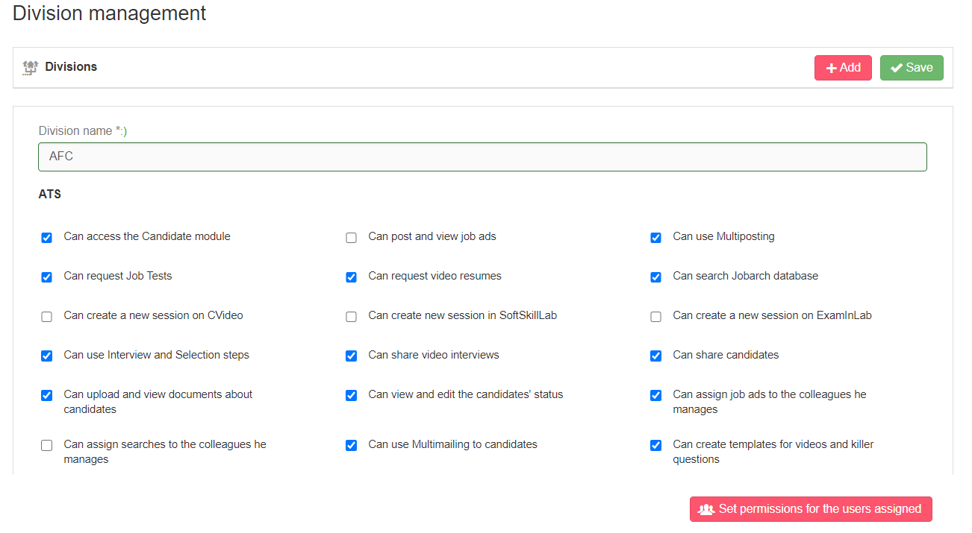

**Departments**: third level of company assignment. You have to enter the name of the department, associate it with a department and save.

### Candidates

In this section you can manage some settings, which can be useful in the selection process. In particular:

**Candidate evaluation form**: this section allows you to manage the evaluation parameters (title and field type) expressed in the evaluation form in the candidate profile.

**Video resume questions**: this section allows you to edit the preset questions of the video resume.

**Killer questions and video interviews templates:** this section allows you to create video interview templates or questionnaire templates to select in the “Interview” step:

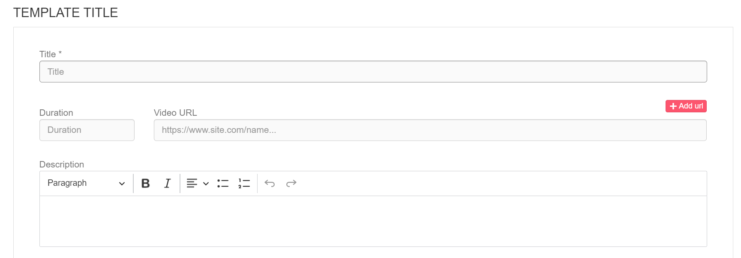

NB: ‘Duration’ field (*optional*): for installations that include it, it is possible to specify the months of validity (1, 2, 3 etc.) of a candidate's score.

If the recruiter decides to send the same questionnaire or video interview template for several advertisements, he/she can specify here the validity period of the score obtained by a candidate who applies to all these advertisements. It will thus be sufficient for the candidate to answer the questionnaire or video interview only once, and the score will also be reported in step 2 of the other advertisements.

**Soft skills templates**: this section is only visible to the admin account. In this section, you will find some pre-defined personality types, developed in collaboration with the Catholic University of Milan. These personality types have been defined on a sample of 100,000 candidates and aim to support the recruiter in choosing the right person for a given role.

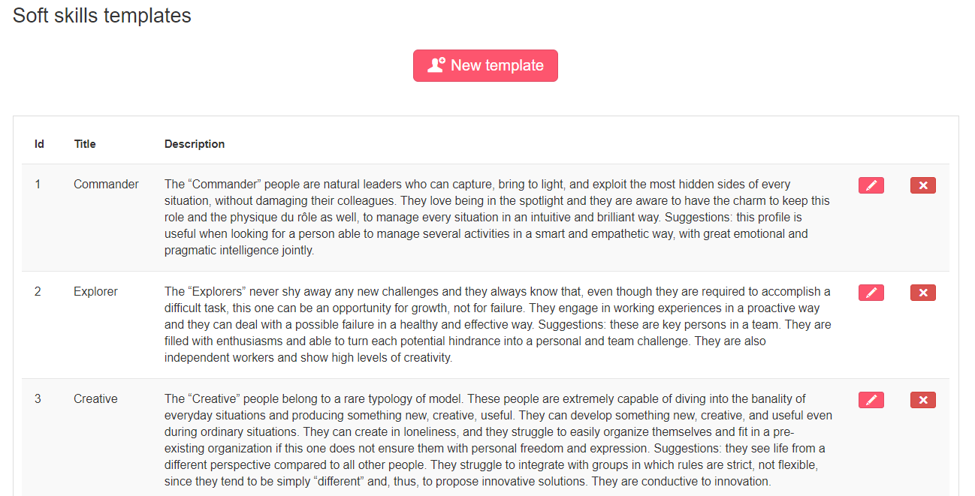

To add a new personality type, simply click on “New template” at the top of the list of the pre-defined ones: it is necessary to fill in the title and description and set the parameters of the soft skills attributes by adding the minimum and maximum limits. The new template is taken into consideration only after flagging the option "Active":

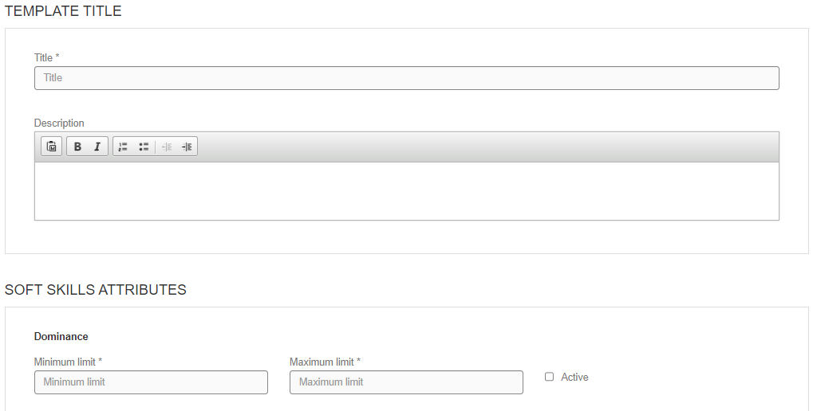

We strongly suggest to use only pre-filled templates, as the expertise of a psychologist is needed to correctly set the parameters of a new template.

**Merge candidates:** it allows two candidate profiles referring to the same individual to be merged.

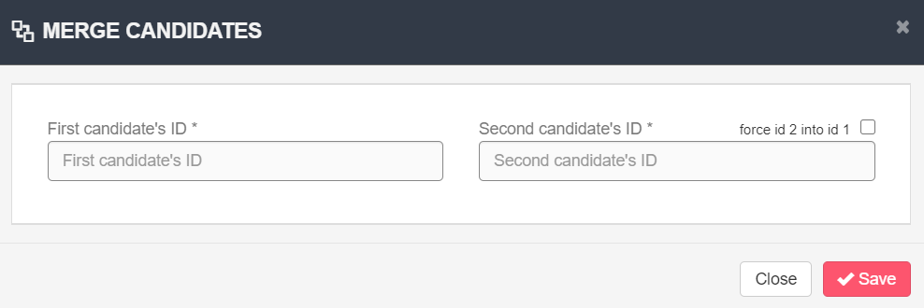

By entering the candidate profile IDs, the dates when the profiles were last updated are compared and the most recent data are retained. The ID and data (personal details, language, education, CV, evaluation information) of the profile with the most recent update date are retained. Whenever possible, information from the oldest profile is retained, as in the case of activities, documents and jobs to which the candidate has applied.

In the case of data available in one profile and not in the other, the present data is retained regardless of when the profiles were last updated. For example, if the result of a soft skills test is present in one profile and not in the other, the present data is retained, regardless of whether the profile in which the test is present is the oldest.

The flag "force id 2 into id 1" results in the merging of the second candidate’s ID into the first one, regardless of the last update date. This means that the data in profile 1 are retained as a priority (all documents and activities are retained).

### *Companies*

‘Merge companies’ enables you to merge the relevant tabs similar to the ‘merge candidates’ (see previous section).

‘Merge contact persons and sites’ works in the same way as the ‘force id 2 into id 1’ flag: id 2 is merged into id 1, regardless of when it was last updated. This means that only the master data of id 1 is maintained, while the activities of both ids are maintained.

It is not possible to merge two sites of two different clients.

It is not possible to merge two contact people if those contacts are not in the same site.

In the case of connection with administrative management systems, it is not possible to merge companies or contacts with external software IDs.

### Management setup

It allows you to set some dropdowns of the system.

**Group**: it allows you to create groups of companies with a common characteristic; the groups will then be associated by the employer in the company profile.

**File tag:** it defines the type of files that can be uploaded on the profile of each candidate/contact person. The file tag can be entered and changed by the employer, but for the candidate it is in read-only mode (the candidate can see the tag entered by the employer but cannot add or change it from his/her personal area).

**City** **(optional module*)**: it is required in systems communicating with third-party software; you can enter the cities that will appear in the compilation of the city fields. New cities or suppressed municipalities not available in the software can be added from here; the name of the municipality and the cadastral code must be entered.

**Referrer (optional module*)**: it is linked to the related field in the company profile. The referrer is a person from outside the organization who reports the company to the employer within the system.

**Mailing list tag:** tags that can be associated with companies and contact people to create mailing lists.

**Competitors (optional module*)**: lists of competitors that can be associated with opportunities, companies and/or candidates.

### File storage (OPTIONAL MODULE*)

It allows you to upload files that can be shared with both other employers, candidates and/or contact people.

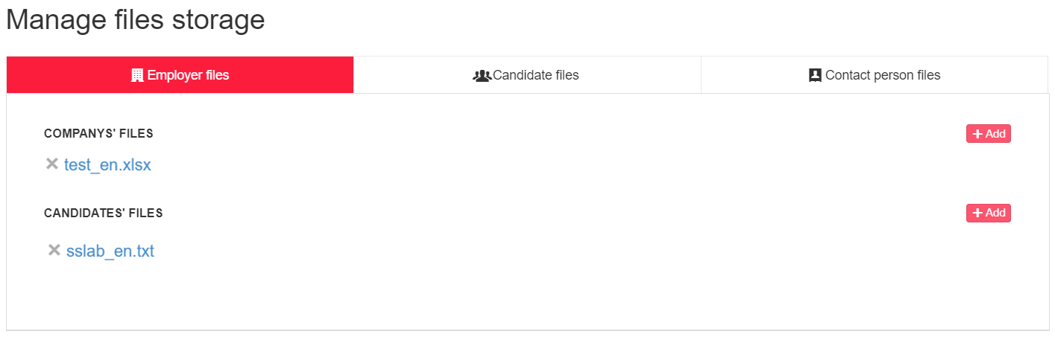

* From this section, employers can download uploaded documents.
* Candidates and contact people can do the same from their personal area (Account management > File storage)

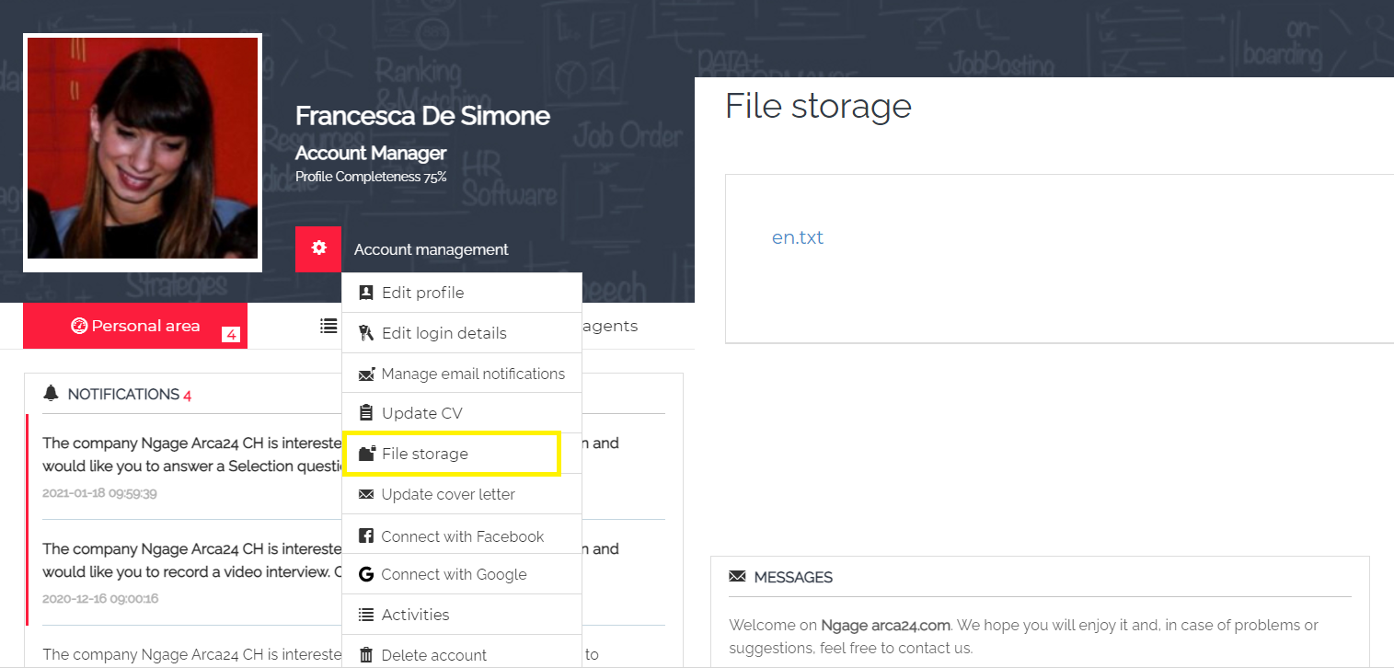

### 1.7. Job ads logo (OPTIONAL MODULE*)

**N.B**.: If the modules “Job ads logo” and “File storage” are both active, “Job ads logo” will be included within the section for archived files.

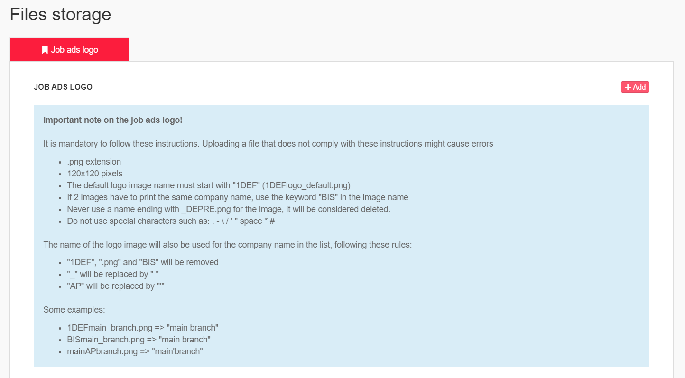

“Job ads logo” is a section that allows you to manage, add and delete the images that you want to upload in the job creation form in complete autonomy. The chosen images will be displayed at front-end in the job ads page, next to the job description.

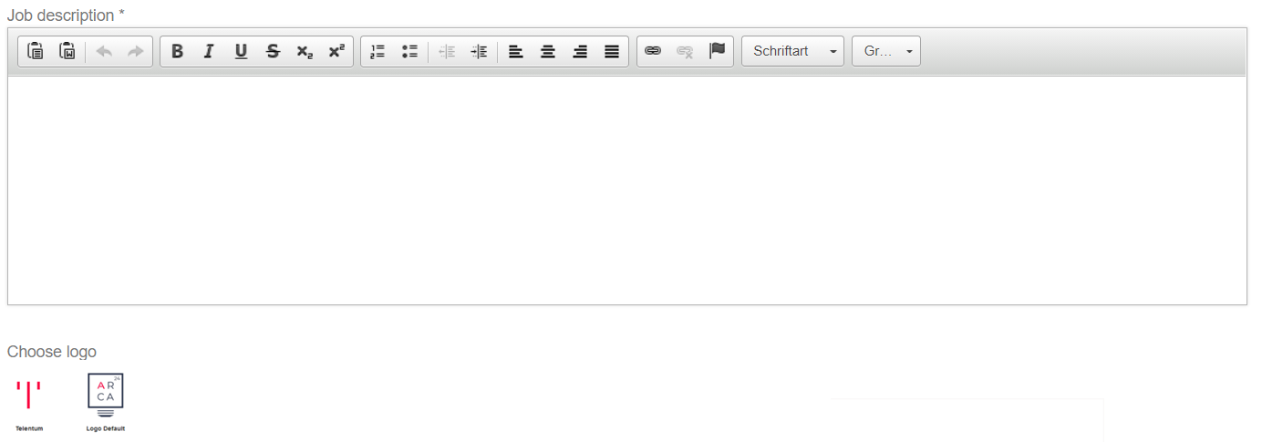

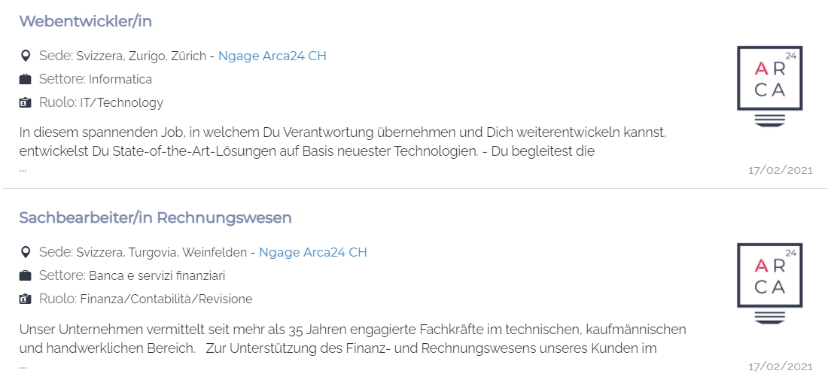

## MODULE “AGENDA”

You can view your activities or those entered by your colleagues, if you have visibility on them, by using the filters “Site” and “Colleague”.

By clicking on a date in the calendar, you can enter an activity directly from it. It is possible to add three types of activities: personal activities, activities on candidates and clients.

Links can be inserted within the activity by clicking on the appropriate button in the bar with the various functionalities. Links should be written preceded by: https://

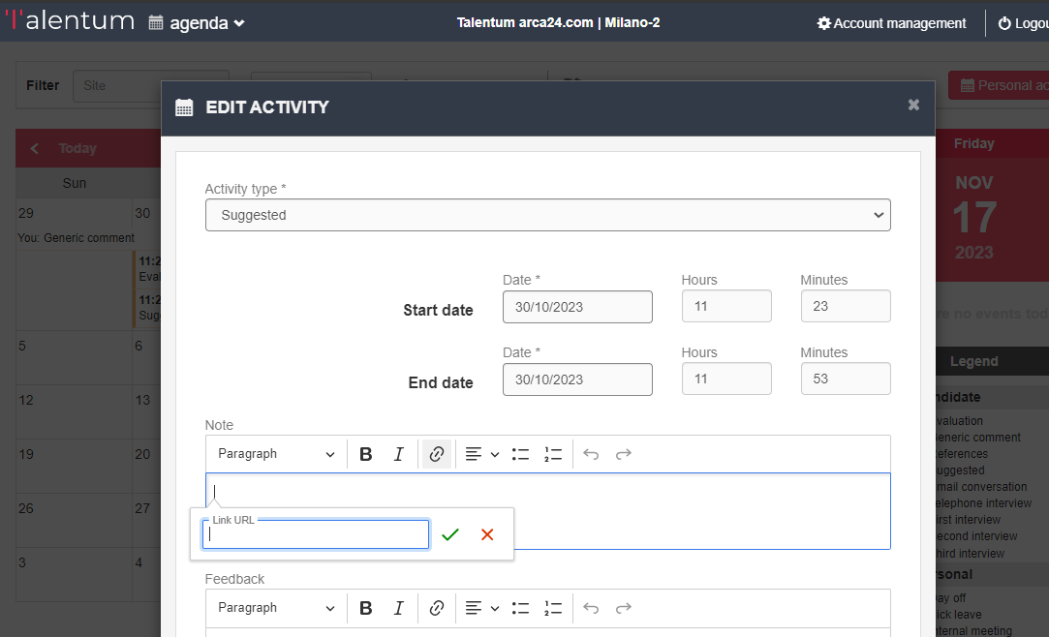

Once you have entered the activity type, date, time and any comment, you can configure the activity thanks to 3 flags.

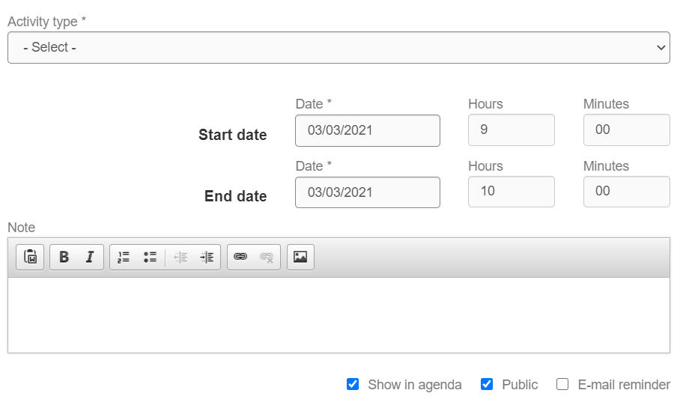

**Show in agenda (with flag) – Public (without flag).** The activity is visible for you in your agenda, but not for the colleagues of your hierarchy in their agendas. The activity is always visible in the candidates and clients’ profiles.

**Show in agenda (without flag) – Public (with flag).** The activity is not visible either for you or for the colleagues of your hierarchy in the agenda. The activity is always visible in the candidates and clients’ profiles. *The activity cannot be visible to colleagues unless the option “Show in agenda” is also selected. This is because the activity needs to be visible to you in order to be visible to your colleagues too.

**Show in agenda (without flag) – Public (without flag).** The activity is not visible for you and for the colleagues of your hierarchy in the agenda. The activity is always visible in the candidates’ profile.

**Show in agenda (with flag) – Public (with flag).** The activity is visible for you and for the colleagues of your hierarchy in the agenda. The activity is always visible in the candidates and clients’ profiles.

|  |  |  |
| --- | --- | --- |
| **Flag** | **Not marked** | **Marked** |
| Email reminder. | No reminders sent. | Notification mail sent on the day of the meeting starting from 7 am. The reminder is sent to all involved people **(comments are not visible)**. |

**N.B.:** the notification email will be sent based on the following rules:

1. The employer who entered the activity, and any colleague the activity was shared with, receive the reminder containing all the activities of the day, regardless of the type of activity (i.e., also personal activities);

2. The company on which the activity is entered only receives the notification if the activity is of type meeting (meeting with the company, with the former client, presentation);

3. The candidate for whom the activity is entered only receives the notification for activities categorized as “Interview” (first, second, third interview).

As far as personal activities are concerned, the "show in agenda" flag is not present, because these activities must always be visible to the user.

**Shared activity:** an activity can be shared with colleagues by selecting them from the dropdown and clicking on “Add colleague”. A shared activity is also visible to the person it is shared with, in his/her agenda.

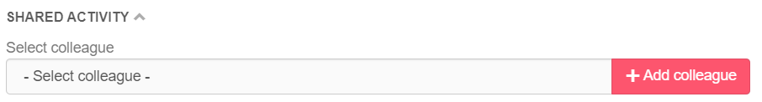

At the top of the page, you can use some **filters** (Site/Colleague), access the module “Candidates” or to the module “Clients” (Search candidates/Search companies), add personal activities or even **export data** within a specific timeframe into a **CSV file**.

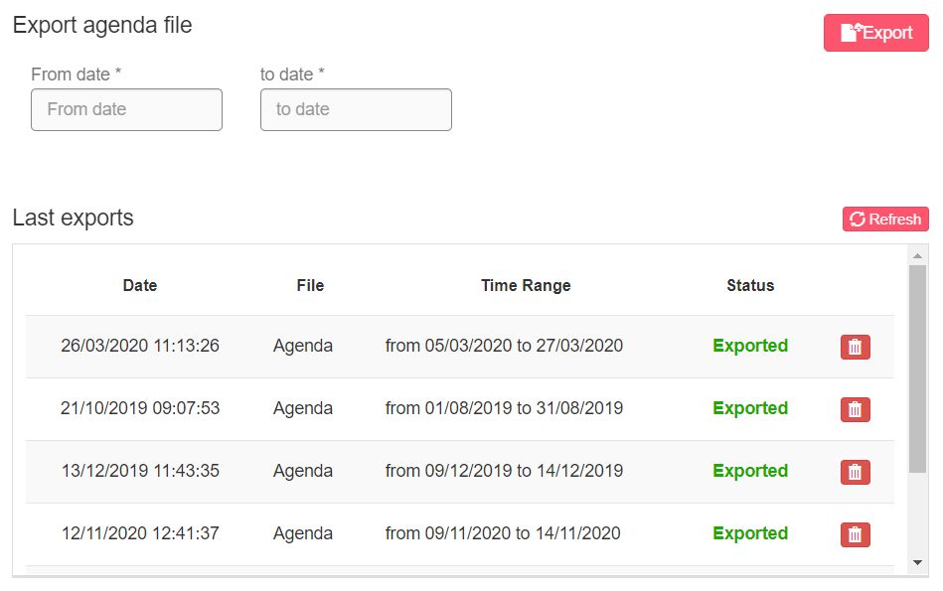

Filter on tasks in the legend: allows tasks to be displayed on the agenda according to type.

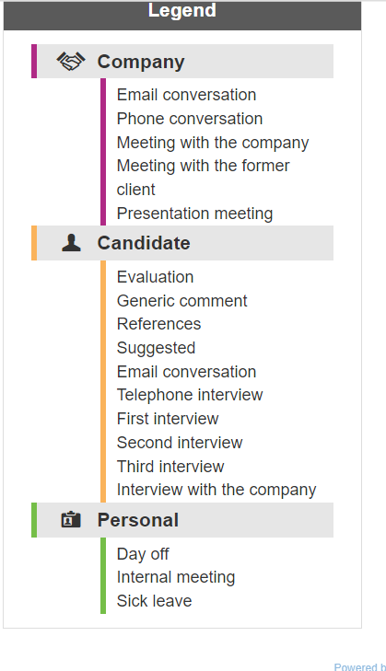

- By clicking on the entry corresponding to an individual task, all appointments corresponding to this type of task will be hidden in the agenda screen.

- By clicking on the title of the three types of activities, all activities belonging to the selected group will be hidden.

- If you wish to display only one type of task, you can hide them all by clicking on the group title and select only one by clicking on it.

Exporting tasks in CSV format takes into account the filters used; the file will only include the tasks visible in the calendar at that time.

Set filters cannot be saved.

## MODULE “CANDIDATES”

### Dashboard

In this section you have an overview of the candidates’ database as well as on updates about pending requests. In addition, you can see a set of counters (job slots and video credits).

**Quick search bar:** it allows you to search for a job title in the database based on the selected location and km radius. You just need to click on the button “Find” to start the search.



**Evaluation results:** if you got candidates replies to tests or new feedbacks on shared profiles, the box shows the links to their profiles. Next to the title “Evaluation results”, you can see the number of responses that have not been opened yet. Each candidate string not yet opened is highlighted in red. If you click on the profile, from any process, the notification will be set as read.

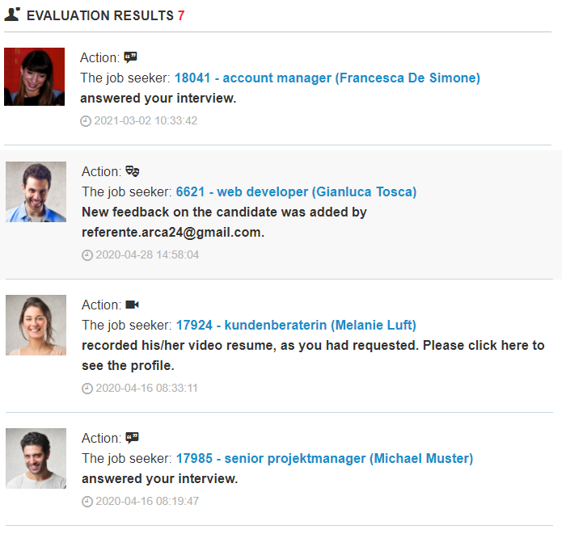

**Box “Candidates”:** it provides details of the candidate database. (the data is saved in a temporary memory, and updated on the software every 5 hours).

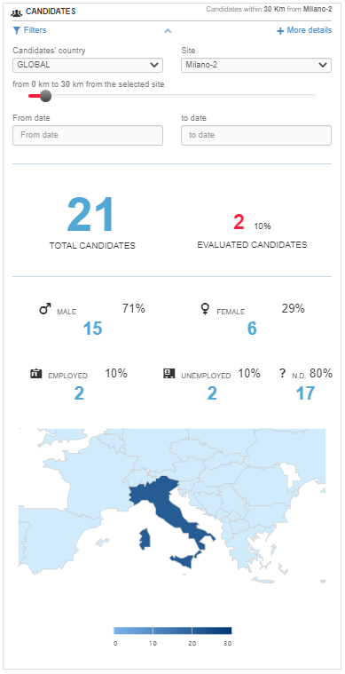

By clicking on "Filters", you can view and set the geographical filter according to which the candidate details will be displayed. The filter "Candidates' country" defines which country needs to be taken into consideration (based on the "Country" field entered by the candidate in the form); the filter "Site" is used to determine the **center of the kilometer radius**. In order to have the data referring to the whole system, you need to select "Global" as candidates' country and "All" as site. "From date" filter "to date" in the Dashboard enables to show candidates in the selected time range based on the registration date.

By clicking on "More details", you can view a chart referring to the following data: traffic sources, age, education level, job seekers per role and per job sector. In each of these cases, it is possible to extract the charts in different formats (PNG, JPEG, PDF, SVG, CSV, XLS). In the last two charts, you can also exclude some columns by clicking on them.

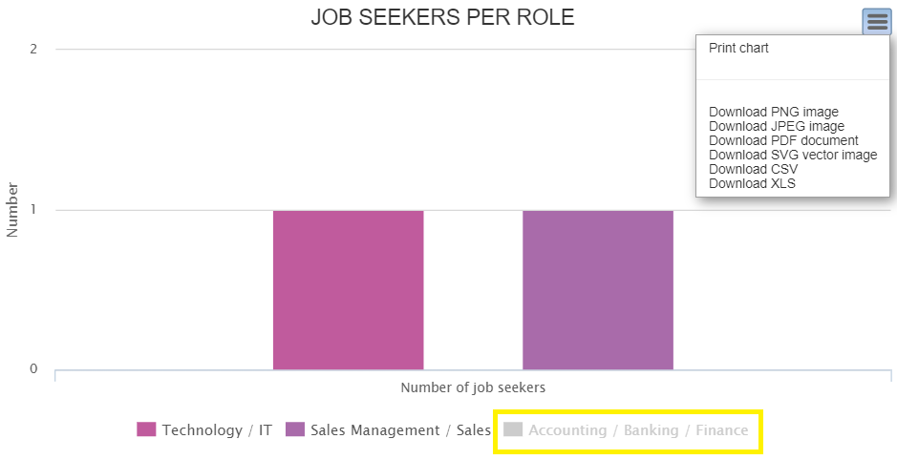

**Box “Counters”:** It allows you to check the different counters related to:

* Your **job ads** (both online and offline).If you click on “More details”, you can see where your job ads are geolocated;
* Your **video credits** (both remaining and used);
* (*If a maximum number of CVs is included in the contract*), the remaining **CVs** and those currently available in the database. The number of remaining CVs in the database will turn red when 90% of the total number provided for in the contract is exceeded.
* Total **emails** sent by you at the current date.

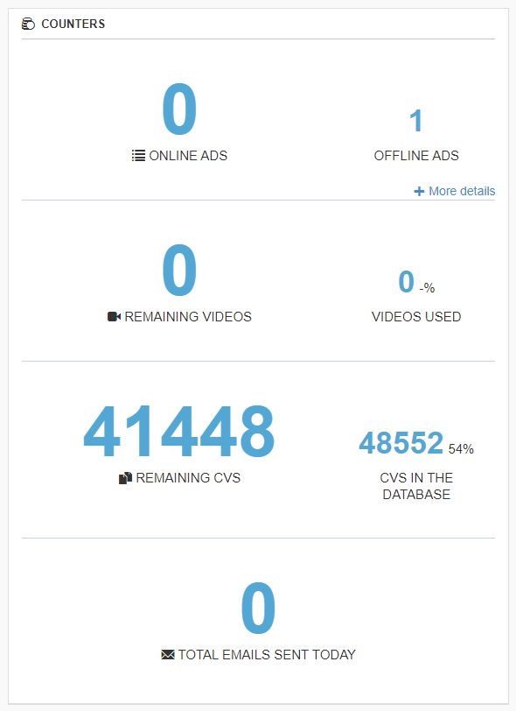

### Post a job

In this section you can easily post a new job advert.

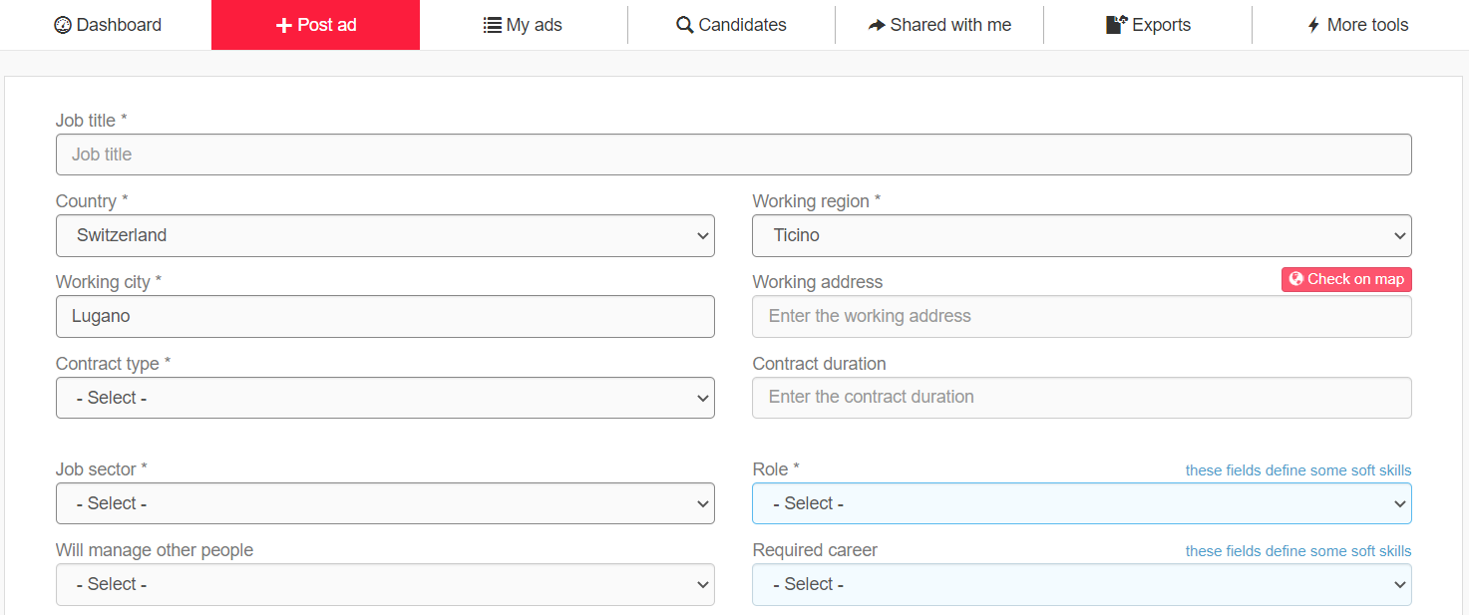

The fields “Job title”, “Job description” and “Required skills” are used to **extract the professional tags**, which are read by the semantic search engine. They are analyzed according to the preferred language of the employer (Account management > Personal > Edit profile > Field “Preferred language”). In the field “Job title”, only the individual **job title** must be entered in order for the semantic engine to obtain a more precise result. Any other information, which can be entered in the other fields, might alter the extraction of the professional tags. In the field “Job description”, it is important to list the tasks related to the job.

The fields related to the **working location** (“Country”, “Working region”, “Working city” and “Working address”) are filled in by default with the employer's site. These fields are important as they allow the proper **geolocation** of the job offer and the search for matching candidates. The geolocation can be checked using the button “Check on map”; it is always suggested to do this check before posting the job. If you do not want to enter the working address, you can leave the field empty and the geolocation will be carried out starting from the city center.

**\*Optional* "Automated interview"** allows you to invite candidates to the video interview/questionnaire at the time of the application. The applied candidates will then be moved directly to step 2 and will receive the invitation email. After flagging, you must go to step 2 to create the video interview/questionnaire session.

**\*Optional* "Automated Job Test"** allows you to invite candidates to the Job Test as soon as they apply.

**\*Optional* “Automated Video Resume”** allows you to invite candidates to video resume as soon as they apply.

**\*Optional* “Expiration date”**: date on which the ad will be automatically set offline.

The fields “Role” and “Required career” define the use of the profiles for the “Job Test”: 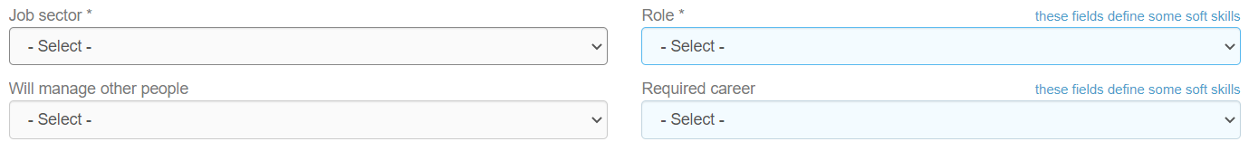

It is therefore necessary to fill in these fields so that the filter “Soft skill” is automatically pre-filled with the corresponding soft skills template:

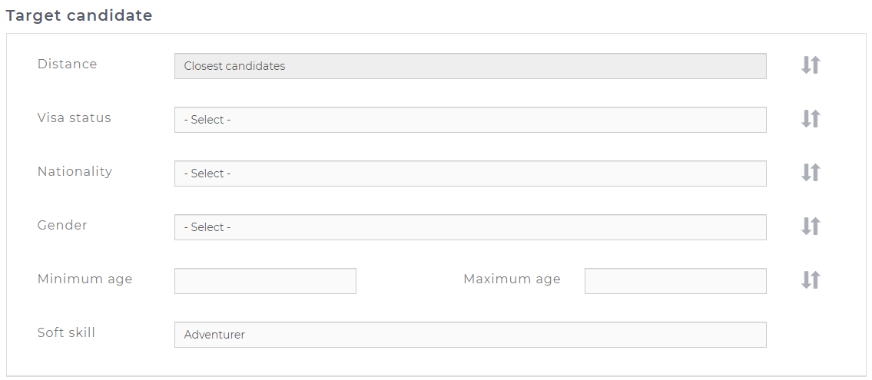

**“Upload attachment”:** option availableto attach downloadable files to the job offer. You can attach images in .jpg and/or .png format. The image must be less than 100 KB, preferably short and wide. In this way, it will be inserted directly in the front-end between the title and the job description.

The box **“Target candidate”** includes data that will not be published on the job advert; it is therefore visible to employers only. This section allows you to pre-select filters that will be set on matching candidates.

The option **"Email frequency"** defined how often the employer to whom the job ad is assigned will receive an email containing new matching profiles. If the employer logs into the system every day and selects "Daily" on the frequency fields, no mails will be sent to him/her, since several notifications showing new matching candidates are set up in the system.

By clicking on “**Preview**”, you can see how the job will be displayed to candidates. By clicking on “**Create**”, the job ad will be published on your website and the multiposting screen opens up automatically. (See “Multiposting” in the section “Online ads”).

### My ads

This section allows you to manage all the published job ads (both online and offline) and all related candidates.

Online jobs are automatically moved to the archive three months after the **last modification date**.

#### Online ads

This section displays all jobs currently online:

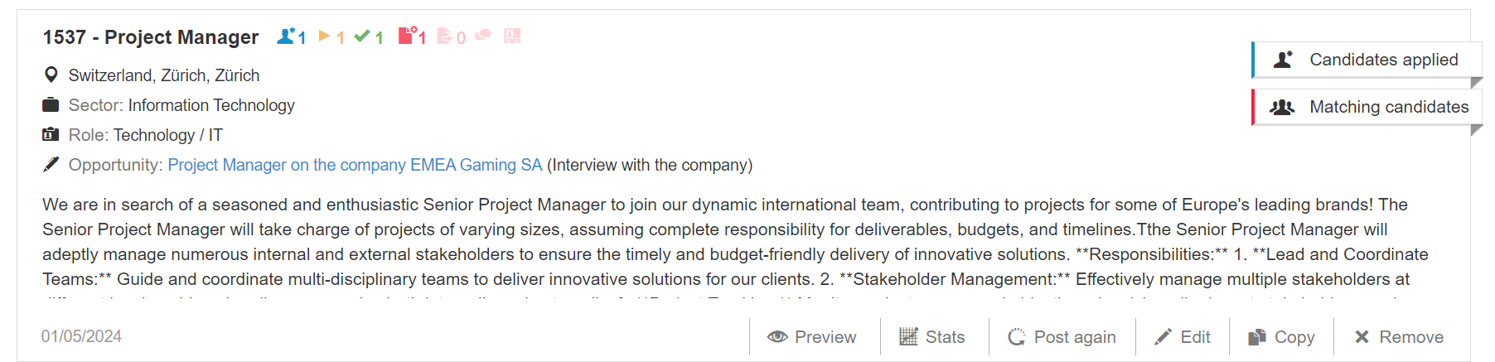

Next to the title of the advertisement are several icons (available on request) expressing certain activities performed on candidates in that selection process (described in section 3.3).

In the job ad string near the entry "Opportunity" you will find the link to the related opportunity in the company profile.

**Here is the list of filters available:**

**Keyword**: this filter allows you to search by exact word in ID and by whole or partial word in job title, working city and job description (it is not possible to search for country, region, sector, role). If you search for “man”, results with the combination of letters “man” will be shown as well (e.g., Manager). In such cases, it is useful to insert spaces before and/or after the word for more specific searches.

**Site**: filter by site according to “Site groups”. If a user does not have visibility on a specific site, he/she will be able to view job ads associated to that location in read-only mode, without the possibility to manage them. However, this user will be able to manage his/her own job ads.

**Colleague**: filter by employer according to “Users groups”. In order to display a colleague in the filter, that user must have published at least one job ad.

**Opportunity status:** it makes it possible to filter the job ads according to the status of the linked opportunity.

**New candidates**: filter allowing you to choose whether to display all job offers or only those with new applications not yet displayed.

In the bottom left-hand corner, the date on which the advertisement was last modified is shown.

**Preview:** you can preview what the job ad will look like to candidates.

**Multiposting:** multiposting is the tool that allows you to publish job ads on external job boards and aggregators. You can publish your job ads on free job boards (organic feeds), payable job boards or social networks (a post is generated). You just need to select the job boards and/or social networks where you want to publish your job ad. If you set a job ad offline in the system, that job ad will be set offline on external portals as well (deletion time may vary according to each organic feed).

In the Multiposting window, a message is displayed next to each job board flag: Online ads sent to this job board: <number>. The message is also shown for the cumulative flag “All Organic feeds”. The number shown corresponds to the active flags for the employer assigned to that advert and the counts are made only for online job offers.

N.B.: The number is not indicative of actual publications of the offers on the job boards.

The following are visible next to the Multiposting button: *Status on infojobs:* Only in case of subscription with the portal, here you can see the status of the jobs in Infojobs.

Number of portals: indicates how many flags are active on the Job boards in the payable job boards section.

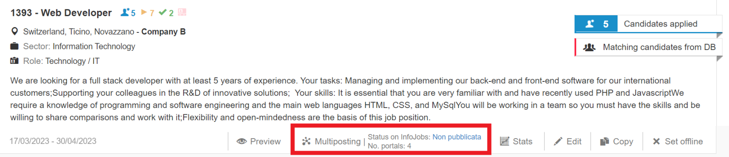

**Stats:** statistics referring to each job ad. They are based on **registered candidates** and are related to the following information: gender, job status, country, traffic sources, age, education level, job seekers per role and per sector. If you click on each country, the graph of candidates per region will be displayed.  
Each chart can be exported in different formats. The interface is the same one used for the charts available in the dashboard.

**Edit**: it allows you to edit a job.

**Copy**: it allows you to copy a job in order to create a new one from the original job.

**Set offline**: it allows you to set a job ad offline and to move it to the archive.

#### Job ads archive

This section displays all jobs currently offline:

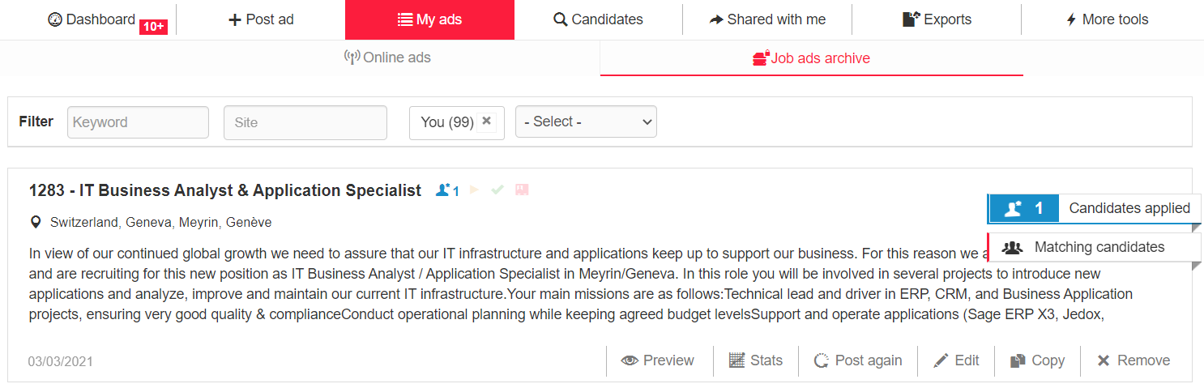Compared to online jobs, here you have additional options:

**Post again**: it allows you to post a job again. In this case, the multiposting settings will be maintained; therefore, if you want to check/change them, you need to use the multiposting option on the job ad only after reposting the advert.

**Edit**: job ads that were posted/put online less than 3 months before the current date are put back online if edited, otherwise they remain offline.

**Remove**: the job ad will be fully deleted.

#### Counters on candidates (OPTIONAL MODULE*)

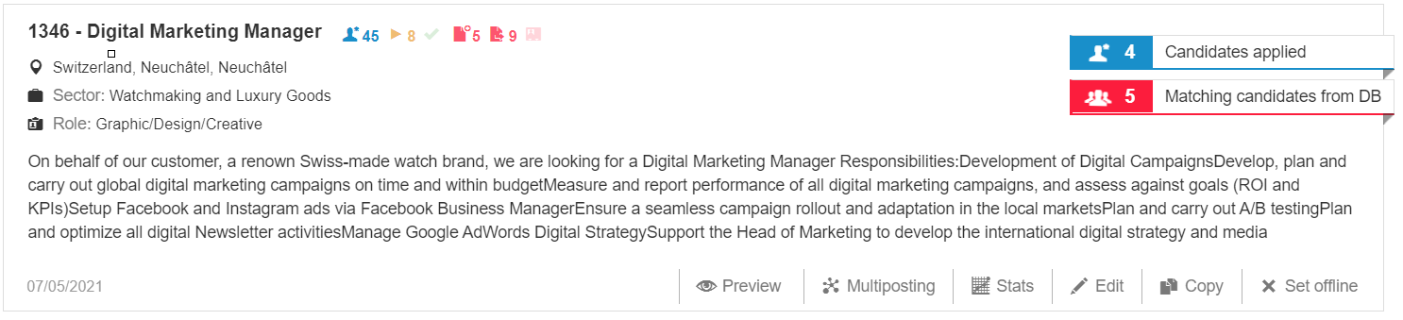Next to the job ad title of each job you can find a set of counters, which refer to candidates registered, candidates in the interview step, candidates in the selection step, candidates’ summaries created and sent as well as candidates hired. The counters are dynamic and updated in real time, except for the icon showing the number of applicants, next to the job ad title. It can take up to 4 hours for this counter to be updated. For example, the numbers of counters vary if a candidate unsubscribes or if profiles are moved within the three steps.

Number of candidates who applied for the ad

Number of candidates moved to the Interview step

 Number of candidates moved to the Selection step

 Number of candidates with created summary

Number of candidates with sent summary

Number of candidates with "Interview with the comapny" activity (NB: in the Opportunity Dashboard this icon is only visible if the activity has been planned in step 2 and 3 of the process).

 Number of candidates hired

### Recruitment step

**Candidates applied and matching candidates from DB**

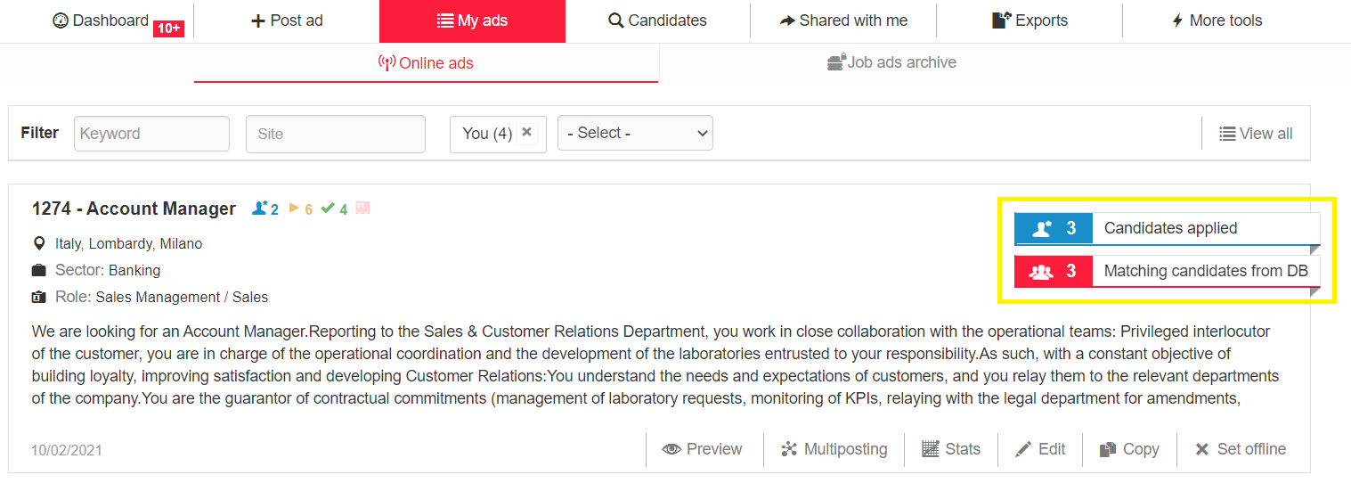

Within the section *“Candidates applied”* all candidates applied directly to the vacancy, either from the career page or from external job boards/aggregators and candidates who have been added manually to the recruitment process are shown. All applications are thus shown, without the possibility of filtering.  
If you have the filter "Order by" in the section “Candidates applied”, the candidates are sorted by **date of registration** in the database.

To see the candidates who have applied for the given job by date of registration (from the most recent to the oldest), you have to use the filter sorting by "**Update date**". Indeed, in this section, the sorting by update date takes into account the **date of application** for that job advert. In searches, instead, it takes into account the update date of the CV or professional profile, which is also printed in the candidate preview.

Within the section “*Matching candidates from DB*”, you will see all the candidates extracted from the system who meet the requirements of your search, including those who have directly sent an application.

The number shown on the flashing label refers respectively to new applications and matching candidates. These labels stop flashing as soon as they are clicked by the user assigned to the advertisement, who then accesses the corresponding sections.

##### **Candidate icons**

Within the candidate string, you can view different labels or icons, which convey relevant data/information about the candidate they are referred to.

* **“New!”(** **):** this icon refers to new candidates in the database or to candidates who applied to a specific job ad. This icon will remain visible for three days from the last update of candidate's profile, regardless of when the candidate’s profile was opened.
* **Hired:** hired candidates () or ex workers (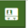).
* **Applied candidates:** candidates manually added to the recruitment process () and candidates who applied directly to a job vacancy ().
* **Highlighted (****)**: candidate marked as “highlighted”.
* **Irrelevant (****)**: candidate marked as “irrelevant”.
* **Job test (****):** candidate who carried out the Job Test.
* **Soft skills compatibility (****):** candidate's soft skills matching those required for the job (> 60%).
* **Updates** **(****):** candidate who updated his/her profile after having received an update request from the employer.

**Candidate string and preview**

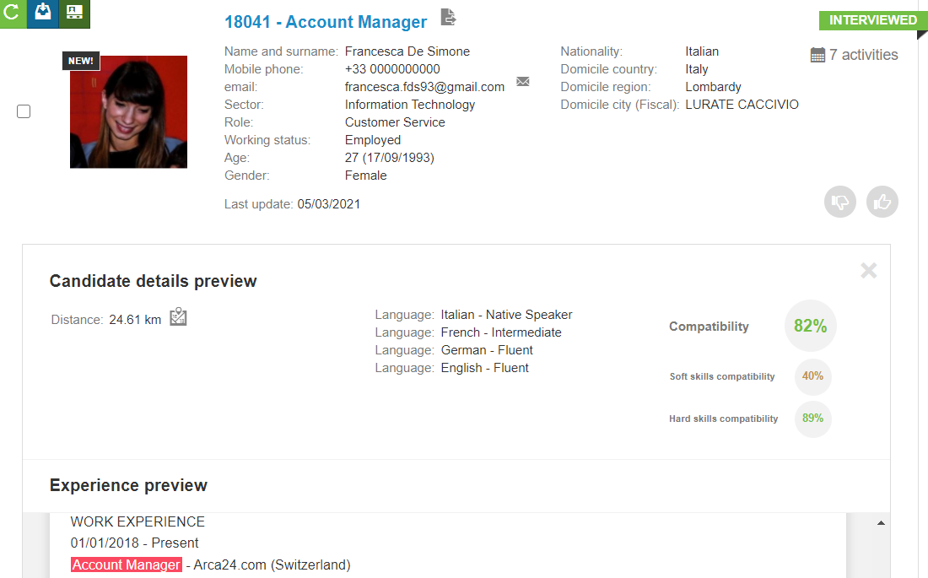

The candidate string displays the candidate’s ID and the job title. Whenever available, you can also see the following information:

* Name and surname
* Mobile phone
* E-mail address (from the icon near the email address, you can directly send an email to the candidate)
* Sector
* Role
* Working status
* Age
* Gender
* Nationality
* Domicile country, region and city
* Newsletter (only if consent to receive communications has been given)
* Last update date
* Source

If you hover the cursor over the job title, you can see an additional section with:

* Distance from the workplace
* Languages
* Compatibility percentages

**Compatibility**. It is the overall compatibility for each candidate, given by a weighted average between hard skills compatibility, which has more weight, and soft skills compatibility.

**Soft skills compatibility.** It is the compatibility related to the soft skills of each candidate. It is calculated according to the template pre-filled in the job ad or to the one manually selected in the filters as well as the candidates’ job test result.

**Hard skills compatibility.** It is the semantic compatibility for each candidate. The compatibility calculation, although much more complex, can be explained as follows:

* 40% derives from the job title (i.e., comparison of the main profession indicated by the applicant on the application form and the job offer title);
* 20% derives from the keywords in the CV as full text (i.e., comparison of the text extracted from the CV, working experiences entered by the candidate, job description and required competencies entered in the job ad creation);
* 40% derives from the semantics analysis (based on the extract text of the CV, working experiences entered by the candidate, job description and required competencies entered in the job ad creation).
* Experiences (matching tasks, parsed CV, CV extraction).

In the candidate string, hovering over the activity calendar icon opens a pop-up displaying the activities entered on the candidate and a specification on the motivation notes entered on the candidate marked as Irrelevant.

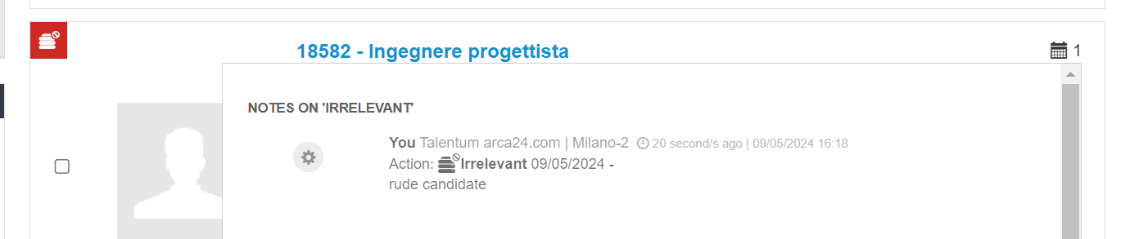

Regardless of the step the candidate is in, by hovering over the calendar icon in the candidate string, you will see a tab containing a preview of the evaluations entered on the candidate, as well as a preview of the activities performed on the same candidate. In other words, if the candidate has at least one saved evaluation within the evaluation forms (evaluation form, technical evaluation form - for customers with the latter), the last saved evaluation entered on that candidate will be visible in the preview, without having to open the candidate's form.

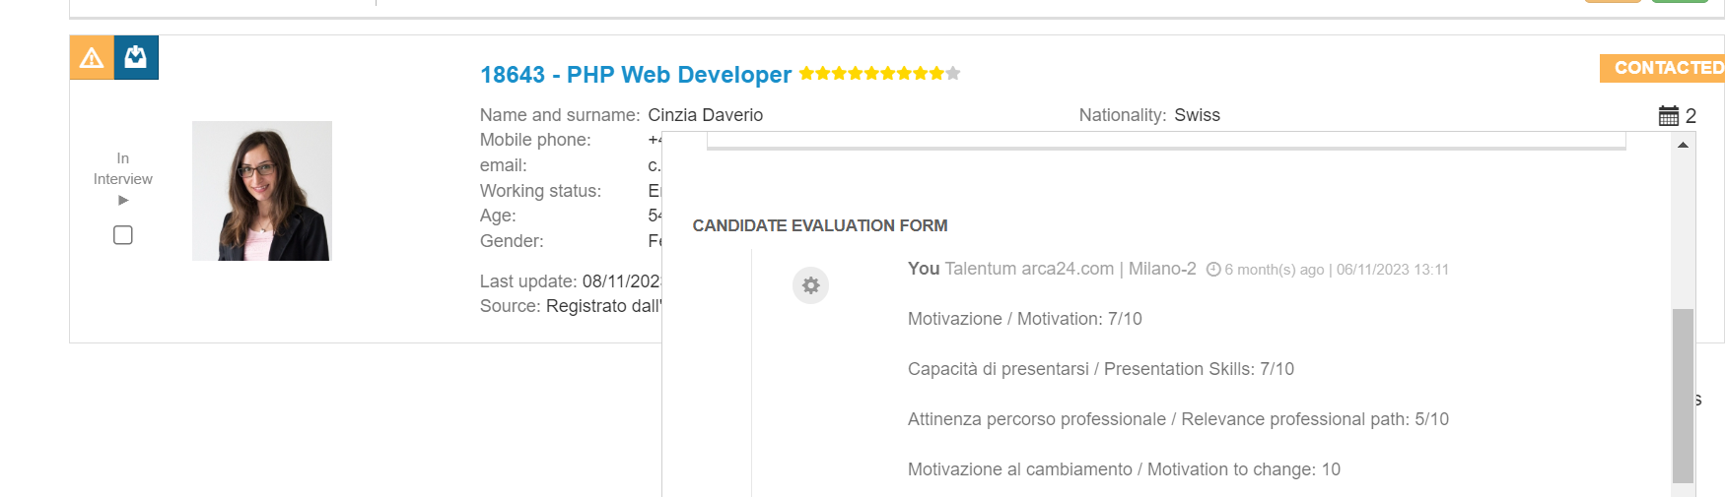

##### **Job titles**

In the section related to **matching candidates**, it is possible to check and manage the professional tags automatically extracted from the job description through the semantic search engine.

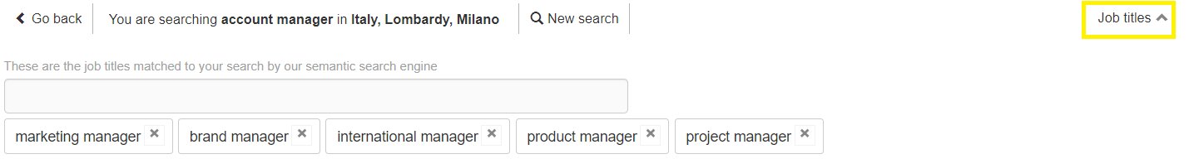

Once you have published a new job ad, it is very important to check this section. The recruiter can delete and add new professional tags considered suitable for the research at any time; just consider into that the more tags are selected, the more difficult it will be to have a candidate who achieves a high score in the compatibility percentage.

In the curriculum preview, you can view the subdivision made by the CV parser; the links allow you to quickly move the display between the following sections: matching tasks, parsed CV and CV extraction.

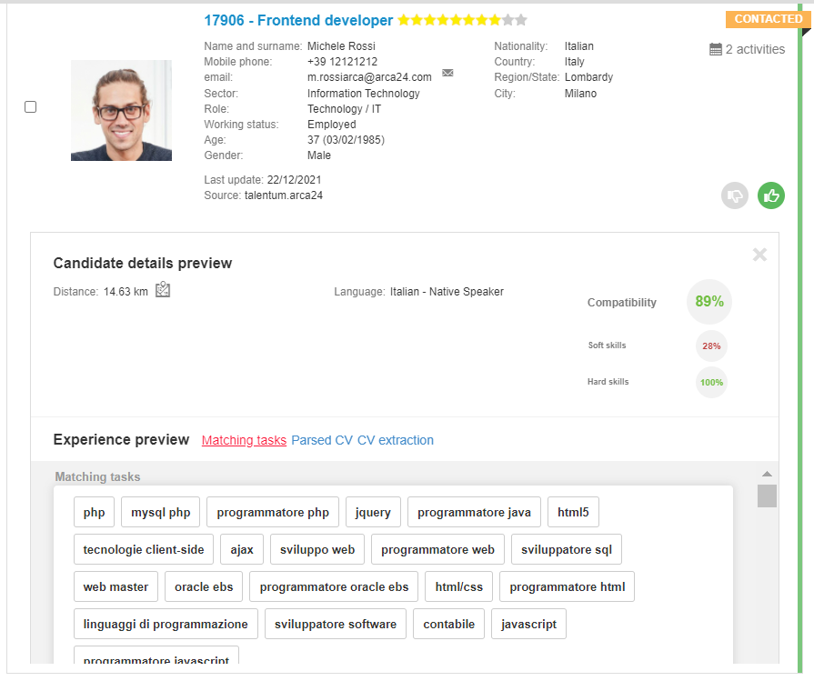

##### **Filters**

Within the section related to matching candidates, there are filters that allow you to reduce or increase the pool of candidates to be considered for the selection process.

After setting the desired filters, just click the button for starting the database search:

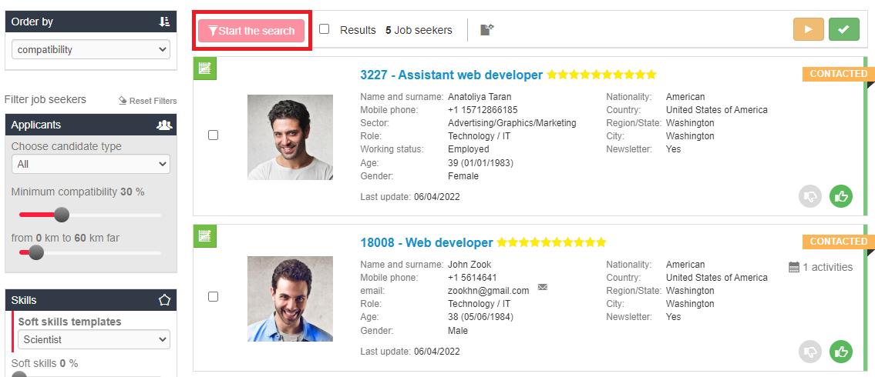

**Ranking:**

* by compatibility (from the highest to the lowest percentage)
* by registration date (from the most recent to the oldest date)
* by last update date (from the most recent to the oldest date)
* by distance (from the nearest to the farthest candidate)
* by stars (decreasing candidate's rating)
* by thumbs (green thumbs, unmarked and red thumbs)
* by age (from the youngest to the oldest candidate)
* by grade (only for software versions with the field “grade” in the candidate form*): can only be applied if the filter on **education level** has been entered. This is useful for searches where a diploma/graduate degree is a preferred requirement.

**Candidate type**: all matching candidates or just those who applied to the job ad (among the matching ones).

**Minimum compatibility:** 30% by default; it can be lowered to increase the candidate pool or raised to reduce it.

**Km radius:** 60 km from the workplace by default; as in the case of minimum compatibility, it is used to increase/decrease the number of resulting profiles.

**Skills**: it allows you to select a soft skills template as well as the percentage of compatibility of soft and hard skills. **N.B.:** a candidate can match even if he/she has a different template from the one selected in the job test.

**Filter for exact word in CV**: the search works in relation to CV extraction, working experiences, candidate's first and last name and candidate’s job title. It is a Boolean search, based on AND/OR principles.

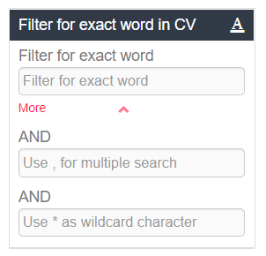

**AND:** it allows you to search for candidates who have **all** the entered exact words in their CV. You can use up to three text fields (the other two are shown by clicking on "More"). Each word must be entered in one field. E.g., first field "programmer", second field "software" -> the system will show only candidates who have entered both words.  
**,** corresponds to **OR:** it allows you to search for candidates who have **at least one** of the entered exact words in their CV. E.g., "programmer, musician" -> the system will show candidates who have entered the word "programmer" and those who have entered the word "musician" (or both of them). The comma can be used as an “OR” in each of the three filter fields.

**\*** corresponds to a **wildcard character:** each asterisk replaces a character within a word. E.g., wom*n -> the system will show both candidates who have entered “woman” or “women”.

**Filter for exact word in activities:** search in comments and feedback on manually entered activities and in evaluations. It does not work on the type of automated activity or on feedback entered when sharing a profile. Boolean search is possible as in the case of the keyword in CV.

**Professional details**: these filters correspond to the fields filled in by candidates when registering into the database.

**Language skills**: these filters correspond to the language fields filled in by candidates when registering into the database. You can use the icons to select the corresponding level (“equal to”) or the minimum level required (“equal to” or “more than”).

**Education**: these fields correspond to the education fields filled in by candidates when registering into the database. You can use the icons to select the corresponding level ("equal to") or the minimum level required ("equal to" or "more than").

**Personal details:** some of these filters can be pre-selected when posting the job ad in the section "Candidate's goal". As an example, the filter by date of birth is useful in cases where it is necessary for the candidate to be of a certain age on the date of contracting (e.g., for apprenticeship contracts). Both filters include the date entered.

**Company structure:** (optional module*). It allows you to filter by site, division and department associated by recruiters to the candidate profile.

**Candidates’ history:** this filter is used to show candidates who have been moved to step 2 or step 3 in other selection processes. If you set sector and role for the job ad you are interested in, the system will show you the candidates who were moved to step 2 and/or 3 **in the last job ad** with that sector and role. By using the thumb filters, you will be able to see, for each step, the candidates who have received a thumbs down/up or who have not been marked.

**Activities:** these filters allow you to search by type and date of activity as well as by employer who entered the activity or the evaluation (in the proper form within the candidate profile).  
**Status**: this filter sorts candidates by status label (not worked, contacted, interviewed, in presentation, hired, onboarding).  
**Hide deleted candidates:** flag selected by default, allows logically deleted candidates not to be displayed in the search result.

**View irrelevant too**: this flag is marked by default to display in the search results candidates who have been set as irrelevant too. If the flag is not marked, irrelevant candidates are not displayed.

**View only highlighted**: If the flag is marked, the system will display only matching candidates who have been highlighted.

**[FOR DATABASE RESEARCHES ONLY]** **Spontaneous applications**: if the flag is marked, the system displays candidates who did not send any direct application for jobs, i.e., who have only spontaneously registered to your database.

**Subscribed to the newsletters**: this flag is linked to the one marked by the candidate when registering into your database ("I consent to receive electronic communications"). This filter can be used when sending a multimailing communication to candidates.

**See disadvantaged candidates only**: (optional module*). This flag can only be used if the proper field has been provided in the application form and allows only disadvantaged candidates to be displayed.

**Source**: this filter allows you to select the source of the candidate's application.

**Login date from/to:** This filter allows you to select candidates based on the login date.

**Update date from/to:** This filter allows you to select candidates based on the update date.

**Status**: This filter allows you to select candidates based on their status (not worked, contacted, interviewed, in presentation).

**On board:** this filter allows you to select candidates based on their onboard status (hired, never hired, ex worker).   
**Multimailing data** (*optional module): these filters allow you to select the candidates for whom data for multimailing was entered or not, whether they were sent by multimailing, over what date range and in relation to role and type of service.

**Candidates you like:** this filter allows you to select candidates based on the evaluation through thumbs (thumbs up, thumbs down or not marked) in each specific research/selection process.

**Save search**: this filter allows you to save the filters you set.

At the top of the Recruitment page, the "**Back to job ad**" button allows you to return to the list of job offers filtered by the ad in question. This option allows you to return more quickly to the single job posting string, where you can view all the edit, offline and multipost window options. This function is also very useful when you can directly open the link to the job offer to which the candidate applied from the candidate's profile; the "Back to job ad" button takes you back to the menu for modifying the announcement itself.

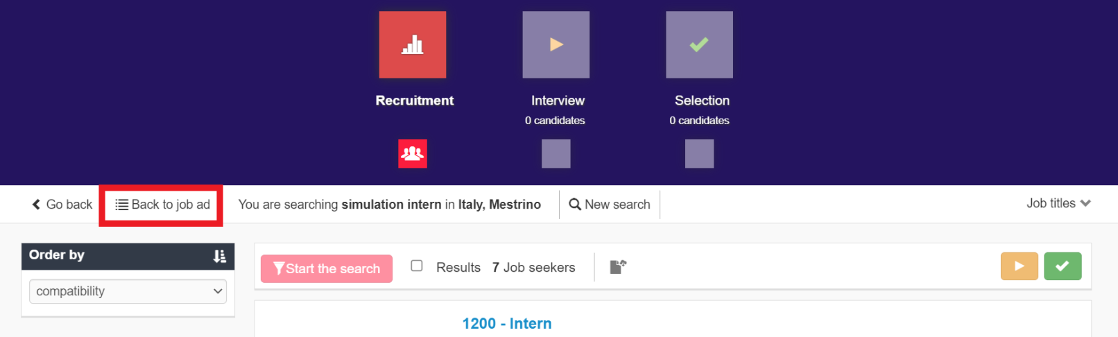

In all searches where the results are divided into several pages, you can display all result pages and select the page to be displayed, so that you do not have to scroll through the pages one by one.

Below are the sections concerned:

- job list (candidate side);

- step 1 jobs/candidate searches

- Searches in the company database

- Searches in the opportunity database

- Searches with Job Radar



The page with the darkest colour is the page being displayed at that moment.

##### Mass actions

Within the recruitment steps, it is possible to carry out mass actions by selecting the candidates concerned. Mass actions are tracked, like individual actions, in the activity tab of each candidate's profile.

Mass actions take time to be processed. The employer is notified of the completion of the mass action by a pop-up that appears at the bottom right of the screen.

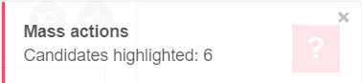

By clicking on the flag "Select all", you can see the filters for mass actions, which allow you to select one or more of the resulting candidates in the ranking at once. You can select only a specific range of candidates (e.g., from 1 to 20). The field "Exclude ID" allows you to select the candidates in the range by excluding some of them. To indicate the candidates you need to exclude from the selection, enter the IDs separated by a comma.

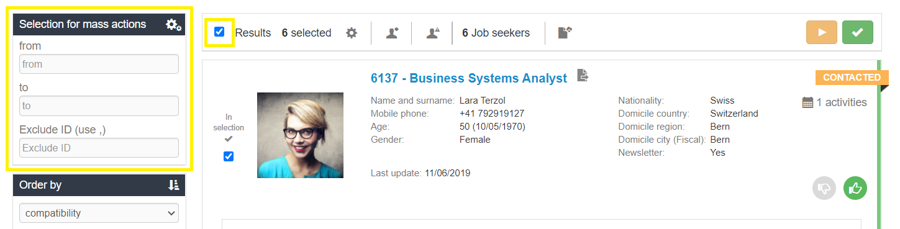

Here are the mass actions:

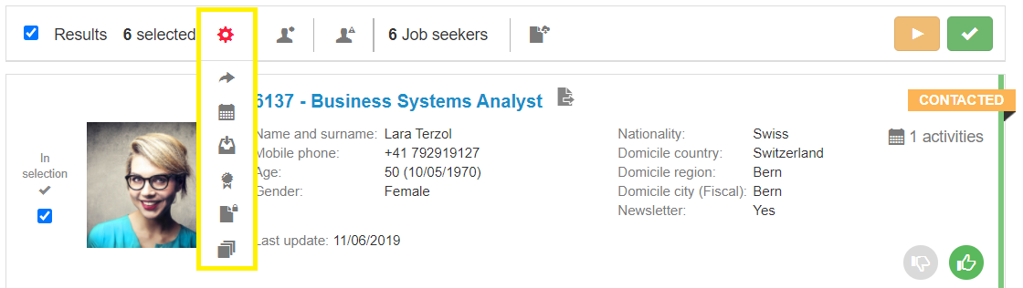

* Share
* Add an activity related to the selected candidates
* Include in a selection process
* Assign to a site/division/department (*optional module)
* Upload public documents for the selected candidates
* Upload private documents for the selected candidates

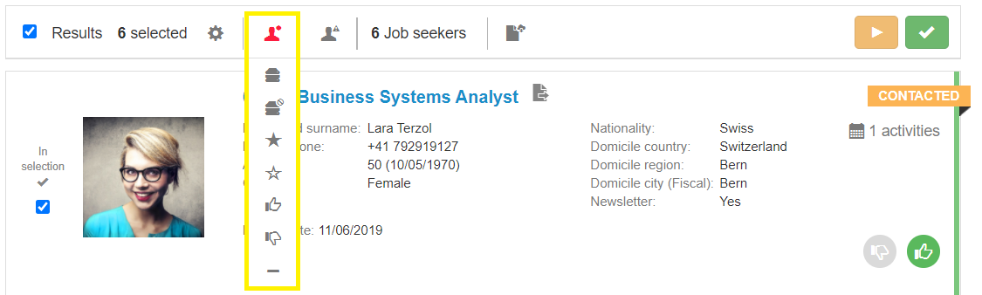

* Mark as relevant in the searches (this option deletes the “Mark as irrelevant”)
* Mark as irrelevant
* Label as highlighted
* Remove highlight label
* Give a thumbs up
* Give a thumbs down
* Remove thumbs

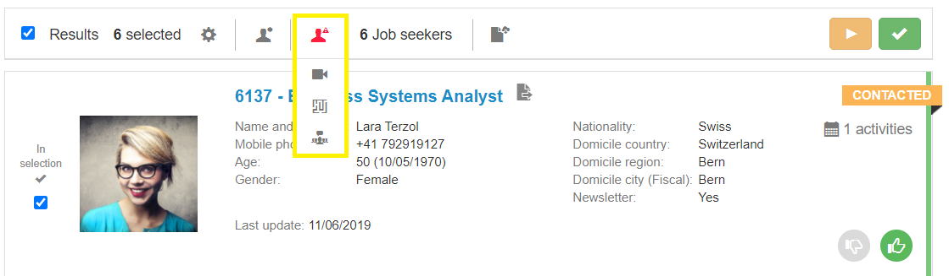

* Request video resume
* Request tests
* Start multimailing (optional module*)
* Start multi-SMS (optional module*)

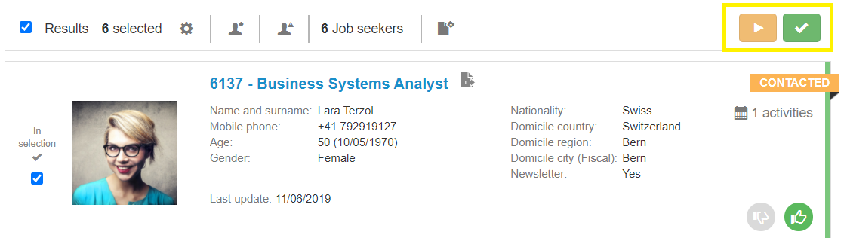

* Move to the next steps

**Multimailing:** by clicking on the button "Start multimailing", a pop up will show you an input mask to set the email.

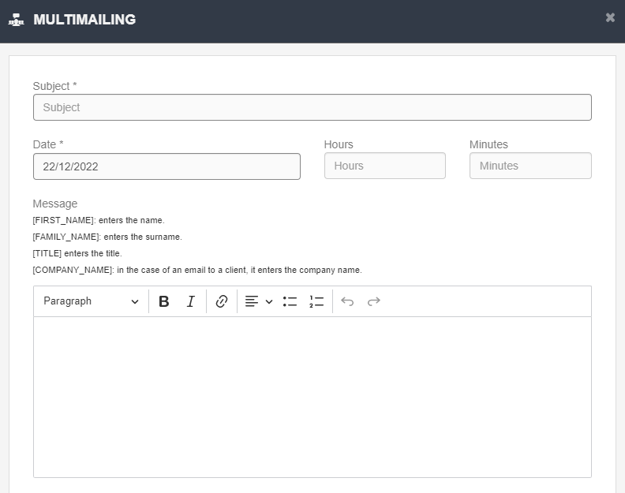

**Date, Hours, Minutes**: you can decide when you would like the mass mailing to be sent (set the date and time).

**N.B:** multimailing messages are sent via a cronjob every half hour (150 mails per half hour); if the number of emails is higher, they will be sent in the next half hour.

**Message**: field for entering the text of the email; you can also use the text editor tools. Using the parameters in brackets, it is possible to send mass emails in a personalized way: with name, surname, title, company name. Just enter one or more parameters in the email exactly as in the legend> Dear [FIRST_NAME].

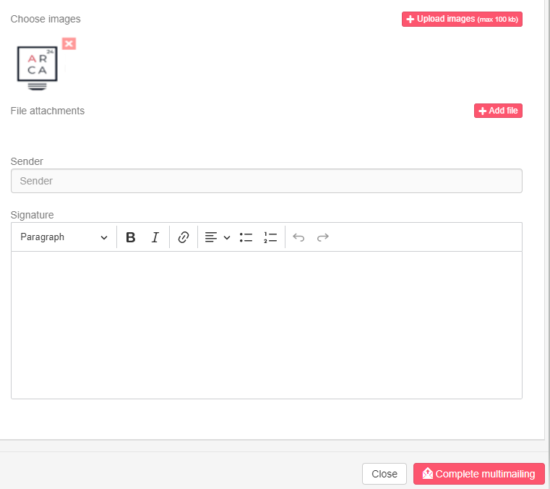

**Choose images:** it allows you to upload images. You just need to click on the image you have chosen and it will be displayed in the body of the e-mail. The maximum size is 100 kb.

**File attachments**: it allows you to enclose files to your e-mail. The maximum size is 2 Mb.

Allowed formats: pdf, doc, docx, txt, odt, rtf, jpg, jpeg, png, xls, xlsx, csv, ppt, pages, pps, pptx

**Sender, Signature**: the system shows the sender and signature set in the section Account Management, however they can be removed or edited. To confirm your choice, you only need to click on the button “Complete multimailing”.

##### **Export candidates to CSV**

By clicking on the icon (), it is possible to export a CSV file containing candidates’ data according to the search.

At the end of the export, a pop-up is displayed asking if you want to view the export section immediately. By clicking on "Ok", you will be redirected to the export tab where you can access the extraction history. By clicking on the export, the file will be downloaded.

### Interview step

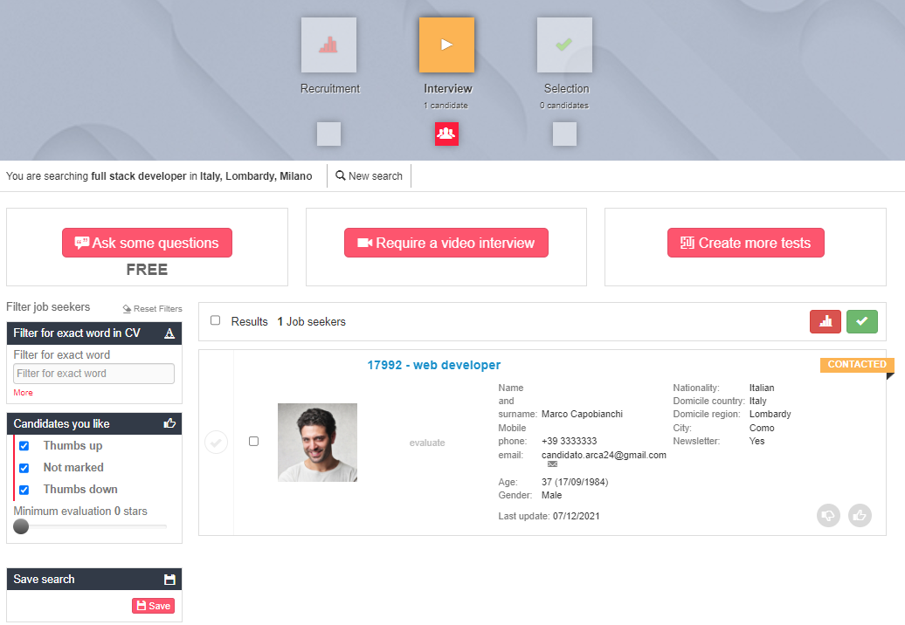

In this step, it is possible to request a written questionnaire (“Ask some questions”) **or** a video interview (“Require a video interview”). If you click on “Create more tests”, you can have access to the test sessions integrated with CVideo, ExaminLab and SoftSkillLab. For more details, please see the handbooks of ExaminLab, CVideo, SoftSkillLab.

In the case of a questionnaire or video interview, **all** the candidates moved to the interview step, from the moment of opening to the moment of closing the session, will be invited to carry out the test by email (sent **only once** per process). In addition, they will be able to access the test either from the email received or from the notifications section in their personal area. Thus, if a candidate has not taken the test before the closure date, and if the session is reopened, the candidate can access it directly from the "notifications" section of his/her personal area. When accessing the session, candidates can always decide if they want to take the test or refuse it. In both cases, a notification email will be sent to the employer who sent the request.

In the string of each candidate moved to the interview step, a status label is shown:

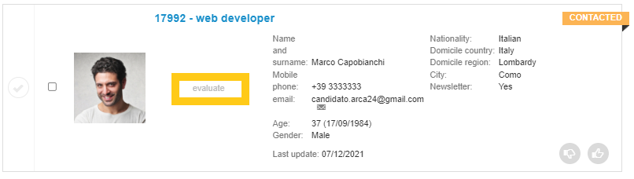

* “Evaluate”, when there is no active session;
* “Waiting for response”, when the request has been sent, the candidate has not replied yet and the session is still open;
* “Declined”, when the candidate refused to take the test;
* “No response”, if the candidate has not replied yet and the session is closed;
* If the candidate answered the test, the results will be displayed based on their score.

**Killer questions:**

By clicking on "Ask some questions", the employer will access the form to create the questionnaire (i.e., killer questions). The test consists of multiple-choice questions aimed at assessing candidates’ technical knowledge and/or prerequisites necessary for the candidates to reach the next step.

The employer can:

* Set the closing date (by default, it is one week after the session opening);
* Choose a pre-filled template or add the questions related to the given recruitment process;

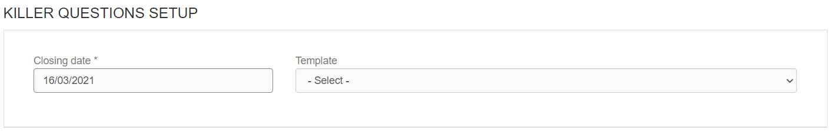

* Add a website or other links (e.g., that of a corporate video presentation);
* Include a text as a description of the test or of your company; 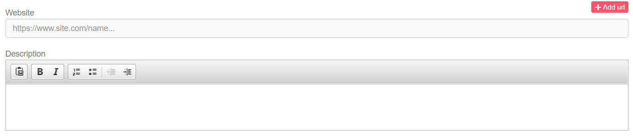
* Write the test questions;
* Select the response time for each question;
* Write the answers for each question;
* Set the score for each answer (scores range from 1 to 10; the option 'disable' gives a score equivalent to -1 and a thumbs down to the candidate who chooses that answer in the interview step).
* Add more questions (the test can take up to 30 minutes).

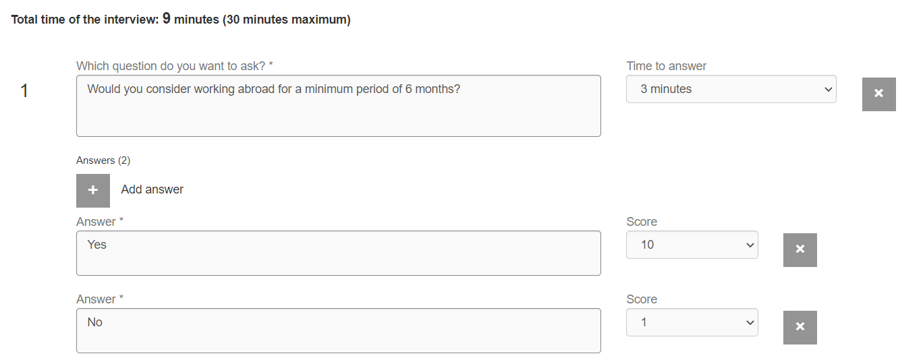

The score of the candidates who completed the test is shown as a percentage within their profile string.

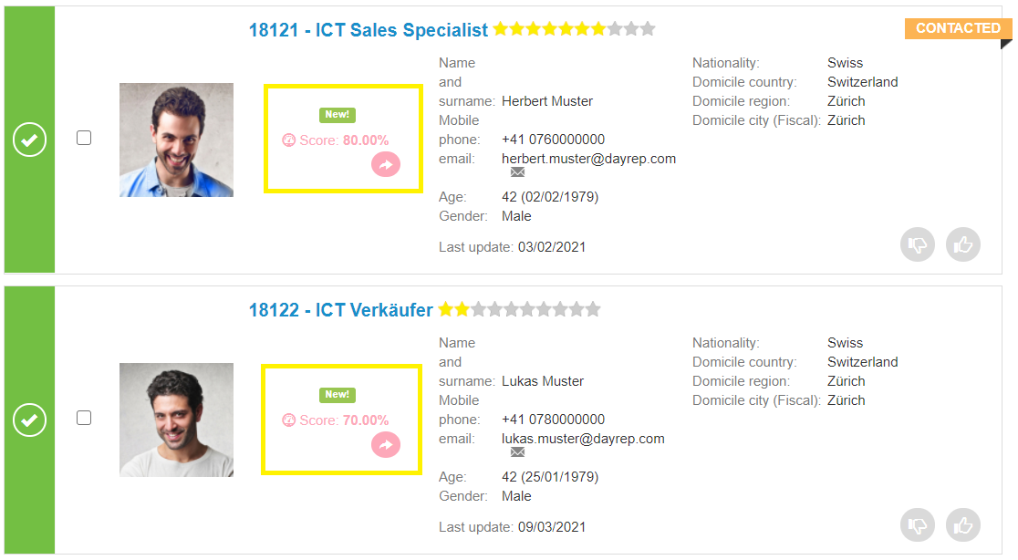

By clicking on the individual candidate's score, it is possible to view the details of his/her answers: the given answer for each question, the response time, the score per question and the final percentage.

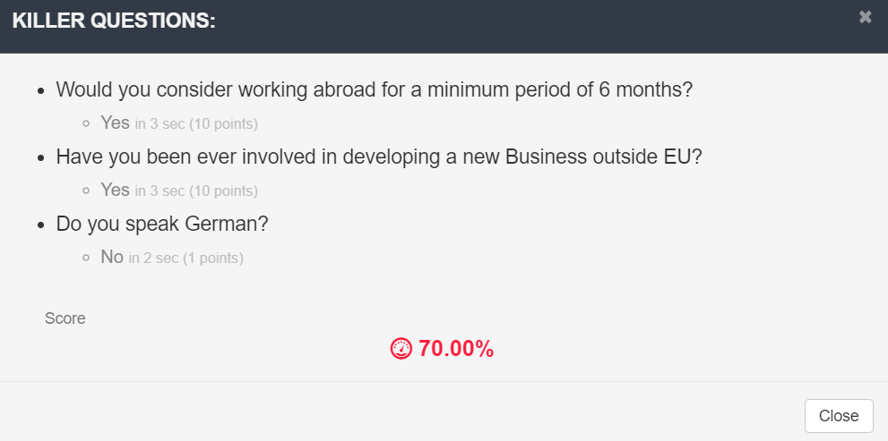

Those details are always visible by all employers within the candidate's profile as well.

By clicking on the icon next to the score ( ), you can see and copy the link to share the result with third parties (for example, colleagues who do not have access to the platform).

**N.B.:** If a candidate **does not answer** a question in the questionnaire within the set time, the time expires and the answer to the question will not be saved.

The test will continue with the next question, if any, otherwise the test will be considered completed. The question for which the response time has expired will not be shown in the candidate's profile (Profile> Test section).

If a candidate **leaves** the page while carrying out a questionnaire, the answer to the question the candidate is on at the time of leaving is not saved. The test will be blocked and can be reactivated by clicking on the "Reset" button, which will appear in the candidate string after about an hour.

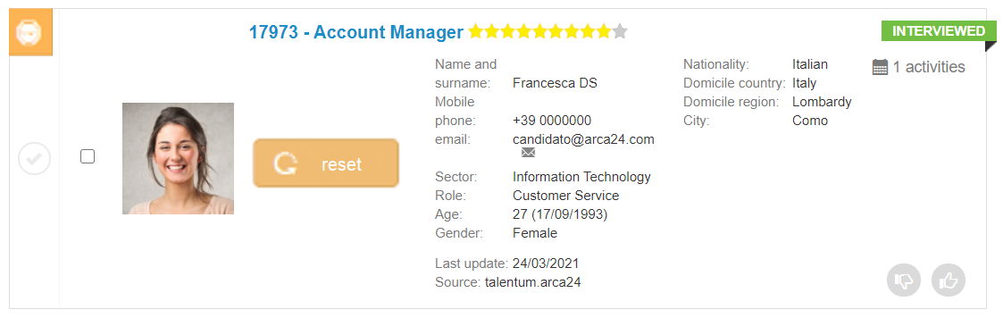

**Video interview**

By clicking on "Require a video interview", the employer will access the form for creating the video session.

The employer can:

* Set the closing date (a week after the session opening by default)
* Choose a pre-filled template or add the questions related to the specific recruitment process
* Add a website or other links (e.g., a corporate video presentation)
* Include a text as a test description or a company presentation
* Type the test questions
* Select the response time for each question
* Add more questions (the test can take up to 30 minutes).

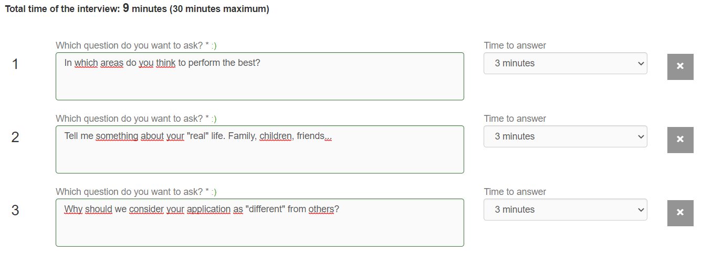

A preview of the video is shown in the string of candidates who answered the test.

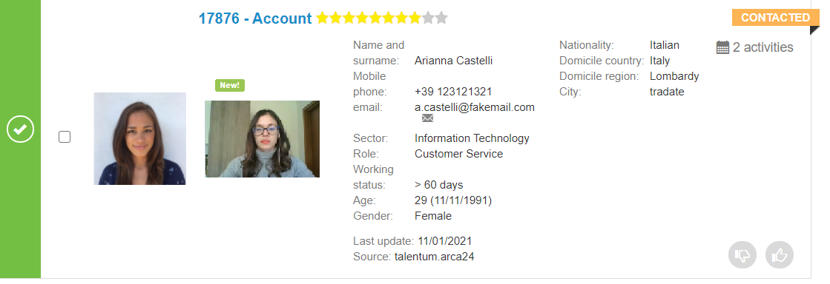

By clicking on it, the video will be opened directly; the same detail can always be viewed by all employers within the candidate's profile (Profile > Videos).

By clicking on the arrow icon, it will be possible to copy the link for sharing.

In case of technical problems during the registration process or the candidate left the session before completing the interview, the button for resetting the test will be shown in the interview step of the selection process.



By resetting, the candidate can use the email received previously: the link to the interview is going to be available again.

**Closing and reopening sessions (for both questionnaires and video interviews)**

The employer can close the session manually using the specific button.

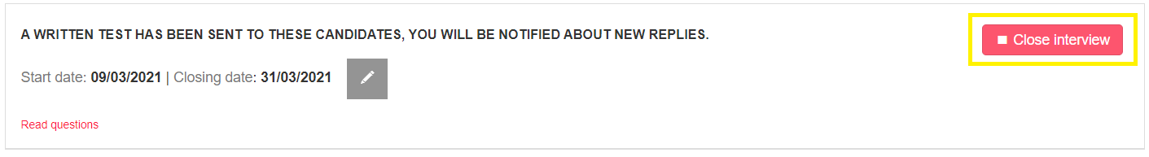

Candidates who try to access the test after the closing date will not be able to take the test.

After closing a session, the employer can reopen it again clicking on the corresponding button. 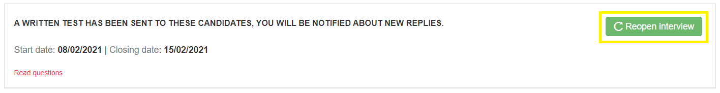

**N.B.:** The email request to the candidate is sent **only once per selection process**. If the candidate had not taken the test, he/she can access it after the reopening of the test by clicking on the link from the 'Notifications' section of his/her personal area (from the last notification of interview request).

The sorting in the step is firstly by thumb (green-thumbed, unmarked and red-thumbed candidates), secondly by descending Killer question score, thirdly by date of entry into step2 descending, finally by date of candidate registration descending.

**Filters**

* Filter for exact word in CV (candidate name and surname included)
* Multimailing data (Yes, no, never sent)
* Thumbs up
* Thumbs down
* Not marked
* Minimum evaluation (according to the rating): it allows you to view candidates rated with at least a given number of stars.
* Minimum test score (visible only if a questionnaire has been activated). It is a slider that allows you to display candidates according to the results achieved in the test.
* Video interview (only shown if a video interview session is activated). It allows you to only view the candidates who have completed the video interview.

Filters applied in the interview step can be saved using the red button "Save".

The sorting in the step is firstly by thumb (green thumb, unmarked and red thumb candidates), secondly by Killer question score, thirdly by date of entry in step2, finally by date of registration of the candidate.

### Selection step

In this step, where the candidates will be shortlisted, you can prepare and send a summary of each candidate's profile to one or more contact people and hire the selected ones. Using the multimailing button, you can also start a mass mailing of short profiles to the lists of companies created in the module “Clients”> Mailing list.

The filters available are the same as in the step “Interview” and, likewise, their settings can be saved.

* Filter for exact word in CV (candidate name and surname included)
* Multimailing data
* Thumbs up
* Thumbs down
* Not marked
* Minimum evaluation
* Minimum test score
* Video interview

#### **Send candidates’ summaries**

In order to create a candidate’s summary, click on "Create summary":

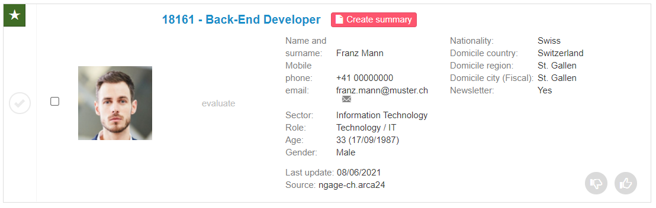

Fill in the available fields:

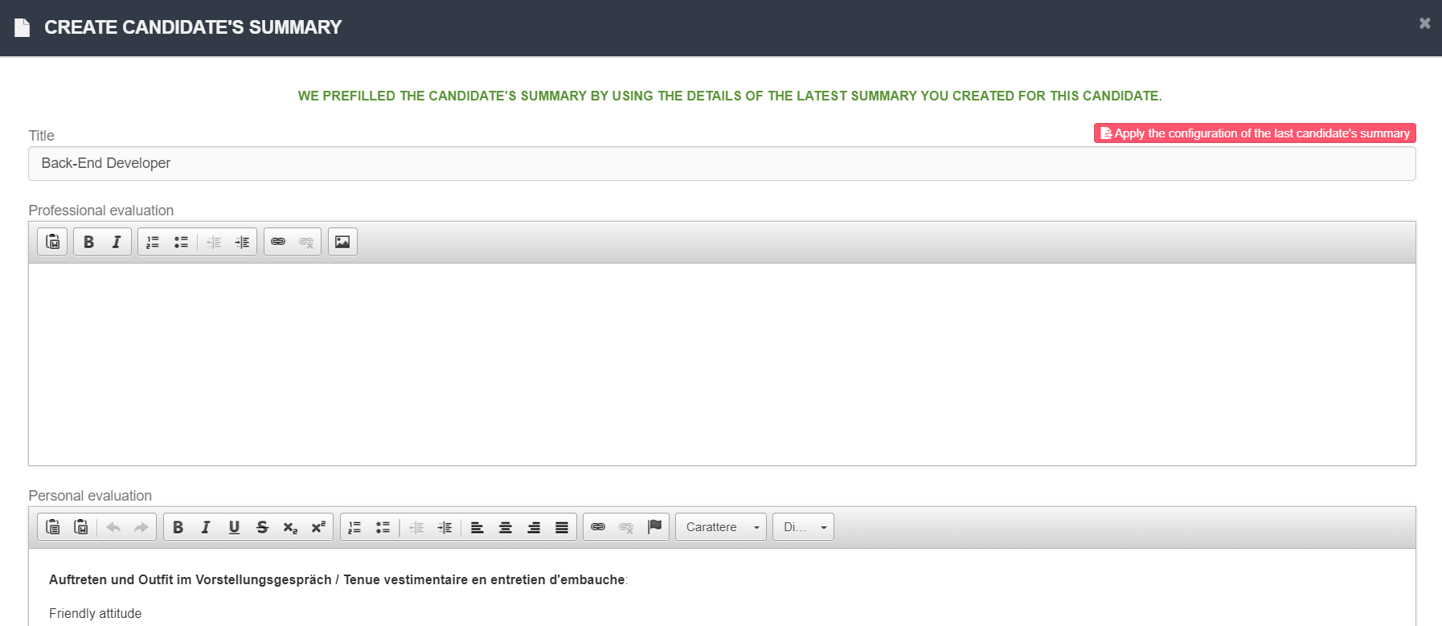

**“Apply the configuration of the last candidate’s summary”**: it allows you to pre-fill the form fields with the setting of the last summary created.

**Title**: by default, the job title of the candidate is entered but it can be changed. The field has a maximum of 50 characters.

**Professional evaluation**: free text field that the employer can fill in with a professional evaluation of the candidate.

**Personal evaluation**: free text field which is pre-filled if the evaluation form has been filled in on the candidate (see the candidate’s profile > tab Evaluation).

**CV preview:** textual and editable field containing the textual extraction of the CV uploaded on the candidate.

**Experience**: text field showing any experience entered manually in the candidate's profile, if completed.

There are several **flags** to set up the candidate’s summary and decide which data is to be shared with the contact person.

When creating/editing a Dossier, it is possible to select the tests SSL, Examinlab, CVideo, Killer questions, Video interviews and Documents. For each of these, there is a specification that enables the selection of a particular test session, so that one or more tests in the same category can be proposed in view to the company contact person.

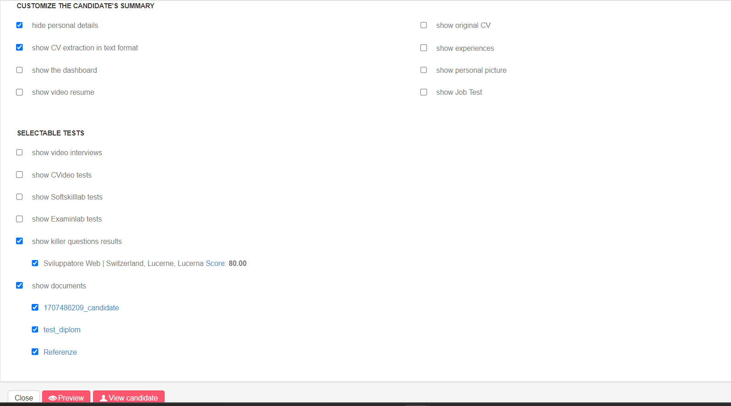

It is possible to configure the CV in different ways depending on the flags selected:

1. “show original CV” and “use original file”



When the flags “show original CV” and “use original file” are selected, the flag “hide personal details” is cleared and the original CV uploaded by the candidate (without parsing) is shown in the candidate’s summary.

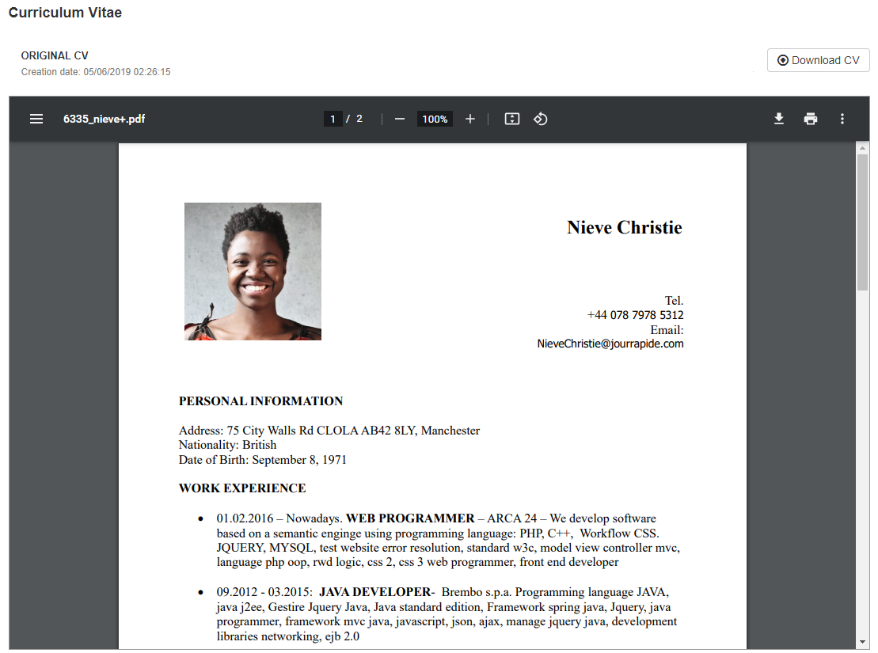

2. “show original CV”



When only the flag 'show original CV' is selected, the parsing of the CV and its original version (uncensored format) are shown in the candidate’s summary.

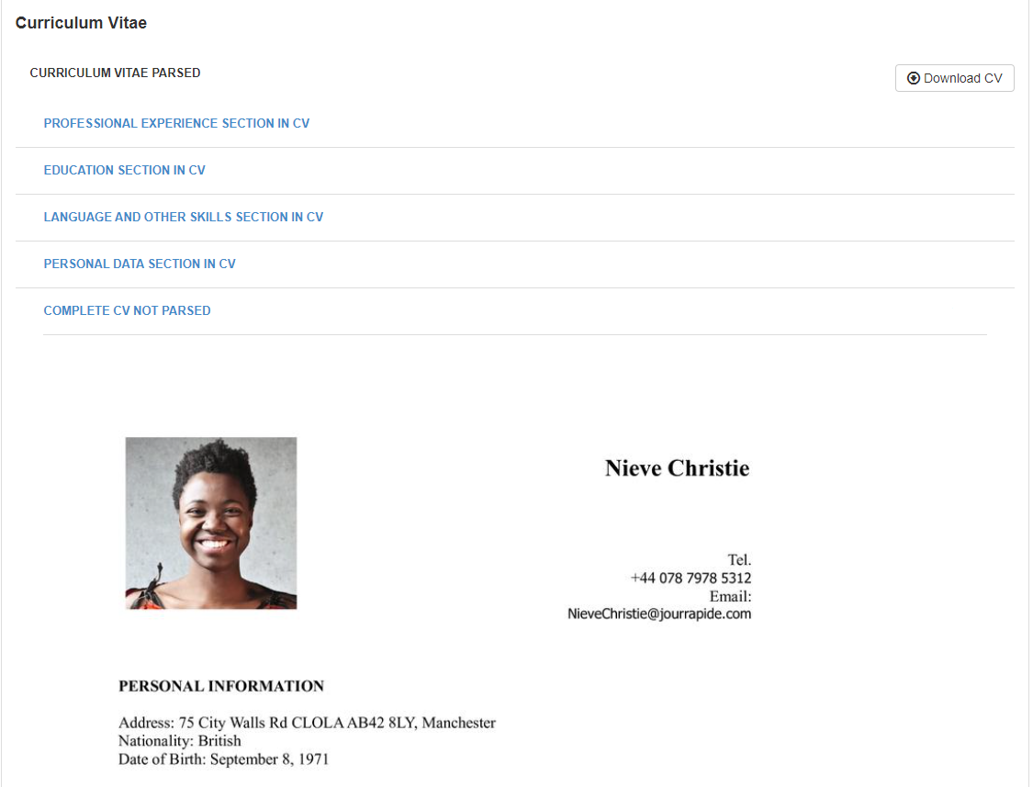

3. “hide personal details” and “show original CV”



When the flags "hide personal details" and "show original CV" are selected, only the complete CV as automatically censored by the system or as modified by the recruiter in the candidate's profile is shown in the summary.

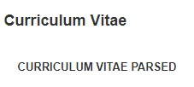

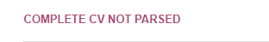



1. “hide personal details”, “show original CV” and “Edit for candidate’s summary”



When the flags “hide personal details” and “show original CV” are selected, it is also possible to use the button “Edit for candidate’s summary” to further edit the parsed CV before sending the summary.

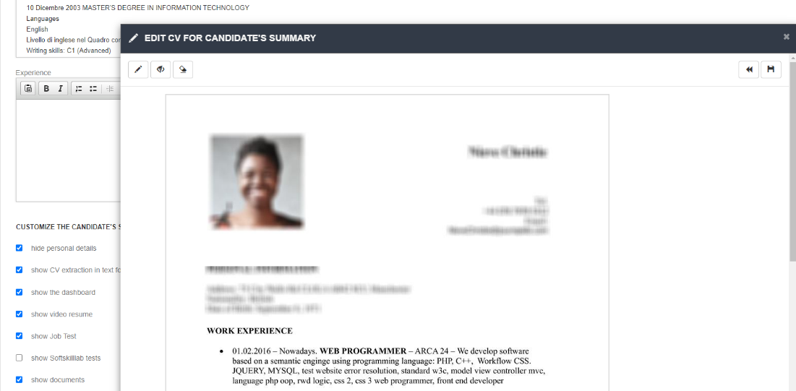

1. “show original CV” and “Edit for candidate’s summary”



When the flag “show original CV” is selected, it is also possible to use the button “Edit for candidate’s summary” to make changes to the parsed, uncensored CV.

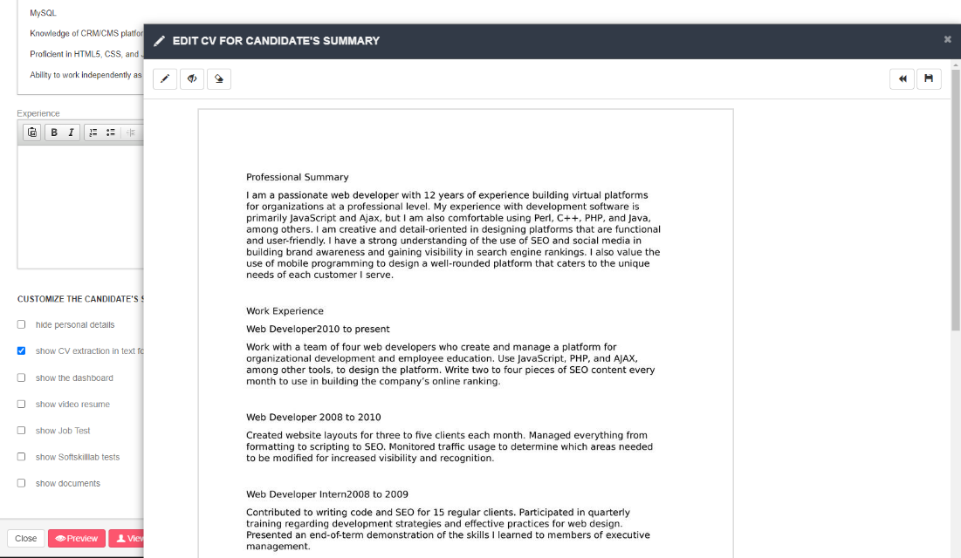

For the process of editing the CV in image version, see section "Profile tab".

If the candidate **has a cover letter within his/her profile**, this will only be visible in his/her summary when the option "show original CV (uncensored)" is ticked.

In the event that the CV has not been parsed and there is therefore no “obscurable” image accompanying the personal data in the CV, it will not be possible to use the button “Edit for candidate’s summary”, but the message "There are no editable images" will appear. In this case, it will be necessary to open the candidate's profile and, in the CV section, click on "Parse CV". At the end of the process, the image format and the button “Edit for candidate’s summary” will be displayed.



**N.B**.: Documents to attach and the original CV are not displayed in the preview in the employer's view, but only in the actual submission.

Once the summary has been prepared, you can preview it by clicking on the button "Preview" and/or save it as part of the selection process by clicking on **“Create”.**

After creating the dossiers, you can send them by ticking the profiles you want to send and clicking on the option "Send summaries".

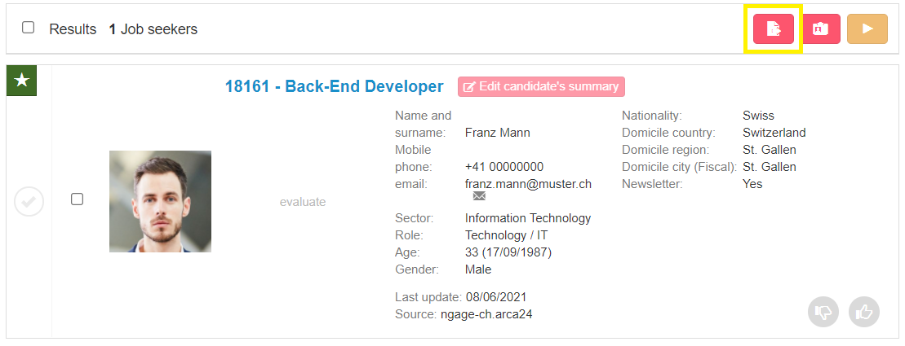

You will be shown the screen allowing you to set the sending and to fill in the text and the subject of the email that will contain the links to the candidate’s summary being presented.

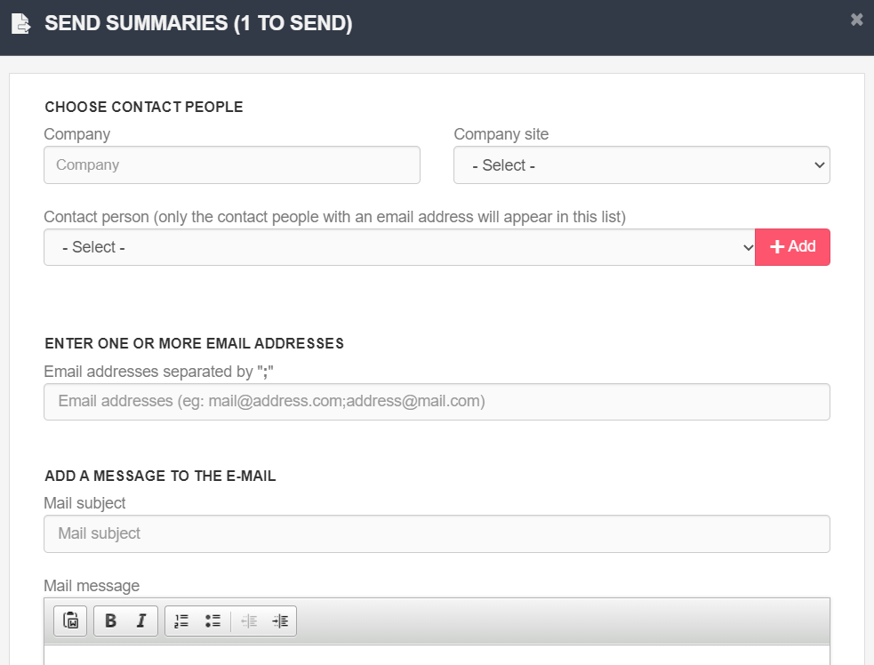

In the event that your software version contains the module for **sending candidates’ summaries via**

**multimailing** (OPTIONAL MODULE*), an additional line will appear for the choice of the multimailing message to which the selected candidates’ summaries are to be sent:

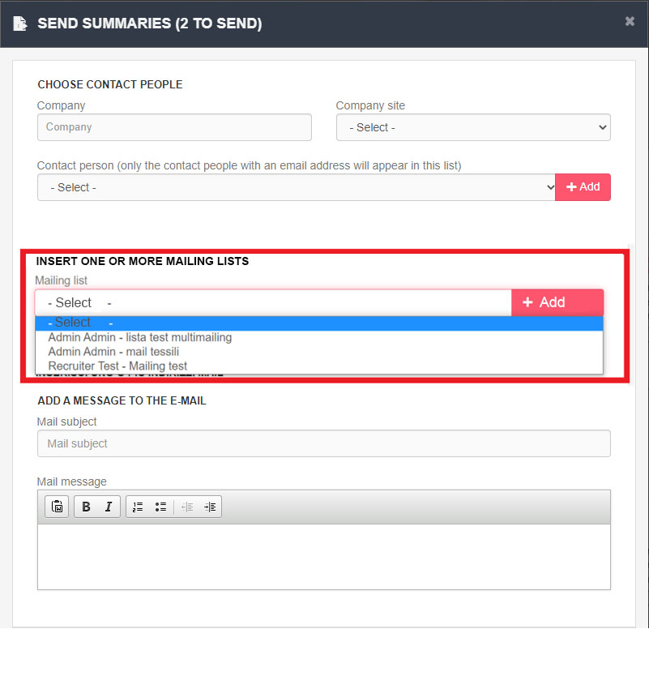

In case the selection process is linked via an opportunity to a company, the company and location will already be filled in and you will be able to choose the contact person to whom the mailing should be sent. If there is no link to an opportunity, you can enter the recipient's data manually.

If the contact person has access to the personal area, they will be able to view the summaries shared with them in their personal area at any time.

You can send the summaries even to email addresses that are not saved in the system by filling in the field "Enter one or more email addresses".

The recipient of the submission can enter his/her feedback directly from the link to the summary sent by email.

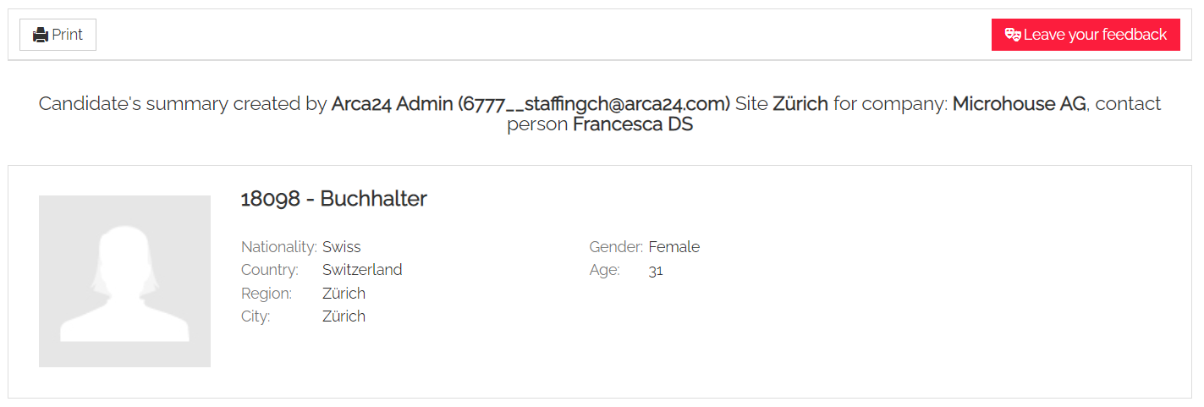

#### **Send to mailing list**

You can send candidates’ profiles to a mailing list by selecting them and clicking "Send to mailing list".

**N.B.:** The section “Evaluation for multimailing” in the candidates’ profiles must have been completed so that the profiles can be sent.

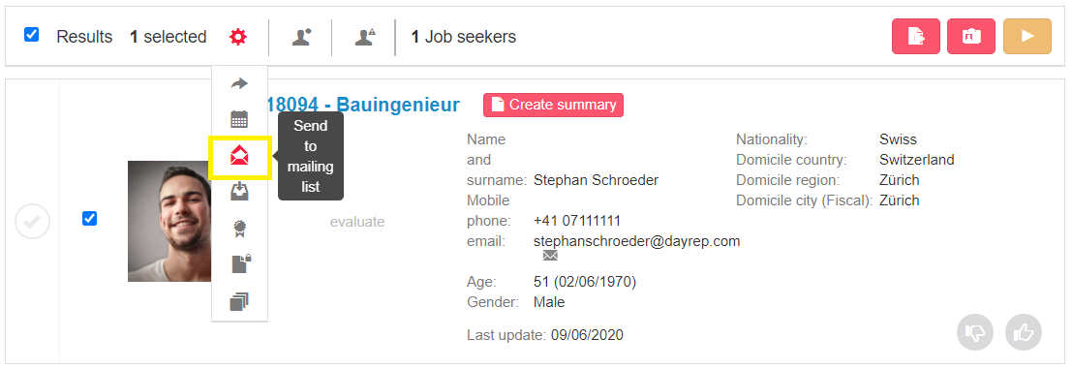

To add the chosen profiles to the list, just select the mailing list, click on 'Add' and set the date and time for sending; then click 'Add'. Opening the mailing list in the module “Clients” will allow you to enter the email text and approve the email before sending.

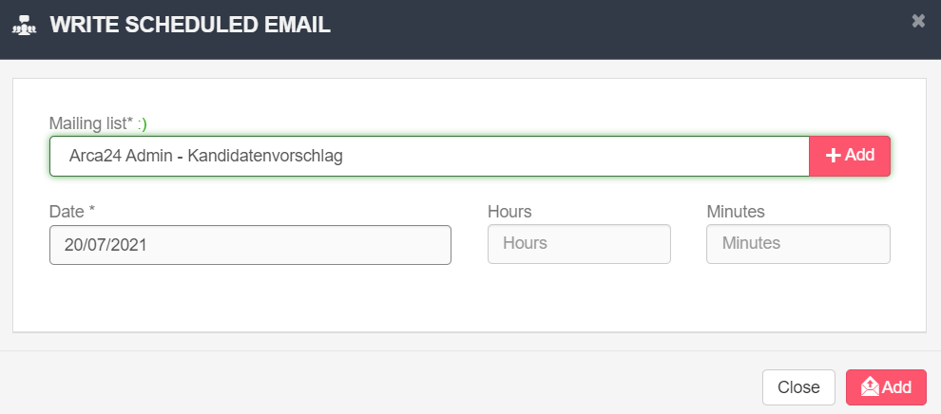

#### **Hiring**

Within the step “Selection”, you can hire candidates by opening each candidate's profile and clicking on the ‘Hire’ button:

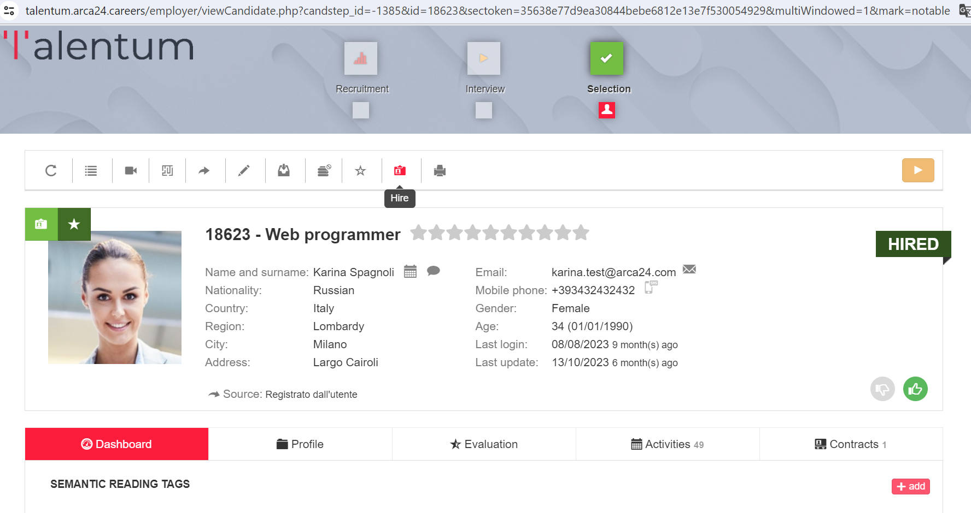

If your version of Ngage does not have the administration module, by clicking on the button, the pop up to create the contract will be opened up. If the contract is created started from a process linked to an opportunity, some fields will be automatically filled in.

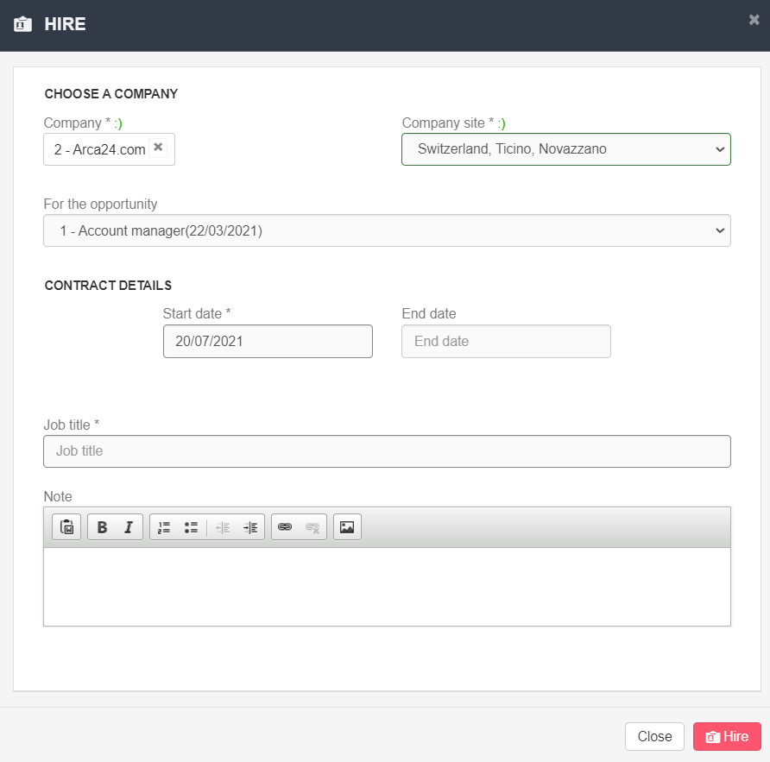

By clicking on "Hire", the contract string will be generated both in the candidate's profile and in the client's one. At the same time, the candidate will be marked as “HIRED”.

To dismiss the employee, just open the employee's profile, section “Contracts”, search for the contract and choose "Dismiss". The employee's status label will change back to "INTERVIEWED".

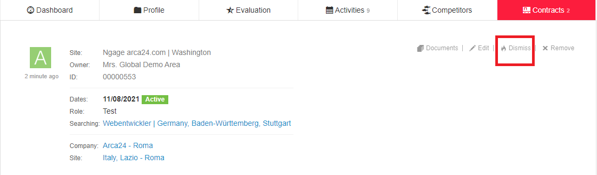

### Candidates (Database searches)

Database searches enable recruiters to search for specific candidates’ profiles and/or carry out database analyses based on pre-set parameters. Database searches are categorized in three steps similarly to the job advert selection process. Based on the search you want to carry out, the following filters are available:

#### **Advanced search**

In this section it is possible to perform advanced searches by:

**Candidate name (exact) ->** exact first name, exact surname, exact first name and surname, exact surname and first name.

**Candidate name ->** first name, surname, first name and surname, surname and first name, even if not exact.

**Job title ->** the search is based on the semantic engine. As for matching candidates within a selection process, it will be possible to manage the job titles extracted within the recruitment step.

**Candidates suggestion (OPTIONAL MODULE*) ->** the search created can be shared with a company contact person registered in the database and with access to the company area. The purpose of the candidate suggestion is to show interesting candidates for that company, so that the contact person can request more information about the profiles. The "Search title" field is shown in the subject line of the e-mail sent to the contact person.

**Candidate ID ->** the ID code is the code preceding the job title in each candidate profile. You can search for several candidates at the same time by separating the IDs with a comma (e.g., 123, 12312).

**Candidate email ->** search by complete email address or exact text before @.

**Phone number ->** it is necessary to enter the complete number without the international prefix.

**All candidates ->** It is possible to search for all candidates in a geographical area. The candidates are sorted by date of registration.

**Activities on candidates ->** search in the text boxes "Comment" and "Feedback" of manual activities and in the evaluation form. The field works as a full-text search. Example: If an activity with the comment "first interview for accounting expert" is entered, the search also works by searching only for "accounting expert interview". If you need to search for one or more words exactly, it is preferable to use the exact word filter in activities.

**Evaluated candidates ->** search for all candidates who have at least one entry in the evaluation tab; this can be the rating, the company structure or the evaluation form.

**Company structure (OPTIONAL MODULE*) ->** search based on the company structure set on the candidates.

#### **Last seen candidates**

In this section, the last 20 displayed candidates’ profiles are listed.

#### **Saved searches**

In this section, saved searches are displayed.

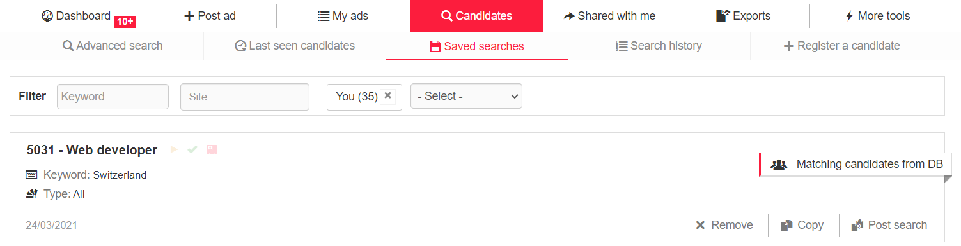

If you want to save a search, you can use the given section within the recruitment step at the bottom of the search filters on the left.

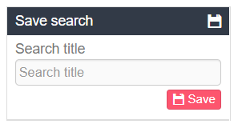

The following options are available for each saved search:

**Remove**: if you want to delete the search.

**Copy**: if you want to copy the parameters set for a new search.

**Post search:** if you want to post a job ad starting from the saved search. By clicking on the button, you will be redirected to the section "Post ad", where some form fields will be pre-filled based on your search.

**N.B.:** if you delete a saved search, the linked job ad will not be deleted.

If you link an opportunity to a search, you can use the dropdown by opportunity status in the filter string to refine your search:

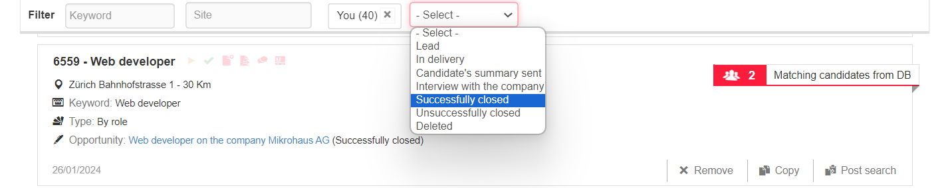

#### **Search history**

In this section, the last 20 searches performed are displayed. Click on each of these to see the detail.

#### **Candidates suggestion (OPTIONAL MODULE*)**

In this section you can view some lists of candidates’ suggestions created by you or your colleagues within the platform.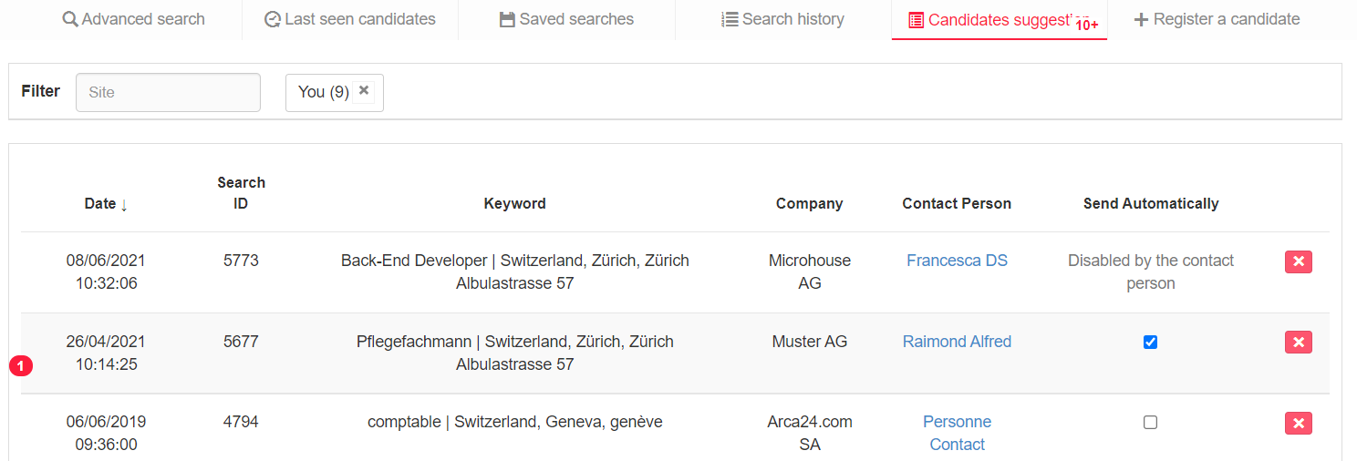

If you flag "Send Automatically", an email is sent to the **contact person** on a weekly basis: the email includes the list of profiles with their job title, city and last update date.

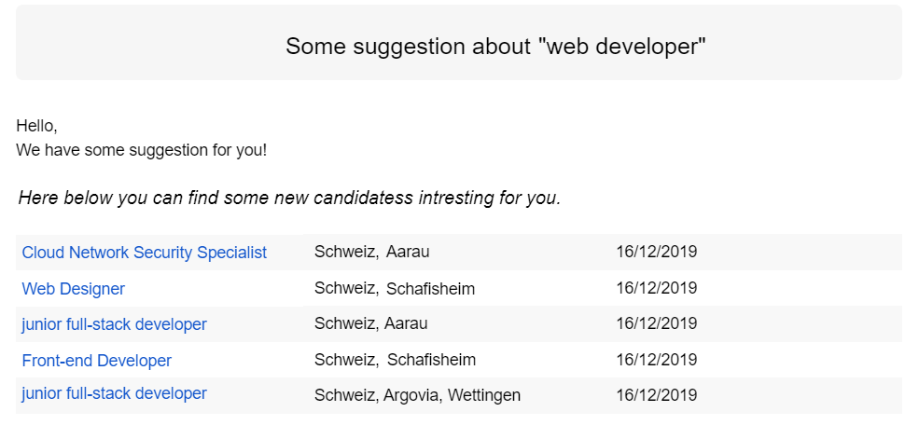

If "Send automatically" is not flagged, the email is sent to the **employer** who created the candidate suggestion.

By clicking on “Deactivate suggestion”, the contact person can directly choose to deactivate it in his/her personal area. The employer will display the proposal as deactivated by the contact person.

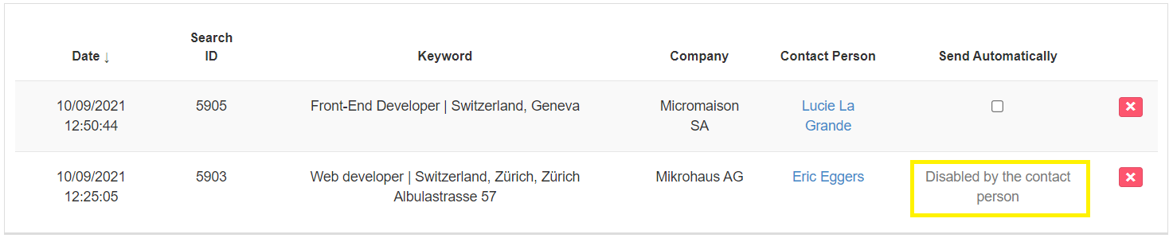

#### **Register a candidate**

In this section, employers can enter new candidate profiles. The form has fewer mandatory fields than the external registration form, just to allow for faster candidate registration.

**N.B.:** in the field “Email (Candidate)” it is important to enter **correct and existing email addresses**, otherwise the candidate will not be able to access his/her personal area.

### 3.8. Shared with me

In this section you can view the candidate profiles shared with you by your colleagues and you can filter them by date of profile sharing and by keyword.

These filters are available both in the 'Shared with me' tab and in the candidate sharing page that is sent out by e-mail: the employer and the e-mail recipient can now view the candidates shared in the time frame they are interested in.

The filter can be set by entering dates or by selecting the period of interest (last month, last 3 months, last 6 months, all time).

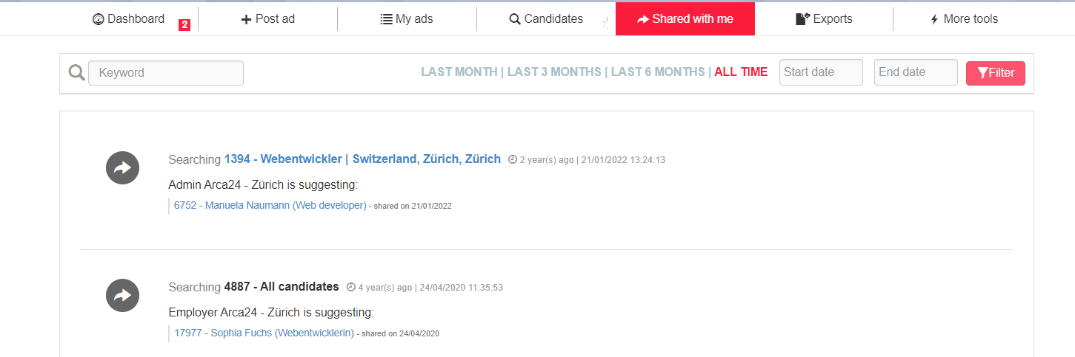

### 3.9. Exports

In this section, it is possible to see, download and even delete the exports carried out. Click on the string to download the CSV file. If you want to download an export, you just need to click on “Exported” on the corresponding string. 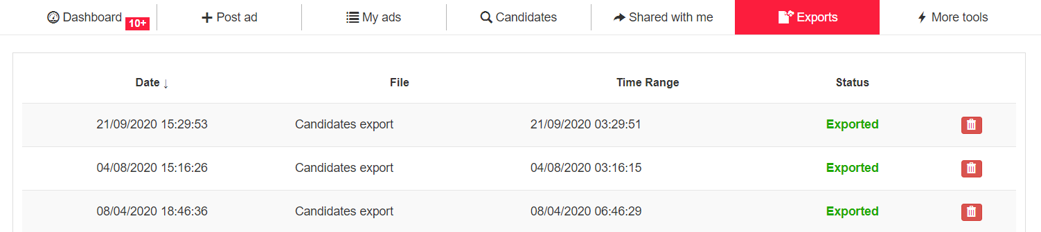

### 3.10. Candidate’s profile

By clicking on each candidate’s string, you can open the full profile, i.e., the profile containing all the candidate’s details as well as the history of the activities carried out by the employer and by the candidate himself/herself (test results, videos, etc.).

#### **Request buttons**

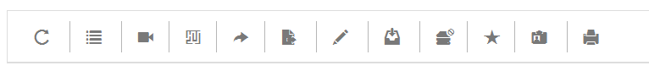

**Update request:** it is visible from 30 days after the date of last modification of the candidate's data. It allows you to send an email to the candidate inviting him/her to login to his/her personal area and update his/her data.

**GDPR log and portability**: in compliance with GDPR, the system makes it possible to view the logs relating to the activities carried out by candidates and employers on a candidate’s profile and to extract a file with the candidate’s data, in order to guarantee the right to data portability. Below are the log types available in this section:

CANDIDATE_ADD': registration of the candidate profile.

APPLY_LOGIN': apply to a job advertisement.

CANDIDATE_UPDATE_CV': update cv.

CANDIDATE_UPDATE_CL': update cover letter.

CANDIDATE_JOBTEST: performed job test

CANDIDATE_DELETE_CL': delete cover letter.

CANDIDATE_UPDATE_PHOTO': Update profile picture.

CANDIDATE_DELETE_PHOTO': delete profile picture.

CANDIDATE_LOGIN': Candidate login with username and password or autologin from mail.

CANDIDATE_UPDATE_LOGIN': change of login data.

CANDIDATE_UPDATE': Edit profile data (candidate table).

CANDIDATE_UPDATE_WORKER': Edit profile data (worker table).

CANDIDATE_DELETE': Logical deletion of the profile.

**Request video resume:** it allows you to send a video request by email. If the candidate answers, you will receive a notification via email, which will be visible in the candidate’s dashboard too. The recorded video will be stored in the section "Videos" of the candidate’s profile.

**Request tests:** it allows you to send a request for the job test, i.e., the soft skill test, and/or other tests requiring the purchase of credits.

**Share this candidate**: it allows you to share the candidate’s profile with colleagues registered in the system or with third parties.

**N.B.:** the candidate’s personal data, the tabs “Dashboard” and “Profile” are shared, including job offers to which the candidate has applied; documents are not shown.

The recipient will receive an email with a link to the list of shared profiles. He/she can actually view all the profiles shared with him/her. The list of shared profiles is organized based on the selection processes for which the profiles were shared. Such share actions are sorted chronologically from the most recent to the oldest one.

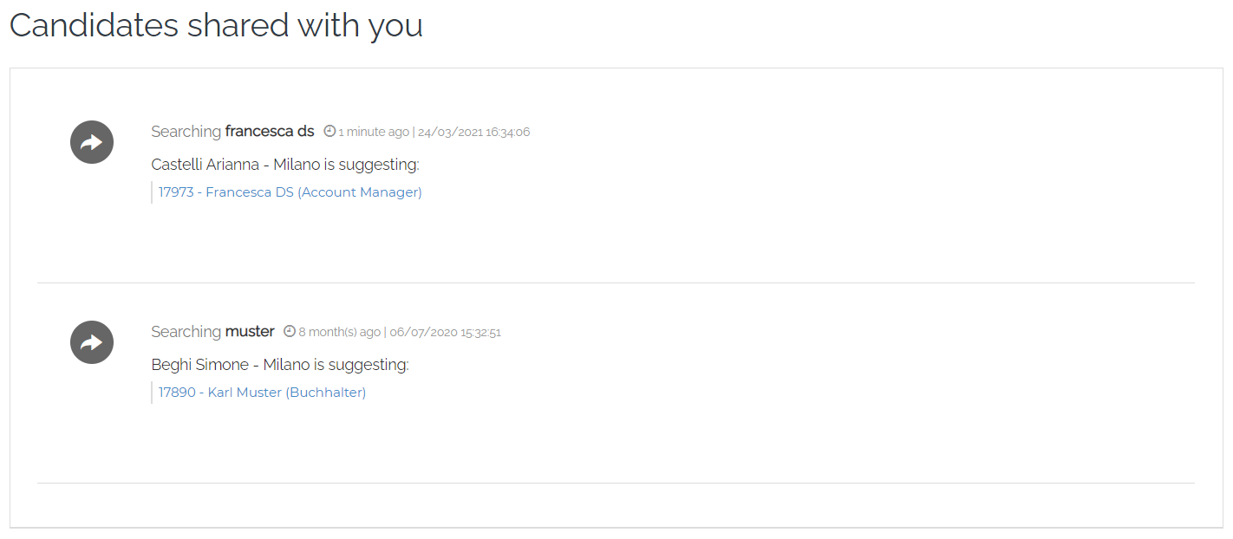

By clicking on each profile, the recipient can make a printout or leave his/her feedback. Such feedback is visible in the candidate’s profile > Activities > Feedback.

If some feedback is added, the employer to whom the job offer is assigned will receive both an email and a notification in his/her dashboard.

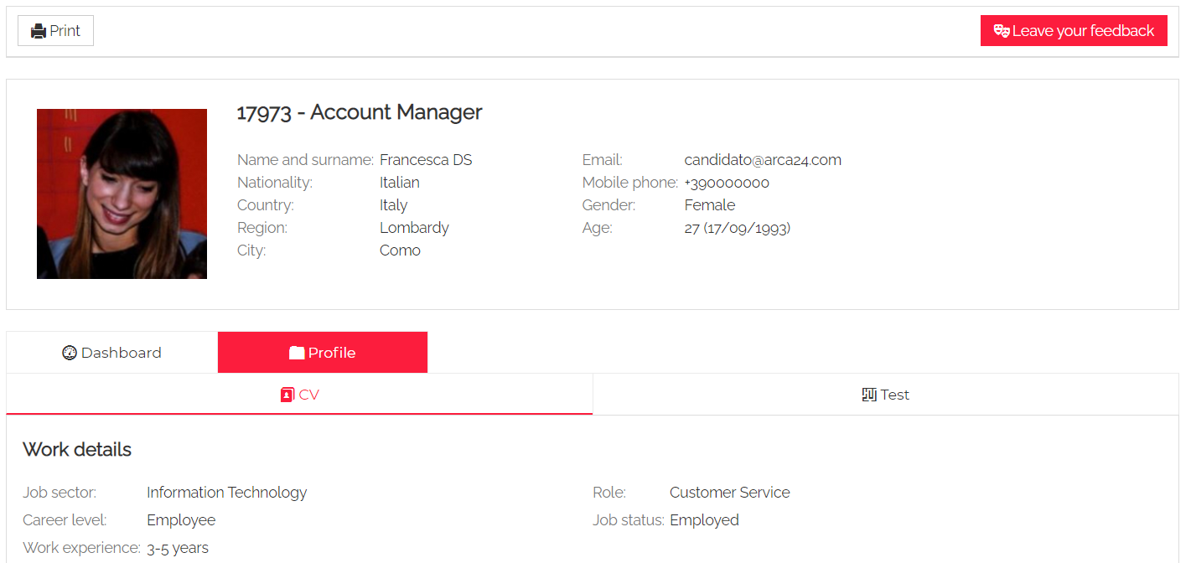

**Edit this candidate**: it allows you to edit the candidate’s data. If you want to edit details such as the candidate’s login credentials, the candidate’s CV as well as the professional tag extracted from the CV, you have to click on “Account management”.

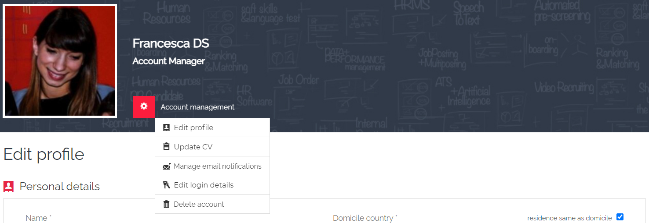

**Delete account:** it allows the deletion of the candidate’s profile by the employer.

In the case of candidates with contracts, it is **logical deletion**, i.e., the candidate no longer receives emails or accesses his/her personal area (he/she can re-register to the portal with the same data). The employer can no longer carry out activities on the candidate’s profile. However, the data are still visible to the employer.

In the case of candidates without contracts, such **deletion is physical**, i.e., the candidate’s data are completely deleted and can no longer be recovered.

In order to physically delete a profile with contracts, you should delete all the contracts first, then delete the profile.

If you proceed directly to deletion, without removing the contracts, only logical deletion can be carried out. However, you can physically delete the profile using the following button:

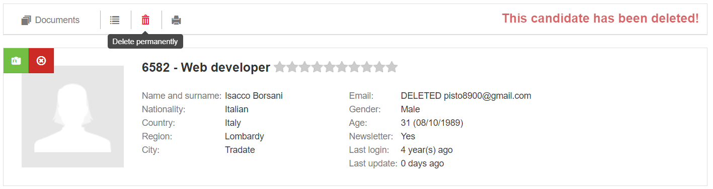

Via the Restore button, it is possible, for Admins only, to restore the logically deleted candidate:

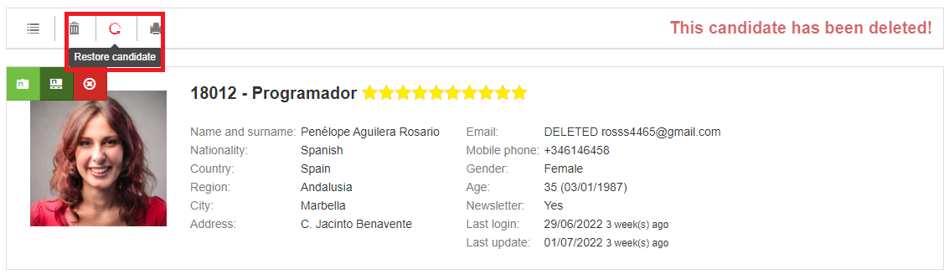

A popup will remind you that once the candidate has been reset, you must **reset an access password** and communicate it to the candidate. The candidate would be then active again and labelled 'Interviewed'

**Include in a selection process:** it allows you to manually move a candidate to another a selection process (including both online and offline job ads or saved searches). This is possible by selecting the colleague to whom the job ad and the related process were assigned. When you manually add a candidate into a job ad, the profile will be inserted in the recruitment step among the registered and possibly compatible candidates. As for saved searches, the candidate will be inserted directly into the interview step. The field to select the target job offer allows both to view a dropdown with the most recent job offers and to search by keyword, so that the search is fast and precise.

**Mark as relevant/irrelevant:** the mark indicates a candidate who should not be taken into consideration for any selection process (when setting up, you can choose whether to set an end date or not). At any time, by clicking the button again, you can reset the candidate as relevant. The irrelevant candidate is marked with an icon and can be hidden among the matching candidates by using the specific filter.

**Label as highlighted:** it allows you to mark a profile as highlighted. The flag indicates a candidate who can be very interesting. The flag can be removed at any time by clicking on the button. That is linked to a filter in the matching candidates that allows you to display only the candidates that are highlighted within a process.

**Hire:** it allows you to mark a candidate as hired.

**Print**: it allows you to print the candidate’s profile.

#### **Status labels**

These are labels that identify the candidate status based on the activities carried out by employers. By default, the labels automatically change according to the activities/contracts entered on the candidate's profile.

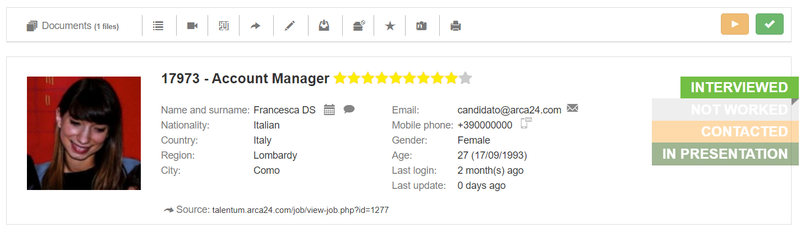

The labels change automatically according to the following rules:

**Not worked**: it is the standard status, where no activity has ever been entered.

**Contacted**: after sending an e-mail from the envelope or entering the activity "Telephone interview".

**Interviewed**: when entering face-to-face interview activities (first/second/third interview/Interview with the company) or adding an evaluation in the evaluation tab.

**In presentation:** this label follows the submission of a candidate’s summary.

**Hired**: it appears when the button "Hire" is used. **N.B.:** if the button "Fire" is used, the candidate's label will be changed again into the interviewed status, even if no interview/contact activities were entered.

**Onboarding:** the candidate has a contract associated with him/her whose start date is later than the current date. **N.B.**: only for software versions linked to administrative management systems or which use the internal administration mode or have a module for employment allowing contract dates to be entered.

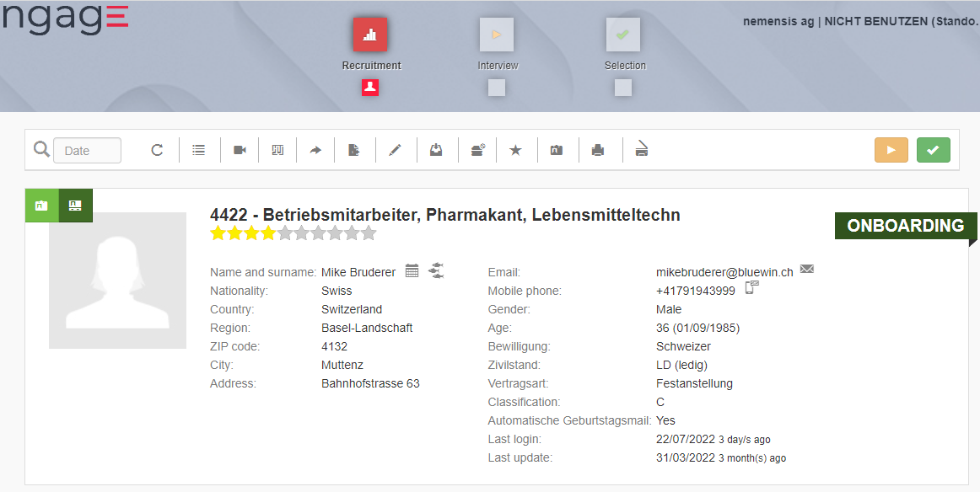

**N.B.:** labels are temporary, with the exception of the label "Hired", which depends on the expiry and the elimination of the contract/dismissal): one month after entering the activity/data that determined its change, the label reverts to the previous status. The reversion always stops at the label "Contacted"; it never goes back to "Not worked".

**Adding activities**

From the calendar icon, it is possible to enter activities related to the candidate (see the section “Agenda” for further details).

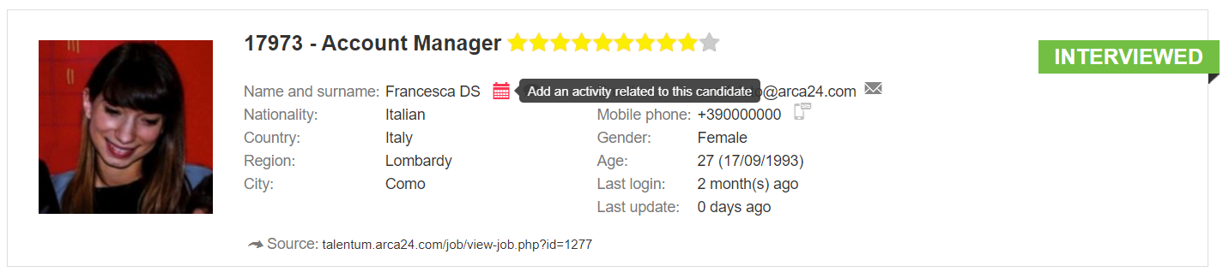

#### **Contacting the candidate from the system**

**Via email**: the employer can send an email directly to the address registered on the candidate. If a candidate replies to this email, the reply is sent directly to the address of the employer who sent the email.

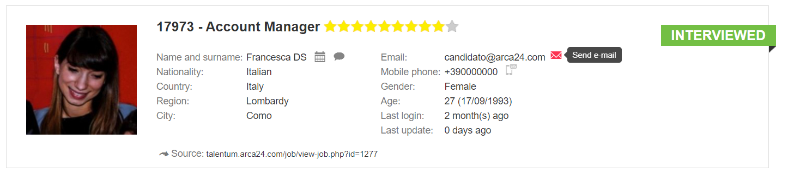

**Via SMS (OPTIONAL MODULE*):** the employer can send an SMS to the candidate (the recipient cannot reply to the message).

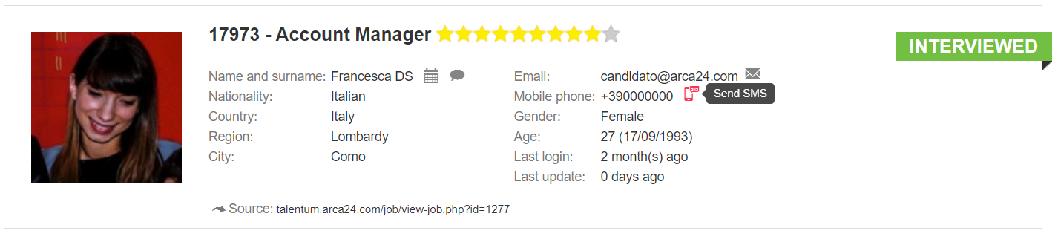

**Real-time communication (OPTIONAL MODULE*):** the cloud icon allows the employer to contact the candidate when the candidate is logged into his/her personal area and to initiate a chat or (video) call. Such activities will be recorded in the candidate’s activity tab.

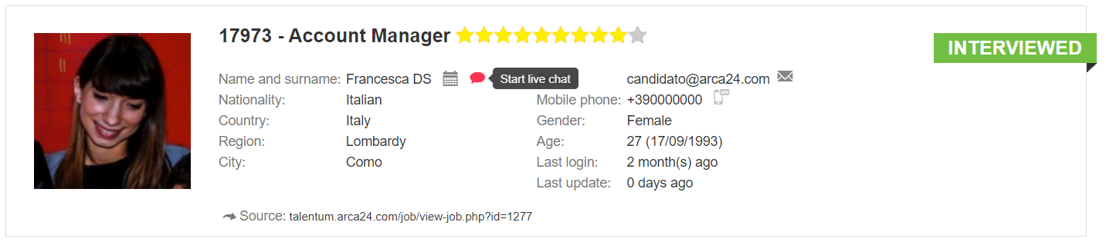

**Competitors (OPTIONAL MODULE*):**

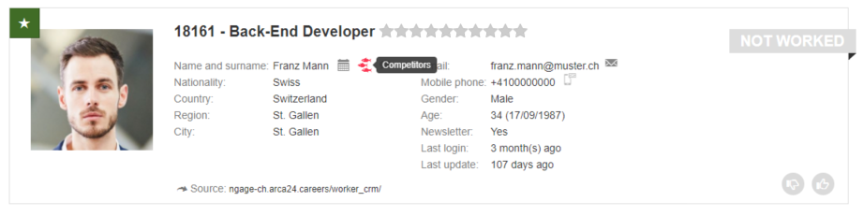

By clicking on the icon “Competitors”, it is possible to fill in some information about activities on competitors that relate to the candidate, e.g., whether he/she has already been contacted by another staffing agency for a specific job offer. It is also possible to select the system user who is to be notified of this information.

The employer who entered these data can then edit or delete them at any time. Data on competitors is saved in the "Competitors" tab and can be filtered by date range, competitor, role, company, site and employer.

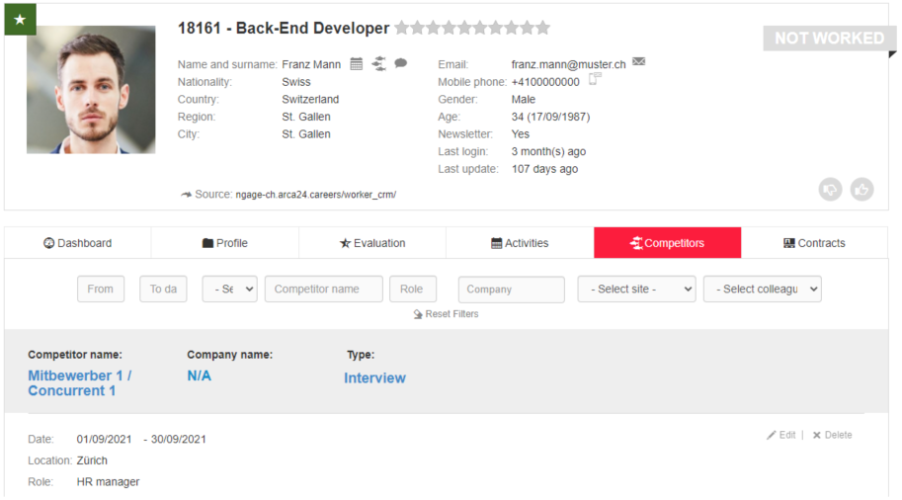

#### **TAB Dashboard**

This tab shows the following details about the candidate's experience:

* Professional tags automatically extracted from the semantic tool (by clicking on the button “Add”, you will be redirected to the page where you can update the candidate’s CV and manage the tags);
* Work experience timeline (work experiences and training path);
* Number of work experiences;
* Working years;
* Number of jobs changed (in the last 5 and 2 years).

**N.B.:** The data is read and calculated based on the candidate's CV extraction as well as candidate’s personal data.

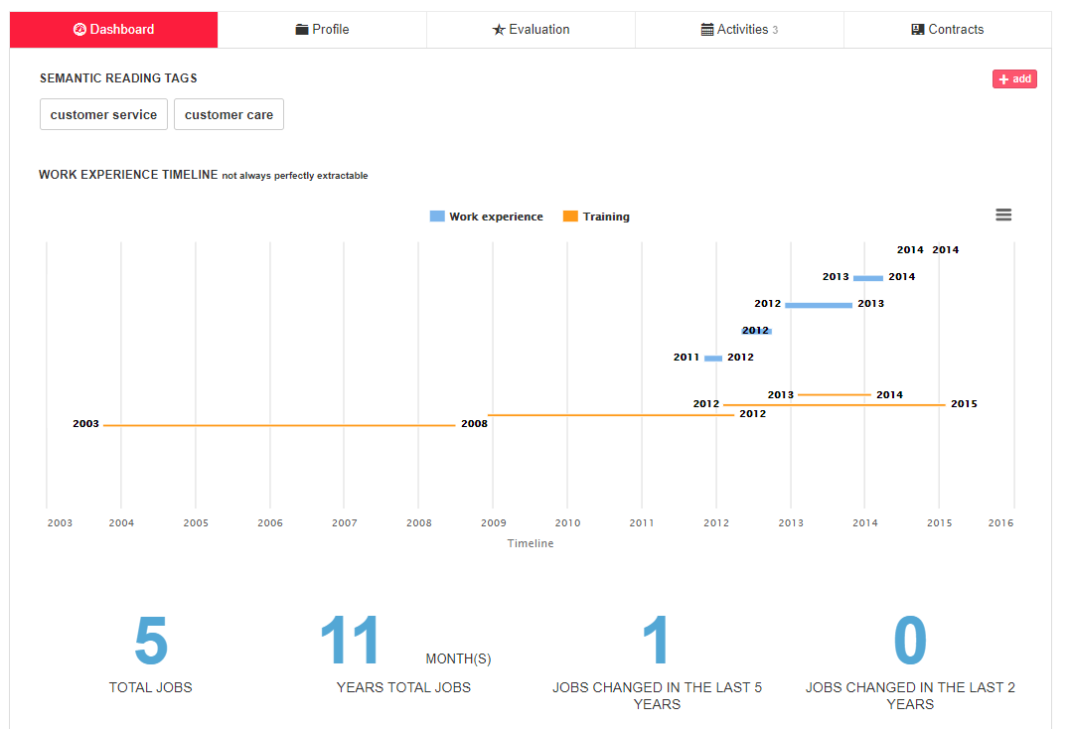

#### **TAB Profile**

**CV:** In this section, the following data are visible: the list of job advertisements to which the candidate has applied, job details, language and education, the analysed CV, the candidate's original CV.

The section ‘Candidate applied to the following job ads’ shows the offers (distinguishing between online and offline) to which the candidate has applied, and shows the origin of the application. Clicking ‘all candidates’ opens the page of candidates compatible with the ad.

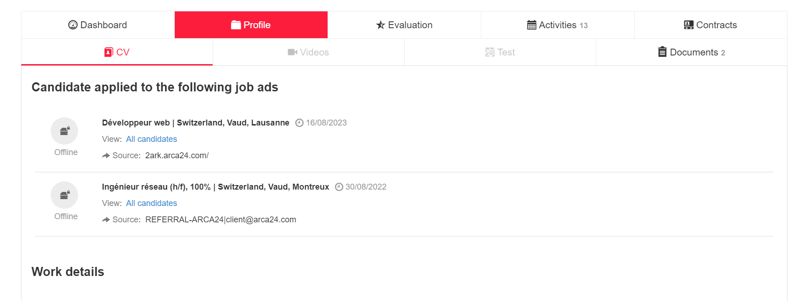

The CV parser analyzes the candidate's CV and divides it into sections:

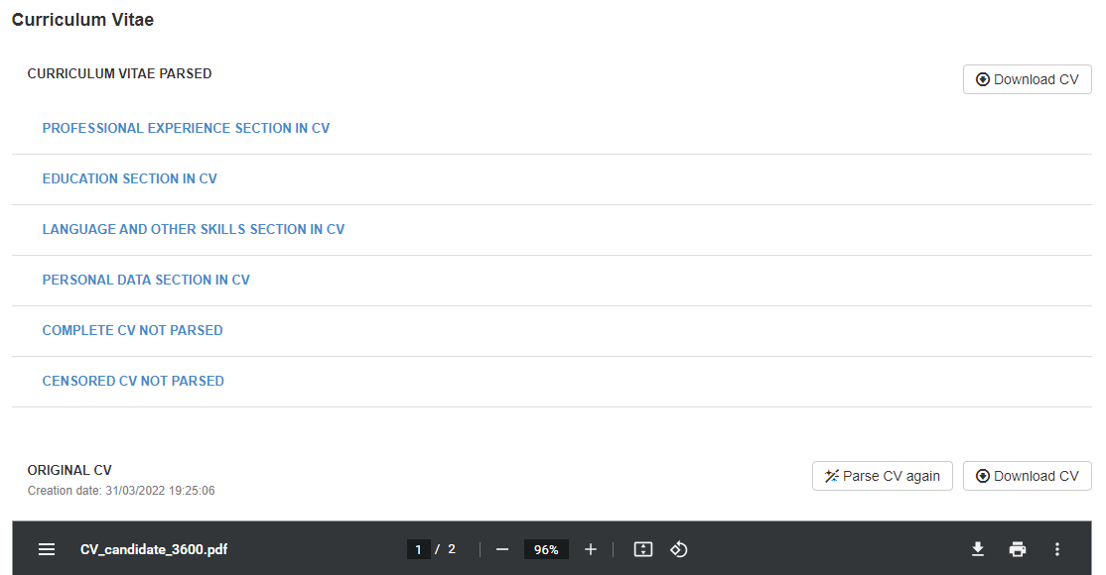

Moreover, it is possible to view the following sections: **COMPLETE CV NOT PARSED** and **CENSORED CV NOT PARSED.** These are two image versions of the CV that can be edited manually in a similar way to a graphics programme.

The two versions have a button on the right, called “Edit mode”. Once clicked, it displays some functions within the document image.

• The **pen** function allows you to enter some comments directly within the CV document. Once you have clicked on the pen, click on the position where you want to add a note and type the text in the box that opens; save the entered text with the button below:

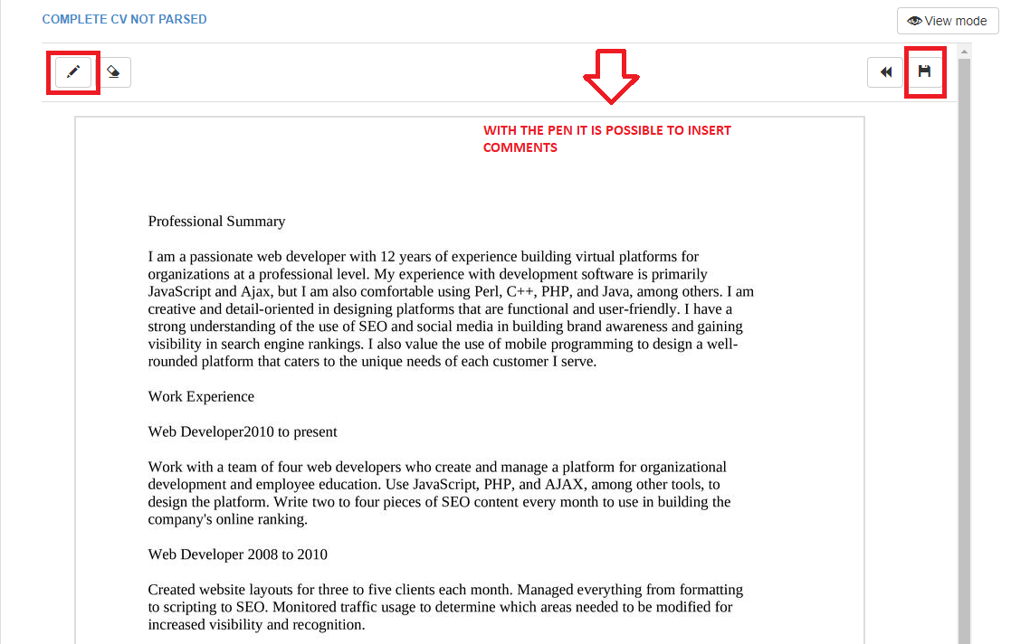

• The “**rubber”** button allows the deletion of parts of the text:

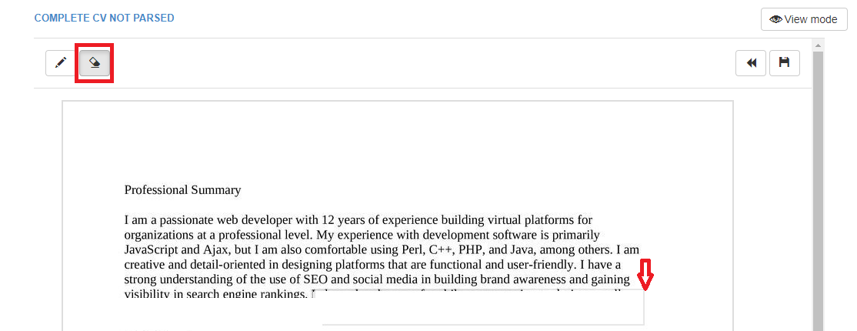

• The two buttons on the right, “**back”** and “**save”**, allow you to undo the changes made and save the final edited version:  
  
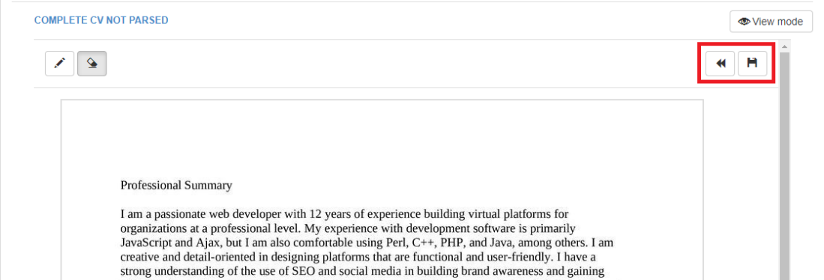

• By clicking on the button on the top right, **View mode**, you go back to the original version of the document.

In the section **CENSORED CV NOT PARSED** certain parts of the CV are automatically censored, but there are two further buttons.

* The **censor** button allows you to blur further sections of text in the image:

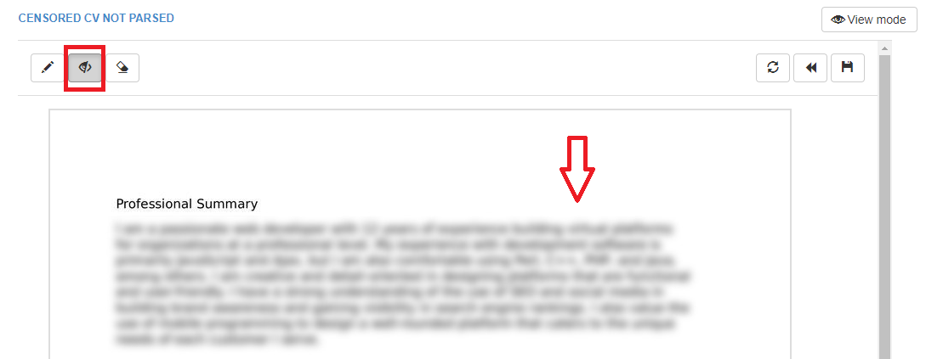

* The following button allows you to undo the automatic censoring of personal data from the CV image and re-start the changes:

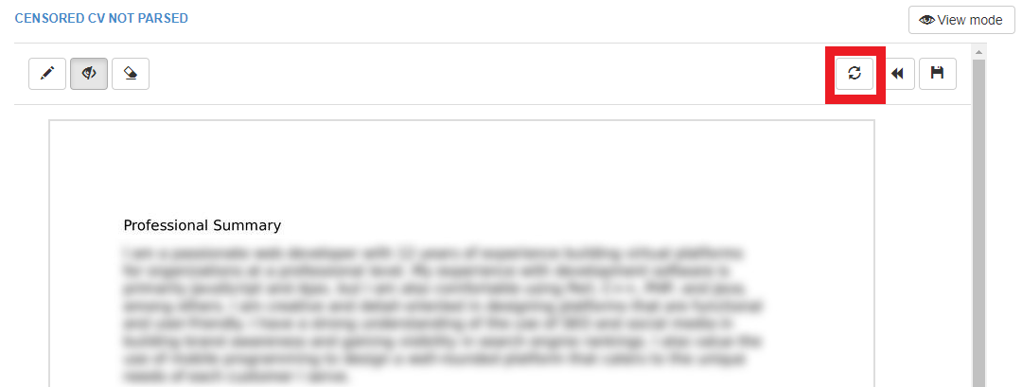

This possibility of editing is only available within the candidate’s profile, because it is a very sensitive modification, which will then be visible in the candidate’s summary too, if you choose the flags "hide personal details" and "show original CV" (which should be the one censored automatically):

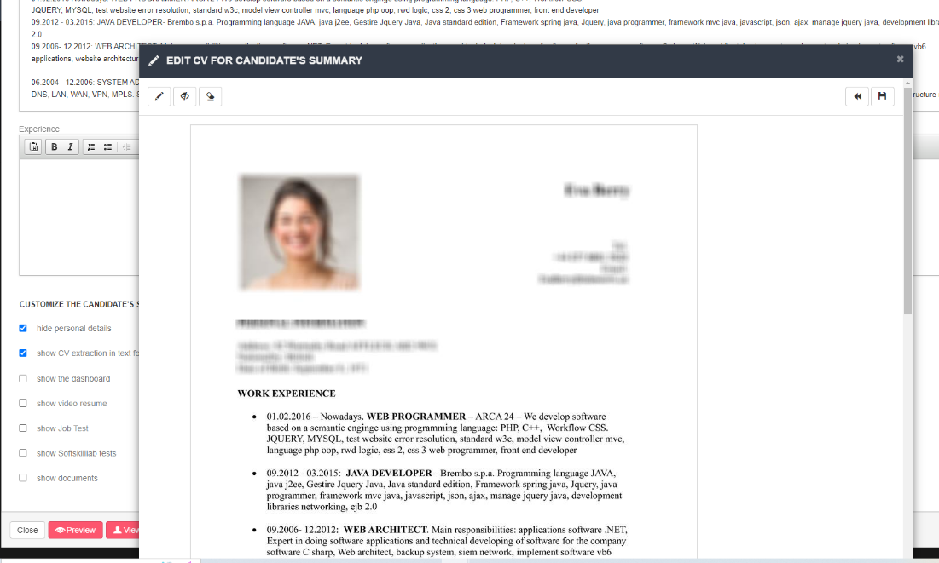

If no CV was entered at the time of candidate’s registration (e.g., applications from some external portals/candidates entered manually) a CV in .txt format is automatically generated with the information available. The CV creation procedure takes place automatically every night.

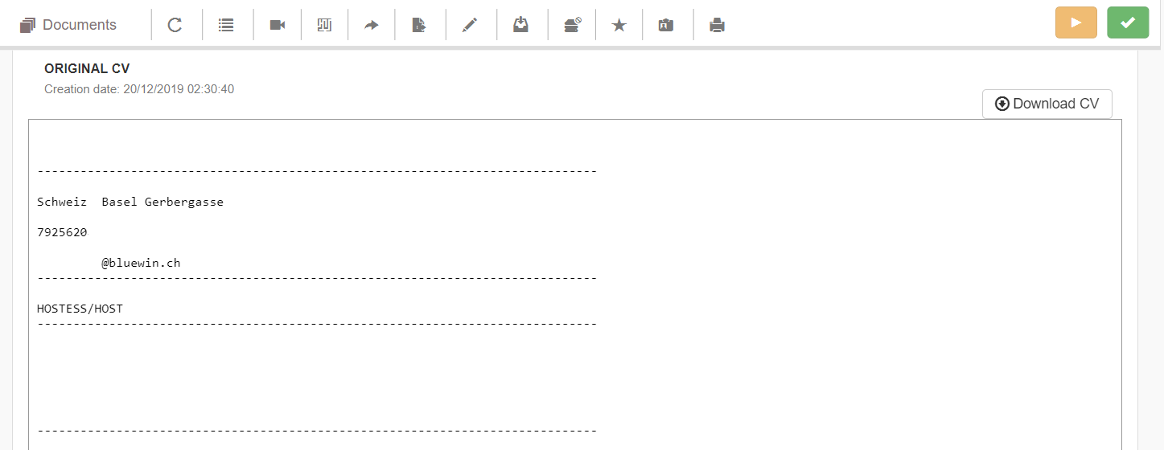

**Videos**: in this section, you can watch all videos, both video resumes and interviews, recorded by the candidate.

**Test**: it shows the results of the tests (e.g., language tests, job tests, questionnaires) carried out by the candidate.

**Documents:** section for managing documents related to the candidate, which can be uploaded by the candidate in his/her personal area or by an employer.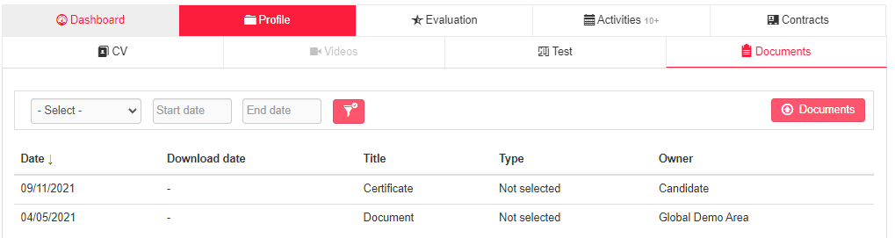

You can upload, download and update the file title and/or description. The maximum size allowed is 2MB.

The flag "Visible in the personal area" allows you to decide whether or not to make the document visible to the candidate.

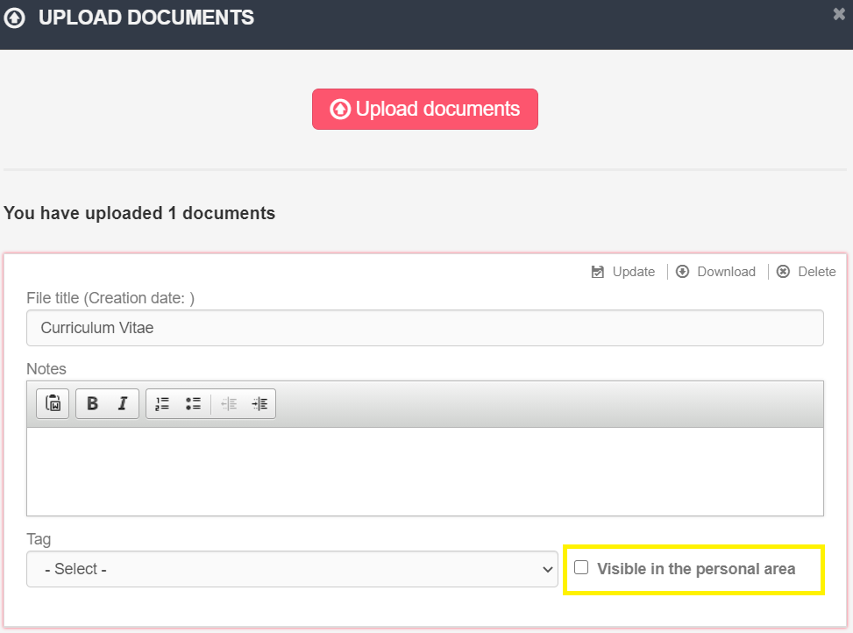

#### **TAB Evaluation**

Section in which it is possible to add evaluations and assessments of the candidate.

**Rating:** evaluation expressed on a scale of 1 to 10. One's own rating is averaged with the ratings entered by colleagues.

**Assign to a site/division/department (OPTIONAL MODULE*):** it allows you to determine where you plan to employ the candidate; a maximum of 3 settings can be expressed.

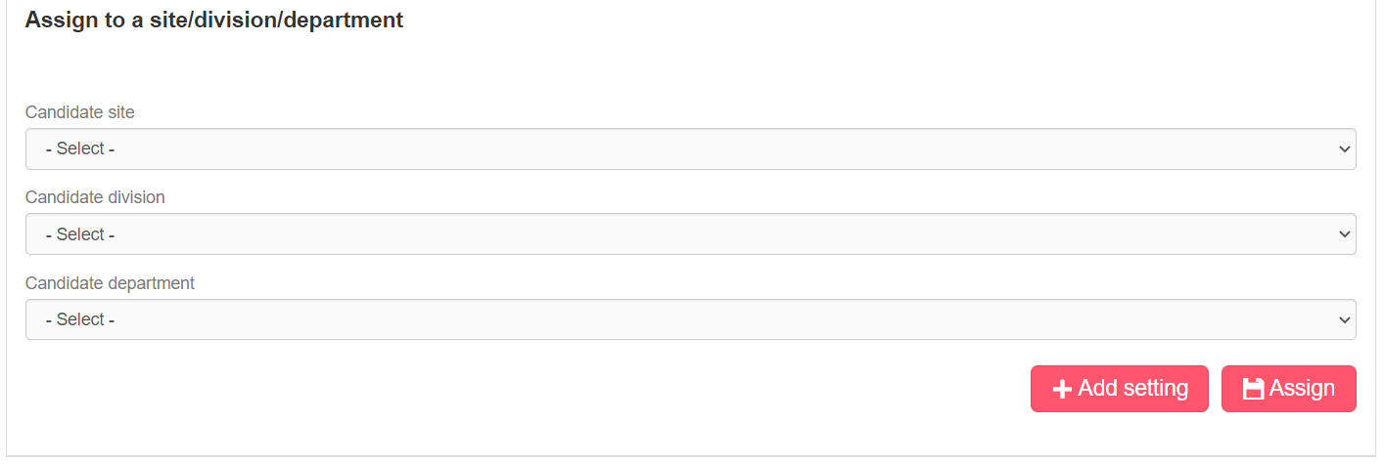

**Candidate evaluation form:** the evaluation form can be set and customized by the system administrator in the account management section. Each time an employer enters an evaluation, it is automatically saved into the evaluation history, a button which is generated when the first evaluation is entered.

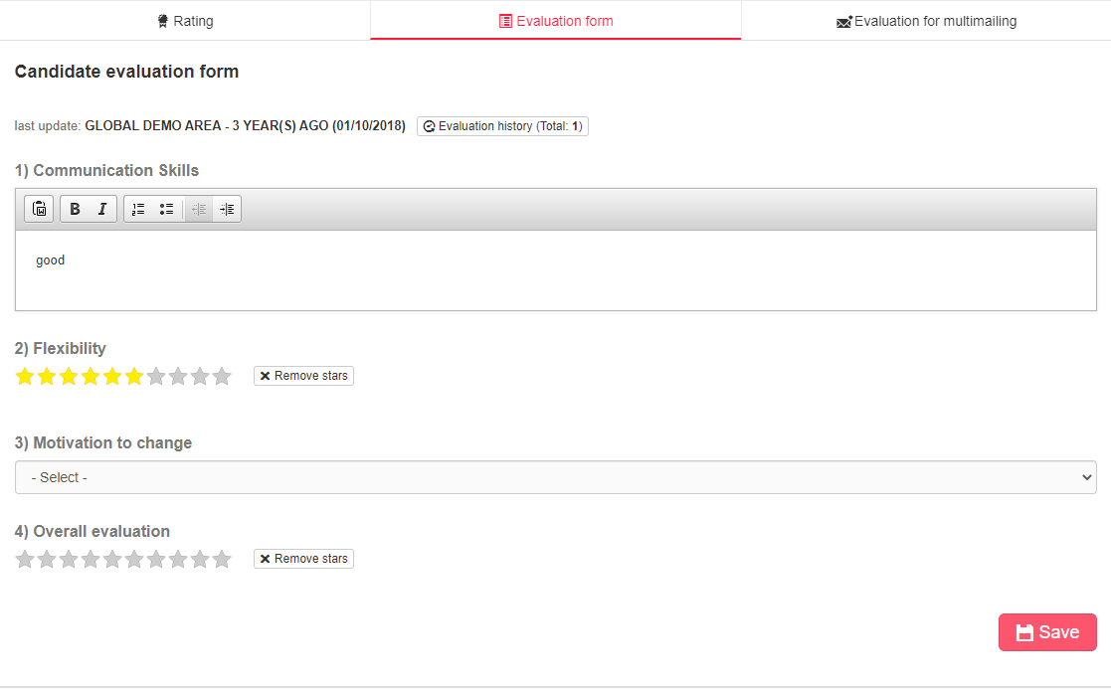

**Evaluation for multimailing (OPTIONAL MODULE*)**: section to be filled in for sending candidates’ profiles through mailing lists.

#### **TAB Activities**

##### *Activities*

Section displaying the history of activities carried out with and on the candidate. The sorting of activities takes into account the activity starting date, with reference to manual activities.

**Filters**

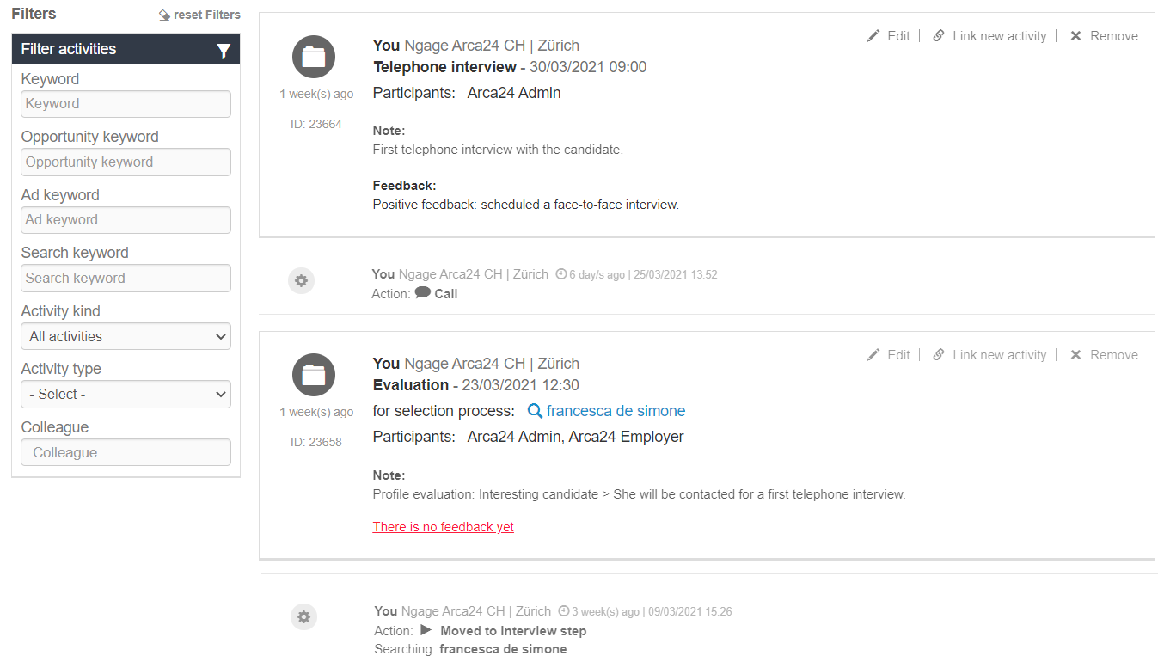

**Keyword:** it allows you to search for a word in the text of both automatic and manual activities; as for the manual ones, it searches in the comment and feedback boxes.

**Opportunity keyword:** it allows you to search for all activities related to a given opportunity. The search is carried out in the field "By opportunity" in the manual activities entered from selection processes related to an opportunity.

**Ad keyword:** it allows you to search for all activities related to a given job ad. This filter searches in the field “For selection process” in the manual activities entered from a job ad and in that of “Searching” in the automatic activities. Moreover, it allows you to search in the text of the job advert.

**Search keyword:** it allows you to search for all activities related to a given database search. This filter searches in the field “For selection process” in the manual activities entered from a database search and in that of “Searching” in the automatic activities.

**Activity kind**: it allows you to filter by chat, i.e., activities related to 2chat, real-time messaging, call and video call system (*OPTIONAL MODULE), automatic or manual activities.

**Automatic activities**

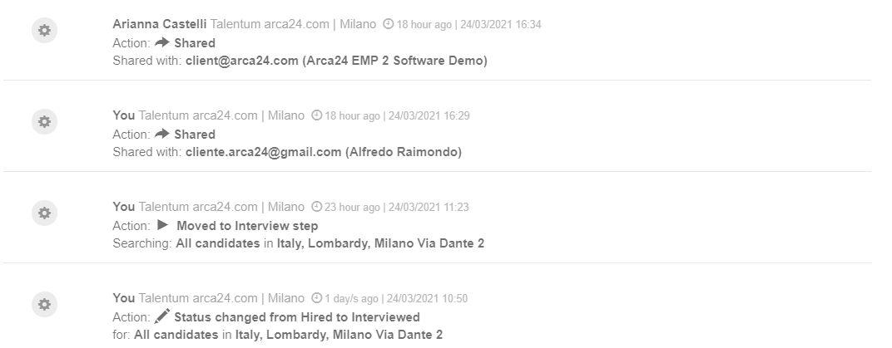

Automatic activities are those identified by a gear icon. These are logs automatically recorded by the system and generated by actions carried out by the employer (e.g., moving through the recruiting steps, requests for tests, videos, etc.).

**Manual activities**

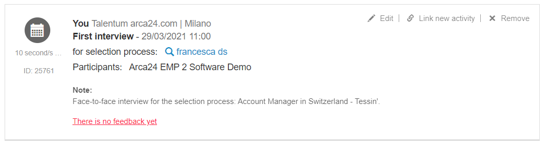

Manual activities are those identified by a folder icon. They are recorded by the employers from their agenda or directly from the candidate’s profile.

**N.B.**: in order to track the selection process in which the manual activity is included, it is necessary to open the candidate's profile **directly from the process** (database search or job ad) **to which the activity relates**.

As for the manual activities, the following options are available:

**Edit.** You can edit **your activities** but not those of other employers.

**Link new activity:** It allows an activity to be linked to a new activity. Several activities can be linked to each activity, but an activity C cannot be linked to an activity B already linked to an activity A: there is only one level of linking.

**Remove.** You can delete **your activities** but not those of other employers.

**Activity type.** It allows you to filter by type of manual activity (e.g., first interview, second interview, etc.) as well as by automatic activity of candidate’s summary sending.

**Colleague.** Itallows you to filter by the colleague who added the activity.

##### *Feedback*

Section displaying feedback from recipients who received shared candidates’ profiles and candidates’ summaries.

It is even possible to enter some feedback manually, by using the button “Add feedback”:

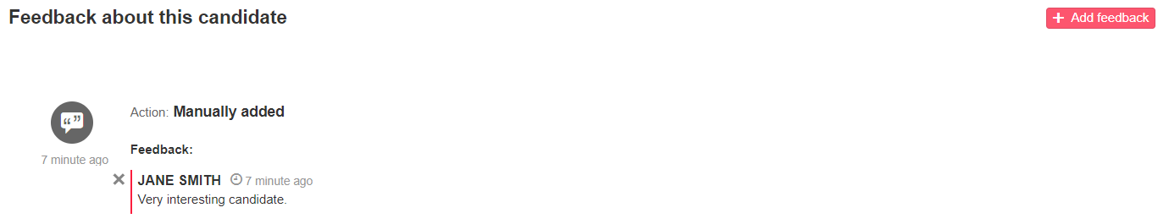

**Contracts** *(OPTIONAL MODULE*)*

In this section, you can view and manage all contracts linked to the candidate’s profile.

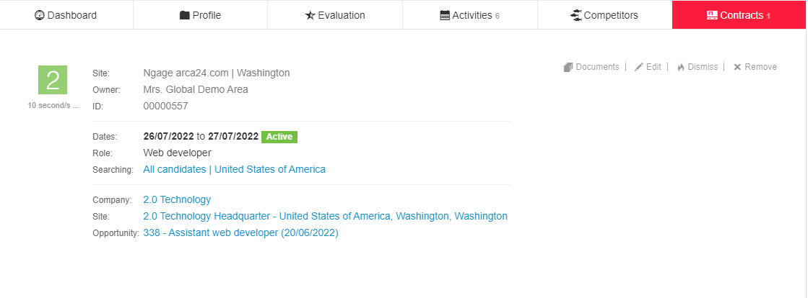

It is possible to attach documents related to the contract, modify the details or delete the contract. Furthermore, it is possible to dismiss the candidate; in this way, the current date is shown on the date of termination of the contract and the profile will result as an ex-worker.

### 3.11. More tools

**Search in JobArch**

JobArch is a software developed and owned by Arca24 providing an external candidate database, which is useful for searching for further profiles.

It is possible to publish job adverts or carry out searches on JobArch, in the same way as in Ngage, and to import candidates via the button "import".

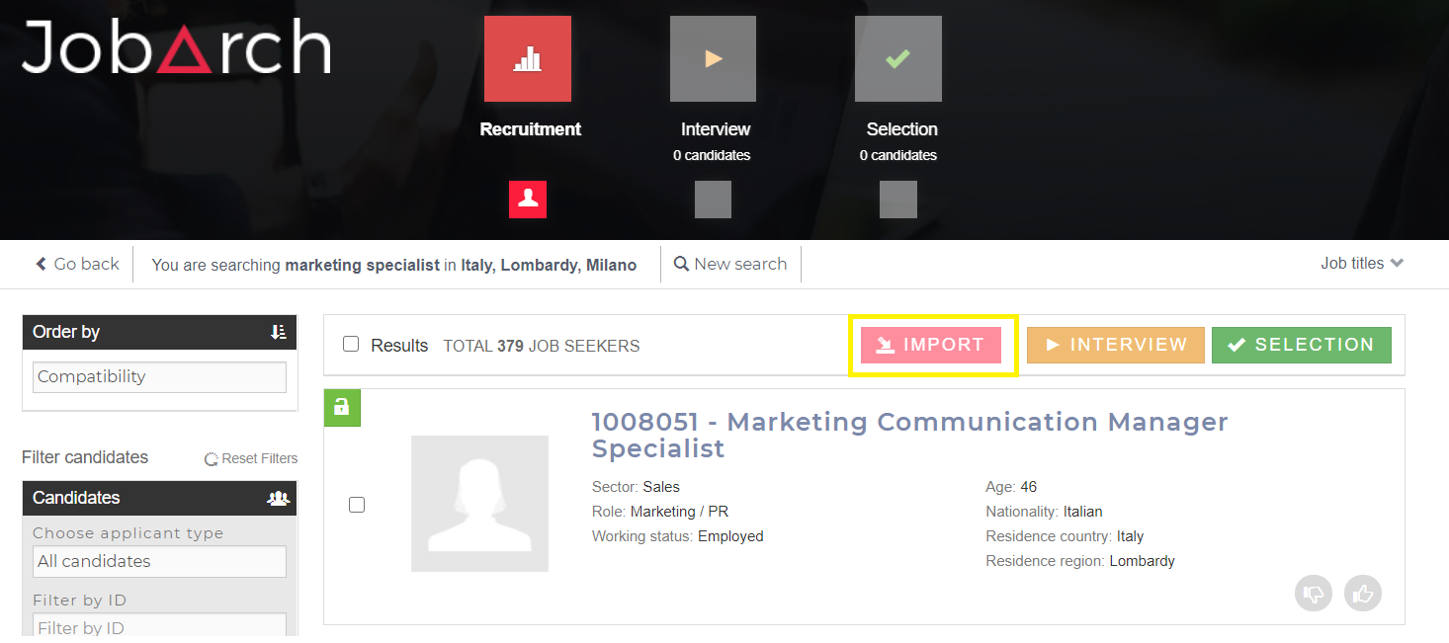

For further details see the handbook NGAGE - JobArch – en.

**CVideo**

**N.B.:** In order to access CVideo sessions, it is necessary to enable the user's permission in the section “Permissions management”.

For more details on the integration, see the handbook NGAGE - ExaminLab CVideo SoftSkillLab – en.

**ExaminLab**

**N.B.:** In order to access ExaminLab sessions, it is necessary to enable the user's permission in the section “Permissions management”.

For more details on the integration, see the handbook NGAGE - ExaminLab CVideo SoftSkillLab – en.

**SoftSkillLab**

**N.B.:** In order to access the SoftSkillLab sessions, it is necessary to enable the user's permission in the section “Permissions management”.

For more details on the integration, see the handbook NGAGE - ExaminLab CVideo SoftSkillLab – en.

## MODULE “CLIENTS”

### Dashboard

**Quick search bar:** In all sections of the module “Clients”, you can use the search bar at the top of the page. This is a keyword search in the company database: it searches for the word in both the company name and in that of the contact person.

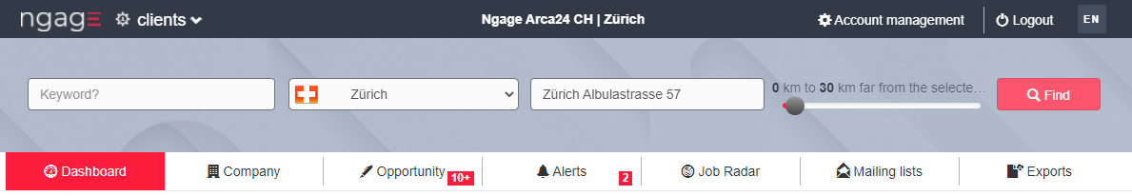

**Dashboard:** in this section you can get an overview of the company database as well as the opportunities and the pipeline. Depending on the filters (date, country and reference site), you can set the parameters for displaying the data. If a site is selected, its address is the starting point of the kilometer radius.

As an alternative, by selecting the flag “only the clients of the site”, it is possible to view data on companies **assigned** to a given site, regardless of the location. To see the details of all the companies in the database, you only need to choose “Select” in the menu “Companies' country” and “All” in the menu “Site”.

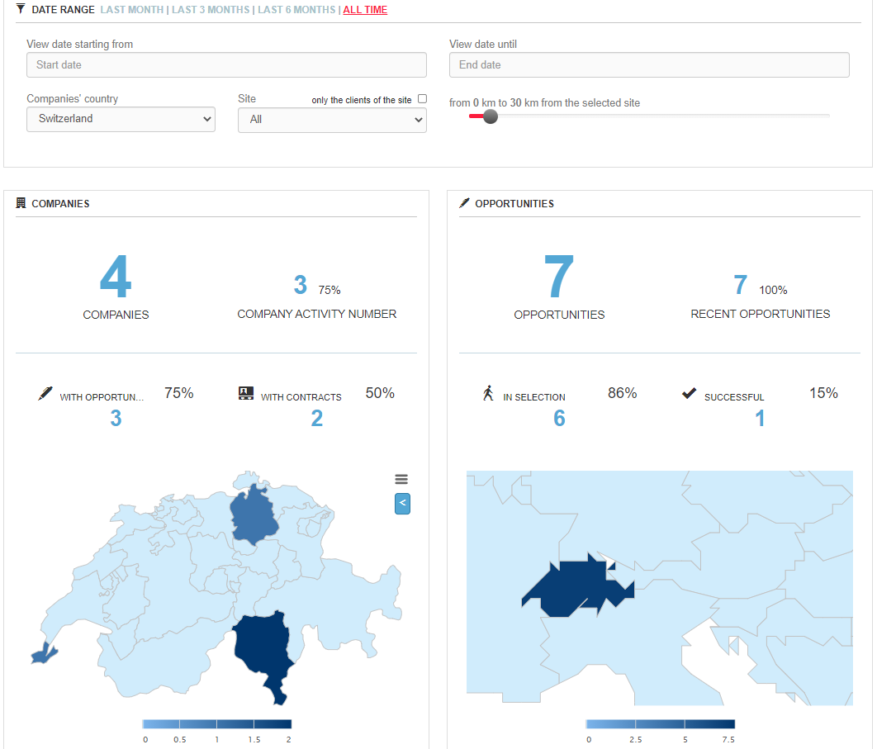

The example above shows all the companies in the database.

There are 4 companies for which 3 activities, 3 opportunities and 2 contracts have been entered; the map below shows the location of these companies (divided by country and region).

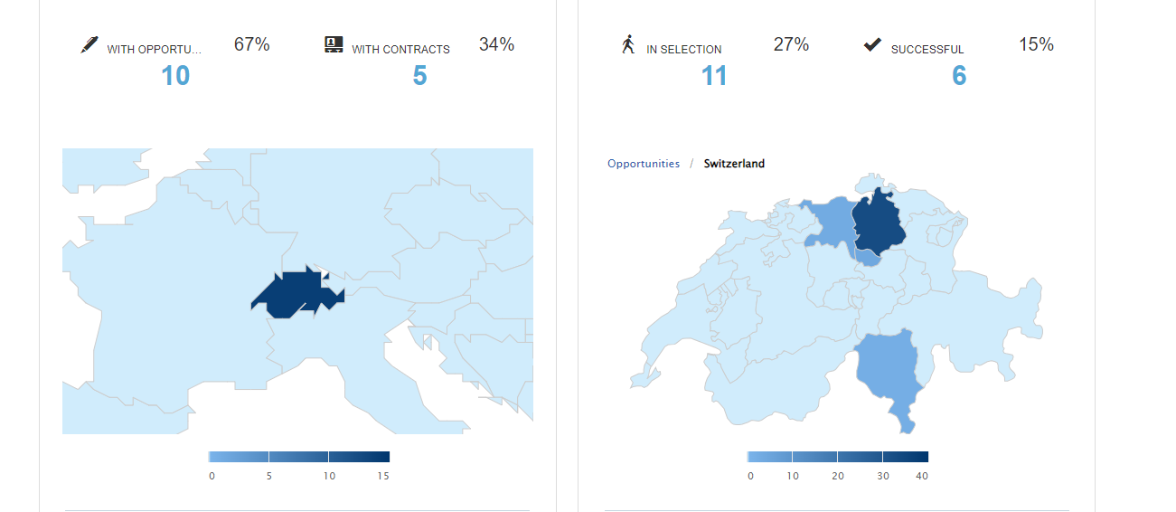

The opportunities entered, regardless of the assignment of the companies, are 7, of which 7 are recent (6 months from the current date or 6 months from the end date entered in the filter are taken into account for this data), 6 in the status “In selection” and 1 was successfully closed; the map below shows the location of these opportunities (divided by country and region).  
The other reports here show the details of the companies’ status and sectors as well as the type of service per each opportunity and the hit rate, i.e., the ratio between open and successfully closed orders:

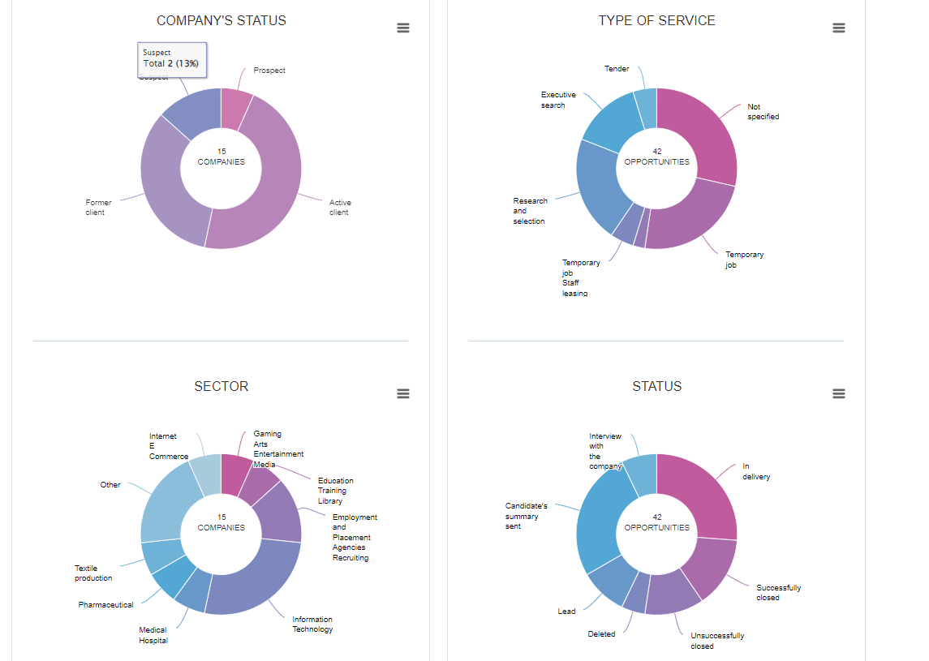

At the bottom of the page the pipeline is shown: in the first graph, the monthly report illustrates the trend of opportunities with the ratio of opportunities opened and successfully closed, while in the second one the incremental value over the year (value=expected value*success rate).

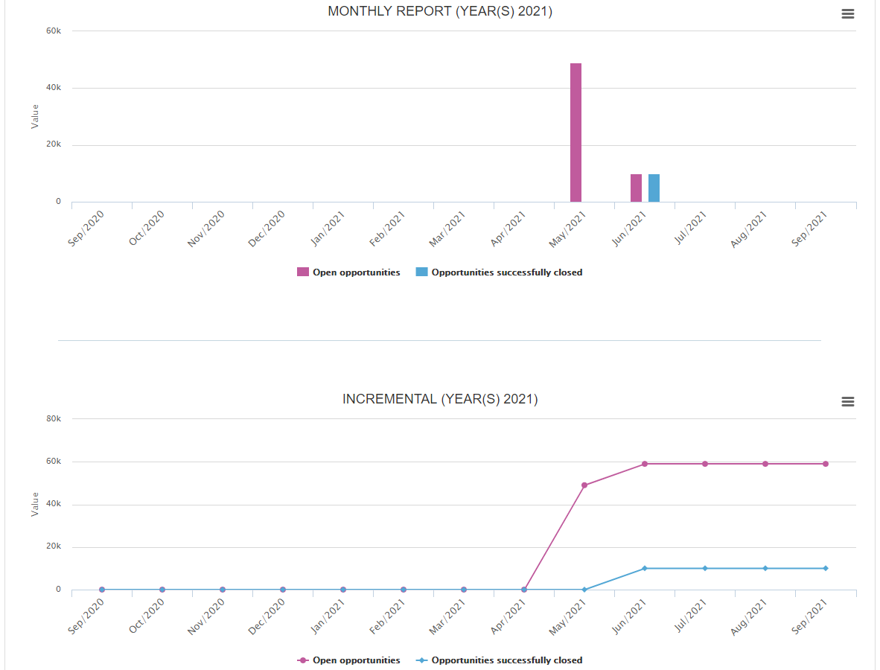

### Company

#### Updates

All changes to the company profile (on status, leads, company details, ratings and training) are listed in this section. Updates can be filtered by site, colleague and date range.

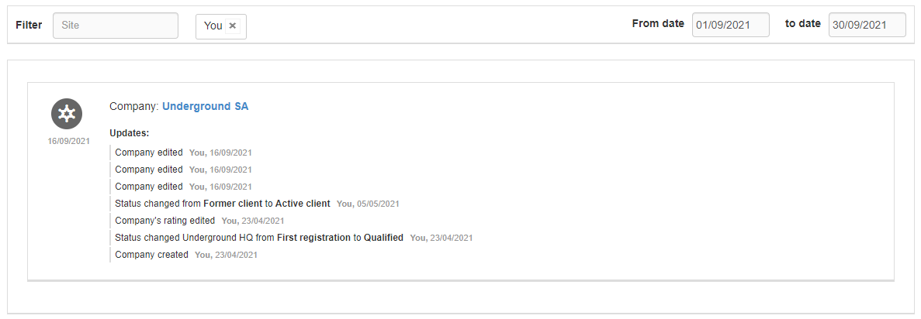

#### Last seen companies

The last 20 open company profile are here displayed. You can click on the company name of the displayed preview to open the company profile.

#### New company

It is possible to add a new company manually by entering the mandatory fields of the data indicated with *.

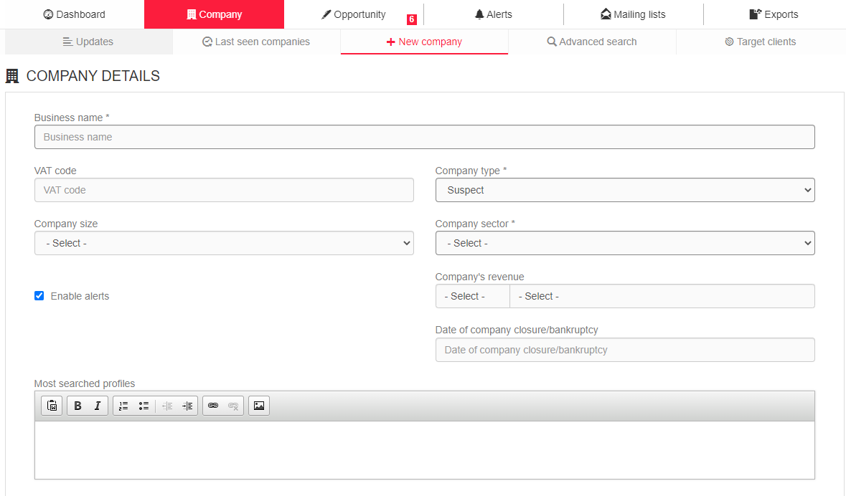

Here the details of some of the client form fields:

**VAT code:** this field enables the insertion of the company VAT code.

**Company type:** this field is used for status labels. Like the candidate labels, they can be edited manually but also change automatically based on the following rules:

Suspect -> company without any opportunities or contracts;

Prospect -> company when entering the first opportunity;

Active client -> company when creating the first contract;

Former client -> company when the last contract expires.

**Company revenue:** this field is locked if the rating tab is active; the data must therefore be filled in from the tab “Rating” in the company profile. Alternatively, it can be filled in manually.

**Company size:** filter to define the size of the company based on the number of employees.

**Date of company closure/bankruptcy:** field in which to enter the date of closure/bankruptcy of the customer, if any. If the date entered is later than the date on which the data is recorded, the tab appears greyed out (obscured) in the customer search when the flag 'Include closed/bankrupt companies' is used in the side filters.

**Enable alerts:** this field allows you to receive notifications from the “Alerts” reminding you how long it has been since you have entered an activity on the company (their default frequency is every three months).

**Most searched profiles**: this filter allows you to enter the profiles most frequently searched for by the company. Within the filter for exact word, in the search filters, you can search for one or more of the job roles you have entered.

**Email**: in this field it is possible to add a **generic e-mail address** and mark the flag “Newsletter to the company email address” to enable multimailing on it.

**Noga code (for Swiss software versions only):** token input drop-down list; by typing a part of the definition or a digit of the code to be entered, the system suggests the complete entry.

**Group**: customizable drop-down menu in the section “Account management” > “Management setup” > “Dropdown management” to define a specific group of companies this company belongs to.

**Mailing list tag**: customizable drop-down menu in the section “Account management” > “Management setup” > “Dropdown management” to create lists of companies to be used as recipients for the mailing list.

**Assigned site/colleague**: field used to indicate the primary ownership of the company, by attributing it to a specific site and colleague. All users of the system can still work on the client profile, if permissions allow.

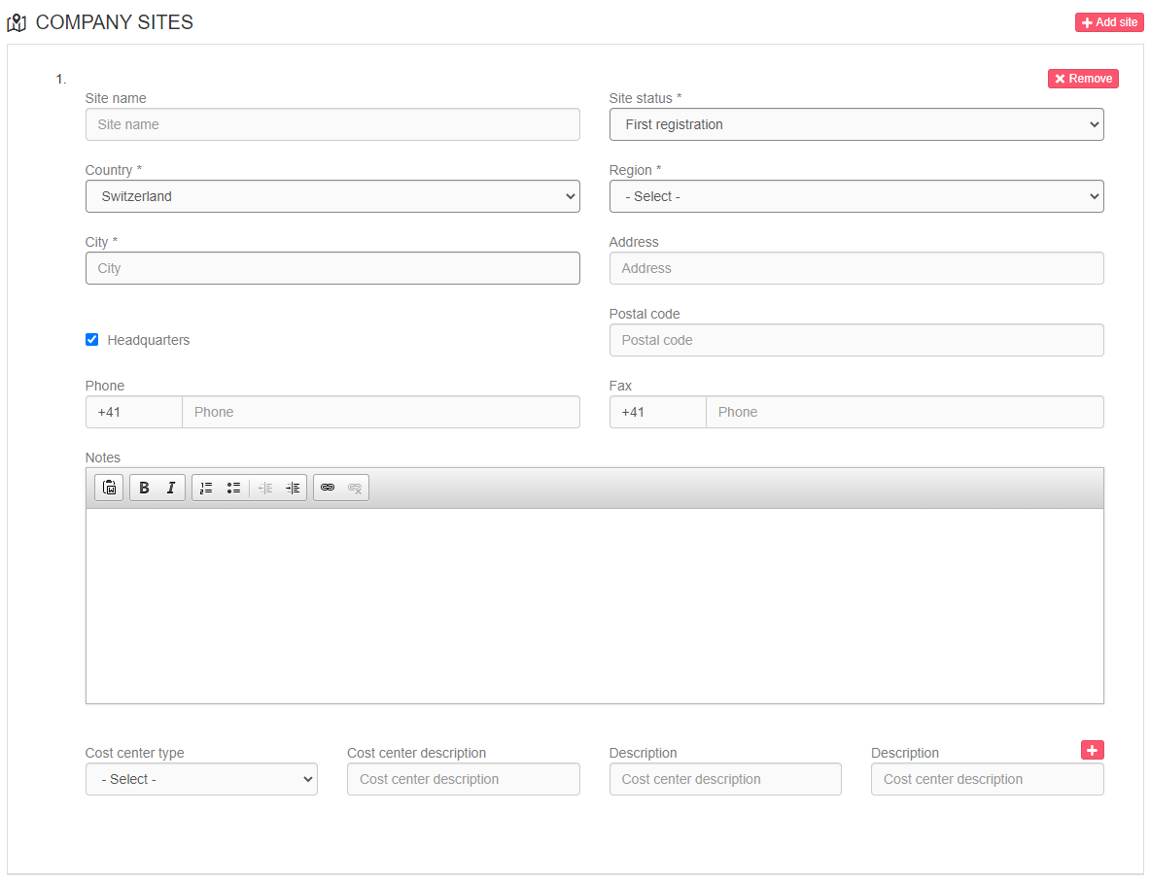

When creating a company, it is compulsory to add at least one company site.

**Site name**: this field is used to give a specific name to a company site, in the case of a multi-site company (e.g., administrative, logistics, production site).

**Site status**: the site status changes automatically based on different actions:

**First registration**: initial status of the registered site;

**Qualified**: status of a site to which at least one contact person has been added;

**Open opportunities**: status of a site with at least one open opportunity;

**Candidate’s summary sent**: status of a site with a linked opportunity from which a candidate’s summary has been sent;

**Interview with the company**: status of a site with linked opportunities, within which an activity of type "Interview with the company" has been entered on a candidate;

**Former client**: status of a site appearing at the expiry of the last contract concluded on the site.

**Headquarters:** the first company site entered is automatically flagged as “Headquarters”. By inserting further company sites, it will be possible to specify which of them is the headquarters.

**Notes:** text field for entering keywords for searches.

By clicking on **Create a new company**, the company profile is generated.

#### Company profile

**Client profile content visibility:** by default, all employers see all company strings within database searches. In the case of companies assigned to his/her own user or to a colleague in the hierarchy, the employer has full visibility and can work on it. In the case of companies for which there is no visibility, only the dashboard and the company sites are visible, without any details of the contact people; to work on the company profile and thus see the other tabs, the user needs to enter a company site assigned to himself/herself.

**Edit:** This function enables you to update and edit the company details:  
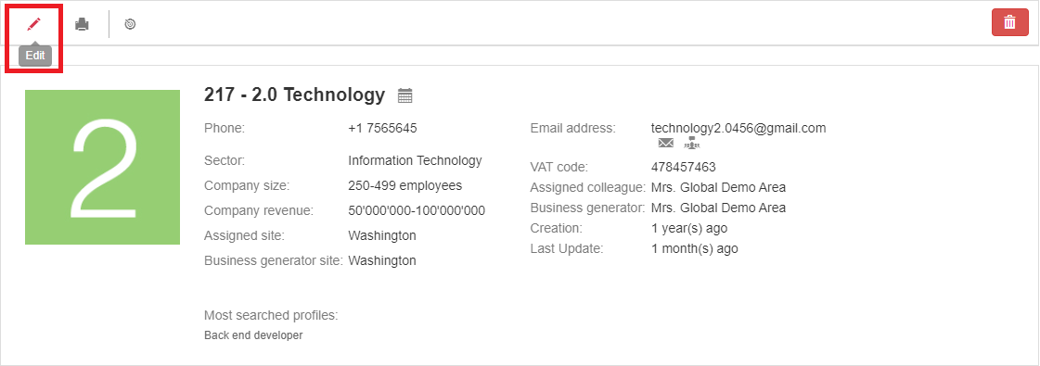

**Print** : this function enables you to print the company profile.

**Target client** 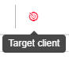: this function enables you to add the company into one or more specific target lists. The function for linking the client with a target list shows the lists in which it is already registered and allows it to be deleted from these lists.

**Delete** 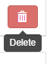: this function enables you to fully delete the company profile.

**N.B.:** an employer can only delete a company profile when there are no opportunities/contracts linked to it. The admin account, instead, can always delete the company profile.

**Image** : here you can upload the company logo.

**Status labels:** the labels match to the entries in the field “Company type” (see point 4.2.3. New company)

##### **TAB Dashboard**

The dashboard includes company statistics, along with graphical representations of data on opportunities.

By entering the date range (within which the opportunity was created) the following data will be displayed:

***Type of service***

**Pie chart.** It shows the opportunities split by type of service;

**Map.** It highlights the countries/regions where at least one opportunity has been opened in the selected date range. Country and region correspond to the **site** of the company selected when the opportunity was created.

***Status***

**Pie chart**. It shows the opportunities split by status;

**Hit rate, histogram.** The number of opened and successfully closed opportunities is compared per month. This means that if an opportunity is opened in March and successfully closed in April, it is counted in the column “total”, but not in the column “success” (if you select April, no opportunity is shown). If you select a date range, the chart shows the month of the start date set in the range.

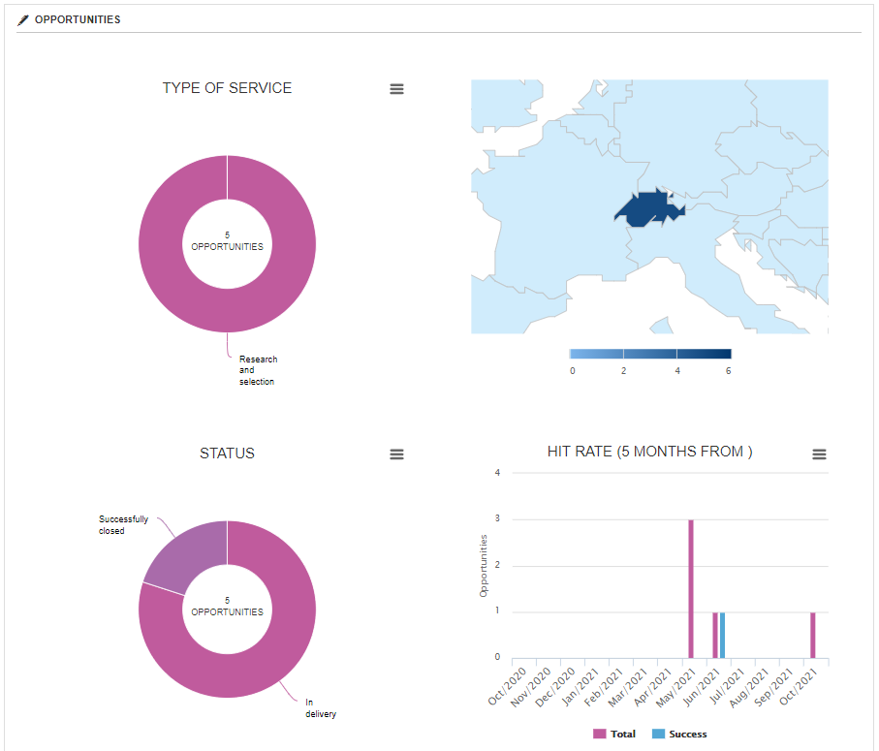

**Pipeline.**The value entered in the field "Expected value" is compared with "Success rate (%)". One indicator expresses the opportunity closed with 100% success while another indicator expresses the expected percentage to display the deviations. The pipeline report includes two charts, the monthly report and the incremental value one.

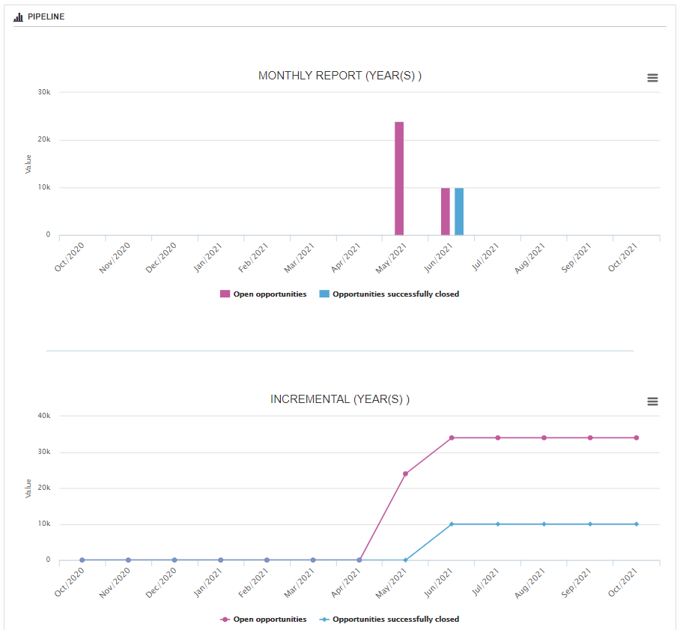

##### **TAB More info**

The tab includes the company sites entered. It is always possible to add new sites by clicking on the button “Add site”: 

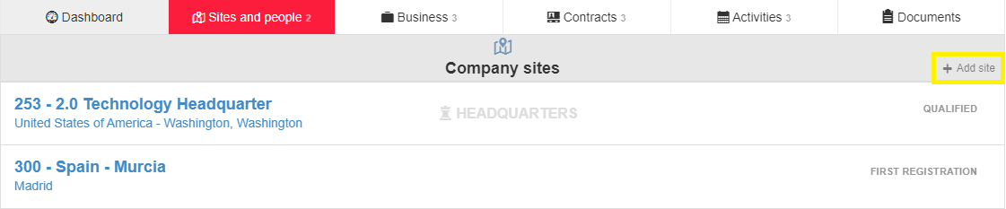

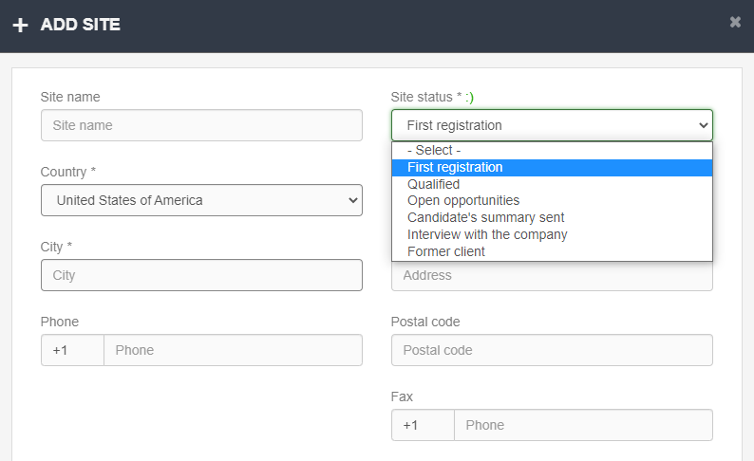

In addition to a manual update, the status of the site changes based on the following rules:

- If the site has the status “Open Opportunities” after 30 days since the last status change, its status is reverted to 'Qualified';

- If the site has the status "Candidate’s summary sent" after 30 days since the last status change, its status is reverted to "Qualified".

- If the site has the status “Interview with the company” after 60 days since the last status change, its status is reverted to 'Qualified'.

The statuses of Open opportunities/Candidate’s summary sent/Interview with the company are automatically changing according to the activities that are carried out in the linked opportunities.

By clicking on the site string, you can open its detail. In the section called “Options”, you will see a drop-down menu with the following options, allowing you to add an opportunity on the site, add a contact person, check the map for geolocation, include the site in a target client list, edit or remove the site.

In case the company site is assigned to an employer on which you have no visibility, you will not be able to edit/delete/add any opportunities on it.

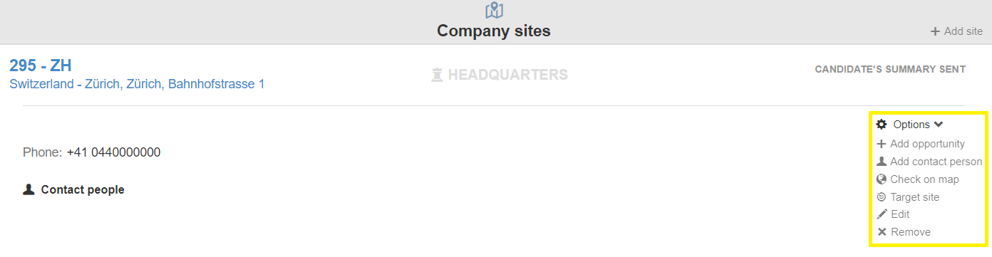

As for the **entry of a contact person** on the site, the following information can be filled in:  
  
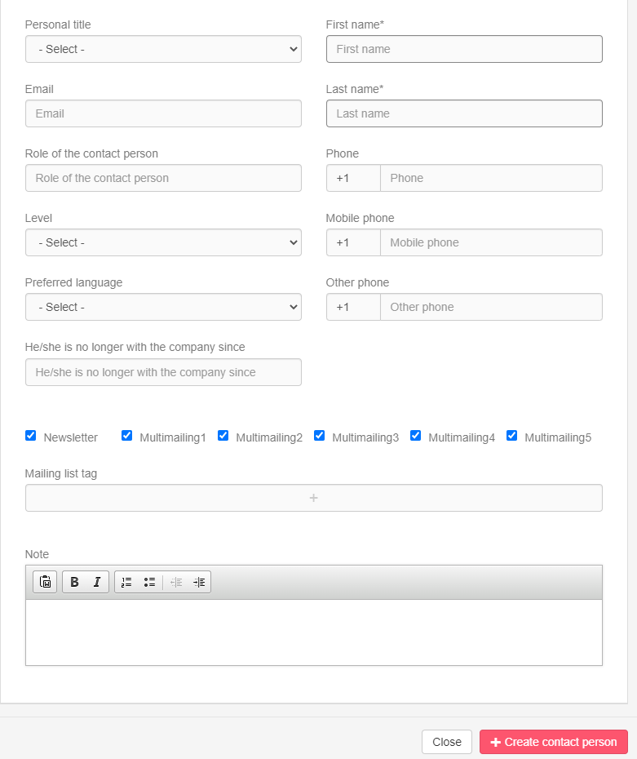

**N.B.:** the field “Email” is not compulsory, but we do suggest to complete it. Only by inserting the email address, you will be able to use some functions that involve the contact person (e.g., send him/her emails and mass mailings from the system, give him/her access to his/her personal area, send candidates’ summaries).

**Preferred language**: this field defines the default language of all the automated communications received by the contact person.

Field **“He/she is no longer with the company since”**: this field allows the date of unavailability of the contact person to be marked, since he/she may be linked to activities and contracts and therefore cannot be deleted. This field, filled in with the date since which the contact person has no longer been with the company, allows to “darken” the contact person so that his unavailability is shown.

Flag**“Newsletter”:** the newsletter flag expresses the contact person's consent to receive emails through a mailing list; a contact person without this flag will be indicated as "unsubscribed" from the mailing list.

The contact person can unsubscribe in his/her company area (candidates > multimailing > unsubscribe from our newsletter).

Flags**“Multimailing 1, 2, 3, 4, 5”:** these flags are customizable. They are linked to the filter "Newsletter" in the searches for "All contact people"; by applying that filter, all the contact people having that flag are shown and they can then easily be linked to mailing lists.

**Contact person’s string**

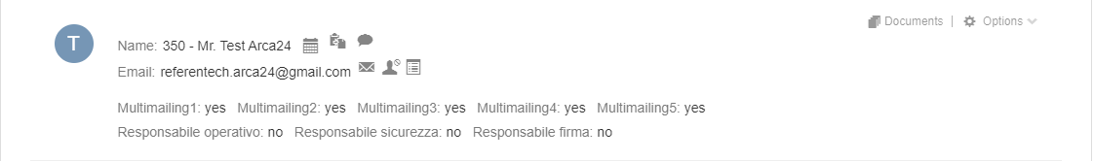

The contact person’s string enables the following functions:

> add a new activity on the contact person;

> export to an external tool (OPTIONAL MODULE*);

> send a direct email to the contact person, whose entry is saved in the activity tab;

> start a live chat or a (video) call with the contact person by using 2chat, real-time messaging, call and video call system (OPTIONAL MODULE*), when the contact person is connected to his/her personal area;

**/** > send/remove access to the company area, so as to send or deactivate the login credentials of the contact person for his/her personal area;

**:** suggest candidates to this contact person, so as to launch a search for candidates in the database, which is then saved which is saved in the searches as Proposed Candidates. New candidates compatible with that search are notified to the company contact person, who displays them in his private area. (OPTIONAL MODULE*);

: send SMS to the contact person from the system (you need to fill in the field “Mobile phone” and not “Phone” to send a SMS). (OPTIONAL MODULE*).

In addition, in the contact person string you can:

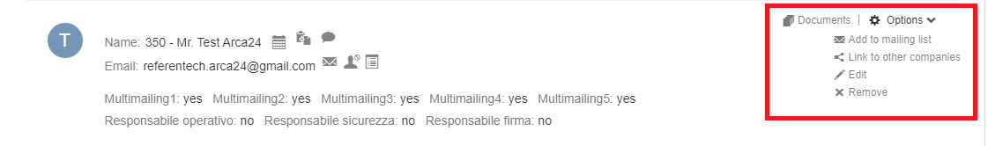

* Add documents;
* Add the contact person to an existing mailing list;
* Link the contact to other companies, so as toduplicate the profile of the contact person in another company and site (changes in one of the two contact’s people strings are also carried over into the other!).
* Edit the contact person’s profile;
* Remove the contact person’s profile.

###### **TAB Rating (OPTIONAL MODULE*)**

In this section you can enter data on the company solvency.

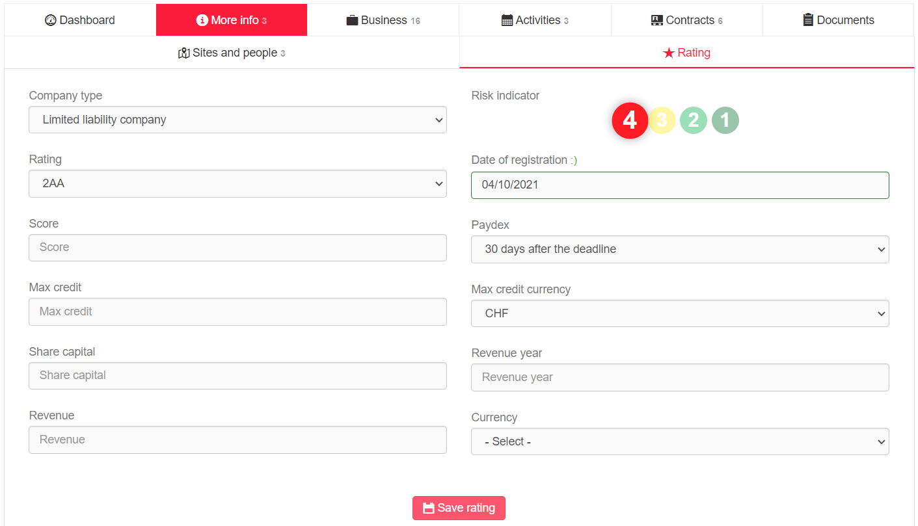

##### **TAB Business**

###### **History (OPTIONAL MODULE*)**

In the section “History”, it is possible to record the most requested services by the company as well as the competitors (OPTIONAL MODULE*) the company is currently working/has worked with.

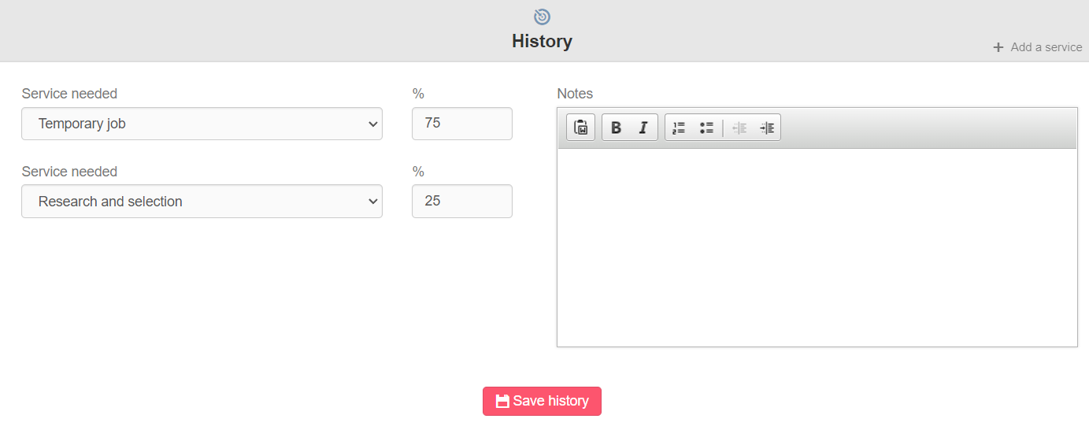 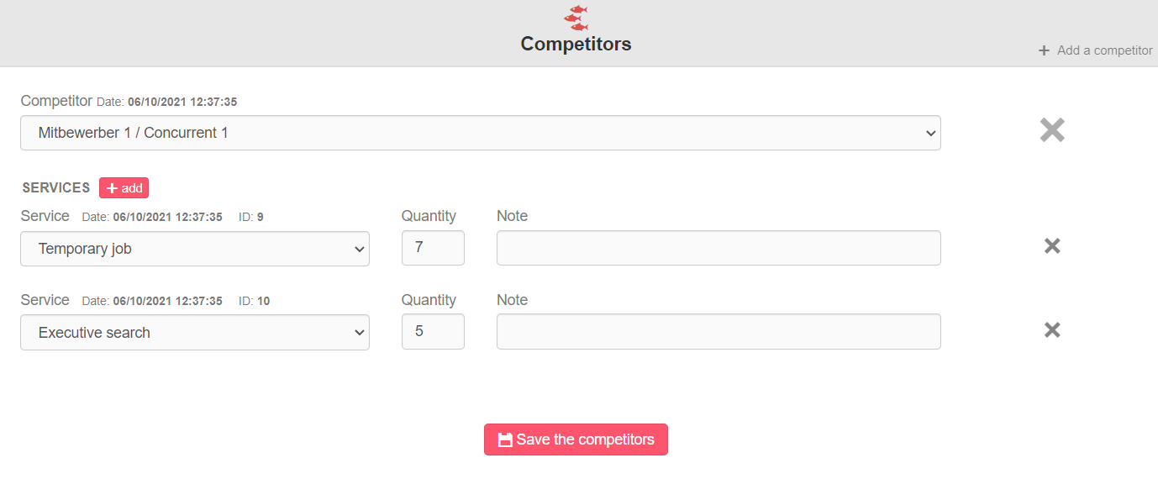

###### **TAB Opportunities**

In the section “Opportunities” it is possible to register company orders, i.e., the job orders, to be linked to candidate searches/jobs in the module “Candidates”, or other projects.

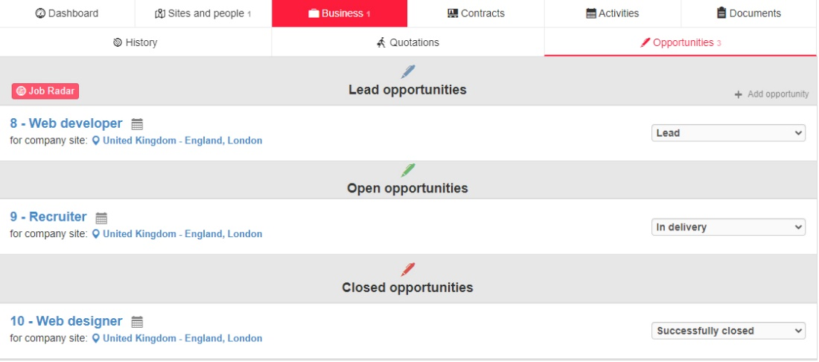

By clicking on “Add Opportunity”, it is possible to enter a new customer’s order/project with the following data:

**Opportunity title >** this field enables you to enter a title describing the opportunity, which may match the vacancy/profile searched. If the opportunity is linked to a search within the database or a job ad, the opportunity title is entered as “job title” in the search and as title in the job offer respectively.

**Status ->** the status of the opportunity can be changed manually as the recruitment proceeds, while the status “Candidate’s summary sent” and the status “Interview with the company” vary based on the corresponding activities carried out on the candidates in the linked selection processes.

Here are all the opportunity statuses:

* Lead
* In delivery
* Candidate’s summary sent
* Interview with the company
* Successfully closed
* Unsuccessfully closed
* Deleted

**Expected closing date ->** optional field to enter the start date of the service provision; it allows the creation of a chart in the Opportunity Dashboard section.

**Company site ->** this field is compulsory and enables you to link the opportunity to a company site.

**Opportunity type ->** this field allows you to identify the service to be provided; the dropdown list can be customized if required and is the same as that shown in the section “History”.

**Expected value ->** this field allows you to enter the possible sales revenue generated by the opportunity; along with the field “Success rate”, it creates the pipeline/incremental value statistic.

**Success rate (%) ->** this field enables you to enter the success rate for covering the opportunity.

The field is in read-only mode and is filled in automatically based on the following rules:

* Status “Lead”, “Deleted” or “Unsuccessfully closed” => 0%
* Status “In delivery” => 40%
* Status “Candidate’s summary sent” => 60%
* Status “Interview with the company” => 80%
* Status “Successfully closed” => 100%

**Vacancies ->** in the event of a request for personnel,this field allows you to mark the number of workers required.

**Opportunity notes ->** this field enables you to enter a description of the request.

**Competitors (OPTIONAL MODULE*) ->** to identify competitors possibly involved in the project by the company.

**Sales and Delivery ->** these fields are filled in by default with the user entering the opportunity, but they can always be edited manually so as to link the opportunity with another colleague.

**Options on opportunities**

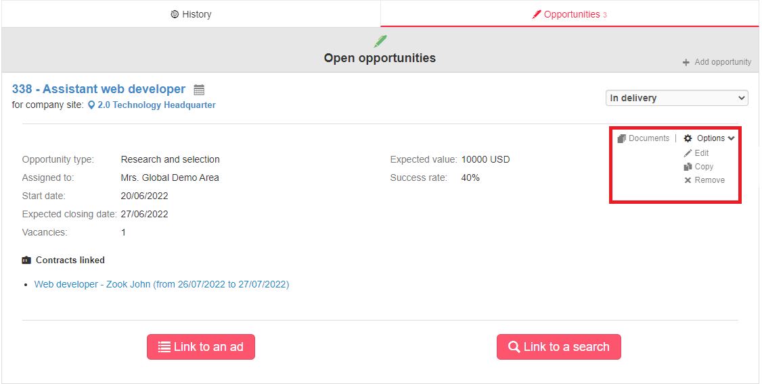

* **Add an activity related to this opportunity**: from the calendar icon next to the opportunity title, it is possible to add activities related to the opportunity.
* **Documents**: to enclose documents related to the opportunity.

From the section “Options”:

* **Edit**: to update the details on the opportunity
* **Copy:** to use an already created opportunity as template to enter a similar one
* **Remove**: to definitely delete a opportunity. **N.B.:** this option is only available if the opportunity is not linked with any searches/job ads).

Within the character string, the activities that have been carried out in the respective process are counted under ‘Activities’: activities entered manually are displayed for both opportunities as well as candidates.

* **Link to a job ad/search:** the function **“Link to an ad”** enables you to link the opportunity with an already existing job offer (with selection of the assigned colleague and the job advertisement > button “Link to the selected job ad”) or to publish a new job (button “Link to a new job ad”).

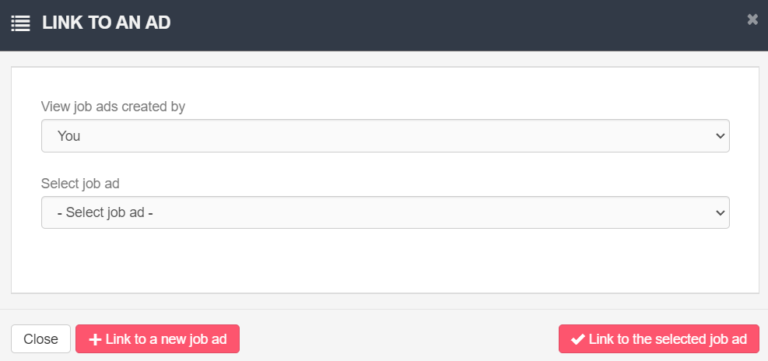

**N.B.:** If you change the opportunity status from “In delivery” to “Deleted” or “Successfully/Unsuccessfully closed”, the job ad is automatically set offline. If you change the opportunity status from “Deleted” or “Successfully/Unsuccessfully closed” to “In delivery”, the job ad is not put online. The job ad status does not affect that of the opportunity: if you set a job offline and that is linked with an opportunity, the opportunity status does not change accordingly. Similarly, if the job is offline (the opportunity is closed) and you set it online again, the opportunity status does not change accordingly.

By clicking on the button **“Link to a search”**, the system will redirect you automatically to the candidate module, where a search by job role can be started based on the opportunity title. Each search that is set up in this way generates a **“Saved Search”**.

**N.B.:** The opportunity of type **“Lead”** can only be linked with a candidate database search, and not with a job advertisement; if you want to post a new job or to connect the opportunity to an existing one, you will need to change the opportunity status to **“In delivery”**.

If an opportunity is linked to an advertisement or a search, you will see in the opportunity string the section **“Linked selection processes”**. Here you can find the linked searches and jobs, the related candidates moved to the step “Selection” and any activities on these candidates.

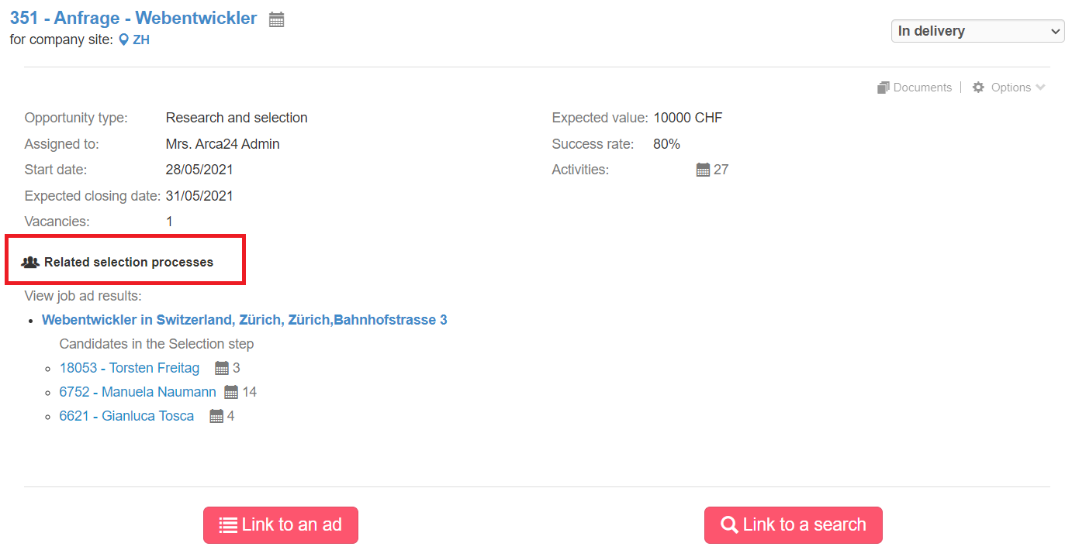

**Links between activities and opportunities**

When you create an activity from the candidate’s profile and that is linked to an opportunity via a flag (as in the first screen capture), it will also be visible on the opportunity in the company’s profile (see second screen capture):

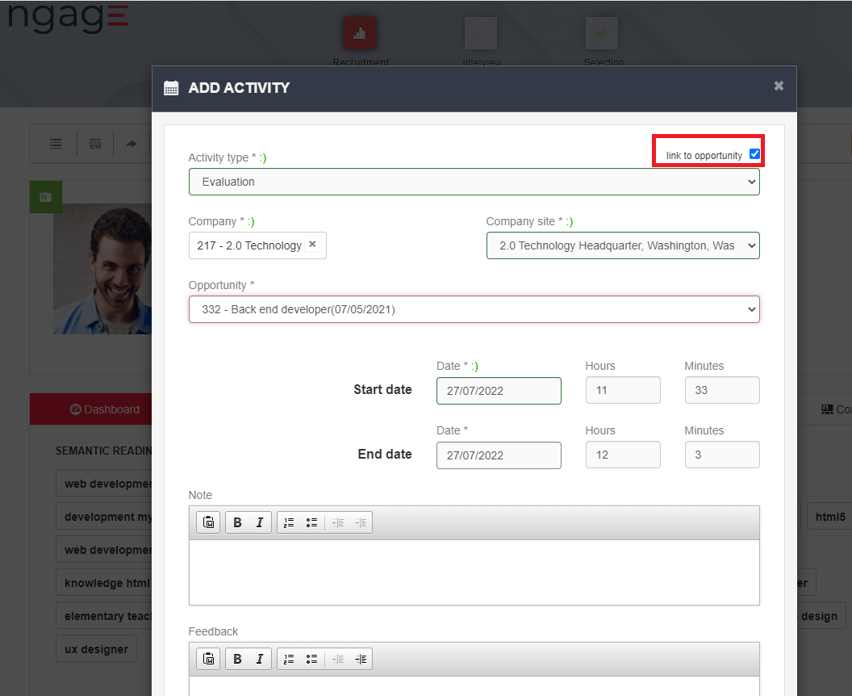

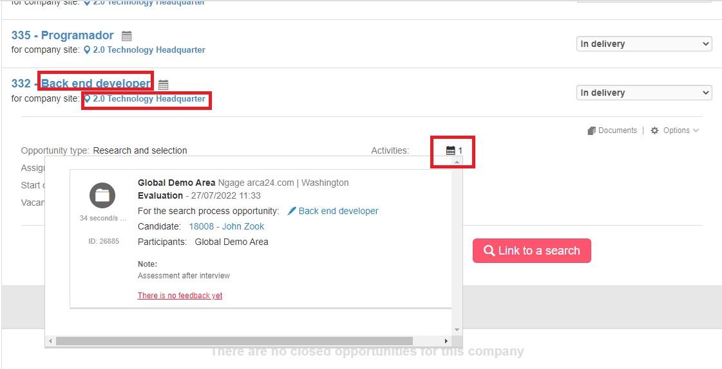

You will see the activity entered in the opportunity will only be possible if the candidate on whom the activity is entered is **at the step “Selection” of the process for the job advertisement or search related to that opportunity**.

##### **TAB Activities**

Section displaying the history of activities performed on the company profile.  
The sorting of activities takes into account the activity starting date, with reference to manual activities.

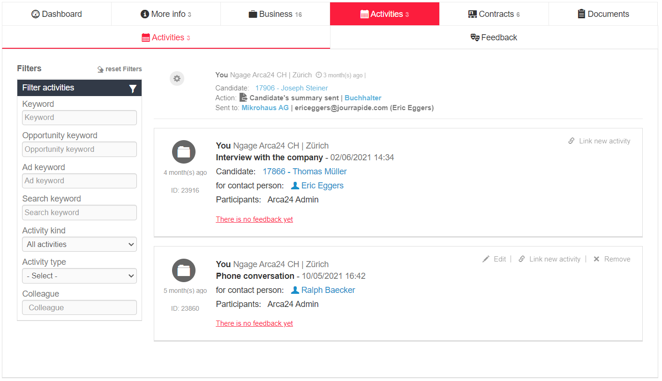

Activities can be filtered by:

**Keyword:** the field enables searching in the text of automatic activities as well as in the comments and feedback of manual activities.

**Opportunity keyword**: the field allows you to search all activities related to a certain opportunity; it searches in the "by opportunity" field in manual activities entered from an advertisement and any automatic activities linked to the opportunity (e.g., sending dossiers from a selection process linked to the searched opportunity).

**Ad keyword:** is used to search for all activities related to a given job advert (e.g., searching for 'accountant', it extracts all activities related to advertisements with this title).

**Search keyword:** the field allows you to search all activities related to a given search in the database.

**Activity kind:** to filter by chats (activities related to 2chat, real-time messaging, call and video call system (*OPTIONAL MODULE), automatic or manual activities.

**Activity type:** filter by type of manual activity (e.g., Meeting with the company, phone contact, etc.) and by automatic ‘candidate’s summary’ sending activity.

**Colleague:** filter by colleague, author of the activity.

**Difference between automatic and manual activities:**

Automatic activities are those identified by a gear icon. These are logs automatically recorded by the system and generated by actions carried out by the employer (e.g., sending of candidates’ summaries, sending of simple e-mails, sending of massive e-mails, etc.).

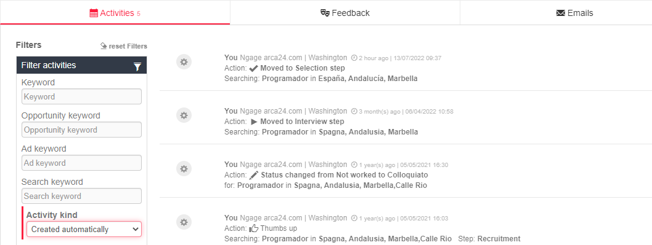

Manual activities are characterised by the folder icon. They are recorded by the employers from their agenda, from candidates’ profiles, contact peoples’ strings or opportunities strings.   
With regard to manual activities, you can perform the following operations:

**Edit**: it is only allowed on activities entered **by you**.

**Link new activity**: allows you to link an activity to a new one. Several activities can be linked to each activity, but an activity B linked to an activity A cannot be linked to an activity C, so there is only one level of linking.

**Remove**: this is only allowed on activities entered **by you**.

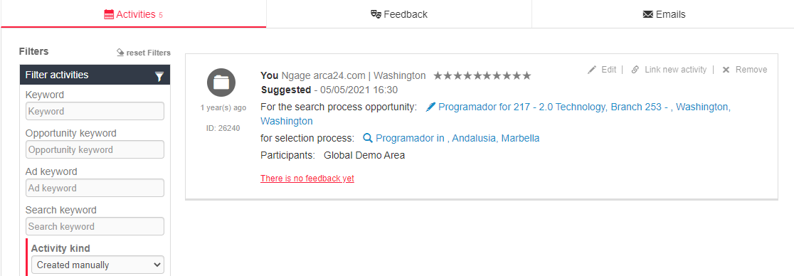

**Addition of follow-up activities**

The following fields were added to the activity entry screen:

* Follow up activity type;
* Follow-up activity date.

The operation is designed to immediately enter a new activity linked to the first one just entered, so that it is immediately clear to a sales figure how to proceed with his/her activity.

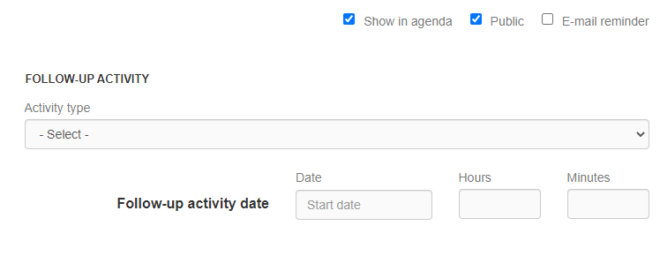

**N.B.**: in order to allow traceability of the activity “Candidate’s summary sent” and the link with the related opportunity and selection process, the submission must be made **from the process** (search or job advertisement) **to which the submission relates**.

**TAB feedback**

Tab collecting the contact person's reactions to the receipt of candidates’ summaries and candidates’ suggestions.

##### **TAB Contracts**

This section contains the list of contracts signed with the company; the data in this section varies based on the activated modules and active links with third-party administrative software.

In the standard version it is possible to attach documents, modify or delete the contract and dismiss the candidate (in that case the date of dismissal is shown within the string).

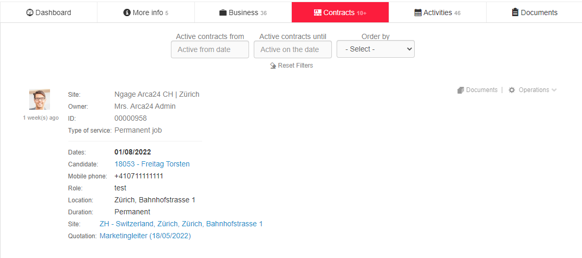

##### **TAB Documents**

The documents section allows you to attach files to the company profile, which are available for internal use only.

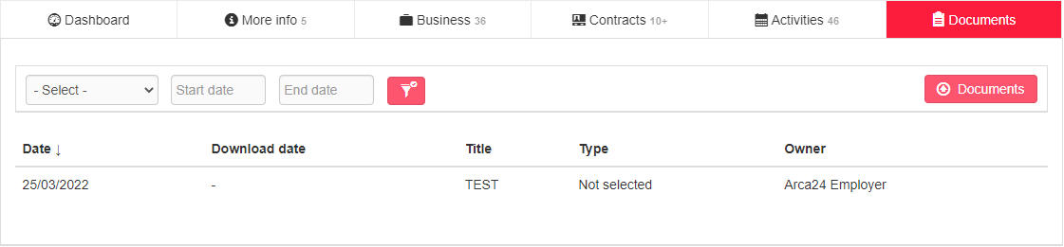

In the section, there is a filter by document type, depending on the entries in the custom dropdown named “Tag”, and filters for start date/end date, depending on the date the document was uploaded.

**Document visibility**: for customers with visibility based on hierarchy, the visibility of the document section within the customer profile also follows the same rule as the visibility of activities and opportunities. Documents uploaded by an employer, be it the client's main owner or the owner of an individual site, are only visible to him/her and his/her hierarchy. Documents are therefore not visible to those who have opened new sites and are not in hierarchy with other “owners” of the company.

#### *Advanced search*

You can search companies by:

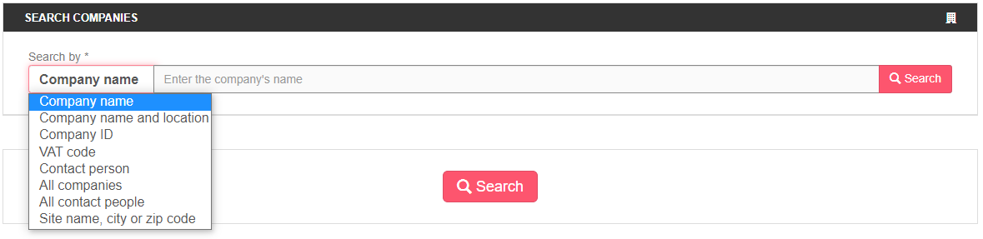

**Company name**: search filter for typed characters; if you type “test”, it also finds results with “tester” (it is not case sensitive).

**Company name and location**: it allows name and location to be defined based on working sites.

**Company ID**: search for a specific ID.

**VAT code**: search for a specific VAT code.

**Contact person**: search in the fields "Name" and "Email address" of the contact person.

**All companies**: search for all records based on the indicated area. The search is pre-set showing the results assigned to you. To cancel the filter, choose "select" in the "site" field;

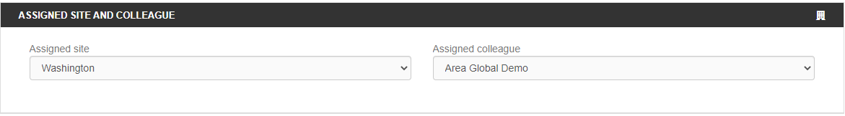

**All contact people**: search for all records that have at least one contact person, based on the indicated location. The search is pre-set to show the results assigned to you. To cancel the filter, choose "select" in the "site" field.

**Site name, city or zip code**: search in the field "Site name", in city and zip code in the master data of the site.

The search result can be refined with some **filters**, which vary depending on the type of search initiated.

**Order by date/distance**: sorts companies by

- Registration date (DB entry)

- Date last updated

- Distance

- Date of last activity (sorts companies by date of last registered activity from oldest to newest)

**Flag "Only headquarters"**: it only shows company profiles where the headquarters is included in the selected kilometre radius.

**Filter for exact word**: search in the company name field, in the site name, in the field “Most searched profiles” and in the site comment field. Boolean search is possible, as in the corresponding filter in the candidate module. That reads the character sequence as is, even if it is included in other words. Spaces and full stops are characters searched within the sequence.

**Created from/to**: date range of profile creation.

**Filters related to company details**: filters that work on the fields of the company profile.  
**Filters related to activities:** filters to extract a list based on the activities performed on the company, on contact people or opportunities. The filter allows you to see companies with activities entered in a specific date range or companies in whose activities a specific exact word was used.

**Filters related to opportunities**: to select companies by type of opportunity and/or “sales” or “delivery” user.  
**Lists**: to filter results to display only companies included in a certain mailing list or target client list.  
**Assign**: section for linking the search to a mailing list and/or a target client list.   
The search is assigned within a mailing list or target list, creating a saved search (similar to what happens in the candidate section). In this case, from the link to the search, which is visible in the lists, it will be possible to re-open the search, possibly modify the filters and consequently the results.  
In order to assign a search to a list, choose the desired list from the drop-down list (it is possible to save the search in a mailing list and a target list at the same time), flag the items to be included and give a name for saving the entry in the field “**Assignment title**”, then click “**Assign**”.

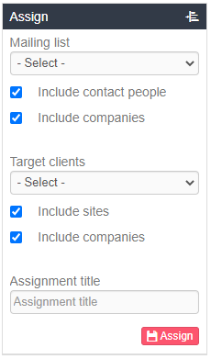

The searches saved within the lists assign the customers/contact people entering the database from that moment on and corresponding to the set criteria through a daily cronjob.

In each search it is possible to make a CSV extraction showing all the main data of the companies in the search. Extractions are available in the appropriate tab.

  
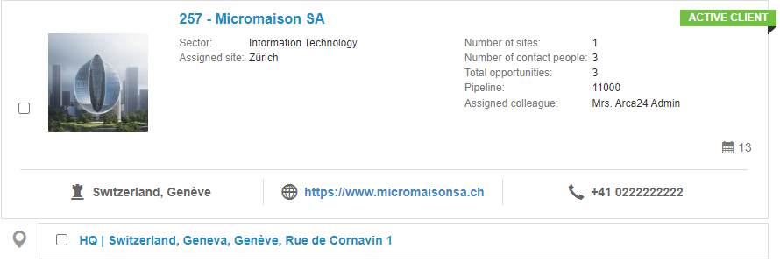

#### 

#### **Mass actions on clients**

As in the candidate module, mass actions can be performed on the results of a search. Depending on the number of companies selected, mass actions take some time to be processed. You are notified of the completion of the mass action through a pop-up that appears at the bottom right of the screen:

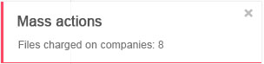

By clicking on the check box 'Select all', the selection filter for mass actions is shown, which allows you to select only some of the resulting companies based on the ranking position (e.g., 20 to 100).

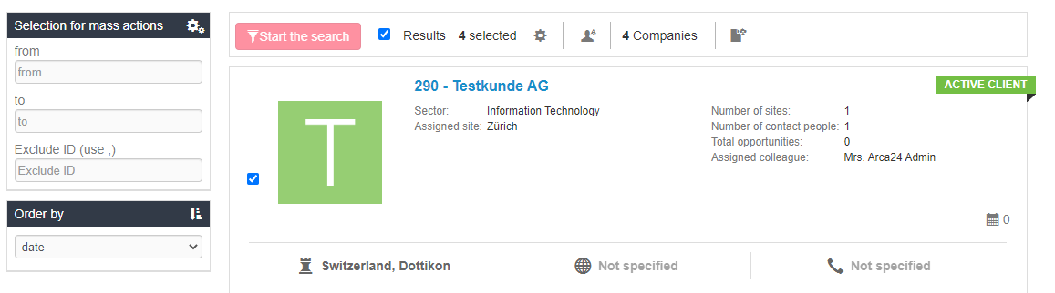

Mass actions are as follows:

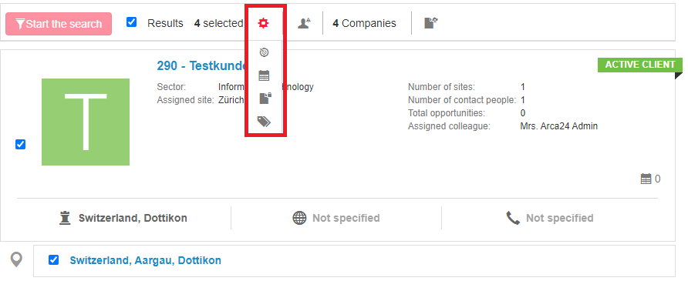

* Addition to target client list -> it allows you to add all selected customers to a target list.
* Entry of activities on the company -> inserts the same activity on all selected companies.
* Upload of documents to the company profile -> uploads a document to the selected companies.
* Tagging for mailing list -> adds a tag to all selected companies for the mailing list.

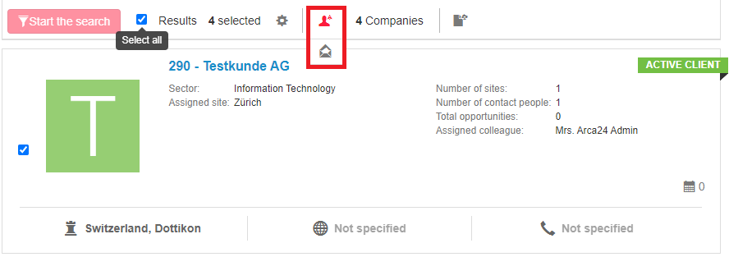

* Addition of results to a mailing list in bulk.

In the calendar pop-up to the right of the string of each company, the target lists and mailing lists to which the company is linked are shown in addition to the activities.

The number on the calendar shows the sum of the activities, and counts 1 if the section target lists and mailing lists is filled in (it does not count how many lists the company is associated with).

Changing the lists to which the company belongs does not affect the sorting by last activity date, only manual calendar activities are considered for that sorting.

An example of the three types of information reported is as follows:

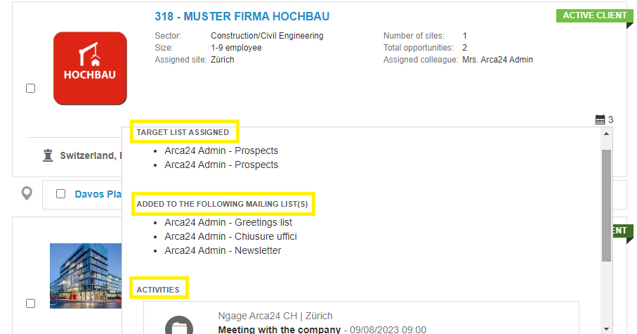

#### *4.2.6. Target clients*

It allows you to create company lists defined as “targets”, i.e., folders that can contain a list of companies, which are useful for organizing your daily activities. Company names are clickable, so they can be easily accessed and edited.

In addition, thanks to the section “Assign” in the search filters, it is possible to link a company search to one or more target lists in the system.

The following operations are possible:

1. **Add a new list**, by clicking on the appropriate icon and enter the list name and any comments.

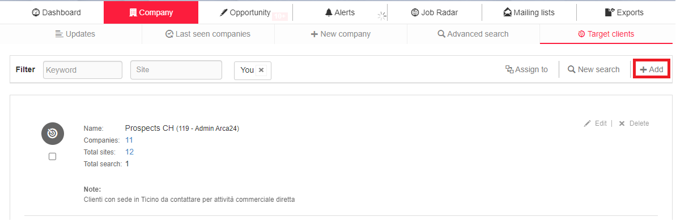

1. **Add companies to the list**, by clicking on the search icon to be redirected to the advanced search page and add items to the list.

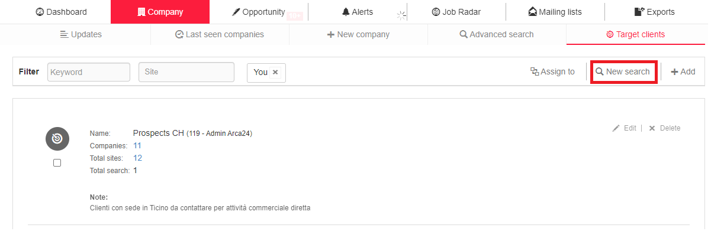

**Assigning a search to the list**

The list can be populated by linking one or more searches to the list (e.g., a search for all companies or for all contact people). The linking of a search allows the **automatic import** of companies and sites included in the search, whereby new companies/registered sites are automatically included in the results. The cronjob that updates sites and target companies runs **once a day**, so data entry into the lists is not immediate.

How to make the assignment: set the search, select a list in the dropdown “Target clients”, give a title to the search and click on “Assign”. The flags "Include sites" and "Include companies" are used to import only data related to sites, only company data or both into the target list.

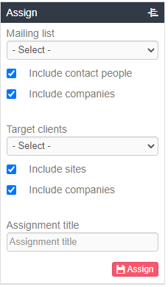

**Mass assignment**

This function allows you to massively select companies to be included in a list. Within a search, click on the icon “Target client” and select the list in which you want to include the companies.

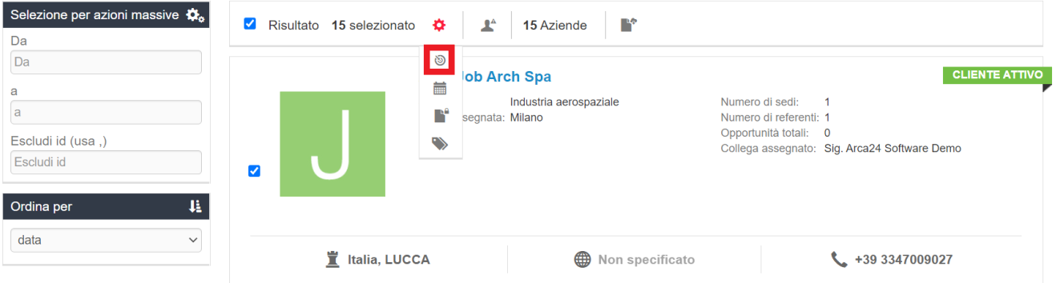

**Individual assignment**

Within the company profile, you can directly assign the company or site to a target client list.

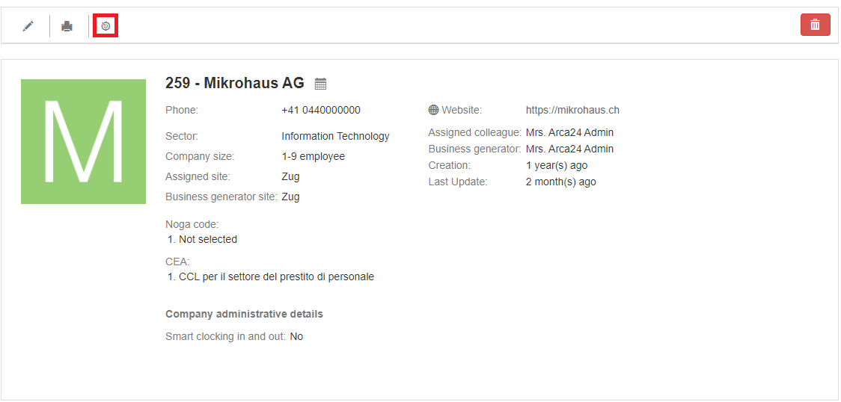

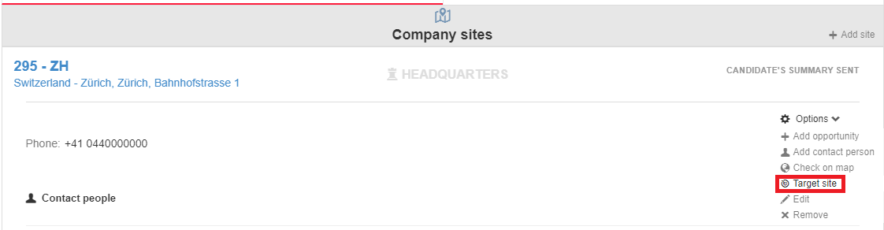

1. **Manage the list**. Once populated, the list can be edited, deleted or assigned to a colleague.

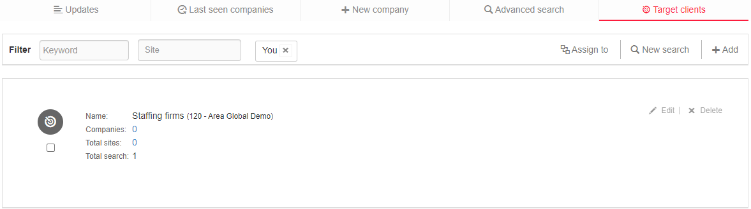

By clicking on “Edit”, it is possible to change the list name, view and delete companies/sites included in the list as well as view and delete any searches linked to the list.

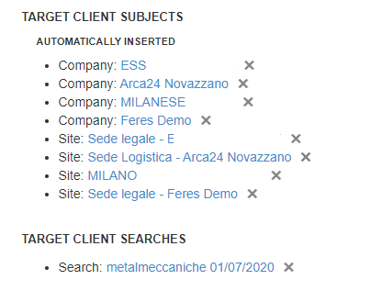

The list of target clients is divided into 2 sections:

**Manually entered ->** Recipients added massively or individually via the button “Target client”;

**Automatically inserted ->** Recipients added automatically via linked searches.

### Opportunities

#### Dashboard

The opportunity dashboard is useful for displaying the processing status of all opportunities by also showing the evolution of the selection processes related to them.

A set of filters is available for the display of opportunities:

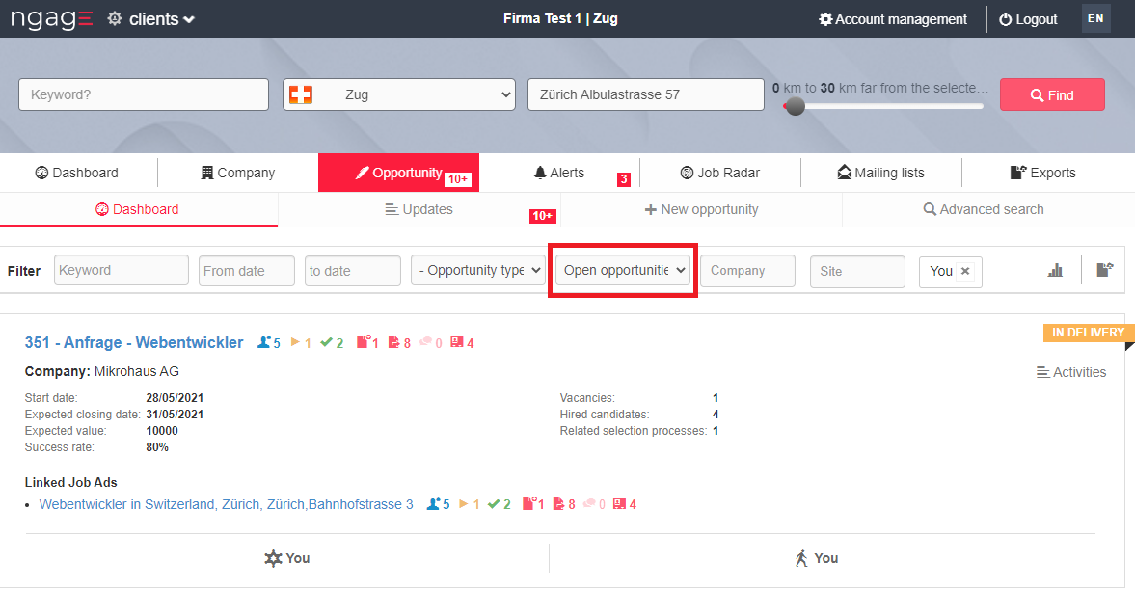

**N.B:** the opportunity status filter is set to open opportunities by default. This filter groups all the statuses that come under “Open opportunities”:

* In delivery
* Candidate’s summary sent
* Interview with the company.

**Filter by keyword**: search in the opportunity title and company name.

**Filter by date**: shows opportunities by date of insertion.

**Filter by opportunity type**: shows the opportunities of a given type, chosen from the dropdown list.

**Filter by opportunity status**: shows the opportunities in a given status, chosen from the dropdown list.

**Company**: token imput filter that allows you to search for the name of the company whose opportunities you want to view.

**Colleague and site**: search based on hierarchies/sites/users groups.

You need to specify a range of dates; if you leave the fields empty, last month’s opportunities are shown.

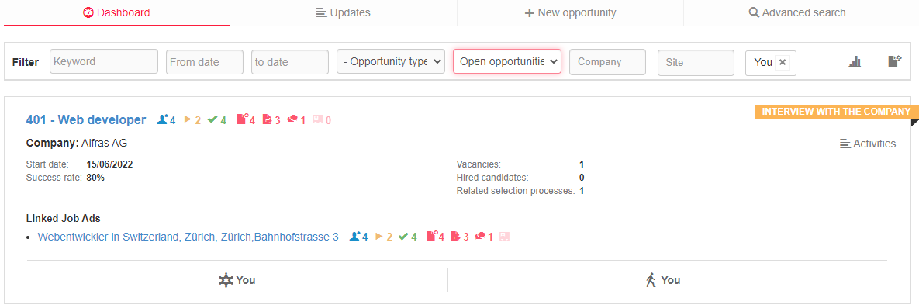

In the activity label, to the right of the string you will also see the paragraph Updates:

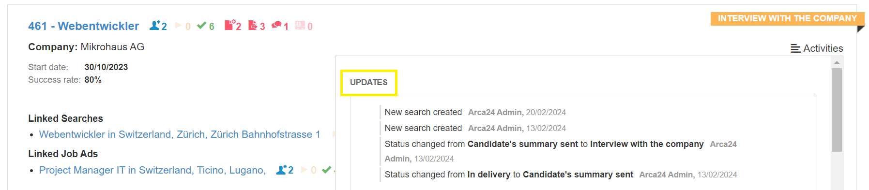

The strings contain the ID and opportunity title followed by some counters representing the sum of the linked jobs and searches. They are a snapshot of the current status of the job offer and are updated in real time.

**N.B**: If you delete a search or a job advert for which you have submitted some candidates’ summaries, those will still be counted.

The title of the opportunity links to the opportunity in the customer profile; the title of the job advertisement and/or the linked search redirect the user to the step “Recruitment” of the clicked process.

**Icon** (): by hovering the cursor over the word ”ActivitIies“, linked **activities and updates** are shown.

**Icon (****)**: employer in charge of talent acquisition (”Sales”).

**Icon (****)**: employer in charge of talent selection (”Delivery”).

**Icon** ():allows you toexport data to a CSV file.

**Icon** (): allows you to change the **view mode** of the opportunity data:

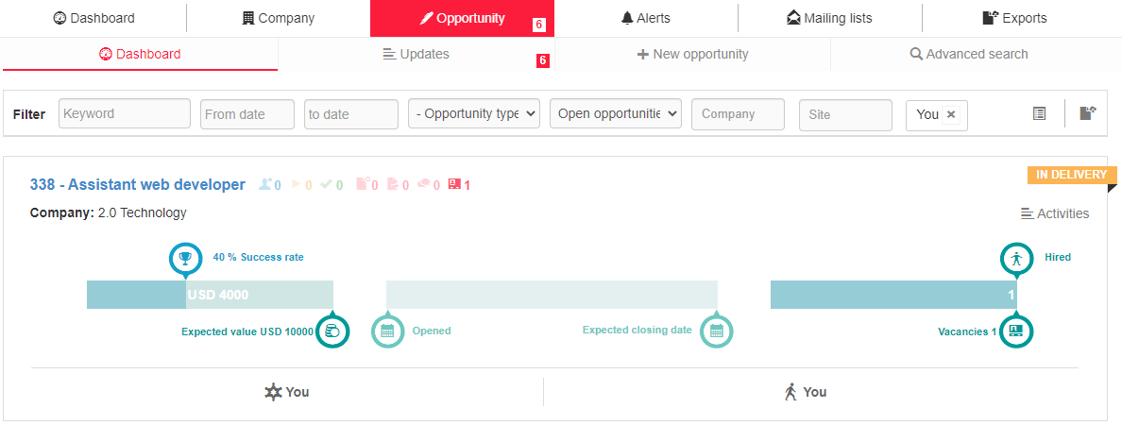

The first graph allows, if completed, to graphically display the achievement of the percentage of **Success Rate** in relation to the **Expected Value**.

The second graph makes it possible to display the current day in relation to the **opening date** and the **closing date** of the opportunity, showing at the same time at what point in the time range the activities "Candidate’s summary sent" and "Interview with the company" were inserted.

The third chart compares the number of workers hired on the opportunity with the number of **vacancies** posted for the opportunity.

#### Updates

In this section, each employer displays updates on the opportunities in which he/she is involved, as the user with whom he/she is connected is in charge of talent acquisition or selection for the opportunity. The section contains a filter by site and colleague, which is based on the hierarchy. The number next to the tab title warns that there are notifications that have not been displayed.

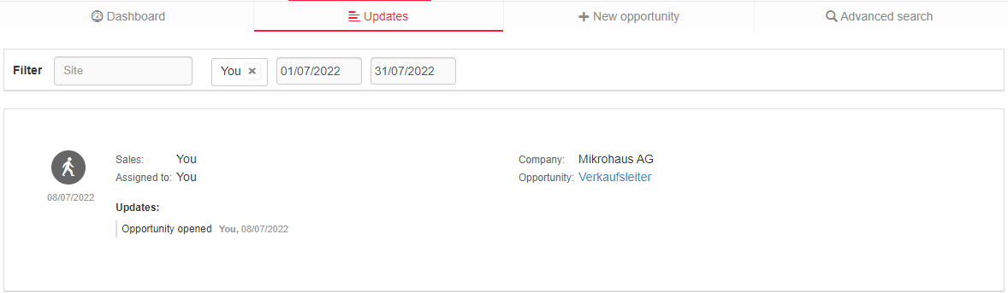

#### New opportunity

This section allows you to enter an opportunity without opening the company profile, which will be chosen in the first field of the entry form. The fields to be filled in are the same as those found in "Add opportunity" within the company profile.

#### Advanced search

You can search for opportunities by **title** and **ID** or you can search for **all opportunities** in a given area.

Again, the search is started based on the fields below “Assigned site” and “Assigned colleague”; if necessary, choose “Select” to see everything.

The system proposes results with the possibility of using various filters:

**Sorting** by date or distance;

**Filters on opportunities**, such as status, type, colleague in charge of talent acquisition, colleague in charge of talent selection, activity, expected value and success rate;

**Filters on activities,** used to filter results based on planned activities directly related to the specific opportunity;

**Filters on the company**, to filter the list of opportunities based on the companies they are related to (sector, company type, site status, assigned site and colleague).

You can extract a CSV file with the results.

**N.B.**: the company filters related to site and assigned colleague work on the assignment fields of the company master data and not on the opportunity assignment fields, which are shown below the opportunity filter group, in the fields “Sales” and “Delivery”.

### Alerts

* **Section Companies**

The section presents a filter by site and users, based on sites/users groups.

**Activities** (section on the left): the system alerts the employer if there are companies on which he/she has not entered any activity for some time (the timeframe is customisable or defaults to three months and multiples thereof).

**N.B**: Alerts relate to companies where the flag “Enable alerts” has been selected in the company profile.

**Section Competitors (right-hand section)**:

Notifications on competitors (OPTIONAL MODULE*) in case data is entered on candidates who have worked or been interviewed by the company through a competitor.

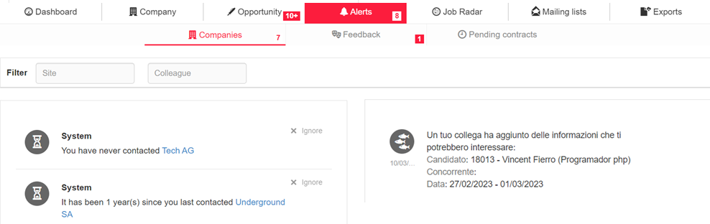

* **Section Feedback**

In this section are displayed the following notifications:

* feedback entered by contact persons (icon with the two masks) to whom candidates have been sent via dossier, multimailing or proposal of candidates (this information is also sent by e-mail to the employer and shown in the ATS dashboard as a message). The time taken into account is the last 3 months.
* views made by a contact person (icon with the person) or by a generic mail (icon with the envelope) to which candidates have been sent via dossier, multimailing or proposal of candidates in the last 3 months. In these cases, the link “View similar candidates” enables to search for other candidates with similar characteristics to the one sent.

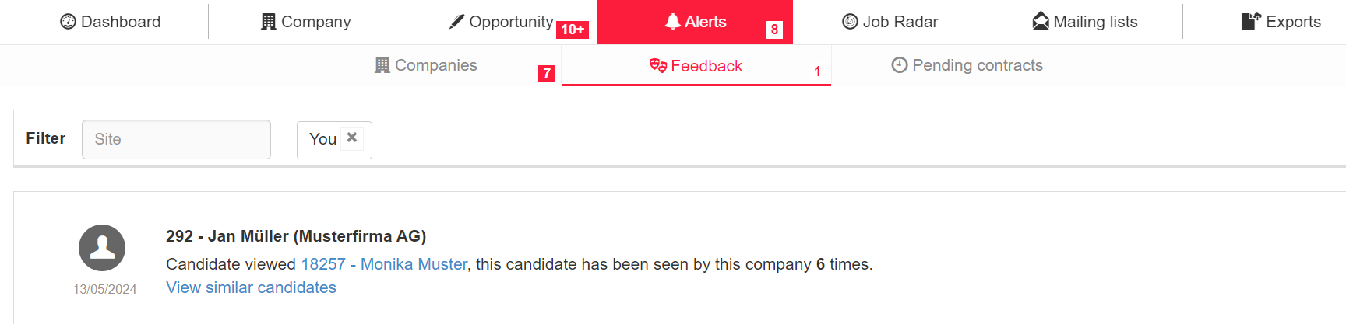

### Job Radar

It is possible to search for job offers published on external job portals and aggregators. Searches can be made by job role or competitor.

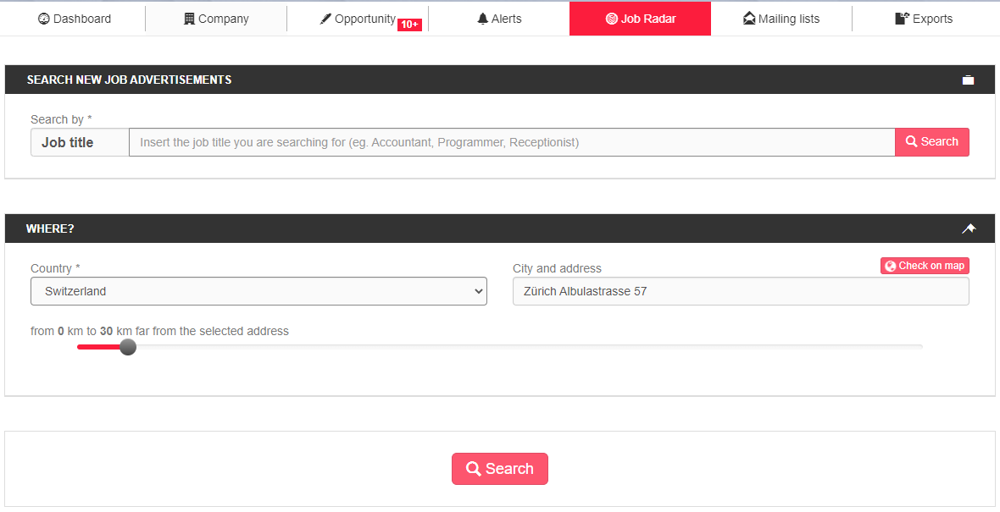

Geolocation allows searches either by kilometer radius or by individual country, where it is not mandatory to enter a starting address.

In the results screen, job offers compatible with the search made are proposed. In addition, in each job advertisement the semantic tags identified are highlighted:

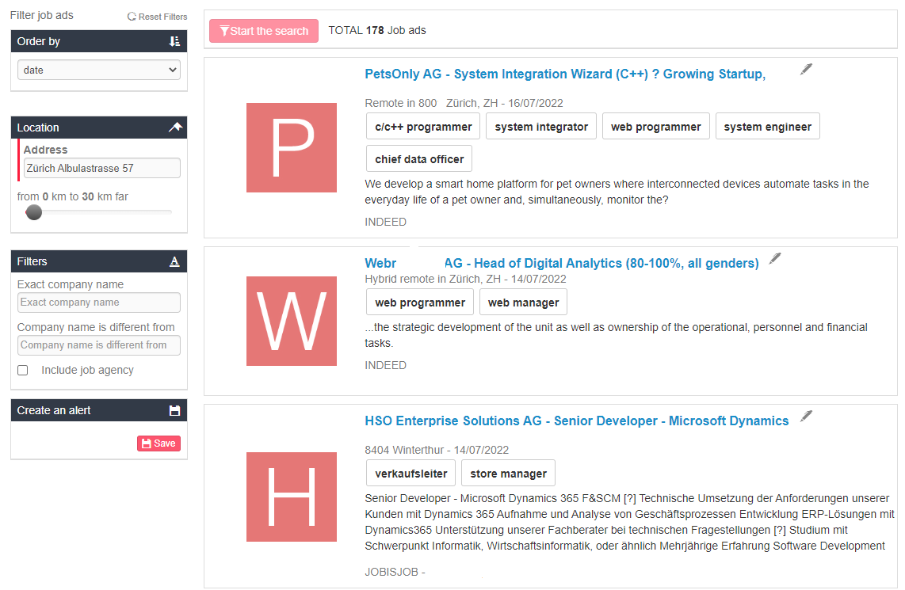

The job offers are updated once a day.

In the case of a search by role, it is also possible to filter by “Exact company name” or “Company name is different from” and to decide whether or not to display job advertisements related to staffing agencies.

By clicking “Save” in the section “Create an alert”, it is possible to create an alert sending an email to the employer with title, date, city and links to new advertisements compatible with the search. A link is contained in the email to deactivate the alert.

Clicking on the job offer title in the string redirects you to the original site that published it, allowing you to retrieve the name of the company for which the job was posted.

The pen button to the far right of the job advert title allows the creation of an opportunity within the client, to speed up the registration of a new order/project or an active proposal for candidates.

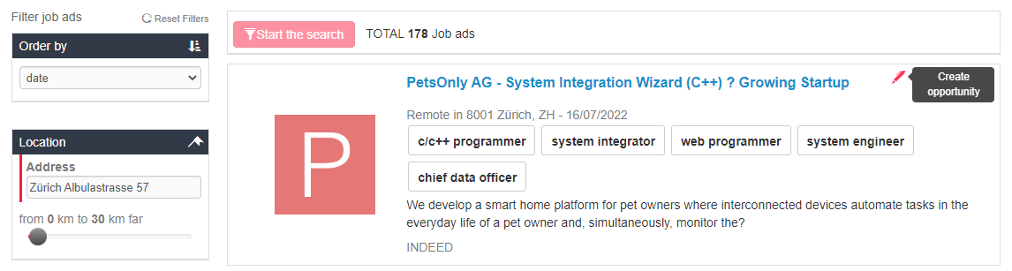

The pen button, which allows the creation of a linked opportunity, opens the opportunity completion window:

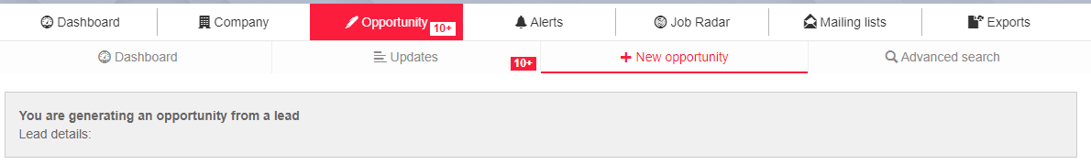

The screen shows all data extracted from the linked job advert, such as the company name, the job title, location, the job advert text, link, date and semantic tags.

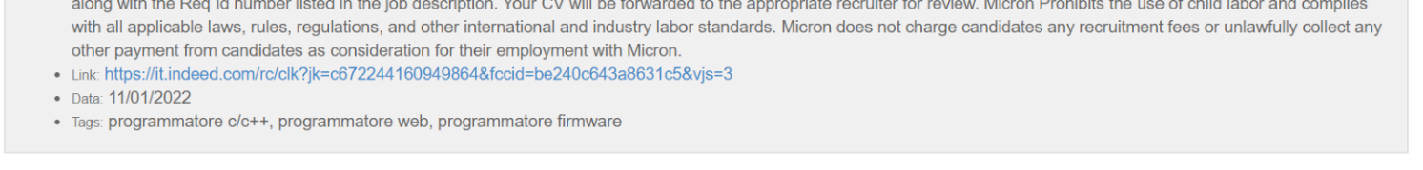

The registration form of the opportunity is partially filled in in Ngage; the **title** and the **notes** on the opportunity are entered:

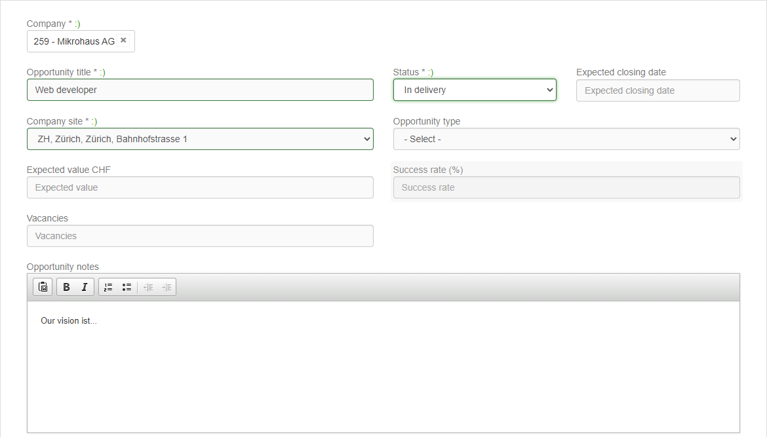

You can now complete the opportunity by entering the company (as in the tab “New Opportunity”) and linking it to the company profile chosen from the dropdown list. In case the company that published the advertisement is not in the database, you need to register it.

The order will be displayed within the company profile and can be linked to a selection process.

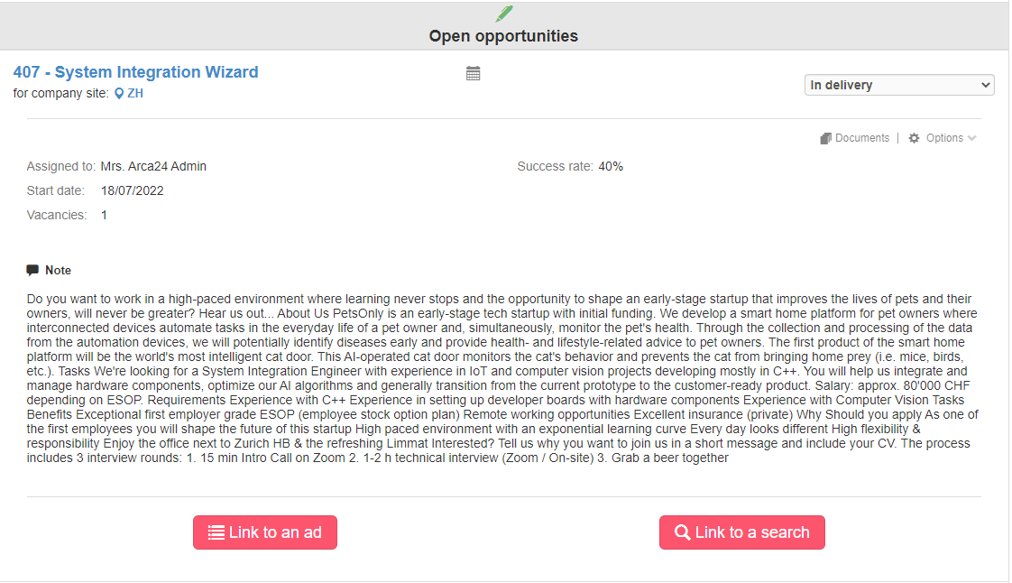

### Mailing List

This section allows you to create lists of companies/contact people to which you can send two types of bulk mail:

* Simple email, with text, images in the body of the mail and attachments;
* Email for “candidates proposals”, containing links to proposed candidates.

This is how the page showing the employer's work is displayed:

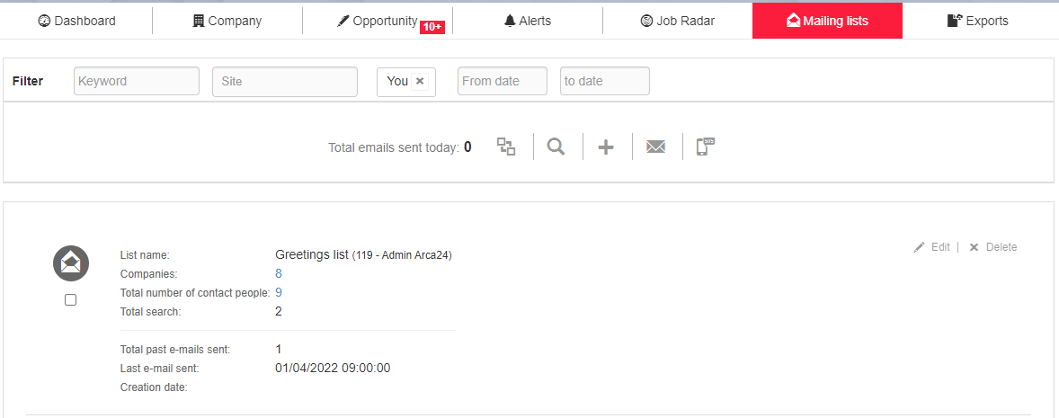

**Keyword filter:** it searches the title and comment field of the mailing lists on the page.

**Filter by site and employer:** it displays lists of colleagues, by site or by colleague, based on hierarchies.

**Date filter:** it extracts the lists created on the desired dates.

: it allows you to assign the created list to a colleague.

: it starts a database search to populate a list, by moving the user to the advanced search page.

: button to perform the **first step, create a new distribution folder (mailinglist)** in which to fill in the title and define the purpose in the note field.

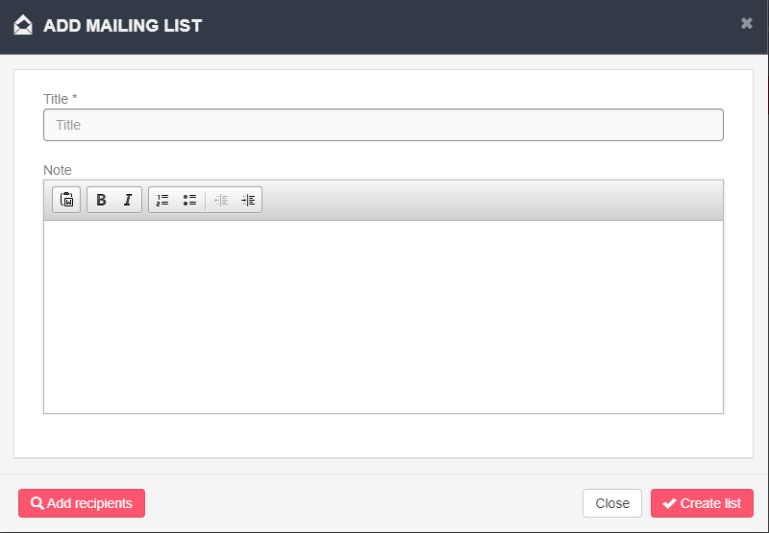

#### **Populating the mailing list**

The **second step** is to populate the lists with the email addresses of the recipients; clicking on “New search”, on the magnifying glass icon at the top of the page, or on the list editing, by selecting “Add recipients”.

In this way it is possible to set up a search in the company database, which will then be used to fill the list of email addresses.

If a search is carried out for **all companies**, the result of the search, and thus the import of the emails addresses into the list, will only consist of the company emails (contained in the company profile).

If a search is carried out for **all contact people**, the result of the search, and thus the import of the emails addresses into the list, will contain both the company emails addresses and the emails of the contact people (contained in the contact person’s tab).

Once the search has been carried out, the email addresses contained therein will be added to the mailing list via a cronjob that runs every 30 minutes (mailing lists are therefore not populated in real time).

Whenever new email addresses matching the parameters of the search linked to the mailing list are added to the database, these are automatically added to the list every 24 hours (again, mailing lists are not updated in real time).

**Individual populating**

Within the individual company profile or under the contact person string, it is possible to insert email addresses in one or more mailing lists. It is necessary to click on the appropriate button and then select the desired mailing lists.

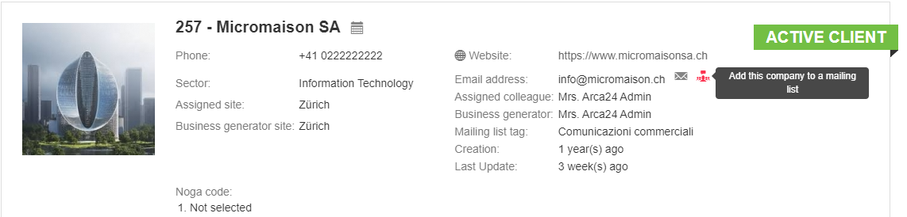

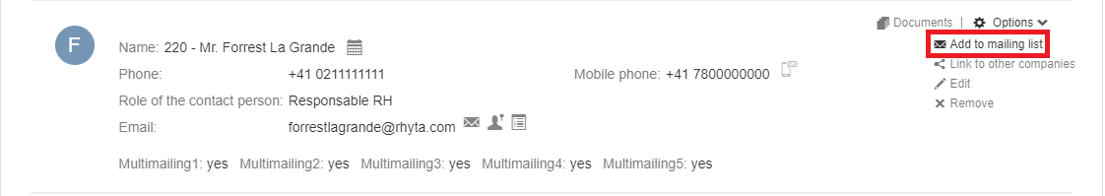

**Mass populating**

In order to **import recipients into the one-off list**, just select the companies concerned and choose “Multimailing” from the mass actions. Next, select the mailing lists desired.

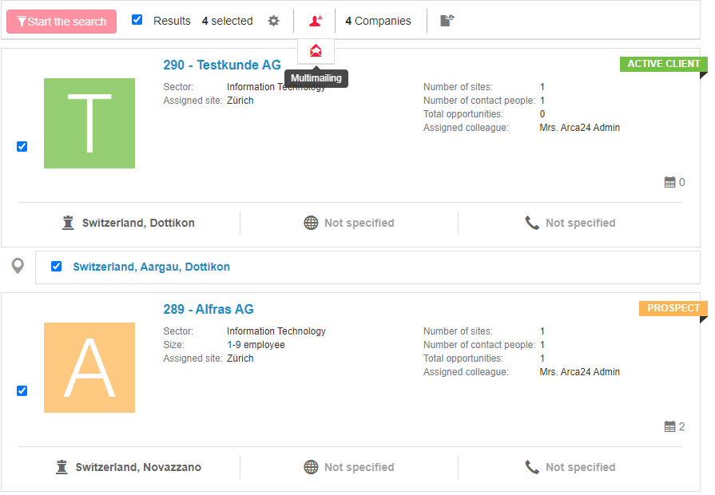

**Automatic populating**

This solution allows the mailing list to be automatically updated by linking database searches to it.

To assign **a search to a mailing list**, you have to start a search in the client module, by setting filters based on your needs, and link it to the mailing list selecting it from the appropriate section.

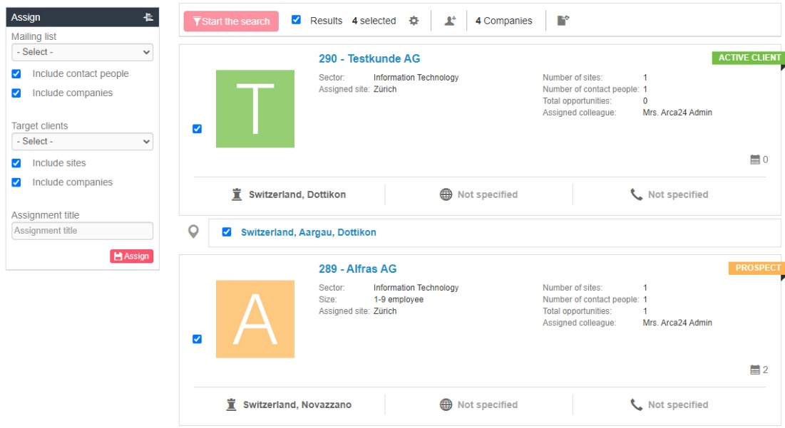

The flags “Include contact people” and “Include companies” allow you to choose which type of result you want to include in the mailing list.

When associating a search with a list, the system will automatically add new companies/contact people from the results to the mailing list. The cronjob updating the mailing list recipients runs **once a day**.

#### **Mailing list management**

In each mailing list, it is possible to view the number of recipients and the number of emails sent.

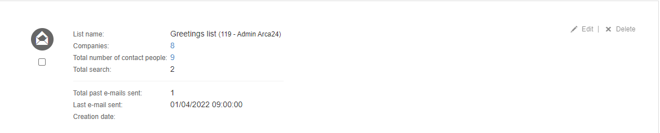

By clicking on “Edit”, you can view the list of recipients in the list; you can also add new recipients by searching the database or even delete the list.

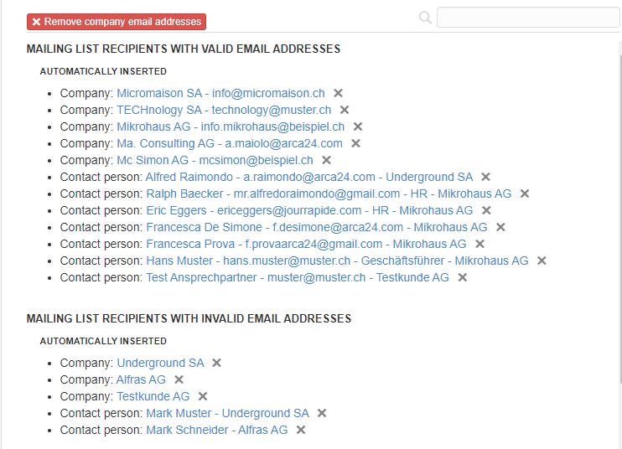

**Remove company email addresses**: it allows you to exclude company email addresses (i.e. the generic ones entered in the company profile), in order to have a mailing list consisting only of contact people addresses.

**Manually inserted:** recipients added via the button "Add to mailing list" (option available both for contact people addresses and for company ones).

**Automatically inserted**: recipients added automatically via linked searches.

**Mailing list recipients with invalid email addresses**, bothentered manually and automatically: it is advisable to check the email addresses of these recipients (e.g., absent email addresses or contact people removed).

**Not assigned to me:** all recipients entered in the mailing list who do not have the “owner” of the mailing list as assigned colleague are reported.

#### **Sending emails**

Two types of mailing list communication can be sent:

1. **Simple email or SMS** (OPTIONAL MODULE*)

Simply select the list, click the appropriate button and fill in the email fields to send an email:

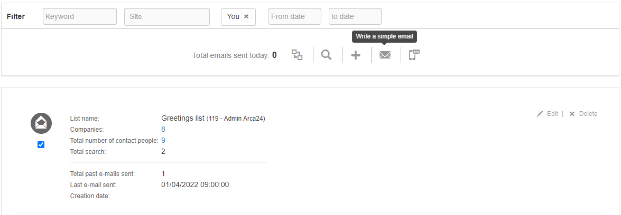

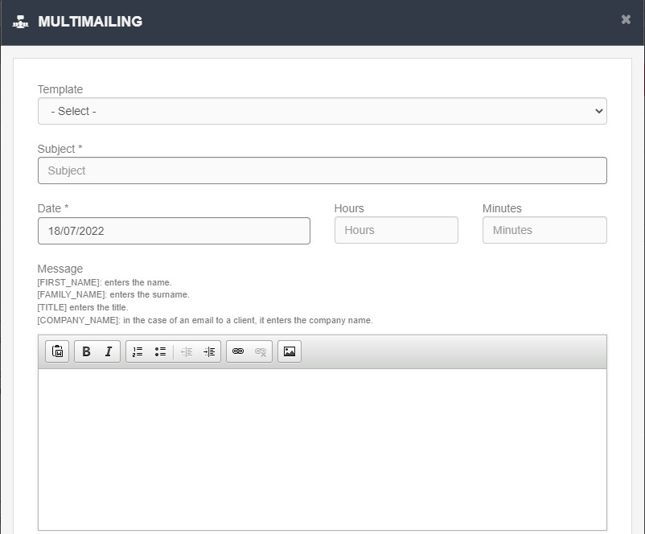

**Template (OPTIONAL MODULE*)**: management function allowing you to set up and save pre-filled email templates in the system, which you can use when needed.

**Subject**: compulsory to fill in.

**Sending date**: define the date and time at which you want to start sending the mass mailings (using the fields "Date", "Hours", "Minutes").

**N.B**: multimails are sent via a cronjob; 150 mails are sent every half hour (e.g., there are 450 mails to be sent: 150 in the first half hour from the scheduled time, 150 in the next half hour, the last 150 in the following half hour).

For more details on the fields available for filling in the mail, see “Multimailing” in the candidate section (section “Mass actions”).

**Message**: it is possible to use dynamic links to write the email, so that the recipients are automatically filled in the message text, as indicated in the template.

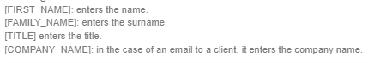

You can also include an image in the message and attach files to the email; in the sender line you can enter the name and surname of the employer or site sending the communication, instead of just the e-mail address, which will be displayed by the recipient.

The signature is inserted automatically based on the completion of the appropriate field in the seation “Account Management” -> ”Personal” -> ”Edit profile”.

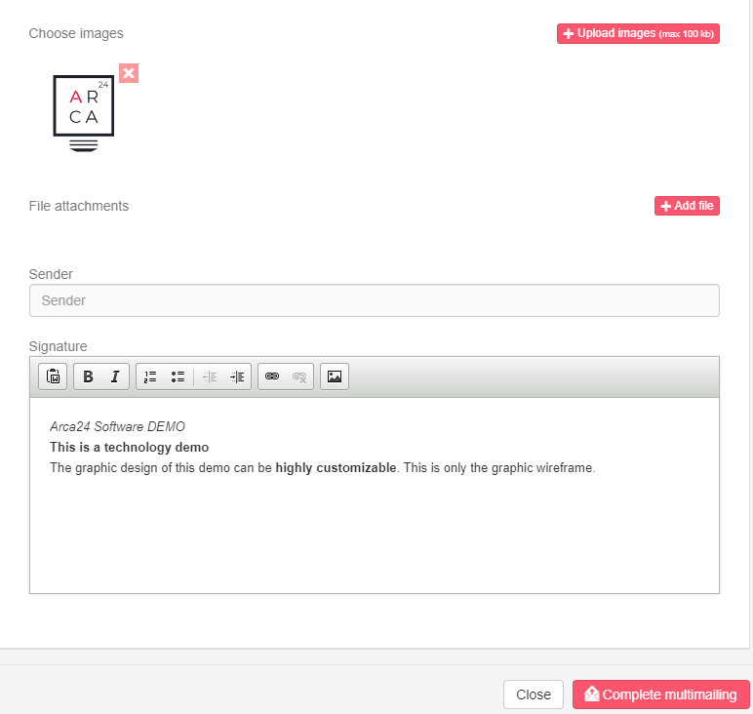

To send an SMS (*OPTIONAL MODULE), select the list and click 'Write a simple SMS':

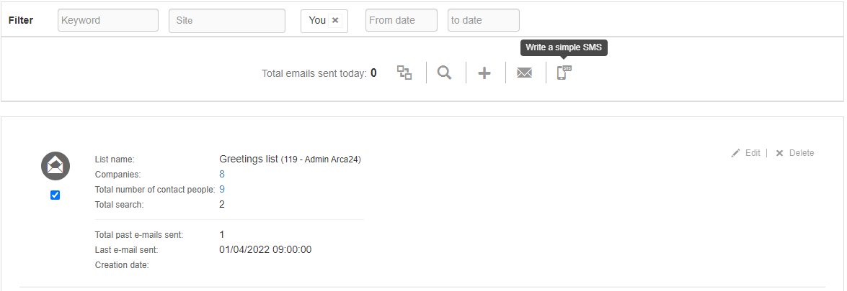

As in emails, fill in the text, date and time of sending.

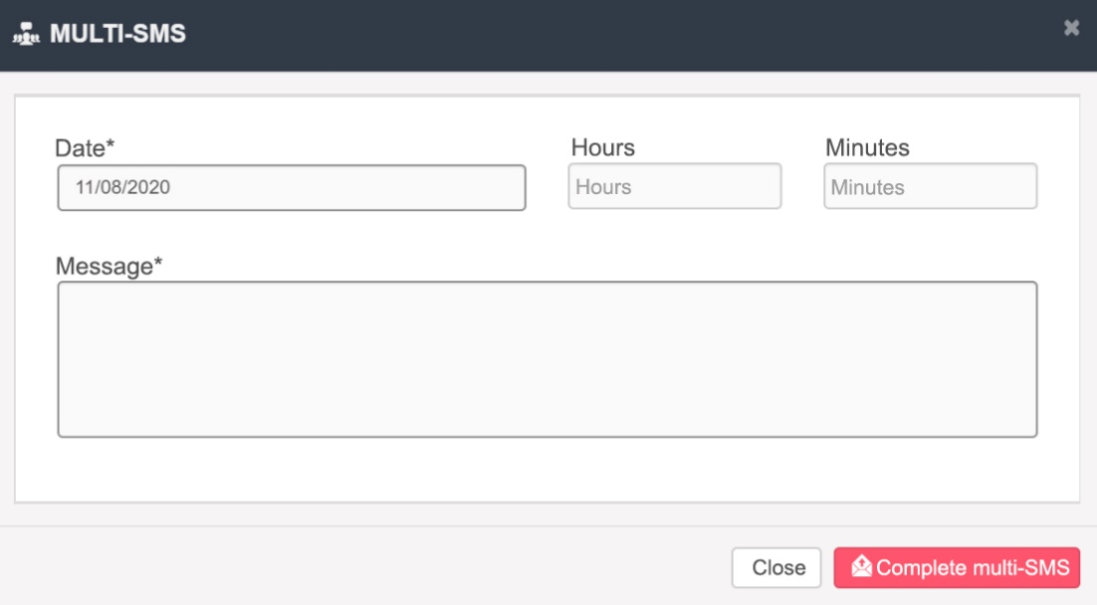

1. **Mail with candidate profiles** (*OPTIONAL MODULE): you need to move to advanced searches in the candidate module and search the candidates you want to propose in the database. Move the candidates to the **step “Selection”** and from there, using the appropriate button, add the chosen candidates to the mailing list.

**N.B.:** In the profiles of the candidates to be sent by mailing list, the tab “**Evaluation for multimailing**” needs to be compiled.

Once the candidates have been included in the list, return to the mailing list section and prepare the email. To do this, just click on “Scheduled mail”.

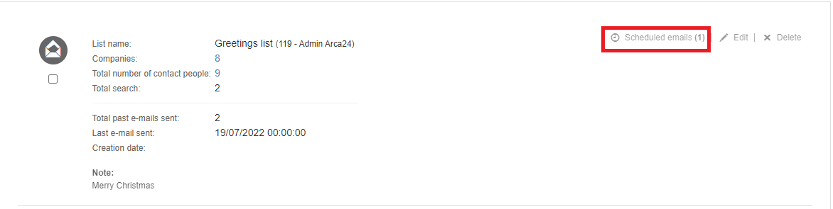

From the screen that opens, you can view the list of mails to be prepared and, if applicable, the number of profiles included in the sending. Click on "Write email" to prepare the email:

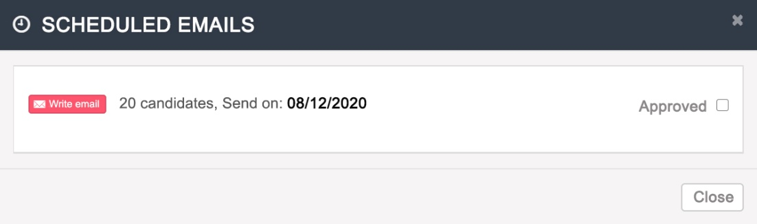

In this screen, you can enter the subject and text of the email, edit the sender and signature and view the list of profiles that will be sent to the recipients.

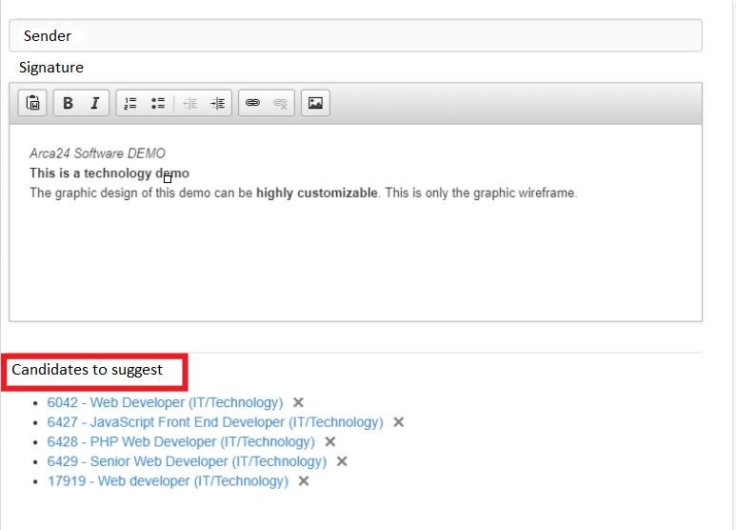

Once the email setting has been saved through the button “Save”, it is necessary to return to the edit mode and select the approval flag to allow the email to be sent. The flag is useful to check the email before sending; this check can be done by the user who scheduled the mail or by a colleague who is in his/her hierarchy.

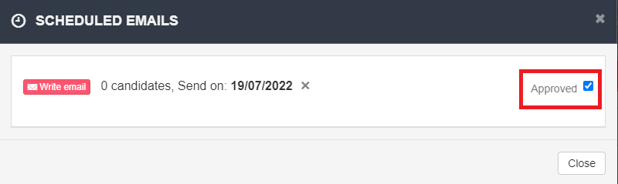

Within the activities of both the company and the candidate, multimailing will be tracked.

The mass email with the candidate proposal shows the notes on the candidates (compiled in the section “Evaluation for multimailing”) in the email text and allows the company contact person with access to the restricted area to leave his/her feedback.

**N.B.:** In case the recipient is a company email address or a contact person without access to the company area, the recipient can reply to the mail, but cannot leave any feedback.

### Exports

In this section, all files exported from the various sections of the client module are saved; they can then be downloaded or deleted.

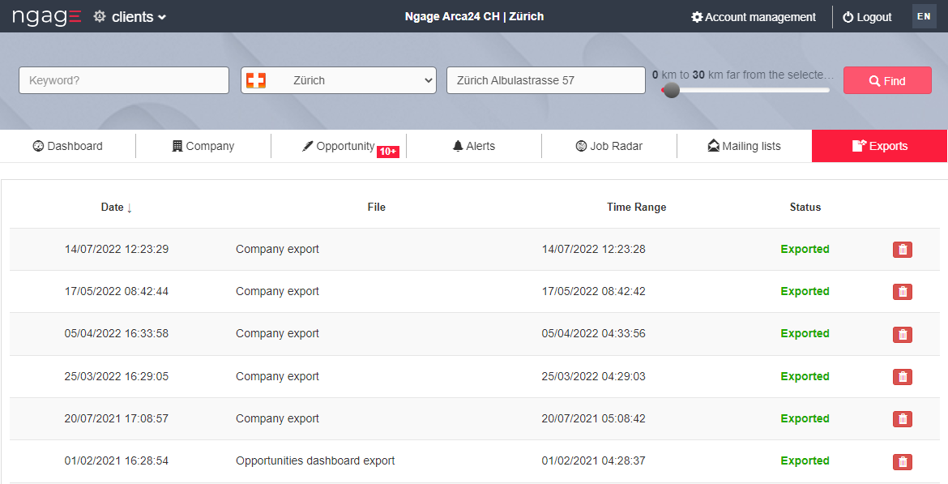

* 1. More tools

**JobArch.com**

Jobarch is a software owned by Arca24 that allows you to have an external database, useful for searching profiles. You can post job vacancies or make searches on Jobarch, in the same way as Ngage, and import candidates via the ‘import’ button.



For more details, see the handbook NGAGE - jobarch – en

**CVideo**

**N.B.:** In order to access CVideo sessions, it is necessary to enable the user's permission in the section “Permissions management”.

For more details on the integration, see the handbook NGAGE - ExaminLab CVideo SoftSkillLab – en.

**ExaminLab**

**N.B.:** In order to access ExaminLab sessions, it is necessary to enable the user's permission in the section “Permissions management”.

For more details on the integration, see the handbook NGAGE - ExaminLab CVideo SoftSkillLab – en.

**SoftSkillLab**

**N.B.:** In order to access the SoftSkillLab sessions, it is necessary to enable the user's permission in the section “Permissions management”.

For more details on the integration, see the handbook NGAGE - ExaminLab CVideo SoftSkillLab – en.

## MODULE REPORTING

The module “Reporting” allows you to monitor all activities related to recruiting and sales KPIs, to check conversions (registrations and applications of candidates based on the application origin as well as on the number of hires), view active contracts and email logs, so as to check emails sent.

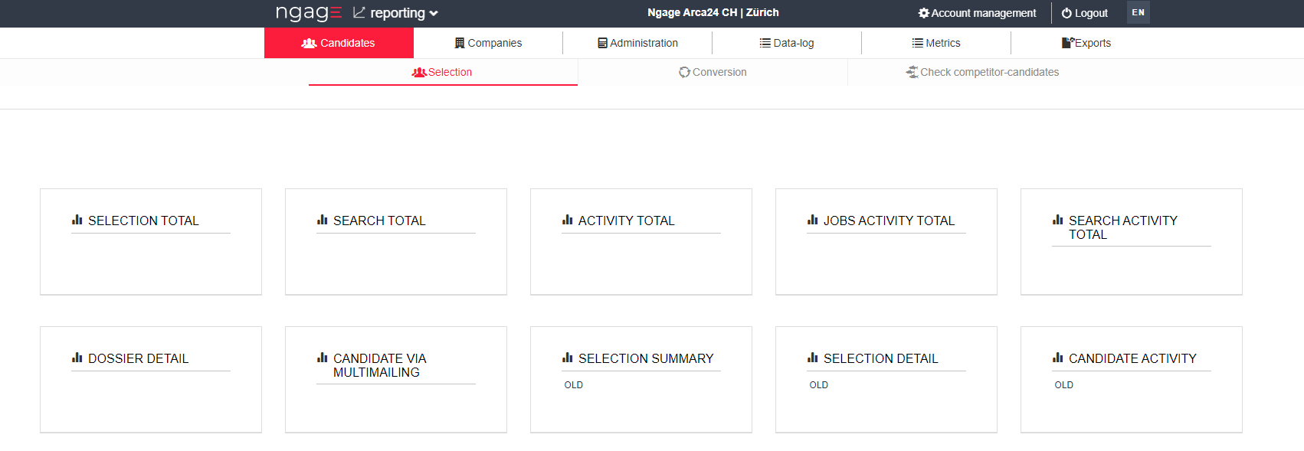

### Selection, Companies and Conversion

**Reports layout**

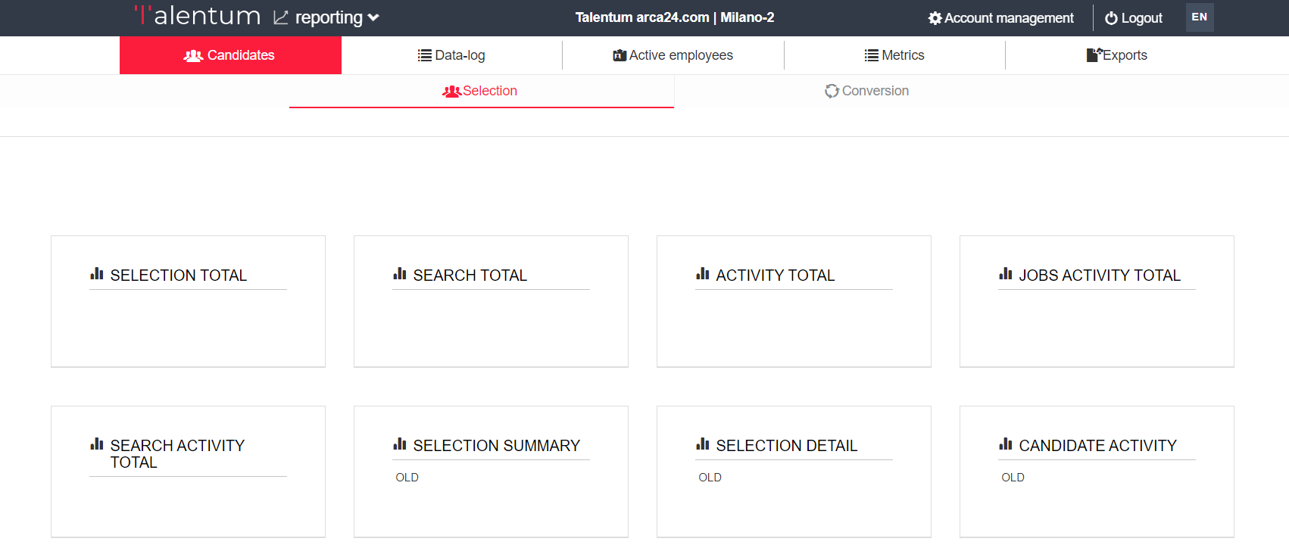

Clicking on the button with the title of the report opens the relevant screen; to return to the main menu, click on the icon 

On the right-hand side is the detailed description of the report content.

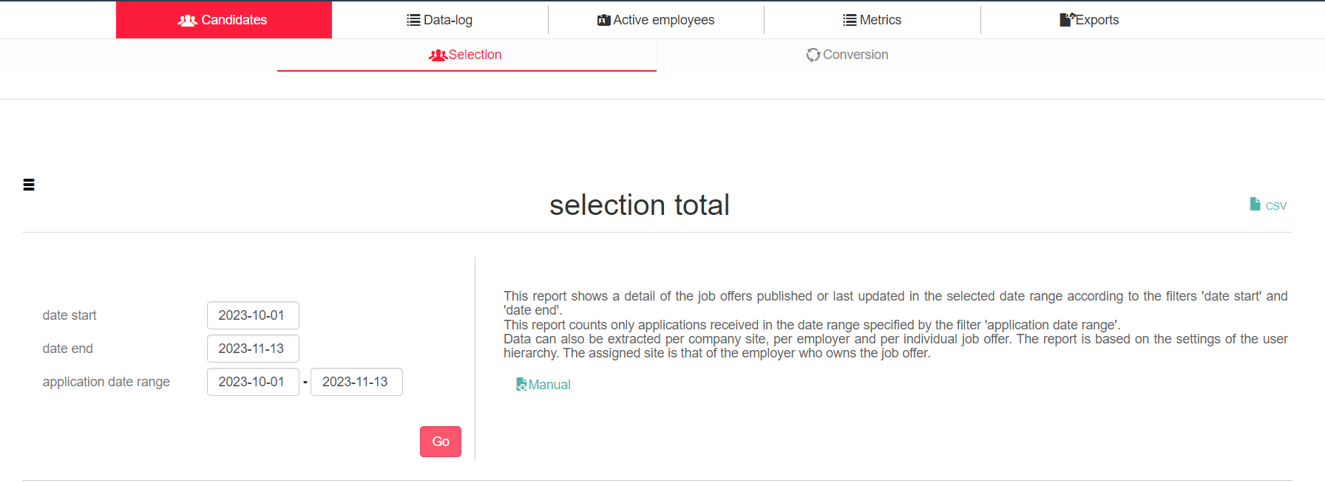

Below the report description, a 'Manual' link is displayed that opens a CSV file containing detailed descriptions of the contents of all fields represented in the RAWDATA, i.e. the report with as much detail as possible.

The Manual of this report contains the following columns:

* Name: The name of the field that is described on the line (e.g. Job post ID)
* Is Link: The link to the applicant or customer that is shown in the report at both
* Format: the format of the content of the column (e.g. Id-title shows the ID number and the title of the advertisement)
* Description: the column contains the exact description of the data shown in that box

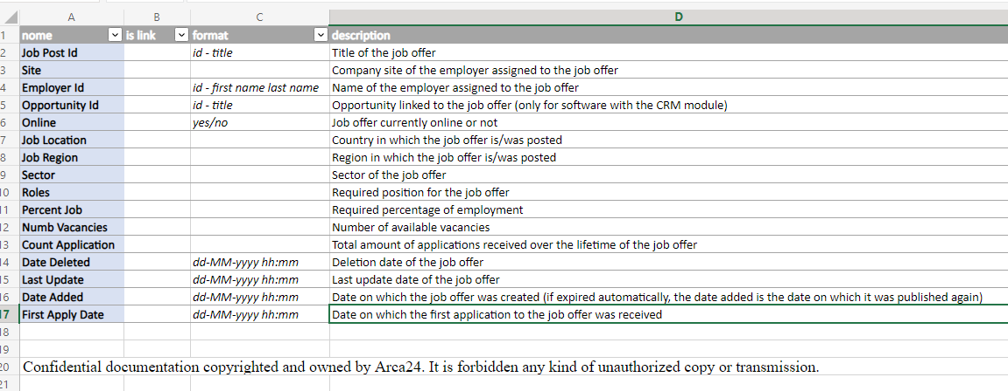  
To start the report extraction, enter a date range (from....to.....) on the left-hand side of the selected report, and click GO.

Only the "Selection total" report has the filter for "application date range", which is used to filter the result according to the date on which the applications took place.

To process the report, you can use the left-hand side:

1. Set the search filters; the filters "**Site**" and "**Employer**" are based on the sites/users groups; they can be pre-filled by default with the name of the person carrying out the search.

How to select filters properly

You need to use the magnifying glass icon to see the full list of entries you can select. You can:

* + highlight one or more entries (by holding down the Ctrl key);
  + select all entries with the button "Select All”;
  + reset the selected entries with the button “Clear”.

It is always necessary to confirm the filter setting by clicking on "**OK**".  
It is possible to reset the set filters by clicking on the “x” near each selected entry.

1. Click on “**Go**”.

By using the appropriate icons in the top right-hand corner, you can extract a CSV file. The download is carried out in real-time.

**N.B.:** all data are displayed in real-time. This means that if the filters are not set correctly, there might be slowdowns/time-outs in the system.

**N.B.:** all reports and the related interface are shown in English.

By clicking on the name of a candidate or customer within the statistics of the reporting section, you can open and view the candidate's and the customer's sheet directly.

**5.1.1 Selection**

**SELECTION TOTAL**

This drill down report enables you to firstly start with an overview of the advertisements created or updated in the selected date range, and then go into detail for each of them. The ‘application date range’ filters also includes the possibility of entering in date range the applications we want to display.

More precisely, in this report the total adverts, online adverts, offline adverts, deleted adverts, the number of adverts that received applications and the total number of applications according to the filter date range are shown.

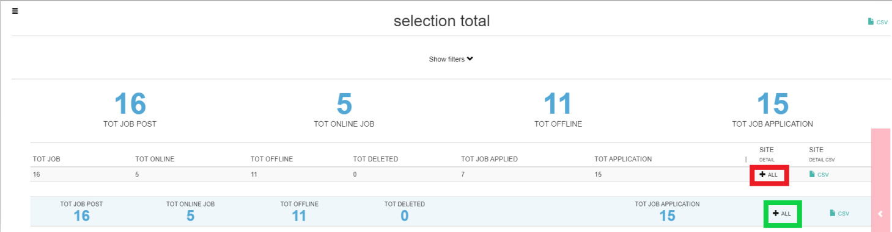

1. Clicking on at "site detail" opens the split with respect to the sites on which the employer has visibility, clicking on CSV at "site detail csv" downloads the csv corresponding to the site detail.
2. Clicking on at the totals row opens the selection rawdata showing the details of each advertisement considered for the calculation of the totals shown in the selection total.

**Site Detail**

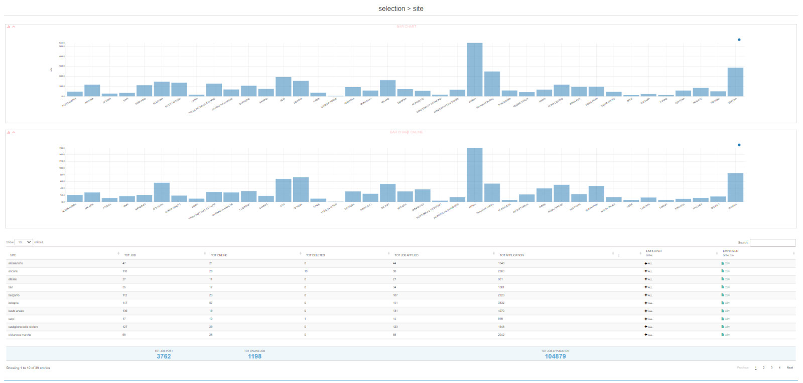  
The charts show for each location: the number of total ads and online ads.

In the table, for each site: the total number of advertisements, online advertisements, deleted advertisements, the advertisements for which applications were received and the total number of applications. By clicking on   
 you can open the employer detail, with the split for each employer in the location. Clicking on CSV under 'employer detail csv' downloads the csv corresponding to the employer detail.

**Employer detail**

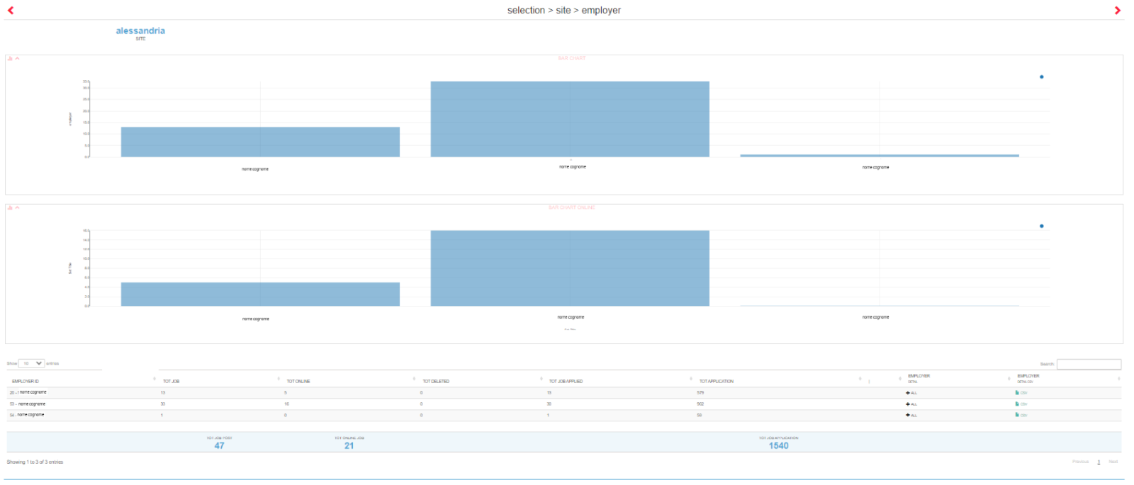The charts show for each employer: the number of total ads and online ads. In the table, for each employer: the total number of advertisements, online advertisements, deleted advertisements, the advertisements for which applications were received and the total number of applications received. By clicking on  you can open the selection rawdata, with the details of each advertisement assigned to the specific user. Clicking on CSV under 'employer detail csv' downloads the csv corresponding to the selection rawdata filtered by employer.

**Selection rawdata**

Please note: If opened via employer detail, it is filtered for the selected employer. If opened directly from selection total, no filtering by employer is applied (so you will see the details of all ads on which the logged-in employer has visibility).

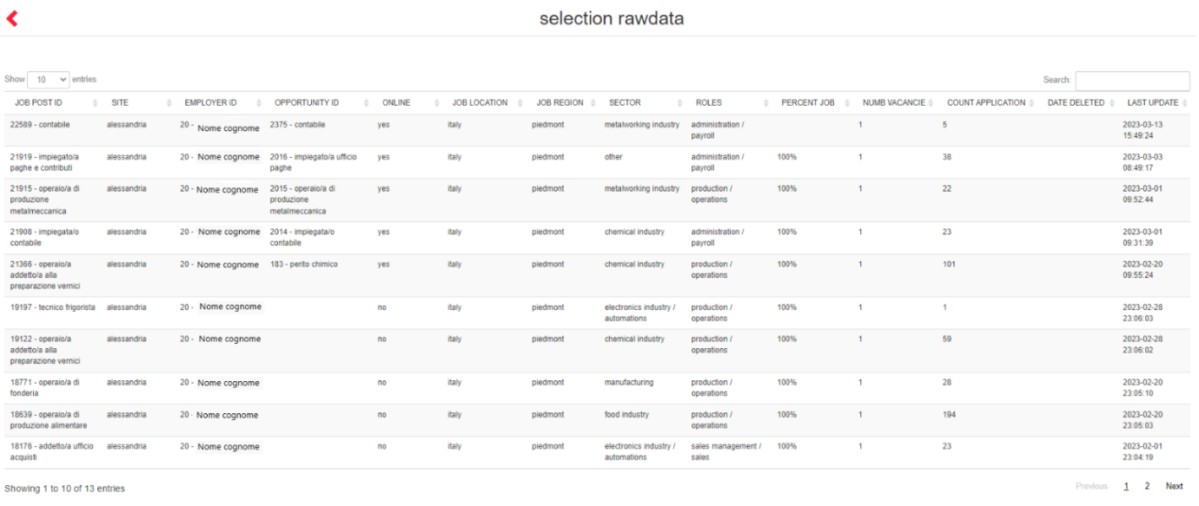  
The following is shown for each advertisement: location ID and title, employer, opportunity (*valued only CRM module active*), online (yes/no), country and region, sector, role, hourly availability, vacancies, application number, deletion date (if deleted), last modification date, date of creation of the advertisement (in the case of an automatically expired offer, the date added is the date on which it was re-published) and date of the first application received.

**SEARCH TOTAL**

Drill-down report showing the details of all searches (saved and unsaved) created or last updated in the selected date range according to the 'start date' and 'end date' filters.

Data can also be extracted per company site, per employer and per individual search performed. Only searches whose last update date does not exceed 24 months are shown. The assigned site is that of the employer who owns the search.

In the Search Total, the total searches, the deleted searches, the number of candidates present in step 2 "Interview" of the searches under examination, the number of candidates moved to step 3 "Selection" for the searches under examination are shown, depending on the date filter and the visibility of the employer that is carrying out the extraction.

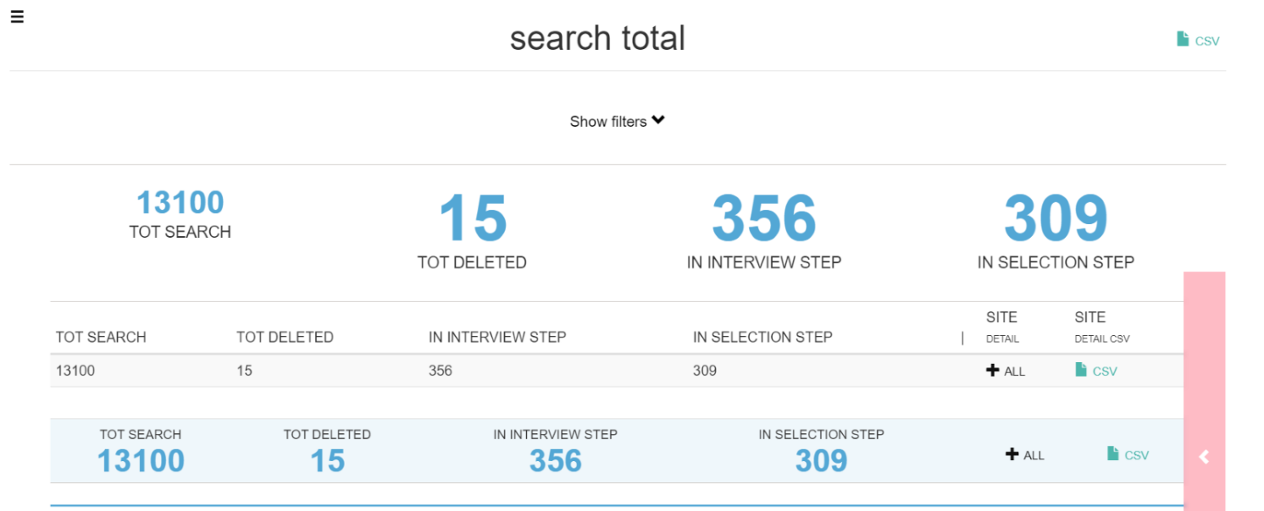

1. Clicking on next to “site detail” opens the split with respect to the sites on which the employer has visibility, clicking on CSV at "site detail csv" downloads the csv corresponding to the site detail
2. Clicking on  next to the totals row, the search rawdata is opened showing the detail of each search based on the totals shown in the search total

**Site Detail**

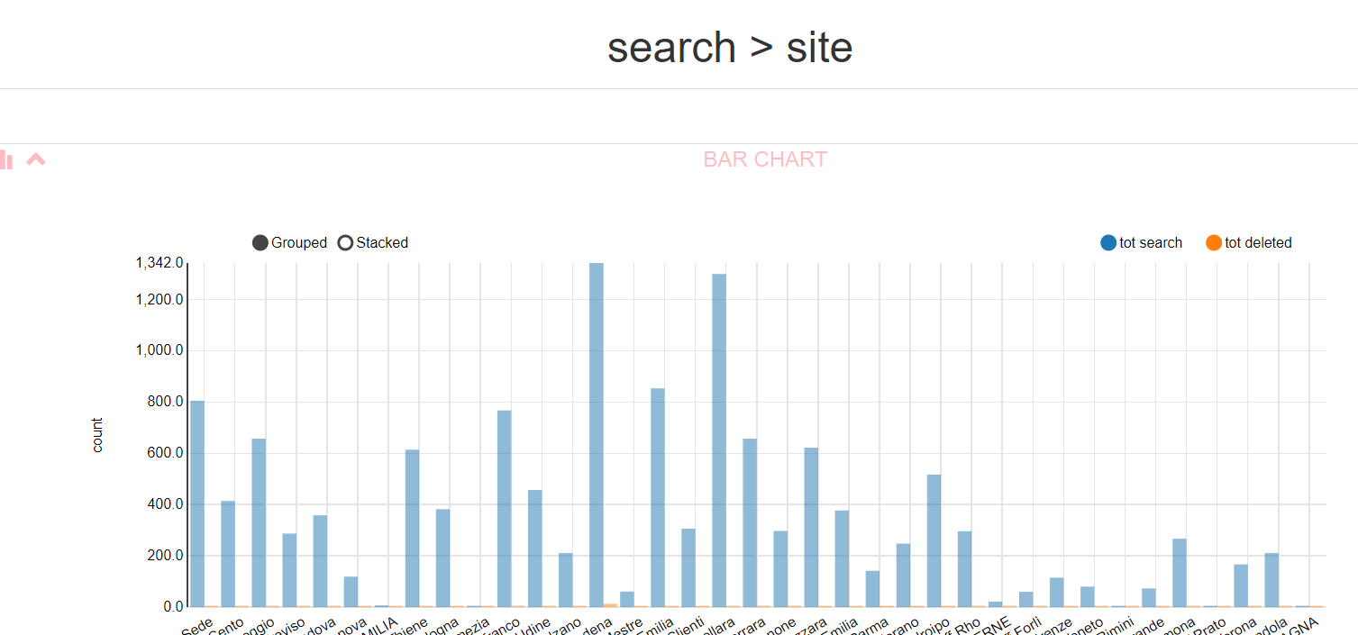

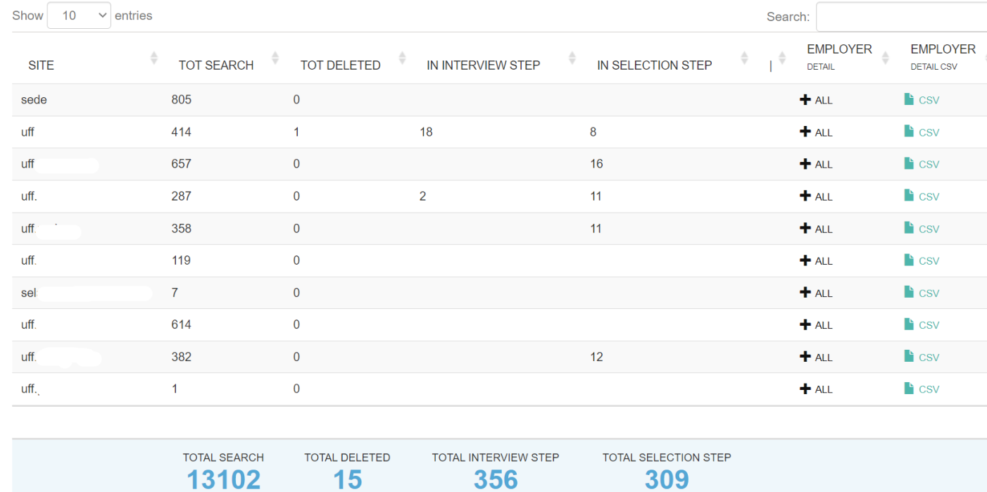  
The graphs show for each venue: the number of searches and the number of deleted searches. The charts show for each location: the total number of searches, the total number of deleted searches, the number of candidates moved to step 2 "Interview", the number of candidates moved to step 3 "Selection".

By clicking on you can open the employer detail, with the split for each employer in the location. Clicking on CSV under "employer detail csv" downloads the csv corresponding to the employer detail.

**Employer Detail**

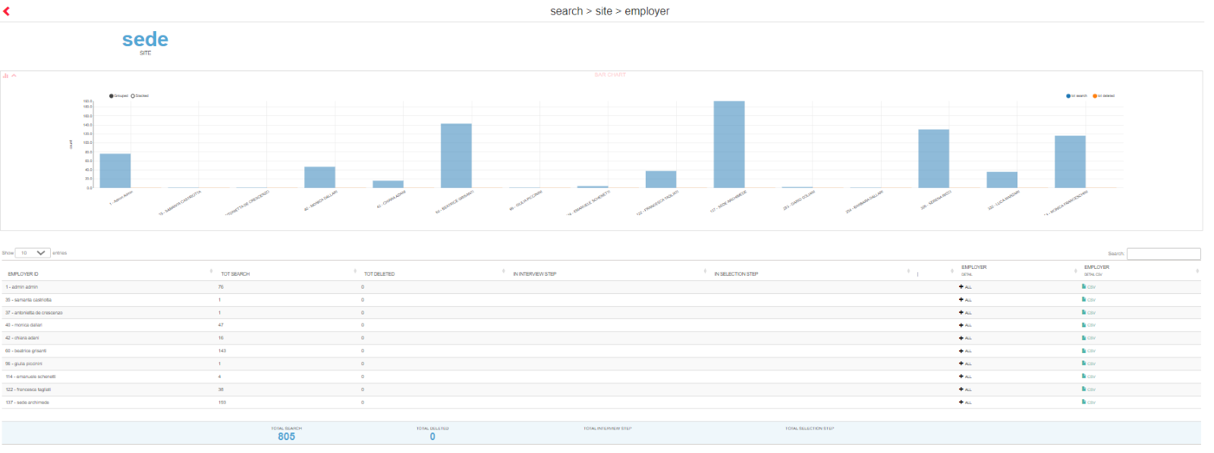The graphs show for each employer: the number of searches and the number of deleted searches. In the table, for each location: the total number of searches, the total number of deleted searches, the number of candidates moved to step 2 "Interview", the number of candidates moved to step 3 "Selection".

By clicking on  you can open the search rawdata, with the details of each search assigned to the specific user. Clicking on CSV under "employer detail csv" downloads the csv corresponding to the search rawdata filtered by employer.

*Search rawdata*

Please note: If opened via employer detail, it is filtered for the selected employer. If opened directly from search total, no filtering by employer is applied (so you will see the details of all searches on which the logged-in employer has visibility).

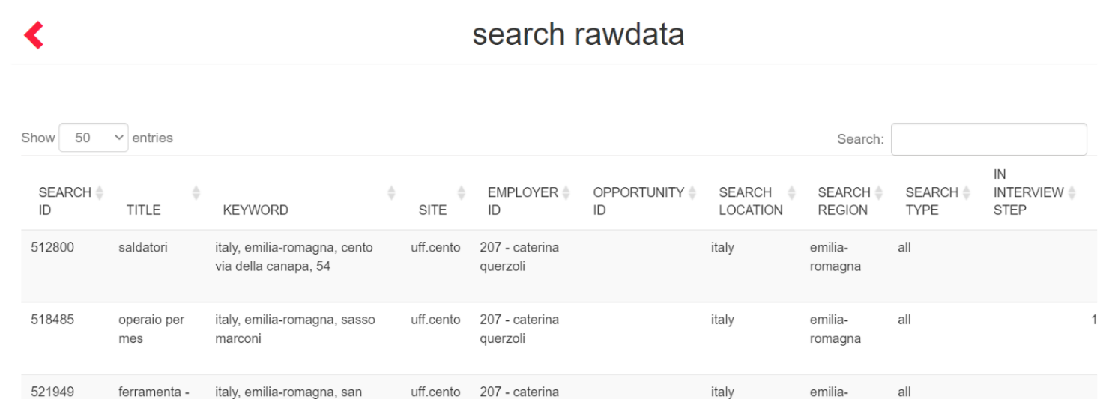

For each search, the following is shown: ID and title, keyword entered in search, location, employer, opportunity (*valued only CRM module active*), country and region, search type, number of candidates in step 2 and 3, date of deletion, date of search update, date of search entry.

**ACTIVITY TOTAL**

This drill down report enables you to start from an overview of the activities manually entered on candidates and get to the detail of each activity. The results take into account the filter date and visibility of the employer who is performing the extraction.

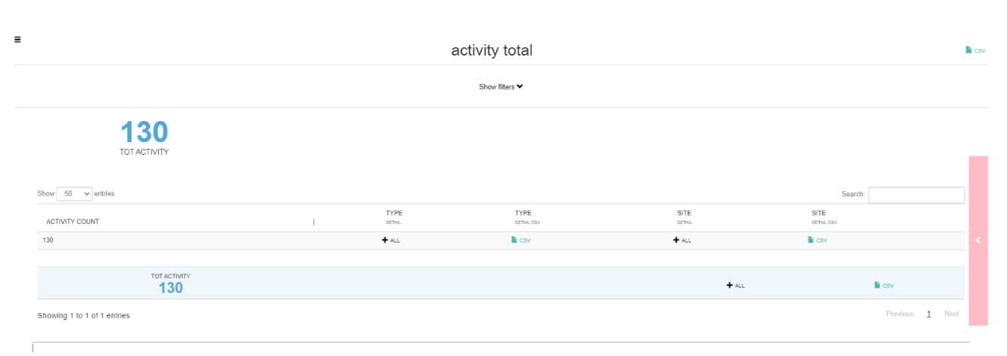

1. Clicking on next to "type detail" opens the split with respect to the types of activities entered on which the logged in employer has visibility, clicking on CSV at "type detail csv" downloads the csv corresponding to the type detail.
2. Clicking on next to "site detail" opens the split with respect to the sites on which the employer has visibility, clicking on CSV at "site detail csv" downloads the csv corresponding to the site detail.
3. Clicking on next to the totals row opens the activity rawdata showing the details of each advertisement considered for the calculation of the totals shown in the activity total.

**Type Detail**

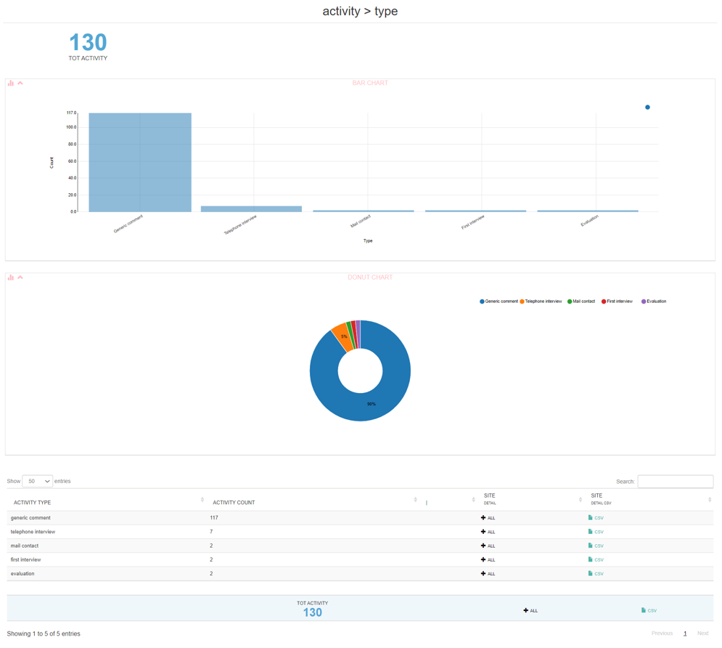  
The charts show the number of activities per type and the percentage of the total. The table for each type of activity shows the number of activities entered.

Clicking on  next to 'site detail' opens the split by site; clicking on CSV at 'site detail csv' downloads the csv corresponding to the site detail.

**Site detail**

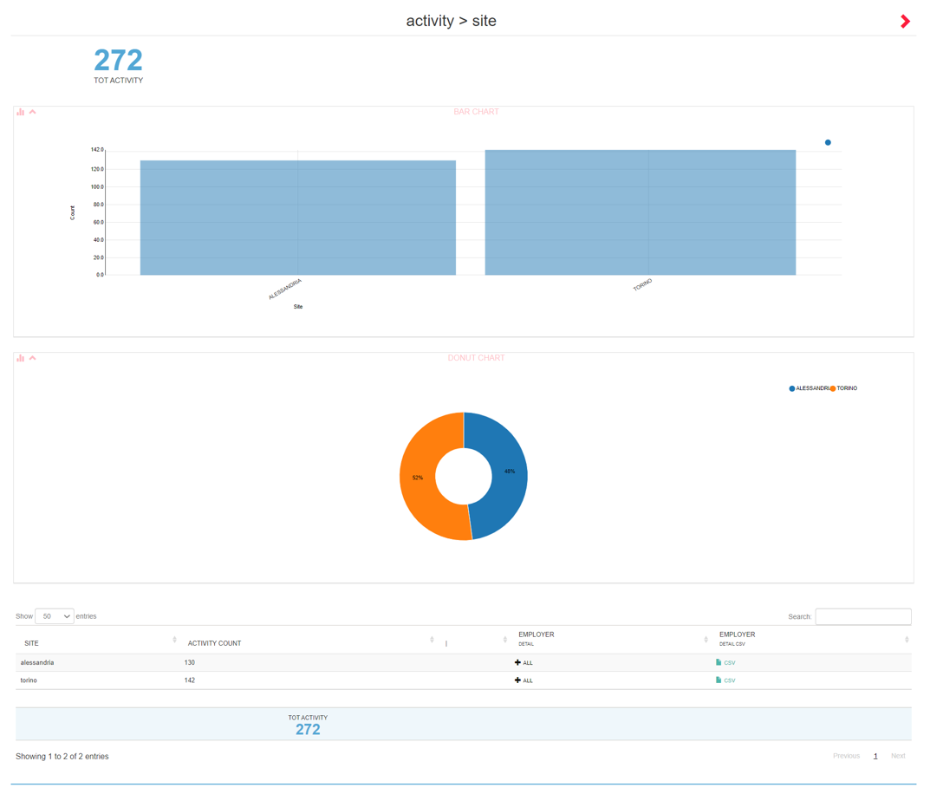The graphs show the number of activities per venue and the percentage of the total. In the table, the total number of activities entered is shown for each location. If the report is opened by activity type it will be prefiltered by activity type. Clicking on  next to "employer detail" opens the split by employer; clicking on CSV at "employer detail csv" downloads the csv corresponding to the employer detail.

**Employer detail**

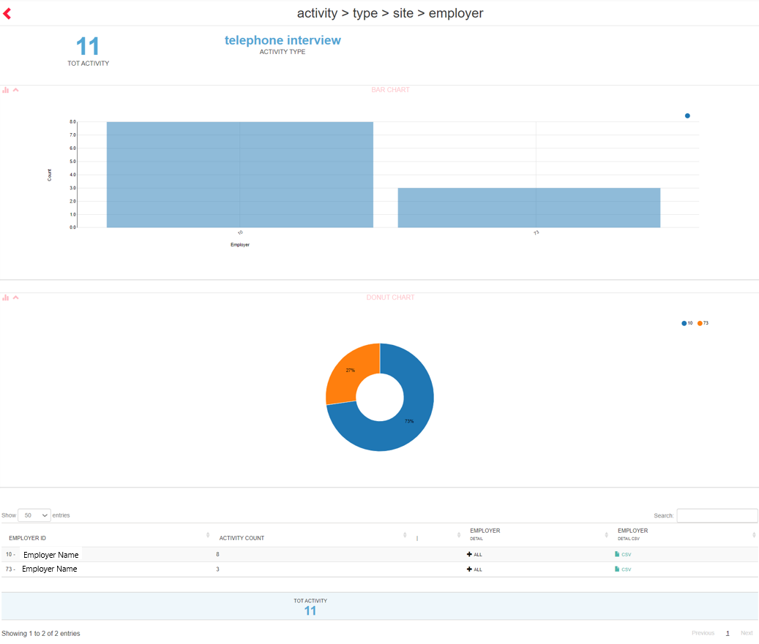

For each employer, the number of activities (possibly prefiltered by type/location) is shown. Clicking on   
next to "employer detail" opens the activity rawdata; clicking on CSV at "employer detail csv" downloads the csv corresponding to the activity rawdata.

**Activity rawdata**

Please note: If opened via employer detail it is filtered for the selected employer. If opened directly from activity total, no filters are applied per employer (so you will see the details of all activities on which the logged-in employer has visibility).

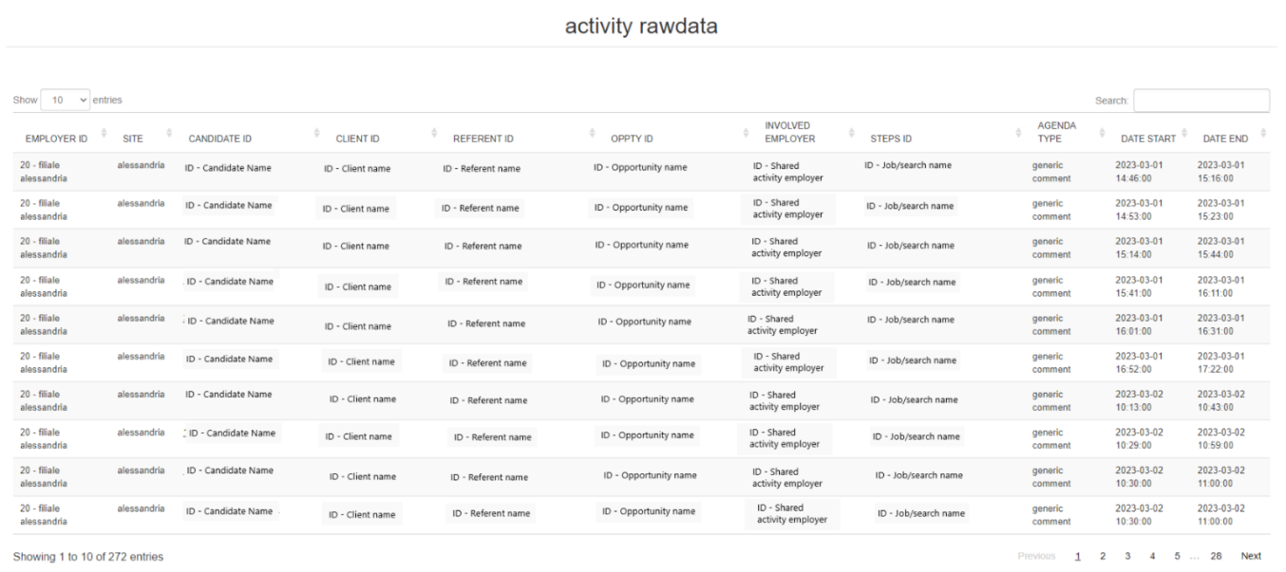  
For each activity is shown employer and assigned location, candidate, employer with whom the activity is shared, advertisement/search to which the activity is linked, activity type, start and end date. For installations with CRM and for activities where provided for, the columns CLIENT ID, REFERENT ID, OPP.TY ID, with customer, referrer and opportunity linked to the activity, are displayed.

**JOBS ACTIVITY TOTAL**

Drilldown report showing the detail of the activities carried out within an advertisement, based on the filter start date and end date. The report is based on the employer's visibility.

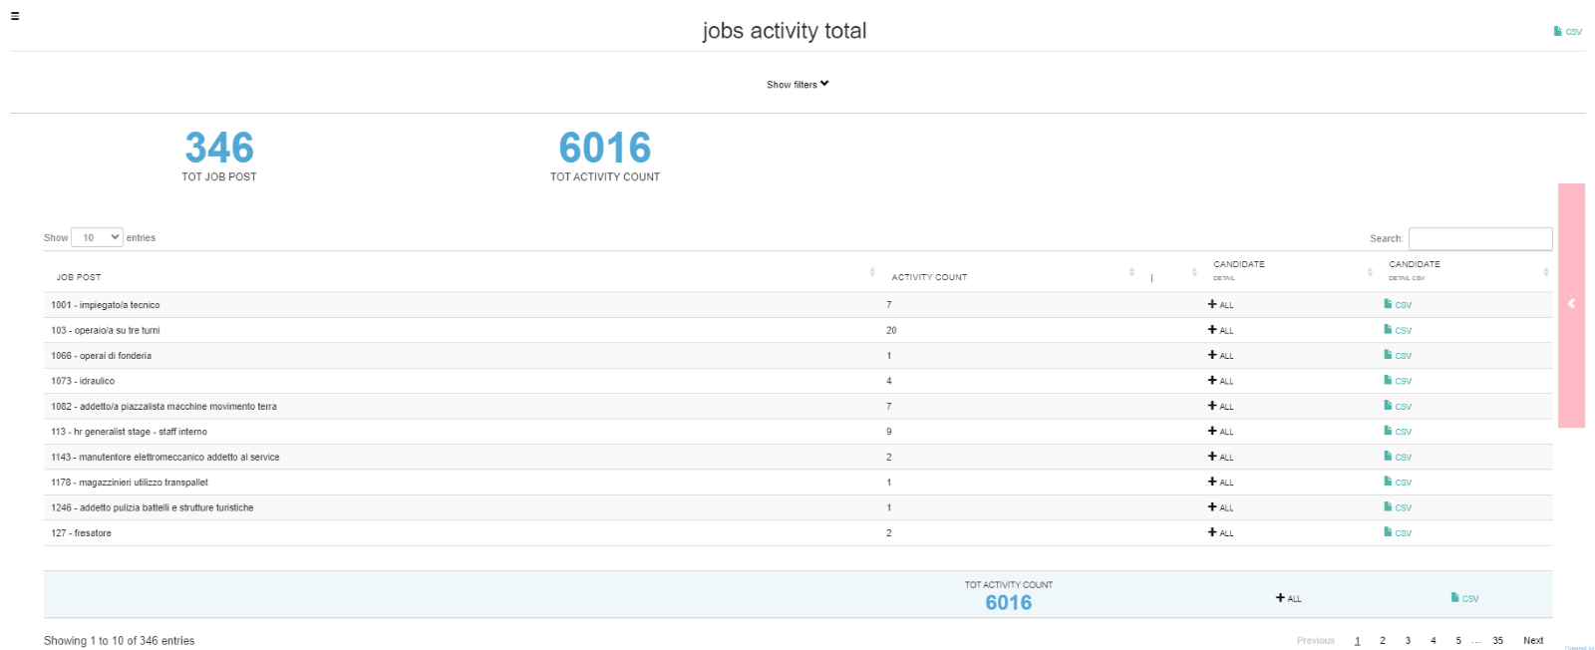  
Clicking on  next to 'candidate detail' opens the split showing the activities performed within the individual vacancy, divided by candidate; clicking on CSV at 'candidate detail csv' downloads the corresponding csv.

*Jobs activity Candidate*

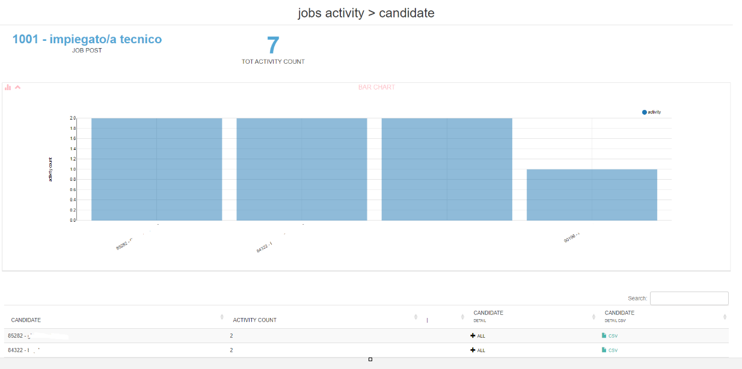  
Clicking on  next to "candidate detail" opens the split against the jobs activity rawdata on the individual candidate, with details for: job number and title, job status (online yes/no), candidate id and name, type of activity, activity notes (if any), start and end date of the activity, creation date of the activity (often different from the start date as activities are programmable)

*Jobs activity rawdata*

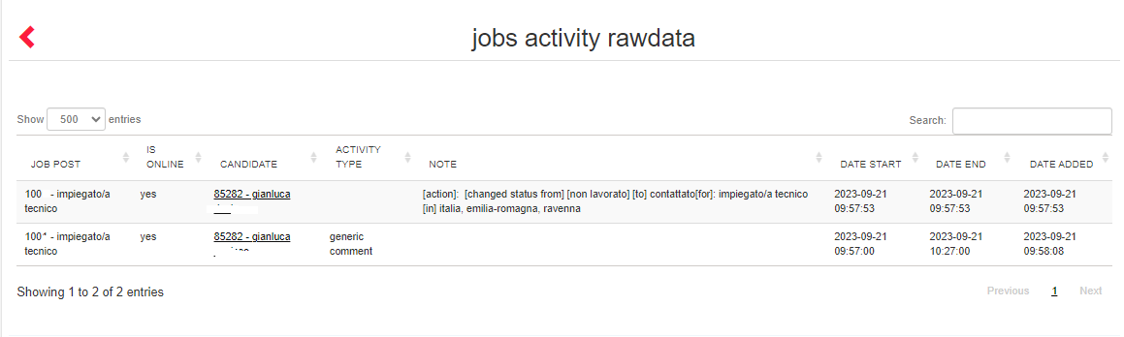  
**SEARCH ACTIVITY TOTAL**

Drilldown report showing the detail of the activities performed within the saved searches, according to the filter start and end date. Data can also be extracted per candidate. The report is based on the employer's visibility.

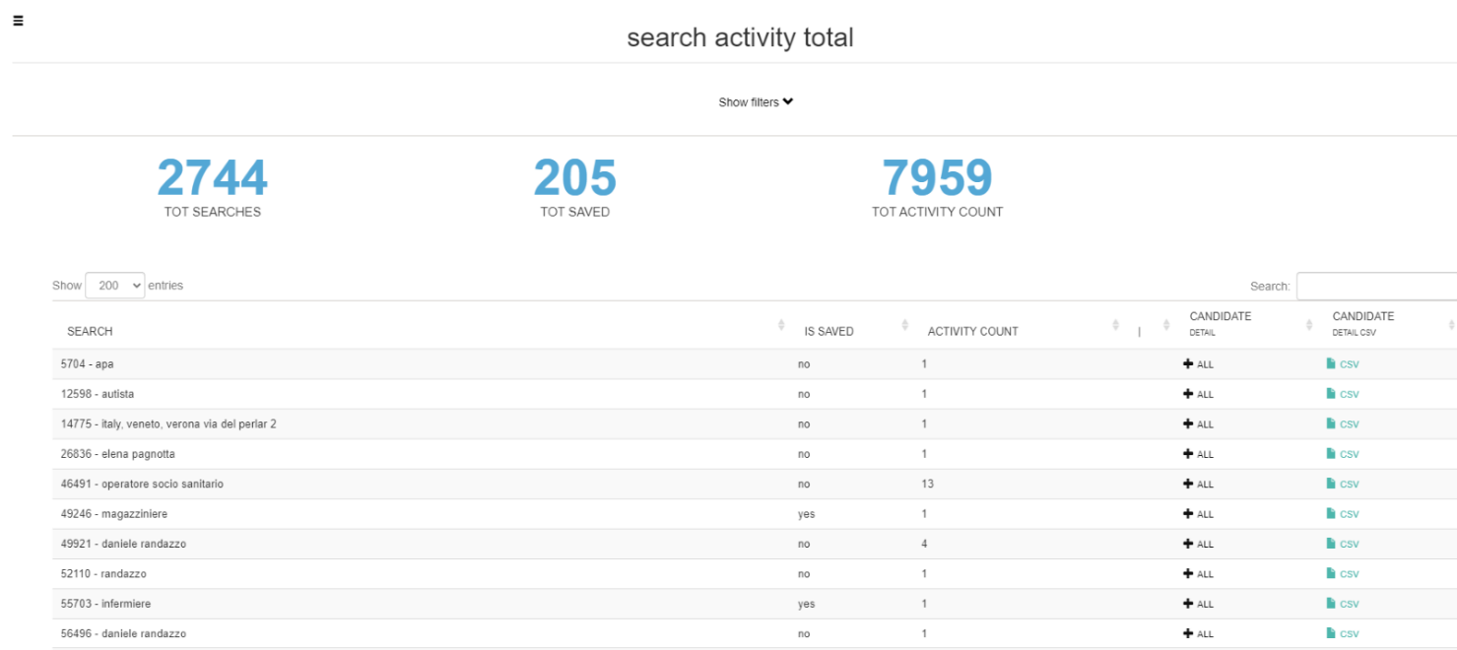  
Clicking on  next to at 'candidate detail' opens the split showing the activities performed within the individual saved search, divided by candidate; clicking on CSV at 'candidate detail csv' downloads the corresponding csv.

*Search activity Candidate*

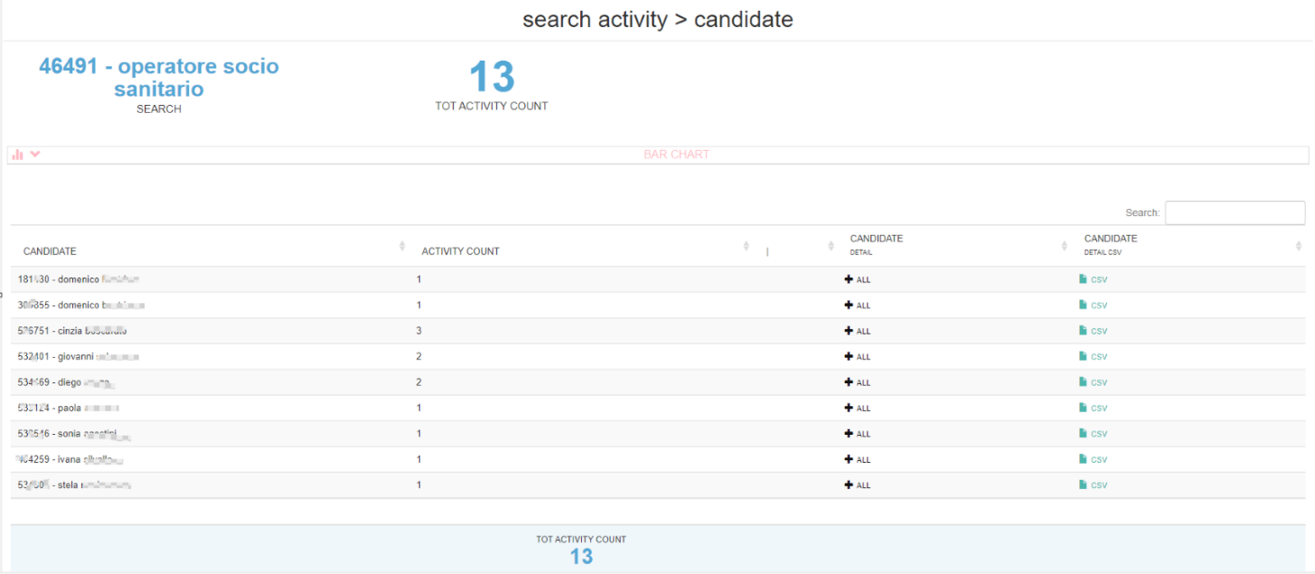

Clicking on  next to'candidate detail' opens the split with respect to the search activity rawdata on the individual candidate, with details for: search number and title, search status (saved or unsaved), candidate id and name, activity type, activity notes (if any), activity start and end date, activity creation date (often different from the start date as activities are programmable).

*Search activity rawdata*

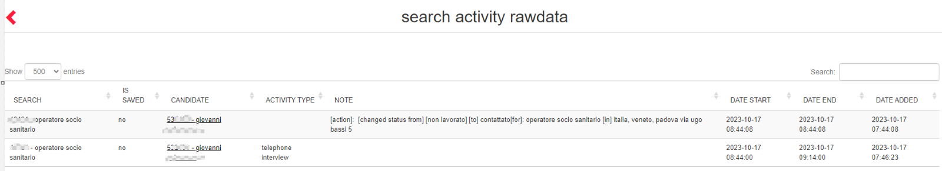

**SELECTION SUMMARY (OLD)**

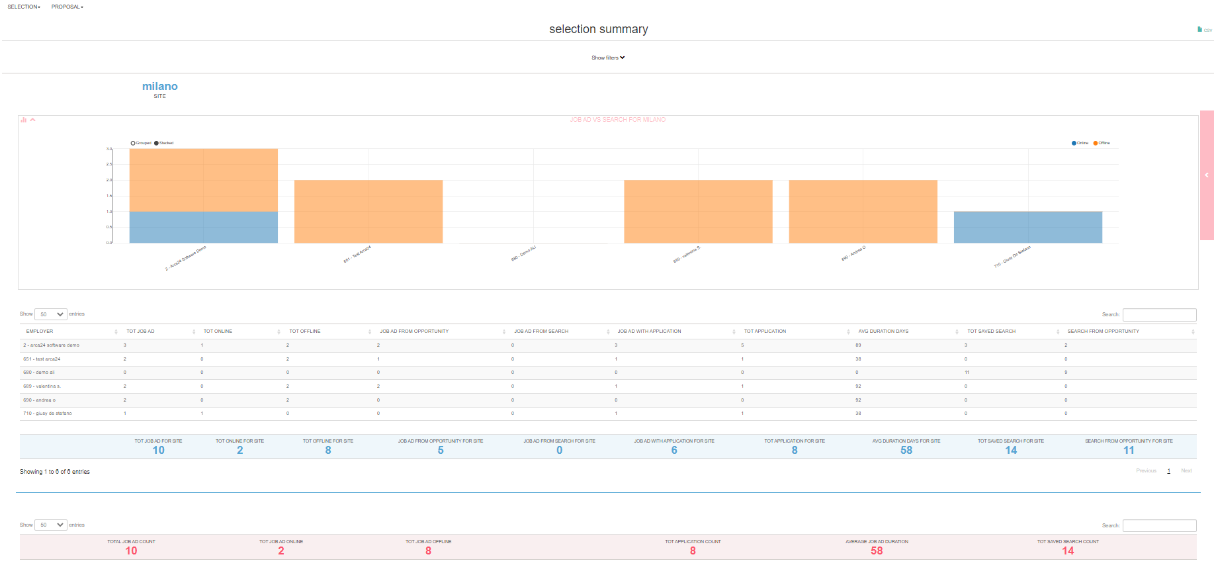

The report shows a summary of the **job offers and the saved searches** in DB in the database by site and employer, according to the date filters "Start date - End date".

For each employer, you can see the total number of online and offline job ads, the number of job ads linked to an opportunity as well as to a saved search, the number of job ads that received at least one application and the total number of applications. The average duration of job advertisements in calendar days is then shown: the result refers to calendar days (weekends and non-working days included over 24 hours). Moreover, you can see the number of saved searches and of those linked to an opportunity.

**SELECTION DETAIL (OLD)**

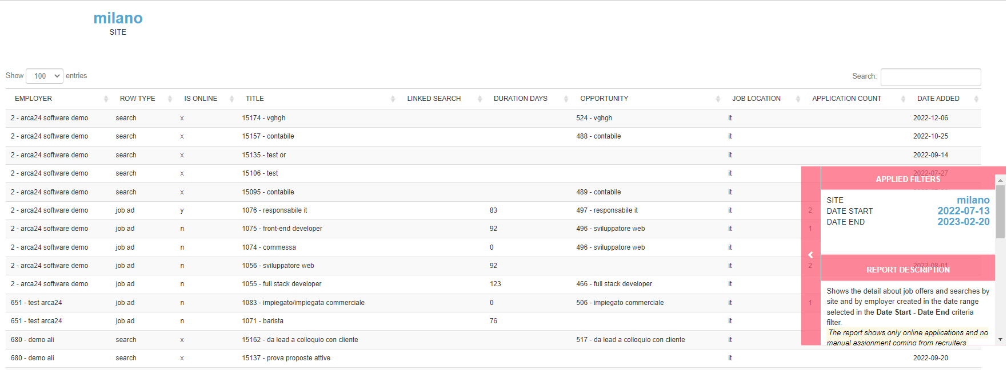  
  
The report shows the details of **each job offer and saved search** based on the date filters "Start date - End date".

The following aspects are taken into account: site and employer, process type (job advert/saved search), whether the job is online (Yes, No and "X" for searches), title, ID of the linked opportunity, linked search from which the job was published (for job ads), duration of the vacancy, country, job location, applications received (for job ads), creation date.

**CANDIDATE ACTIVITY** **(OLD)**

Filtering by site, employer, activity type and dates, the report shows the number of activities divided by type and number of candidates involved for each site.

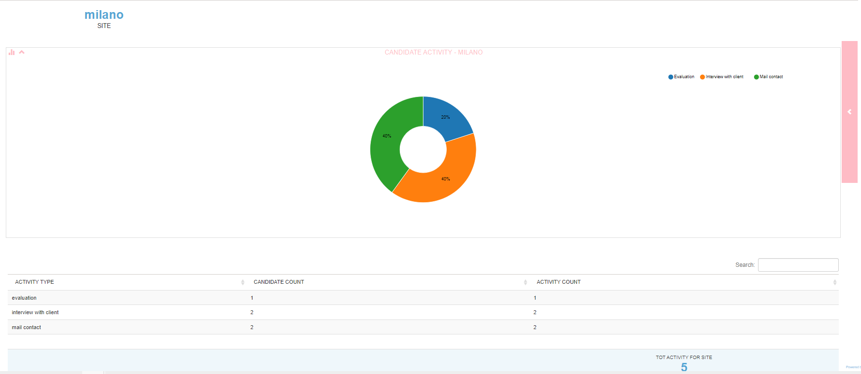

**N.B.**: In all activity type reports, emails sent by the system (envelope icon) are also counted in the activity type "Mail Contact". Emails sent via multimailing are not counted.

**EMPLOYER ACTIVITY (OLD)**

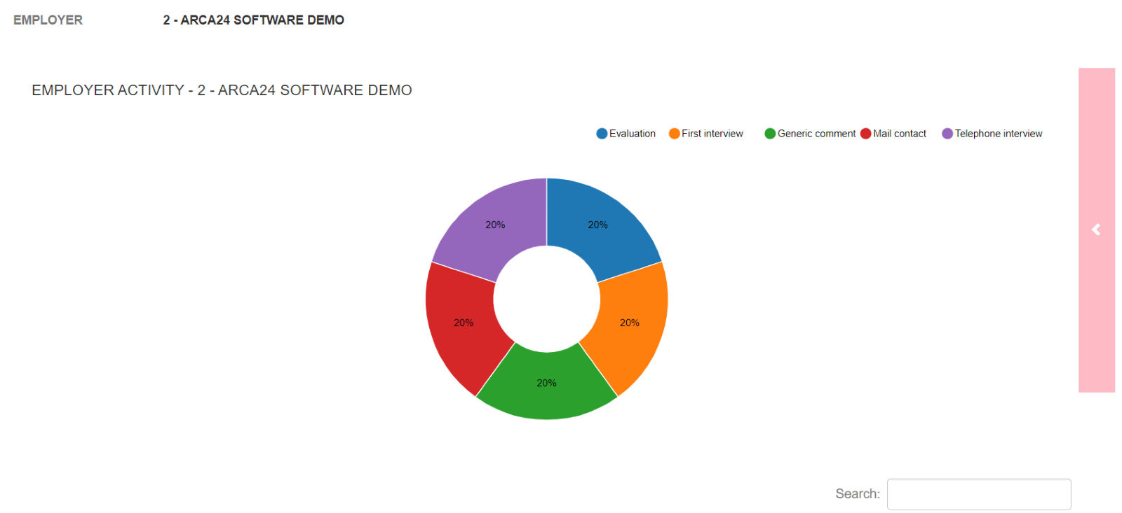

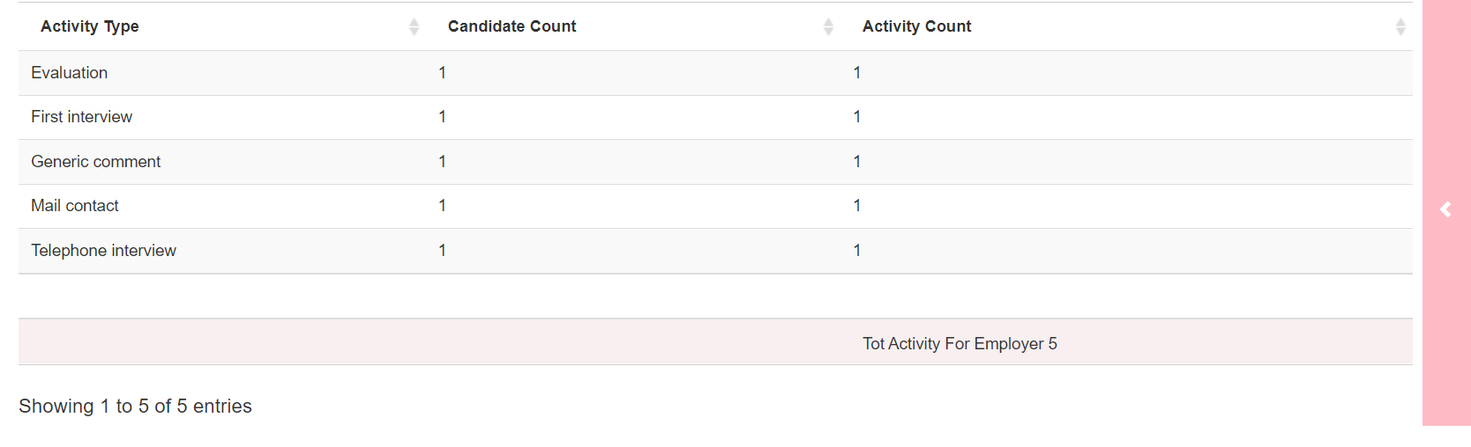

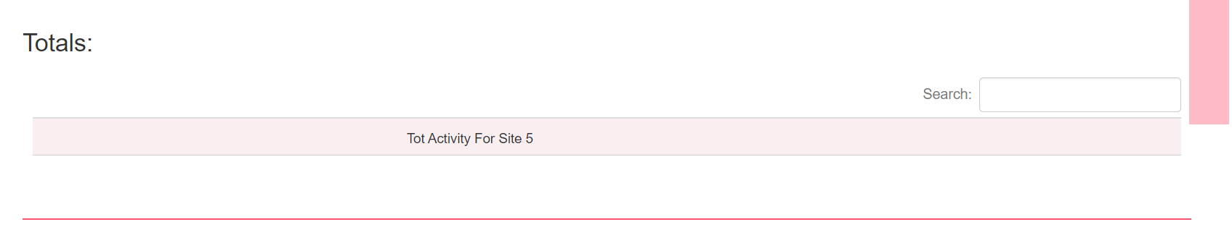 The report shows the types of activities carried out on the candidates by site and by employer on the dates chosen.

This report allows you to select multiple employers before launching the search, returning a result for each employer and not for the total number of activities.

**APPLICATION DETAIL (OLD)**

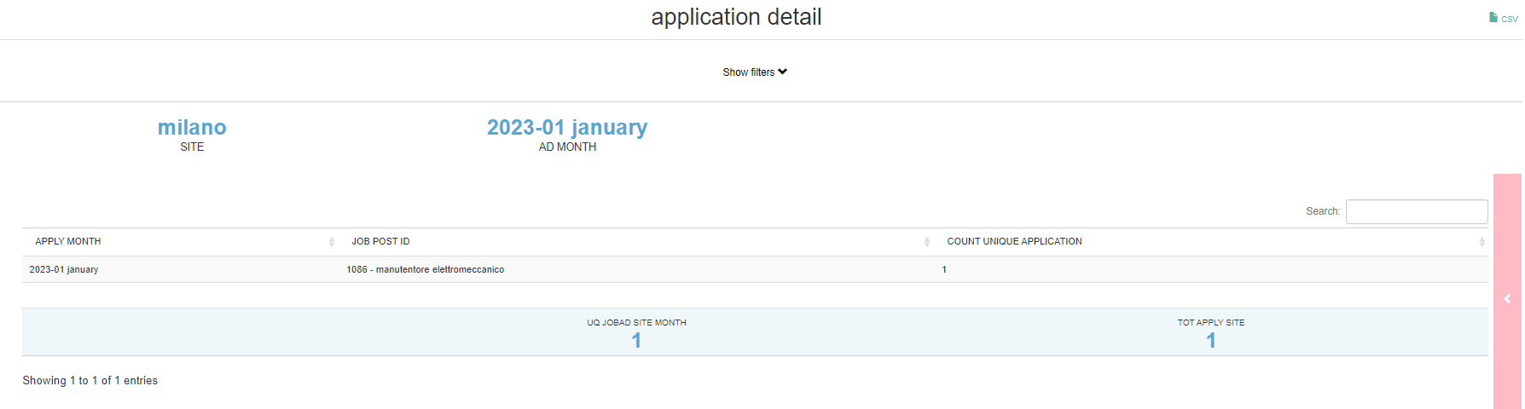

The filters to be set concern the site(s) and the period of creation of the job advertisement. **For each job published in the selected period**, each row shows how many candidates applied in that month and, if applicable, in the following months in which the job was online.

**SELECTION ACTIVITY (OLD)**

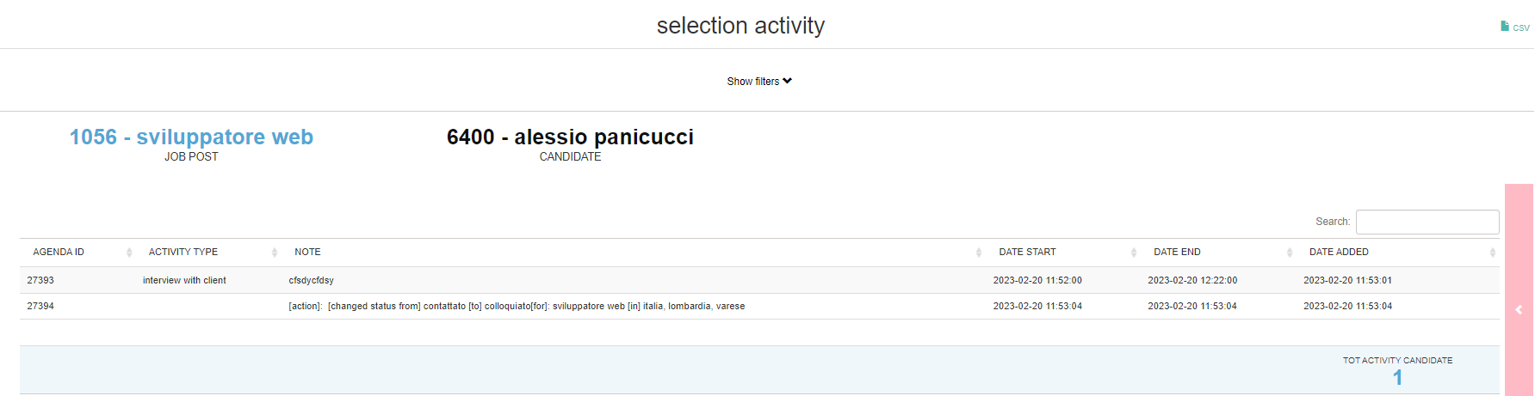

Using the filters by job, candidate ID and start/end date of activity, it is possible to extract **all the activities, both carried out manually and automatically, done on each candidate for each job ad.**

The table shows the type of activity (in the case of manual activities) as well as the comments, the start/end date and the adding date. It is therefore useful to track the selection process carried out for each candidate and for each job advert.

**DOSSIER DETAILS**

This report shows the details of the dossiers sent by the system in the date range selected according to the filters “start date” and “end date”. Data can also be extracted by company location and/or employer. The report is based on the settings of the user hierarchy.

The table shows, by Branch, the employer who sent the dossier, the date it was sent, the recipient customer, the candidate sent, the text of the e-mail, any linked contract (contract ID, customer, duration), the ID of the ad/search and/or linked opportunity.

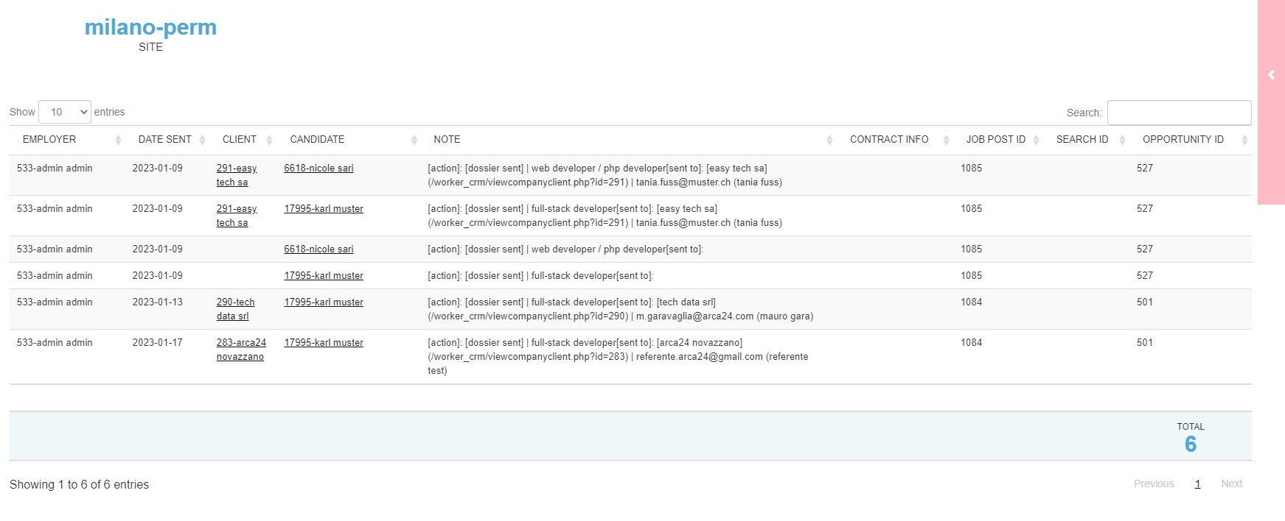  
**N.B.**: an email related to a candidate’s summary can contain several links to candidates. Furthermore, for each candidate several candidates’ summaries can be sent to several companies.

The CSV file can be extracted from the upper right corner of the page; it shows the data for all the locations selected in the filters, according to the hierarchy.

**CANDIDATE VIA MULTIMAILING**

The report shows the number of candidates sent as active proposals via mailing list in the date range selected with the filters "Start date - End date". In detail: for each site and employer, the number of candidates proposed and the number of clients to whom active proposals were sent is shown. At the bottom, you can see the total number of candidates sent via mailing list on the given site.

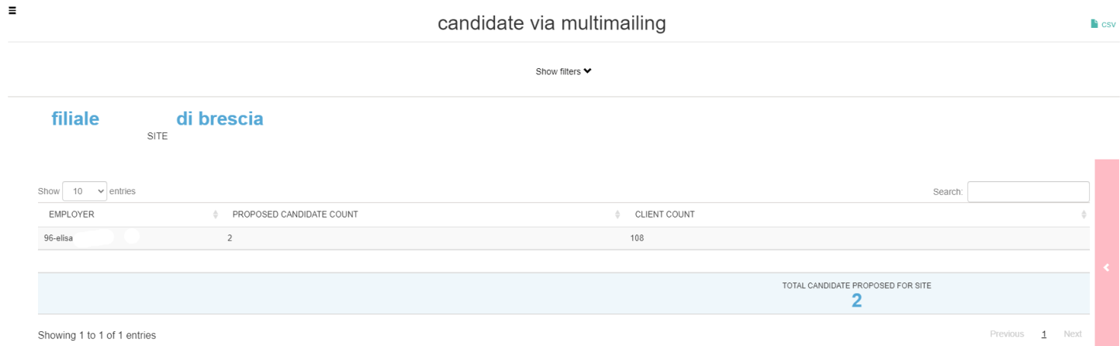

In the upper right corner, the button  enables the extraction of the Csv file with the data shown in the table.

**5.1.2 Companies**

For information on the interface, see previous section.

**CLIENT TOTAL**

Drilldown report showing the number of all clients created within the entered start and end dates.

Click on the  below “Client Type Detail” to display the breakdown of clients by type; click on the CSV symbol to download the file containing the corresponding data.

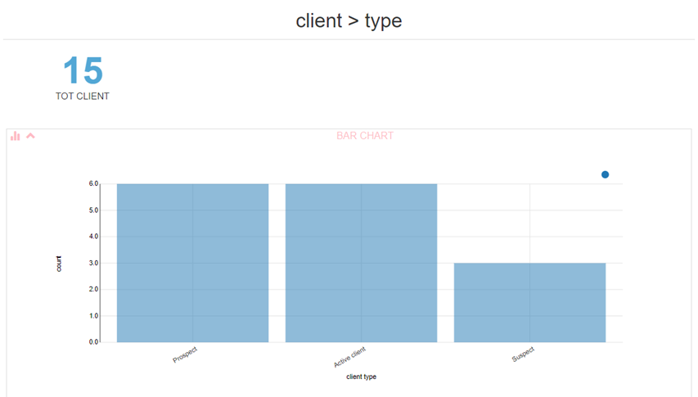

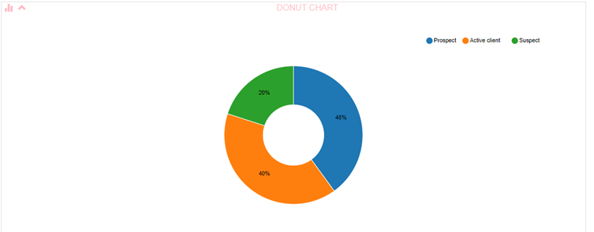

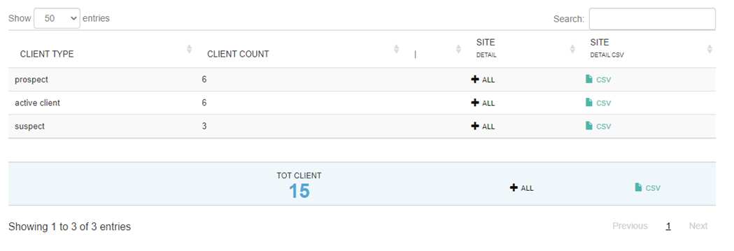

The report gives visibility according to company hierarchies.

N.B.: Even from “Client Type” it is possible to continue opening the detail splits as described below.

*Site detail*

Click on  below “Client Site Detail” to display the split of clients by site; click on the CSV symbol to download the file containing the corresponding data.

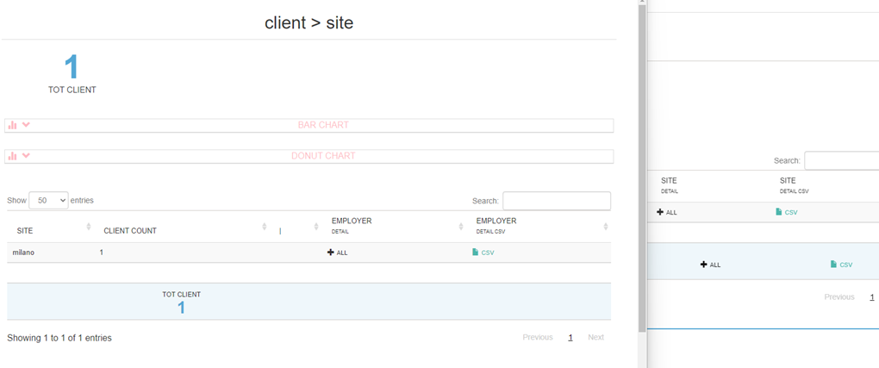

*Employer detail*

Click on  under “Employer Detail” to display the split of the indicated clients by assigned colleague; click on the CSV symbol to download the file containing the corresponding data.

Clicking on under “Employer detail” will display the split Client Rawdata with the following data: Employer id, site, type of client, client id with company name, company sector, country, date of registration in database, number of company locations, number of registered opportunities, number of activities, number of hired candidates, total number of contracts and active contracts, date on which the first contract was concluded.

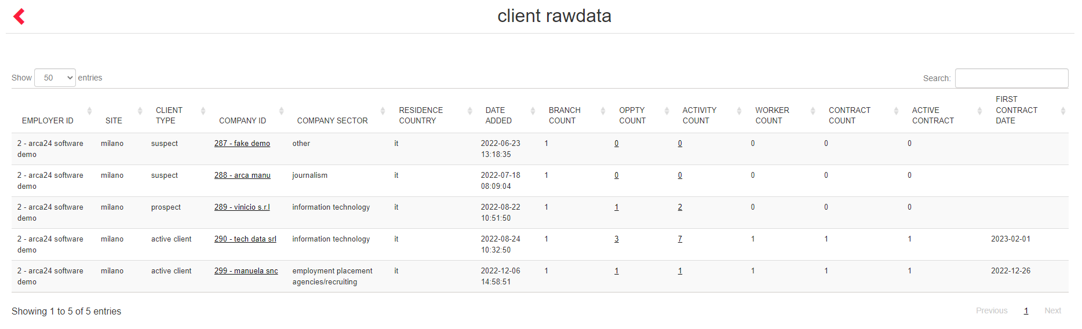

**ACTIVITY TOTAL**

Drilldown report showing the total number of activities created on a date between the start date/end date filter dates. This filter takes into account all the activities whose date of creation in the database is included in the time range specified in the fields “start date” and “end date”.

Click on the  below **Type Detail** to display the split showing the number of activities by type. Use the CSV symbol to download the file containing the corresponding data.

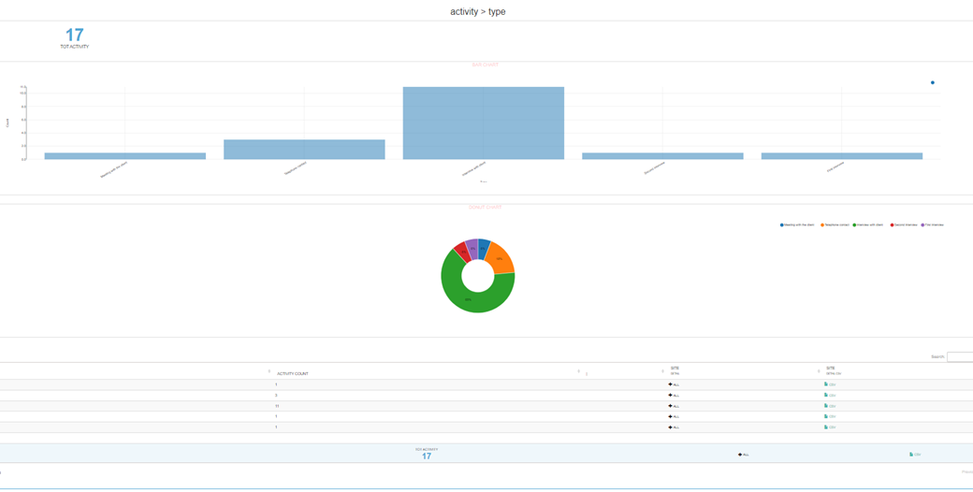

*Site detail*

Click on  below **Site Detail** to display the split showing the number of activities by site; click on below **Employer detail** to display the activity for each individual employer at the selected site.

*Employer detail*

Clicking on  under **Employer detail** displays the split showing the activity rawdata, which shows: em-ployer ID, site, candidate ID, client ID, client type, referrer ID, opportunity ID, employer to whom the activity was shared, selection process ID, activity type, start date and end date.

*Client Type Detail*

Click on  below **Client Type Detail** to display the split showing the number of activities by client type. Click on the CSV symbol to download the file containing the data corresponding to this string. Clicking on  under Site detail displays the split on the site, then the employer and finally the rawdata.

**OPPORTUNITY TOTAL**

The drilldown-report shows the total data related to opportunities managed on clients. The report brings together the previous opportunity reports for “Site”, “Status”, “Delivery” and “Sales” in a single initial selection.

The filter available only consists of two dates (**opportunities entered from/to**) and reads the date on which the opportunity was entered into the system; the result displayed also considers all deleted or cancelled opportunities.

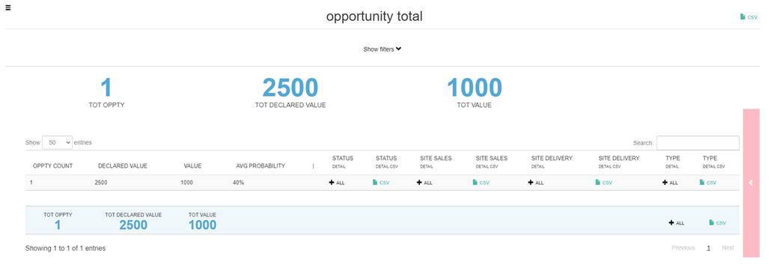

*Status detail*

Click on  below **Status Detail** to display the split showing the number of opportunities divided by **status**, with the following details: the expected value, the weighted value of the opportunity based on the current success rate, the success percentage; clicking on the CSV symbol you can download the file containing the corresponding data.

In the report there are buttons  to display the detail of the sites by delivery and sales; for each of these sites you can see the details by employer and the raw data.

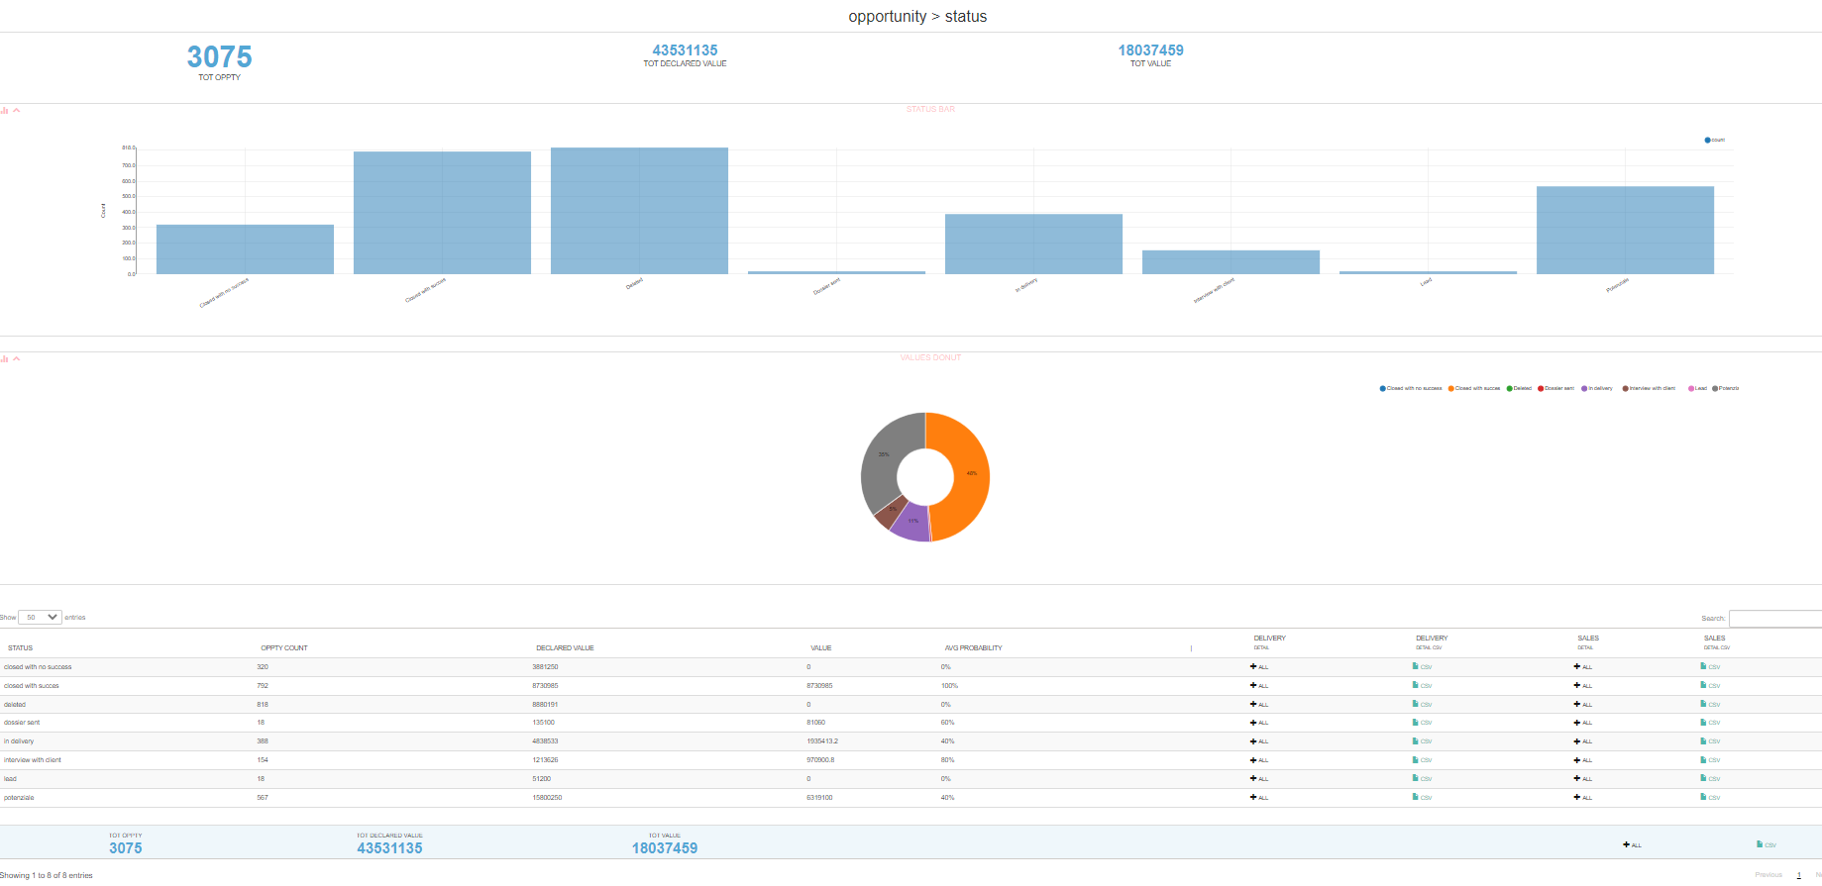

*Site detail*

By clicking on  below **Site Sales** you will see the split that shows the number of opportunities based on the site of the acquiring employer, with the following details: site, expected value, actual value, success percentage; by clicking on the CSV symbol  you can download the file containing the corresponding data.

Clicking on  below **Site Delivery** displays the split showing the number of opportunities based on the employer's site to the “delivery” field with the following details: site, number of opportunities, expected value, actual value, success percentage; by clicking on the CSV symbol  it is possible to download the file containing the corresponding data.

Clicking on  below **Type Detail** displays the split showing the number of opportunities divided by type, with the following details: number of opportunities for each type, expected value, actual value, success percentage; clicking on the CSV symbol  it is possible to download the file containing the corresponding data.

*Opportunity rawdata*

The rawdata shows all data in maximum detail for the opportunities examined in the chosen date filter.

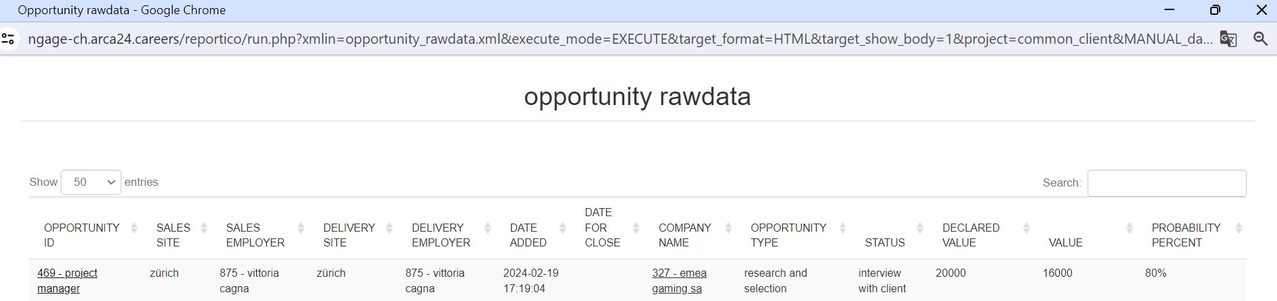

**CANDIDATE VIEWS TOTAL**

The report shows a detail of candidate views following the sending of dossiers or multimailing to either a specific contact person or a generic e-mail address. The report is based on the settings of the hierarchy of the user who sent the dossier or multimailing and on the hierarchy of the client’s profile. The assigned site is that of the employer who sent the dossier or the multimailing. The extracted data is based on the date on which the dossier or multimailing was sent according to the filters 'date start' and 'date end'.

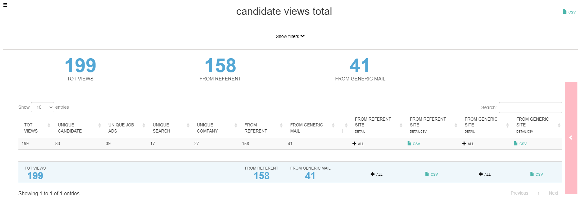

In the top right-hand corner, you will find the  icon for extracting the file with the results based on the following data: total number of views, number of unique candidates, number of unique job advertisements, number of unique searches, number of unique companies, number of contact person who made the views, number of e-mail addresses who made the views.

Click on  below **From Referent Site** to display the split showing the total number of views, divided according to the **site** of the sending employer; then it is possible to expand the detail by employer of the site and afterwards to display the rawdata detail for the individual employer. Clicking on the CSV symbol it is possible to download the file containing the corresponding data.

Click on  for **From Generic Site** to display the split showing the total number of views, divided according to the **site** of the sending employer; then it is possible to expand the detail by site employer and afterwards to display the **rawdata** detail for the individual employer. Clicking on the CSV symbol you can download the file containing the corresponding data.

**FEEDBACK TOTAL**

The report shows a detail of feedback received by either the specific contact person or the generic e-mail address. The extracted data is based on the date on which the feedback was received according to the filters “date start” and “date end”. The report is based on the settings of the user hierarchy. The assigned site is that of the employer who sent the dossier or the multimailing for which the feedback was received.

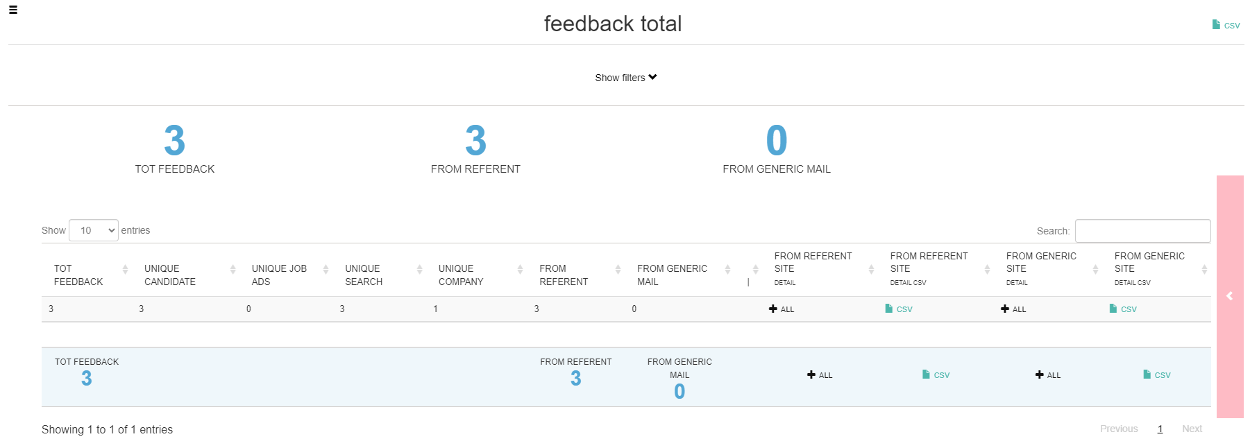

In the top right-hand corner is a CSV icon for the extraction of the file with the results according to the following data: total feedback, number of unique candidates, number of unique job advertisements, number of unique searches, number of unique companies, number of contact people who gave feedback, number of e-mail addresses who gave feedback.

Click on  below **From Referent Site** to display the split showing the total feedback, divided according to the **site** of the sending employer; then it is possible to expand the detail by employer of the site and, on the individual employer, display the **rawdata**; clicking on the CSV symbol you can download the file containing the corresponding data.

Clicking on  relating to **From Generic Site** will display the split showing the total feedback, divided according to the location of the employer who sent the generic e-mail, followed by the possibility of expanding the detail by site employer and, on the individual employer, displaying the **rawdata** detail. Clicking on the CSV symbol will download the file containing the corresponding data.

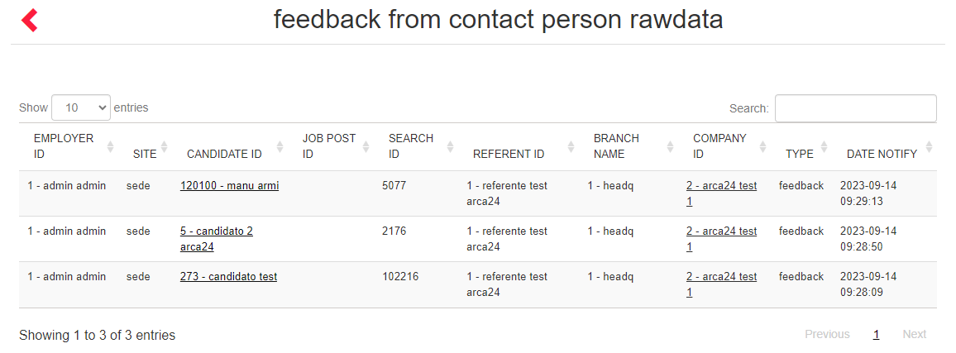

**CLIENT SUMMARY (OLD)**

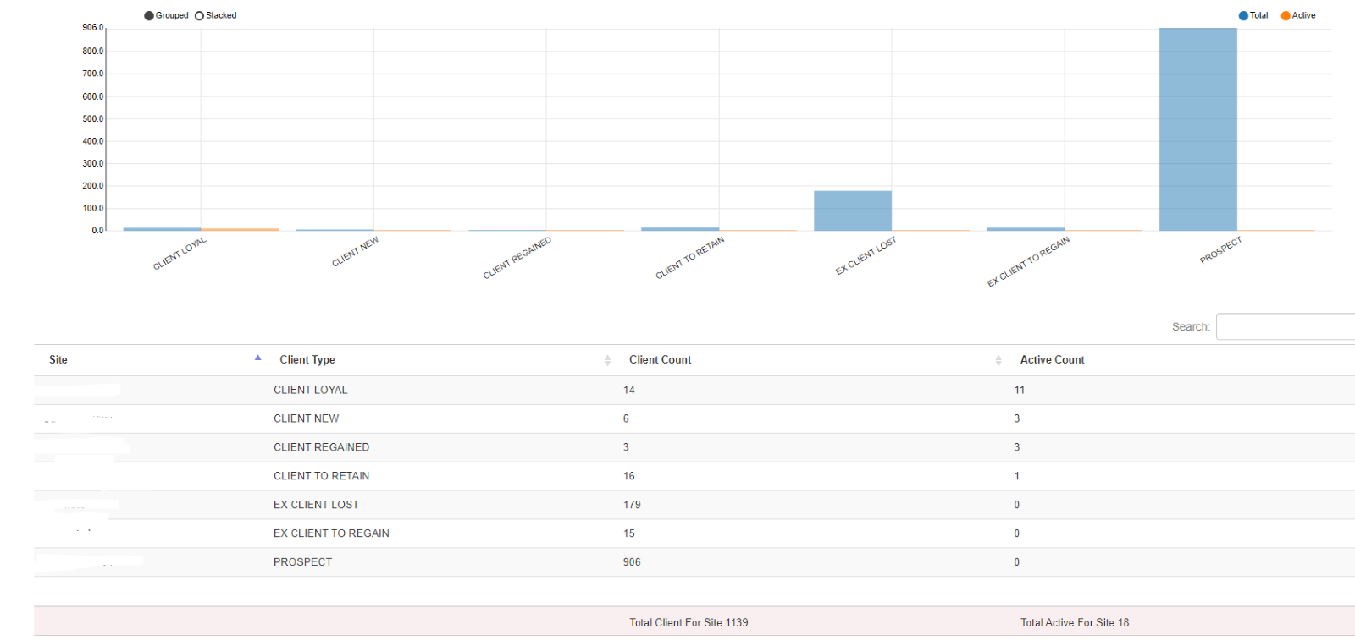  
  
For each site, the report shows the number of clients by type and, of these, how many are active customers.

**N.B.**: the site refers to the employer who created the contract for that client.

**N.B.**: as explained in the report legend, the client types are as follows:

* PROSPECT -> no contract available;
* CLIENT NEW -> contracts only available on the current year, or on the current year and more than 3 years ago;
* CLIENT LOYAL (fidelized) -> clients who have had contracts in the 365 days preceding the start date and also have active contracts in the start date/end date period;
* CLIENT TO RETAIN (to be retained) -> contracts available 2 years ago, but no contracts in the current year;
* CLIENT REGAINED (regained) -> contracts available in the current year and 3 years ago;
* EX CLIENT TO REGAIN (to be regained) -> contracts available 3 years ago;
* EX CLIENT LOST (lost) -> contracts available over 3 years ago.

**CLIENT DETAIL (OLD)**

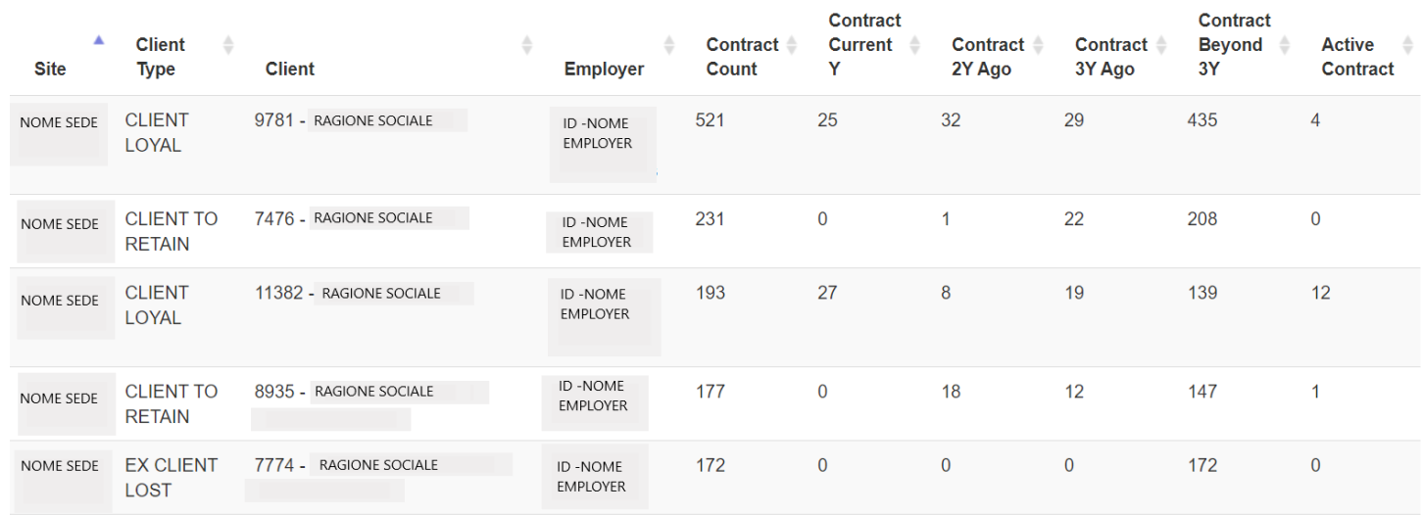  
  
The report shows the **details of the clients**: type, company name, employer and assigned site, the number of total contracts, those created in the last year, those created two, three or more than three years ago and the active contracts in the chosen period. The latter is assigned according to the field “Client.Date.Ref”.

**N.B.**: Years are calculated from “Client.Date.Ref.” backwards. The year is counted based on 365 days.

**NEW CLIENT ADDED (OLD**)

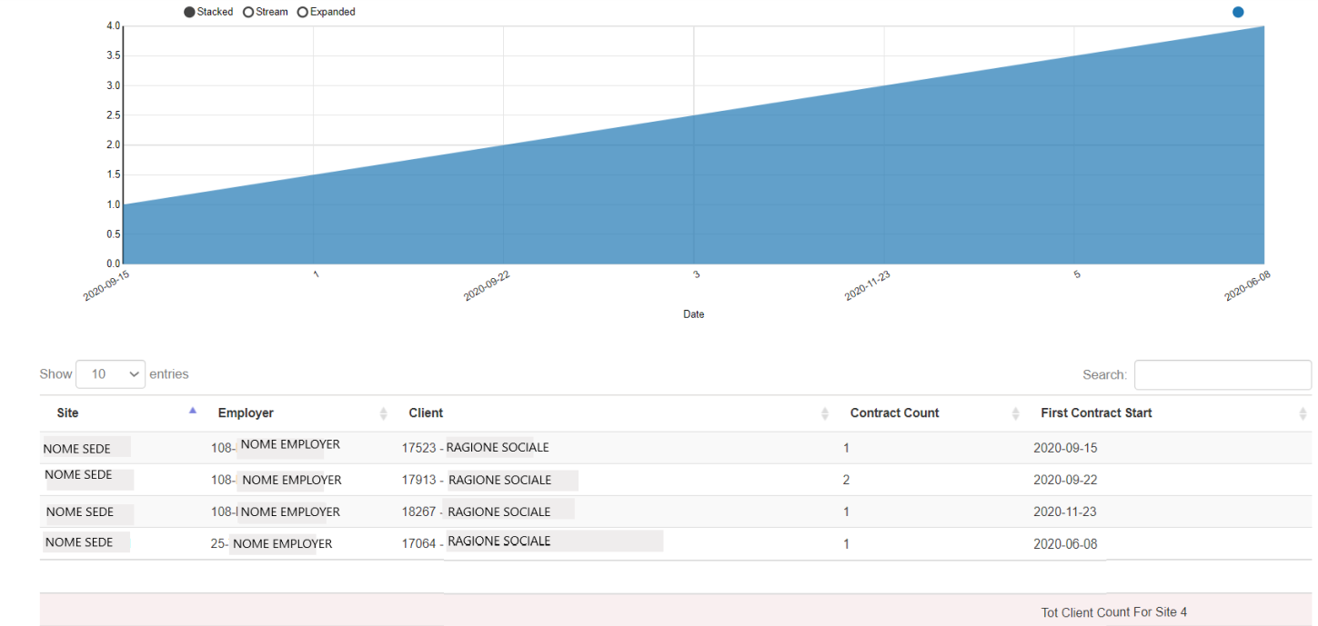

The report shows new clients with contracts in a date range. The string displays the following data: site, employer, client ID, company name, the number of contracts and the date of the first contract created.

**CLIENT ACTIVITY (OLD)**

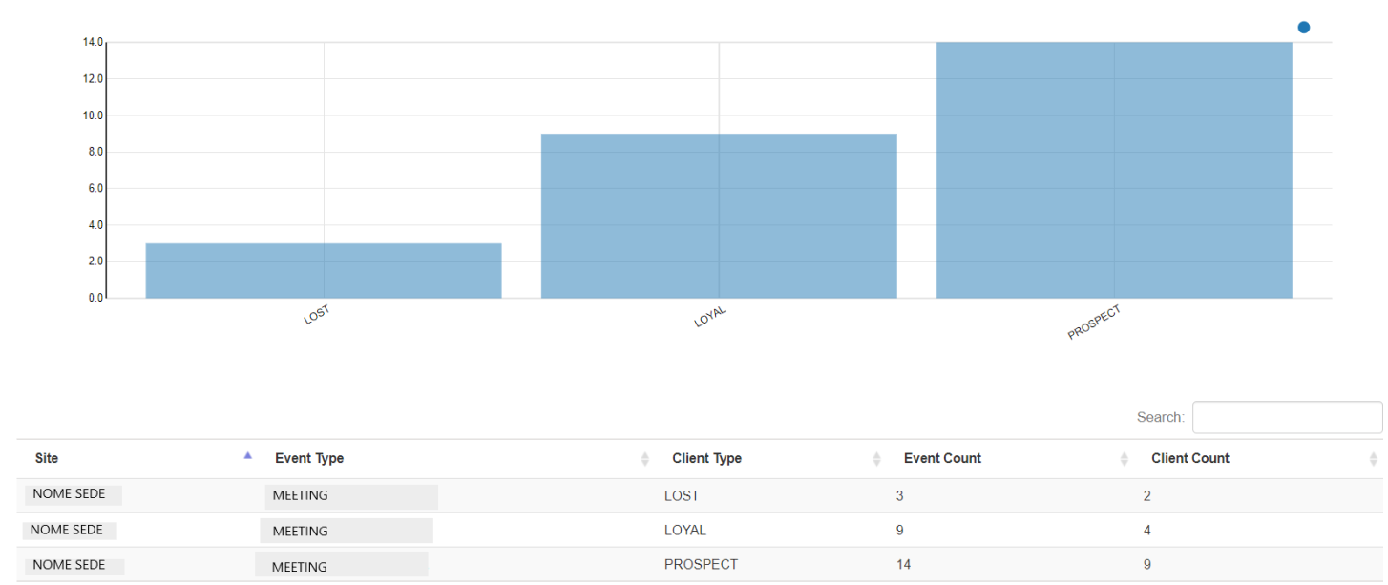  
The report shows the type of activity recorded by site, how many times the activity was entered and for how many clients. The table also shows the type of activity, the number of activities, the number of customers involved.

**EMPLOYER CLIENT ACTIVITY (OLD)**

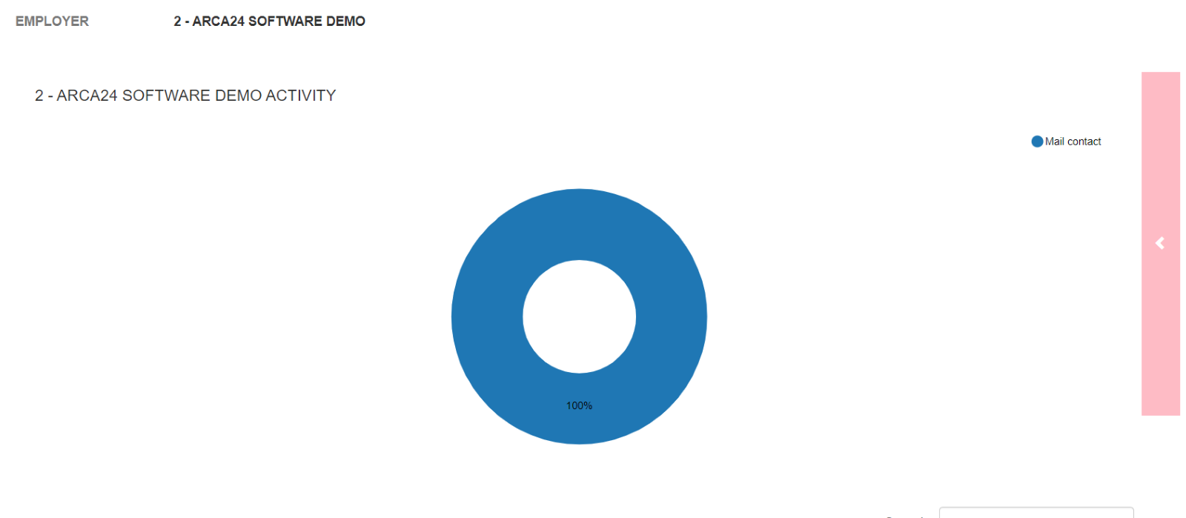

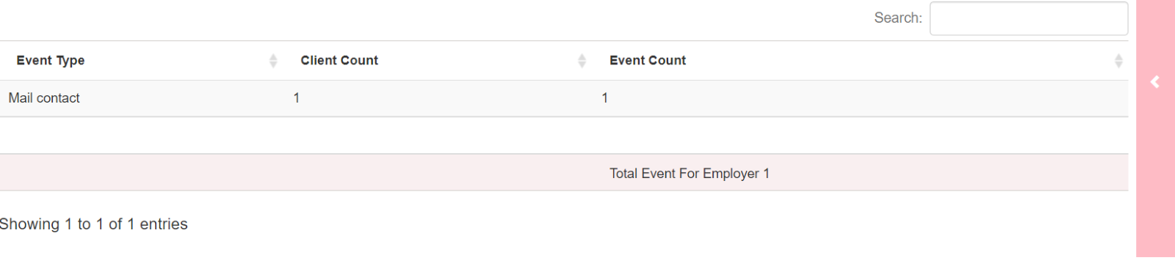  
The report allows you to select several employers before launching the search, but it returns a result per individual employer and not per total number of activities.

**ACTIVITY ON PROSPECT (OLD)**

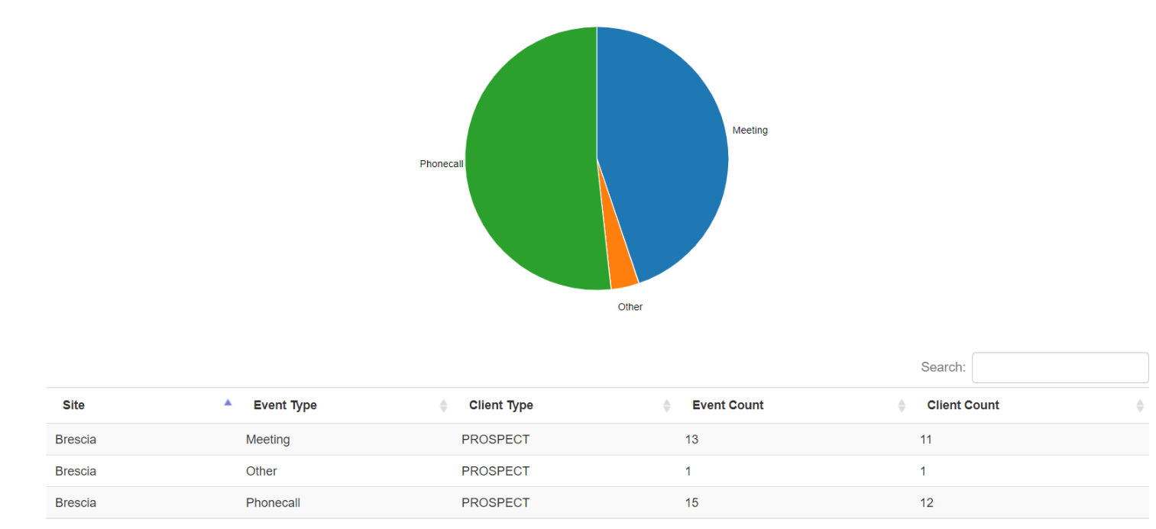  
  
The report shows the detail of all activities on prospects; for each type of activity, the relevant counter and the number of clients on which that type of activity was entered are shown. That is useful to monitor activities that aim to increase the number of clients.

**ACTIVITY ON CLIENT TO REGAIN (OLD)**

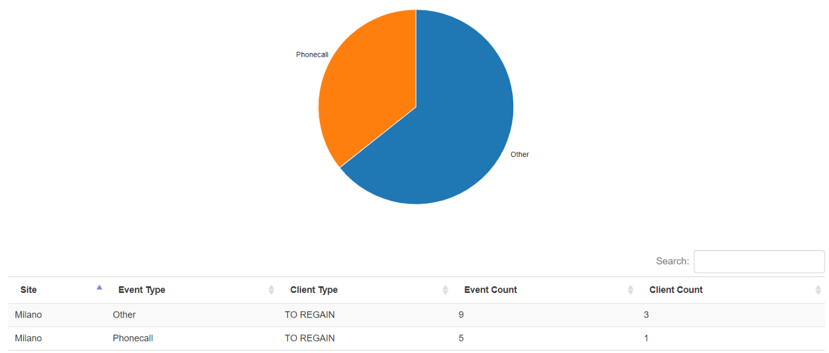  
The report shows the detail of all activities on clients to regain; for each type of activity, the relevant counter and the number of clients on which that type of activity was entered are shown. That is useful to monitor the activities entered on clients to recover and/or lost ones.

**ACTIVITY ON CLIENT ACTIVE (OLD)**

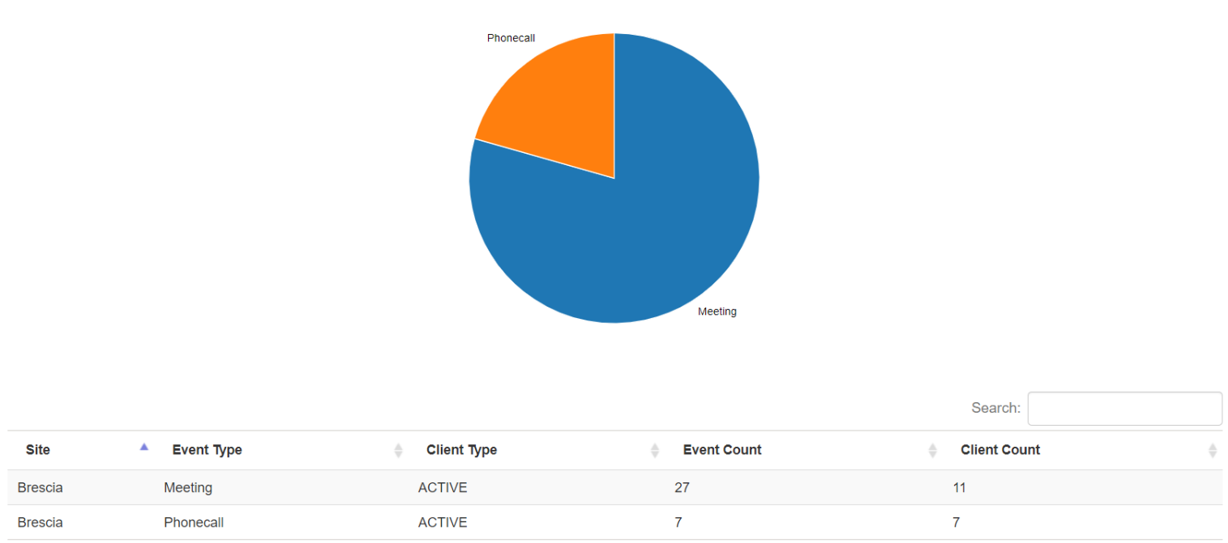  
The report shows the detail of all activities on active clients; for each type of activity, the relevant counter and the number of clients on which that type of activity was entered are shown. That is useful to monitor the activities entered on clients who have an active contract on the day chosen in the field “Client.Date.Ref”.  
  
**NEW PROSPECT ADDED (OLD)**

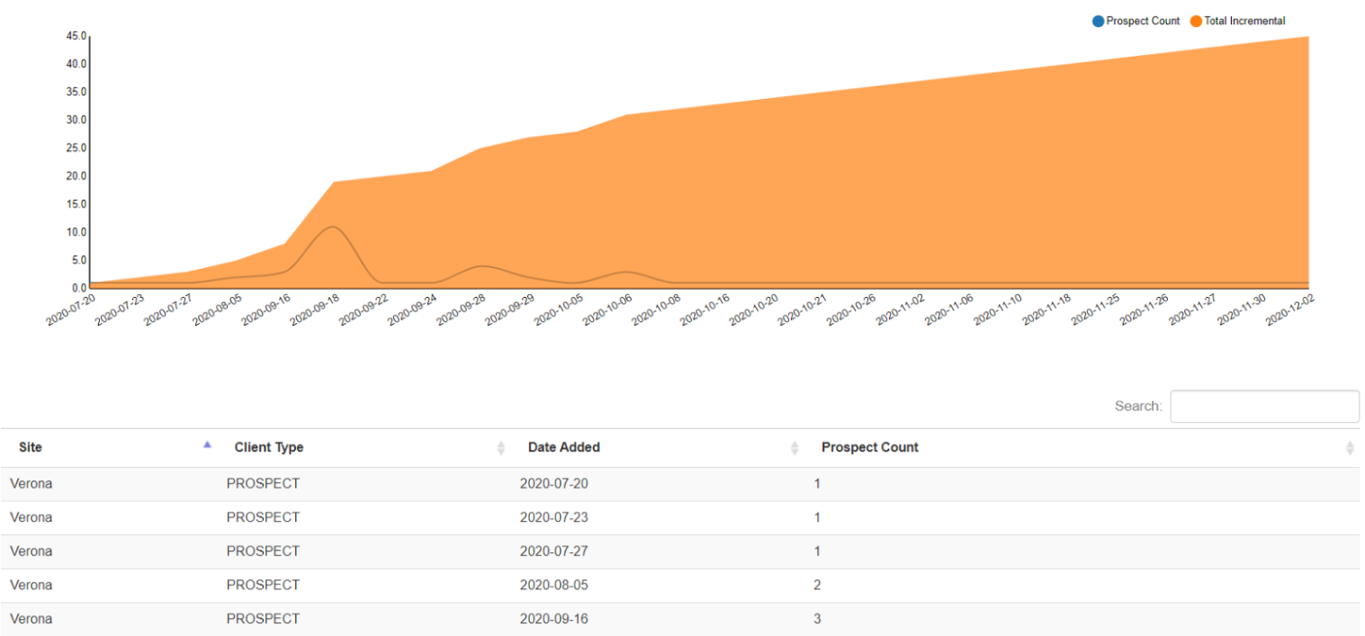

The report shows all new prospects added. In the graphs, the blue line counts the daily entries of new prospects, while the yellow one sums the entries of each day, displaying the incremental value.

**OPPORTUNITY STATUS PER SALES (OLD)**

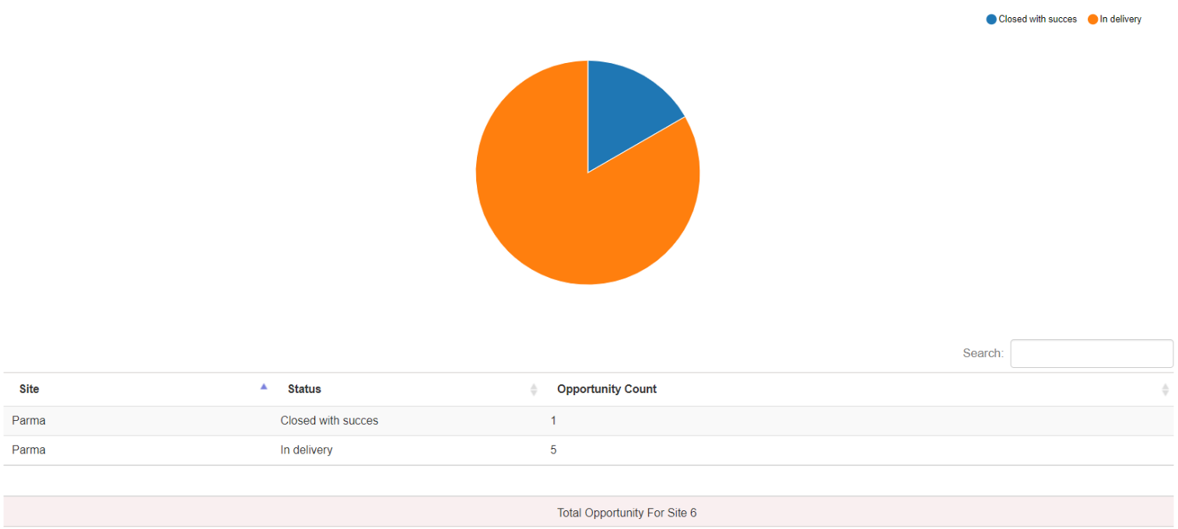  
  
The report shows the number of opportunities divided by status, according to the date range entered and based on the site of the employer in charge of the opportunity acquisition (sales manager).

**OPPORTUNITY STATUS PER DELIVERY (OLD)**

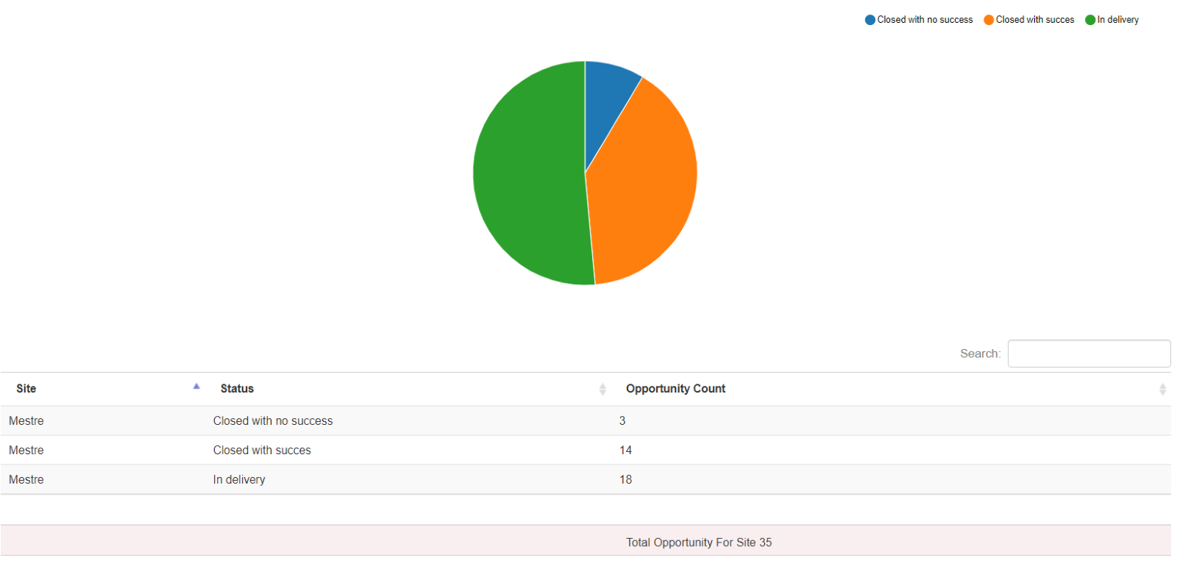  
  
The report shows the number of opportunities divided by status, according to the date range entered and based on the site of the employer in charge of talent selection (”delivery” manager).

**OPPORTUNITY TYPE PER SALES (OLD**)

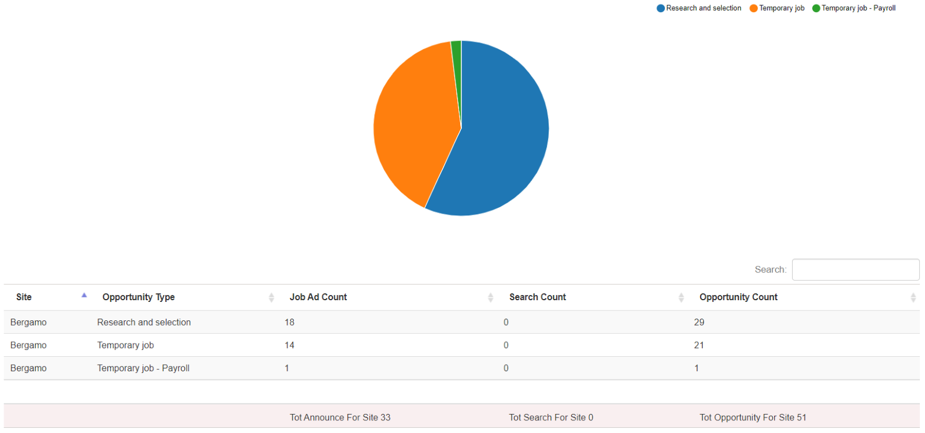

The report shows the number of opportunities divided by status and counters on linked jobs/searches based on the site of the employer in charge of opportunity acquisition (sales manager).

**OPPORTUNITY TYPE PER DELIVERY (OLD**)

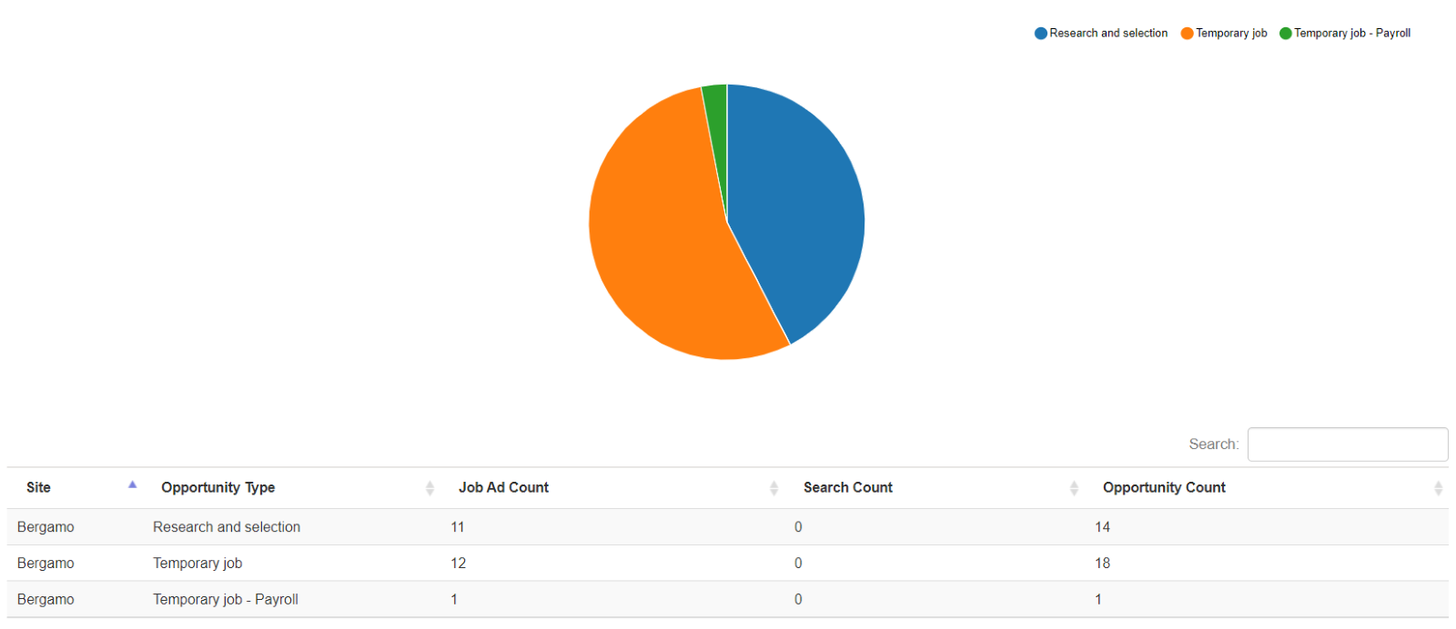  
  
The report shows the number of opportunities divided by status and counters on linked jobs/searches based on the site of the employer in charge of talent selection (”delivery” manager).

#### **5.1.3 Conversion**

**CANDIDATE REGISTRATION ORIGIN**

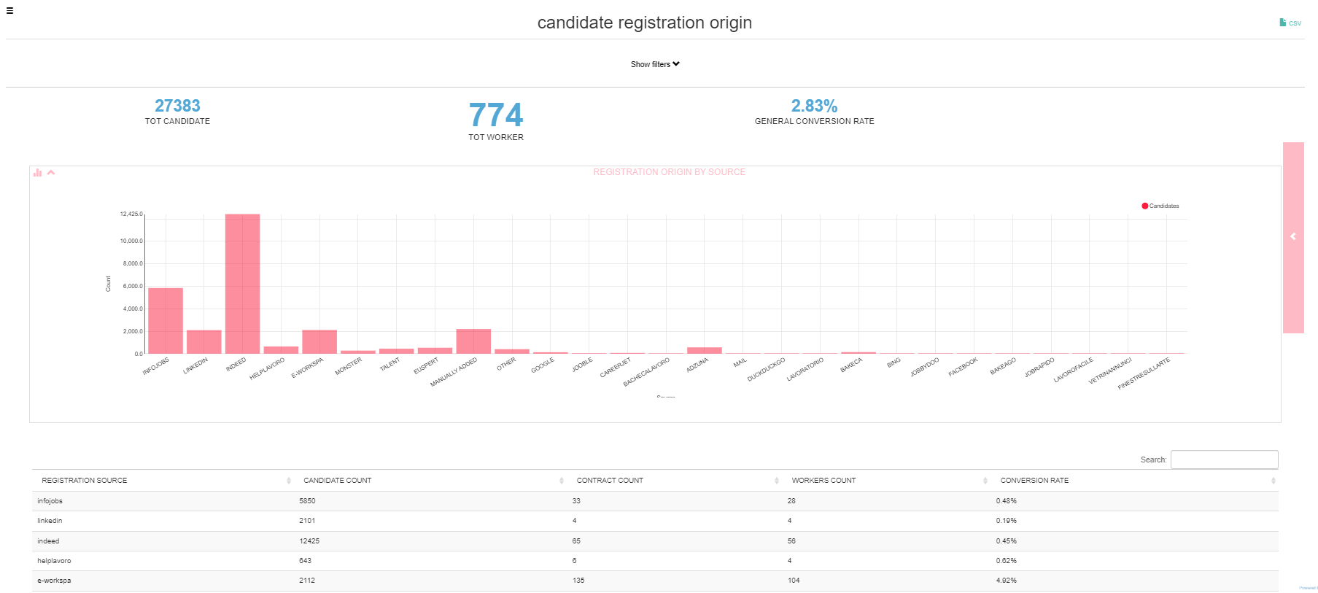

The report shows the origin of applicants who registered in the system from the 'User From' date to the 'User Date To' date, and of these it counts the number of contracts created (regardless of the contract validity date).

The overall conversion rate shows the employment rate of users who registered in the database for the first time in the selected time period.

In particular, the table shows:

* The registration origin of the candidates
* The number of candidates per origin
* The number of contracts created per origin
* The number of contracted candidates (workers)
* The conversion rate for each registration origin (Number of contracted workers/Total candidates per origin)*100

**Mode “Job Agent”:** within all the conversion reports, the source //www.job-agent shows the number of candidates who have applied to a job as a result of receiving an email through the function “Job Agent”.  
**N.B.:** Candidates are considered as public platform data and cannot be attributed to any site/employer; as a result, this report does NOT have visibility based on corporate hierarchy.

**REFERRAL CANDIDATE REGISTRATION ORIGIN/APPLICATION ORIGIN**

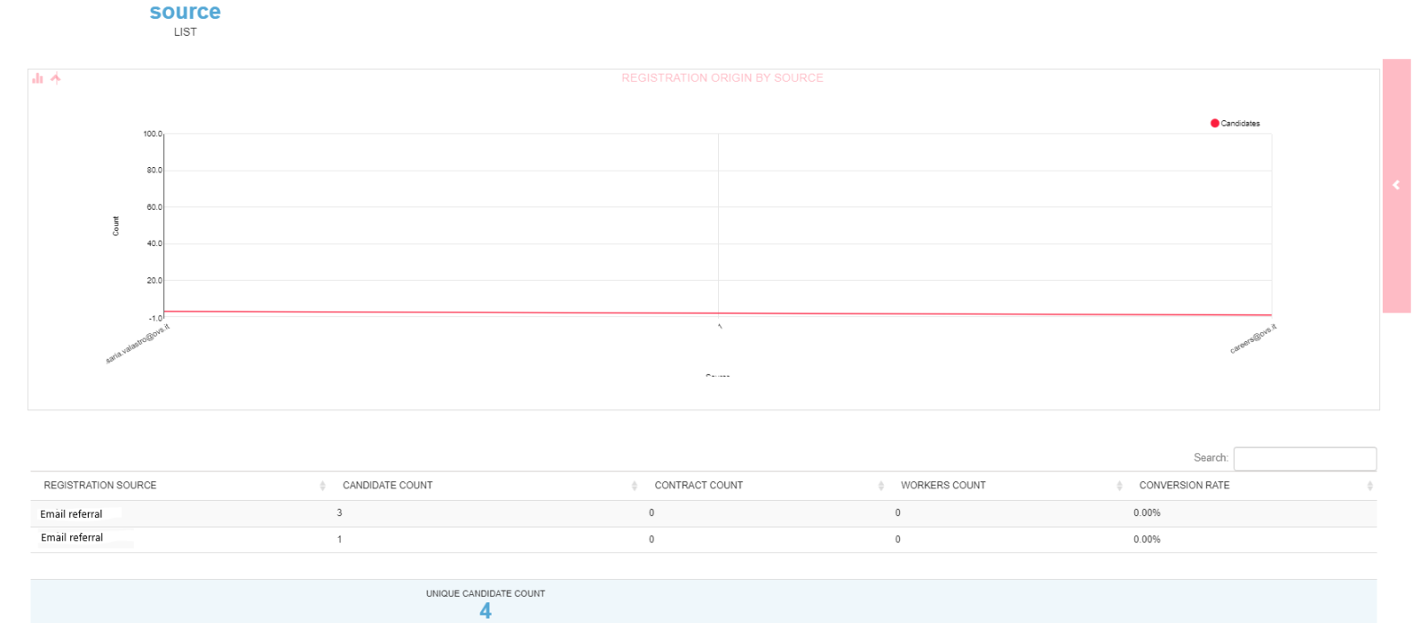The referral module allows you to track, for candidates who register from a link shared by an employee, the company employee who suggested a specific advertisement/spontaneous application to the company. The report shows the e-mail address of the employee who suggested the application, for each, how many candidates have registered, how many contracts and workers there are and the conversion rate.

Please note: Installations without the Referral module will not be able to extract the report.

**CANDIDATE INTERNAL ORIGIN**

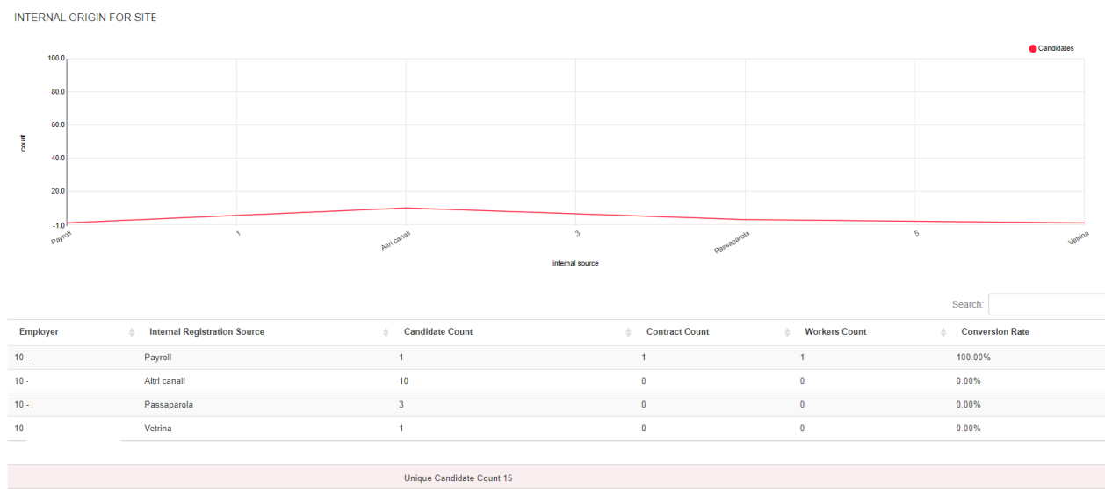  
  
The internal origin refers to the **custom field** "Source" in the candidate registration form filled in by the employers. If your software version does not have that custom field, you will read the string "SOURCE NOT COMPILED"/"NO SOURCE" instead of the origin.

The report shows the origin of the candidates manually registered by the employer according to the dropdown customization in the candidate registration form.

**N.B.**: In this section, the filters relating to the site and employer who registered the candidates are also available.

**CANDIDATE APPLICATION ORIGIN**

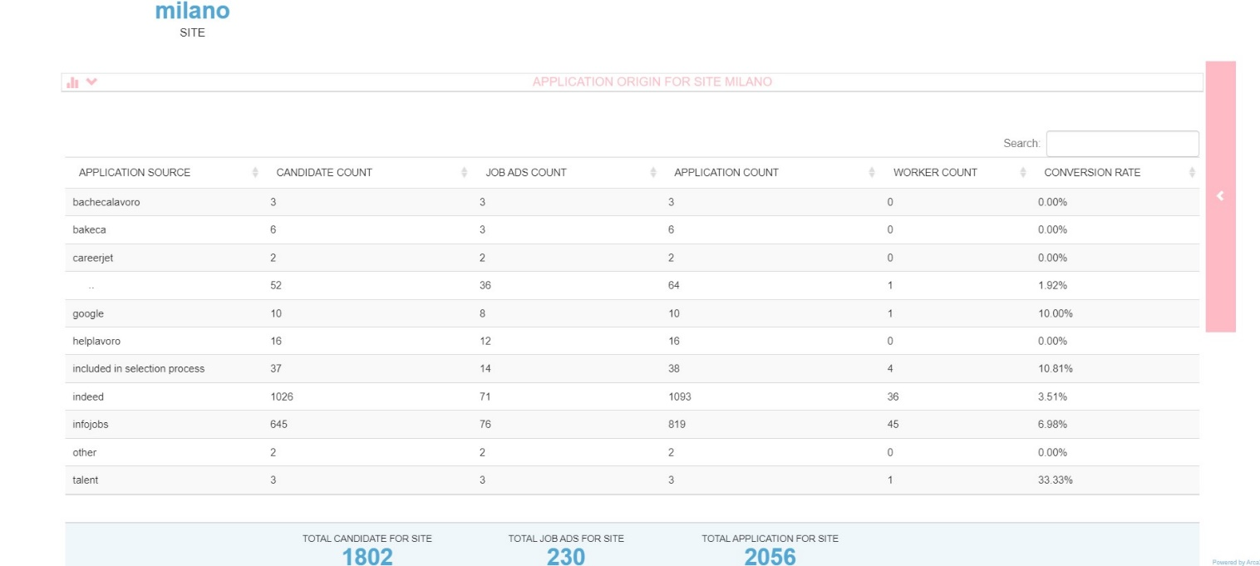

The report shows for each source site and according to the date of the 'Application Data from' and 'Application Data to' filter, the number of candidates who applied, the number of job advertisements for which at least one application was received and the number of applications. It also shows how many candidates have/had contracts (regardless of the date of validity of the contract). At the bottom of the page, you will find the non-unique total count of applicants and the non-unique count of job offers (if an advertisement is published on several portals, it will be counted several times).

**N.B.:** only the candidate's application is taken into account. If you hired a person, thus he/she has just one contract, but he/she had applied from three different portals, that is counted three times.

**N.B.:** data visibility is based on company hierarchy.

**MULTIPOSTING**

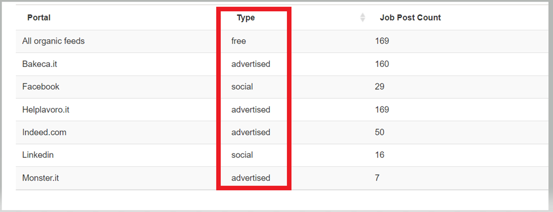

The report, which is based on the filter by site, shows the job status (all/online jobs) and the posting date as well as the number of jobs published on each feed.

**N.B.:** If a job is put offline and published again, it is counted only once, because the system considers the job ad ID.

### Check competitor-candidates

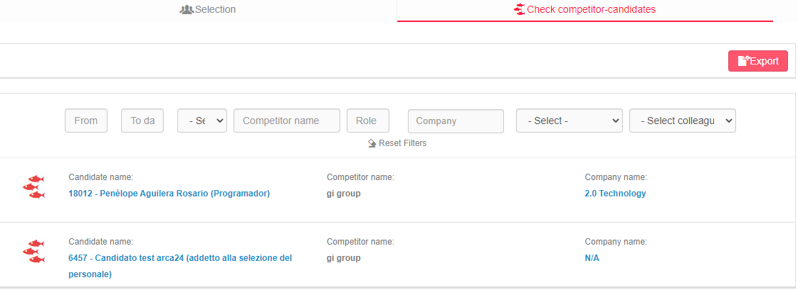

The report shows the list of candidates for whom at least one event with a competitor has been entered. That provides an overview of competitors’ activities in relation to candidates. The filters are based on the following data: start/end date of the event, competitor name (dropdown menu if entered in the section for administration set-up, or text field if entered from the field "Competitor name” when not listed), role, company, site and colleague who entered the event. The lists can be exported into a CSV file.

### Data-log

#### **Emails check**

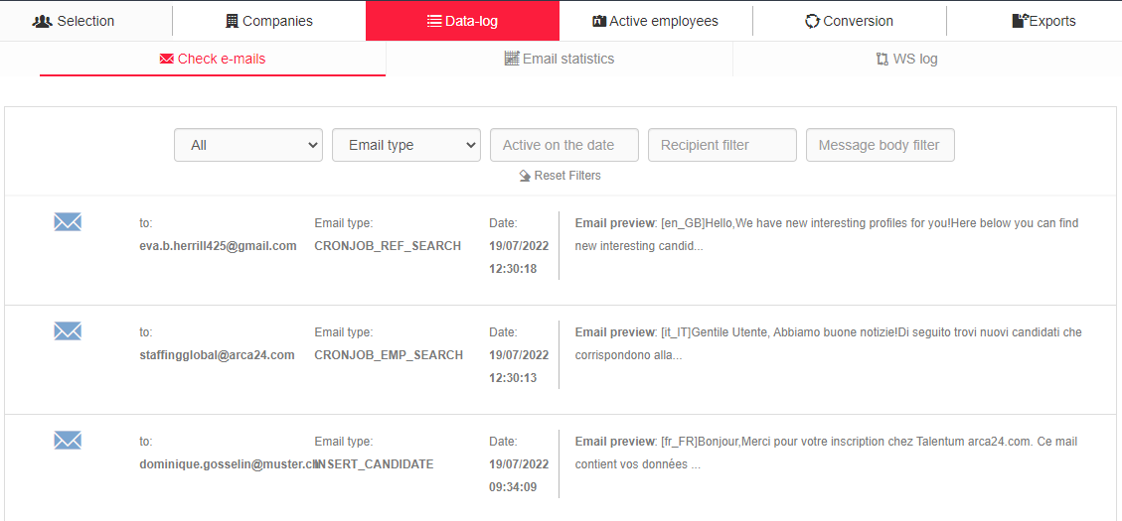

#### In this section it is possible to check the logs referring to the emails sent. The list below shows the recipient email address, the type of email sent, date and time of sending and the text of the email. The following filters are available: site, email type, sending date, recipient (type email address) and keyword in the email text.

#### **Email statistics**

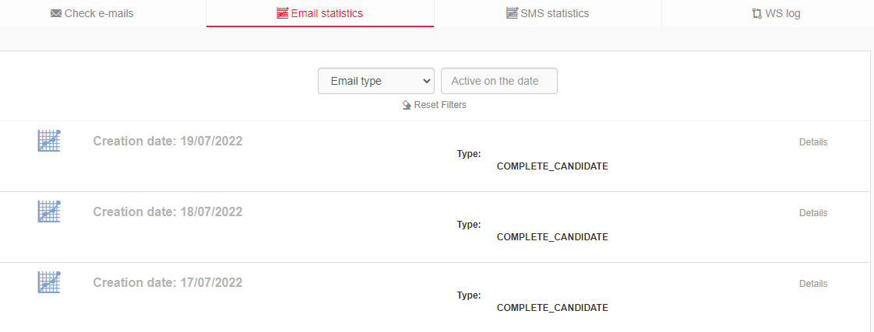

**N.B.** This section is only filled in on software versions connected to Splio, with a dedicated or shared universe.

The report shows email statistics by date and email type. The number of mails covered and the percentage of total emails is shown for each case. The cases are listed below.

**Success**: emails delivered to the recipient.

**Blocked**: emails blocked on receipt.

**Soft bounce**: the server refuses emails delivery (temporary problem).

**Hard bounce**: the server refuses emails delivery (permanent problem).

**Opening**: total openings of the email. If the same recipient opens the same message several times, the count is incremented with each opening. Results are divided by the device from which the opening is made (tablet, mobile phone, other devices).

**Unique opening**: total number of recipients who have opened the mail. If the same recipient opens the same message several times, the opening is counted only once.

**Clicks:** if there are links in the email, the total number of clicks is counted. The count is divided by device (tablet, mobile phone, other devices).

**Unique clicks:** number of recipients who have made at least one click.

**% clicks on opening**: comparison between total openings and total clicks.

**% clicks opening by users**: comparison between the number of clicks and the openings made by the individual user.

**Spam:** mail categorized as spam by the recipient's mailbox.

#### **SMS statistics (OPTIONAL MODULE*)**

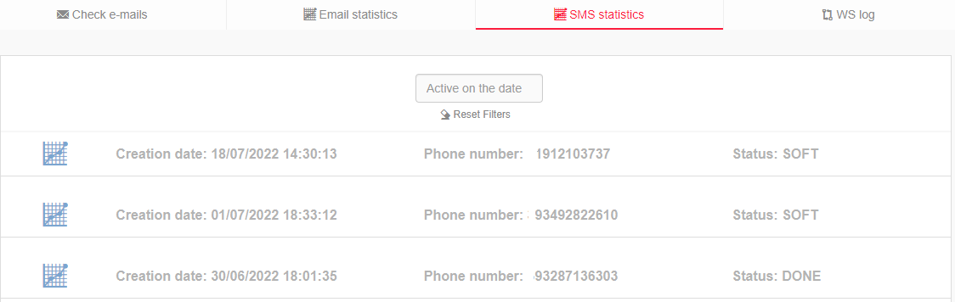

The report shows the date and time the SMS were sent, the recipient's number and the sending status. The statuses are “done” (sending completed), “waiting for callback” and “soft” (message went into soft bounce). They can be filtered by date.

#### **WS log (OPTIONAL MODULE*)**

If web services with a third-party software are active, the logs related to calls made/received are visible. This section is therefore used to check what data has been sent from one software to another, to see the answers to the call and to check for potential errors. These types of logs bear the word “ERROR”: candidate import error, client export error, etc.). The list can be filtered by log type, date and/or keyword.

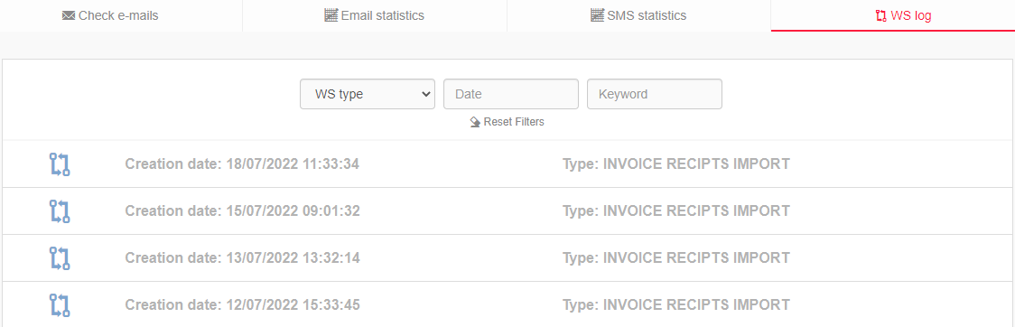

*5.4 Active employees (OPTIONAL MODULE*)*  
In this section you can view the list of all active employees. In the candidate string the contract details are displayed. The ones highlighted in red are the ones expiring the following day to the current date. The ones in pink are the ones expiring from 2 days after the current date to the following week (ex: if today’s number is 06, all profiles whose contract will expire between 08 and 13 inclusive will be highlighted in pink).

With reference to the list, you can:

* Export data to a CSV file, which can be downloaded from the exports panel described at the following paragraph;
* Send mass SMS (*OPTIONAL MODULE);
* Send mass emails to candidates;
* Insert an opportunity linked to an individual contract.

The filters are as follows:

* Order by
  + Active contracts from (contract start date)
  + Active contracts until (contract end date)
  + Last name
* Active contracts from/until: those active on the current date are shown by default
* Start date from/to: contract start date between the dates indicated
* End date from/to: contract end date between the dates indicated
* Branch: branch of the colleague who entered the contract
* Company data (company name and site): filter by the company on which the contract was entered
* Candidate: filter by employee’s contract ID

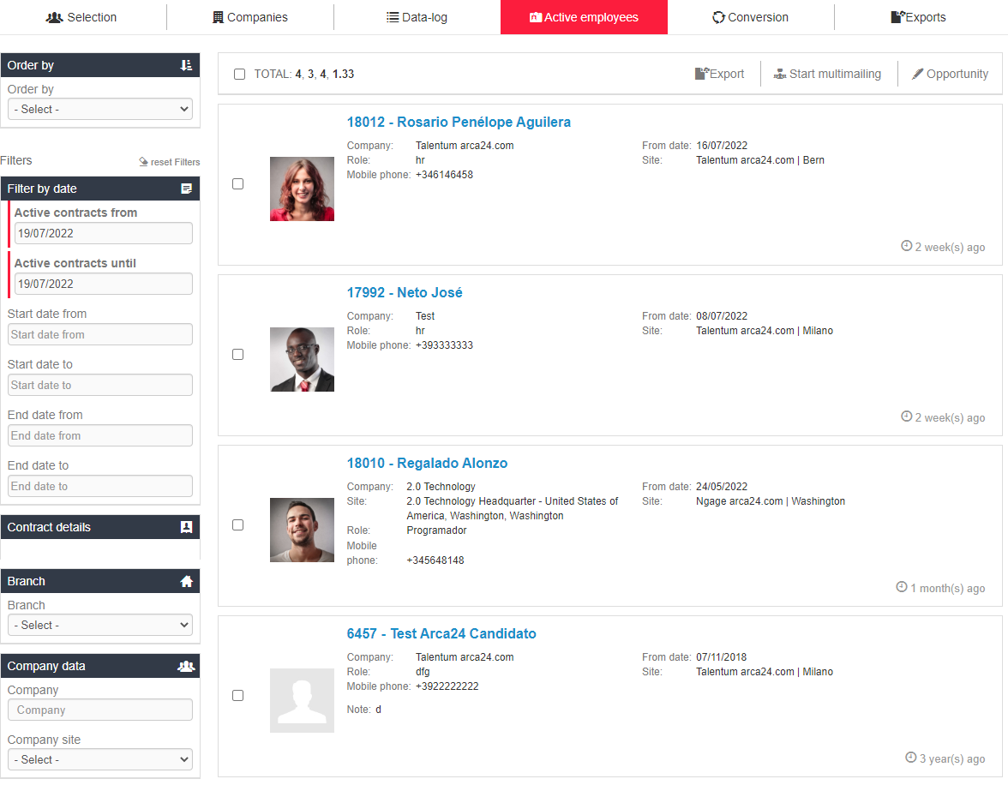

### Exports

In this section, CSV files originating from the extractions requested in the other tabs of this module can be downloaded. Text elements (e.g., note fields) with max. 300 characters will also be printed as CSV file.